Put

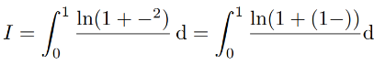.

If we change to 1- we get

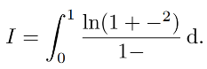

Consequently

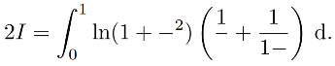

The net step will be integration by parts.

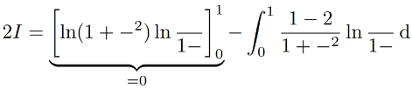

Then 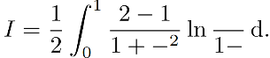

If we substitute  we get

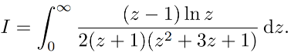

In order to evaluate this integral we integrate along a keyhole contour and use residue calculus. We get that



where