No need multiple-integrals, no need Feynman's trick

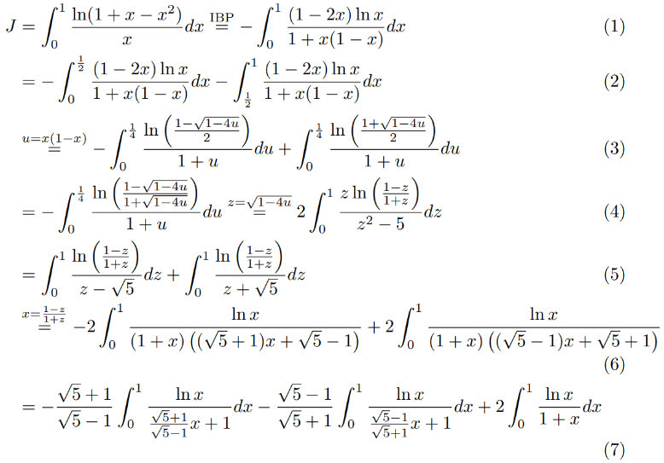

Let ,

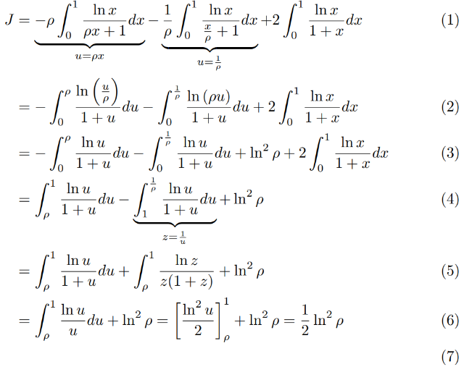

Moreover,

Let , then,

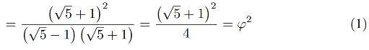

Therefore,

