**1. Create a way for a teacher to add students to his/her class  
      - Make use of students email address**

**Code:**

**.env**

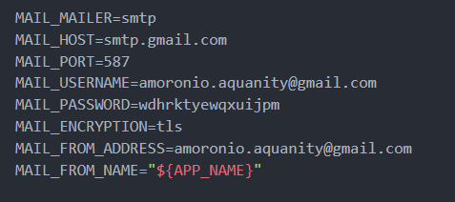

**Routes**



**Controllers**

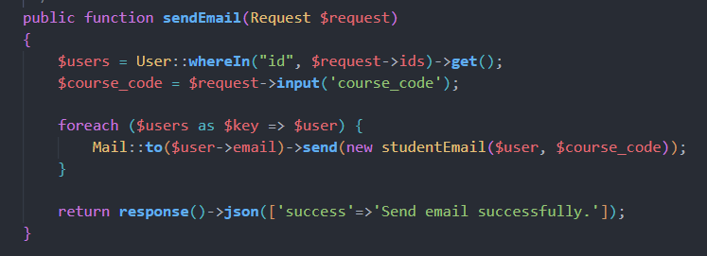

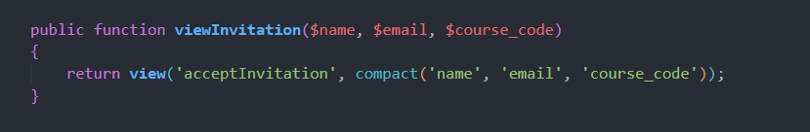

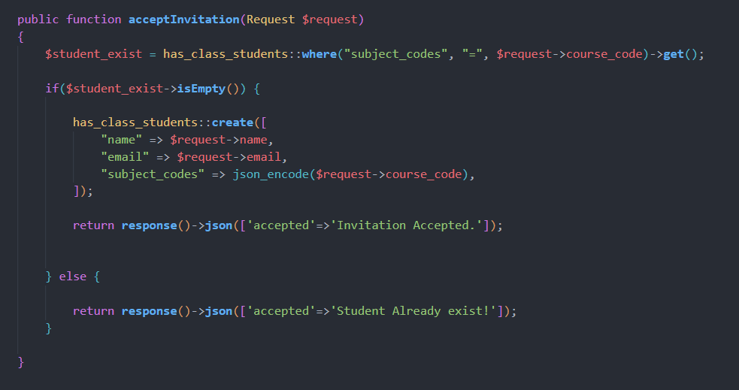

**Blade / Views**

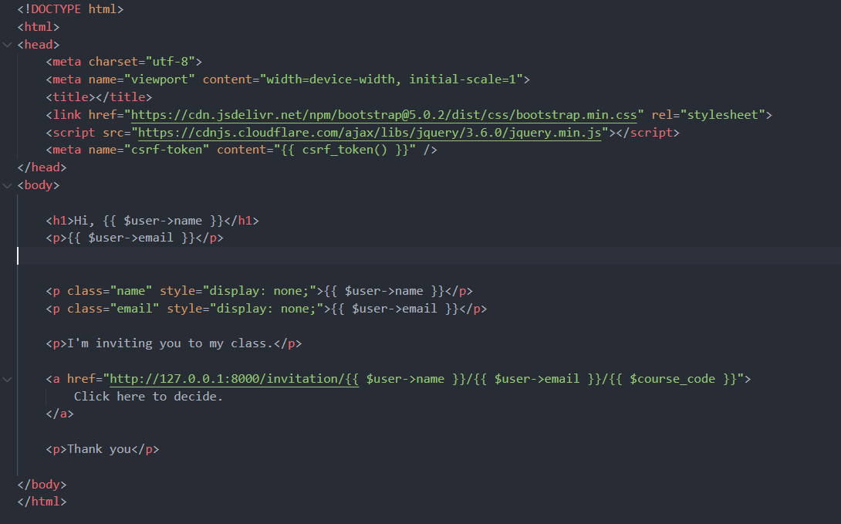

**Mail**

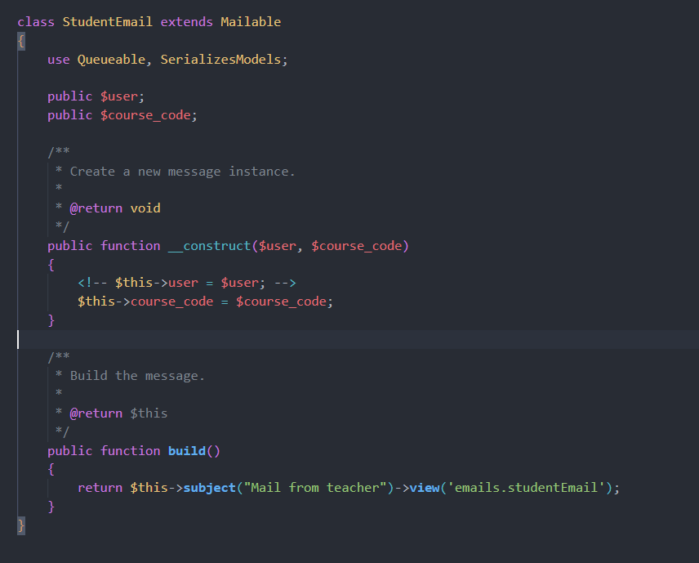

**OUTPUT**

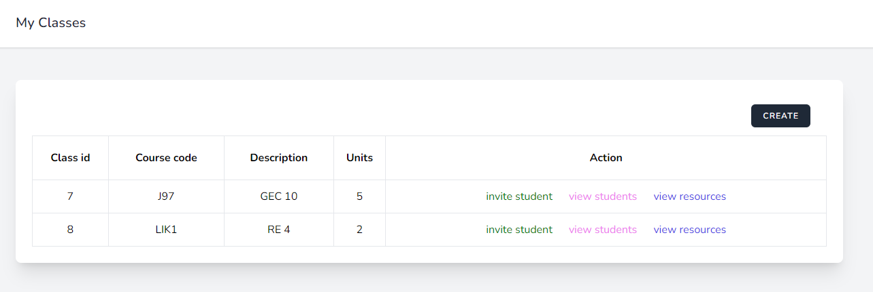

-------------

HJFJ BMBKGH

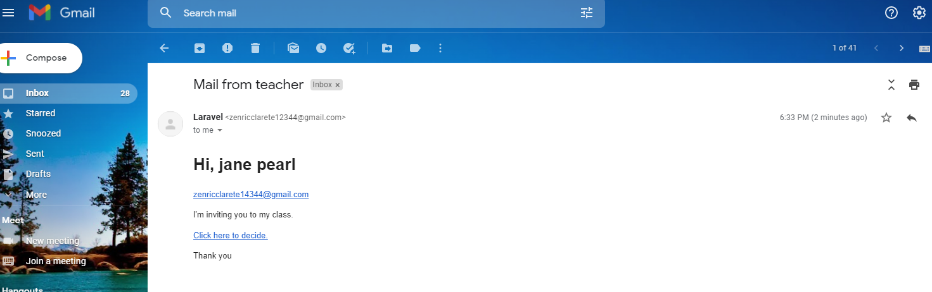

--------------

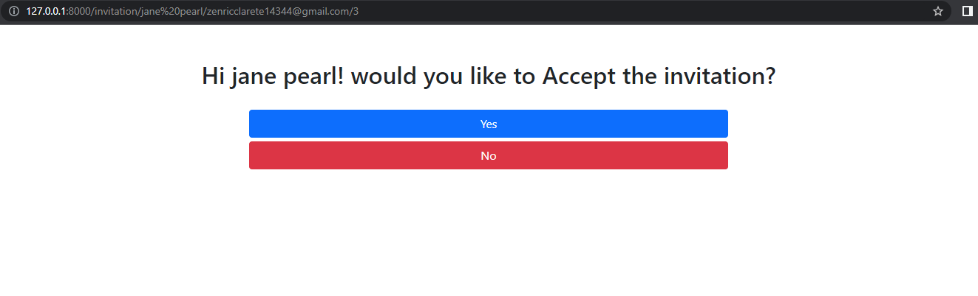

**2.  Create a way for a teacher to upload resources that can be shared to the whole class.  
      - Allowed formats: pdf, ppt, docx, xlsx**

**Routes**



**Controller**

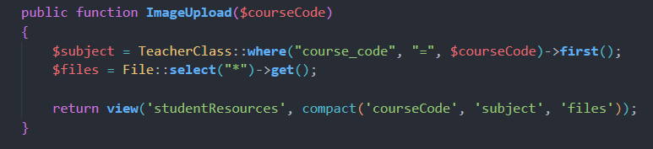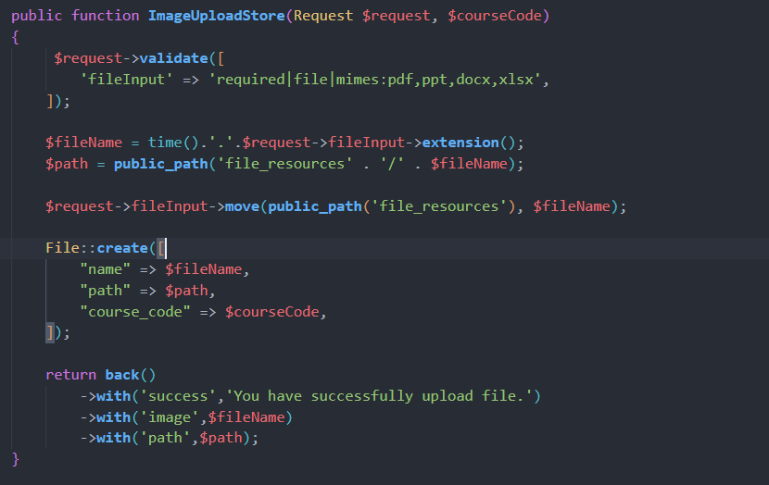

**View / Blade**

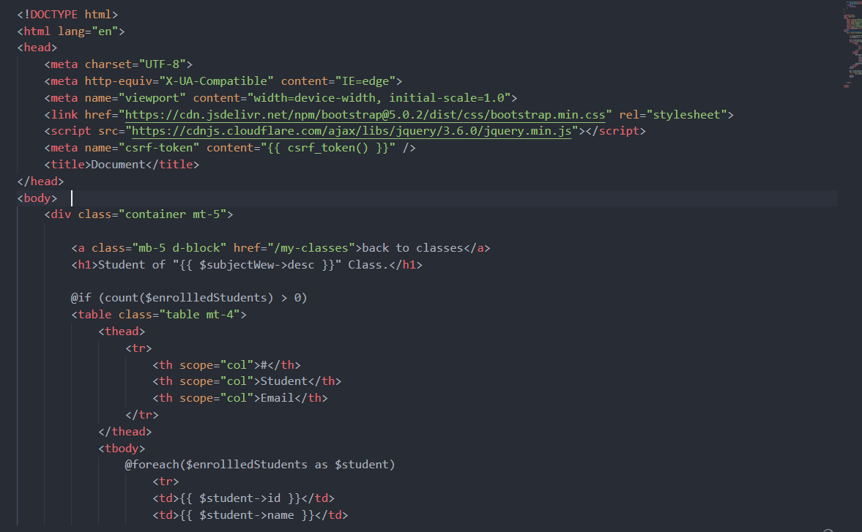

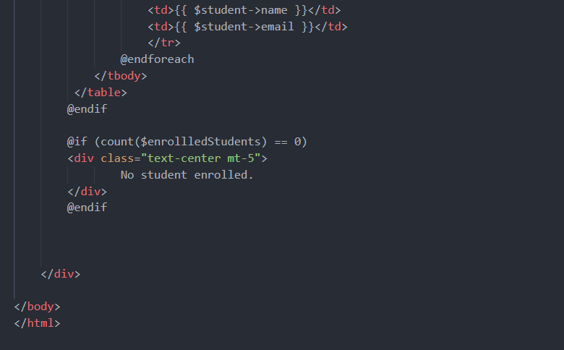

**OUTPUT**





