**1. Create a way for a teacher to add students to his/her class  
      - Make use of students email address**

**Code:**

**.env**

**Routes**

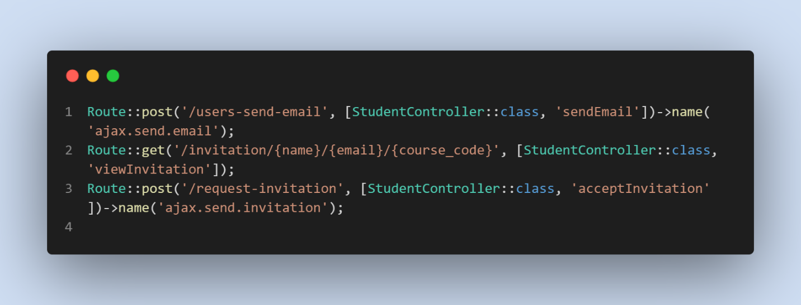

**Controllers**

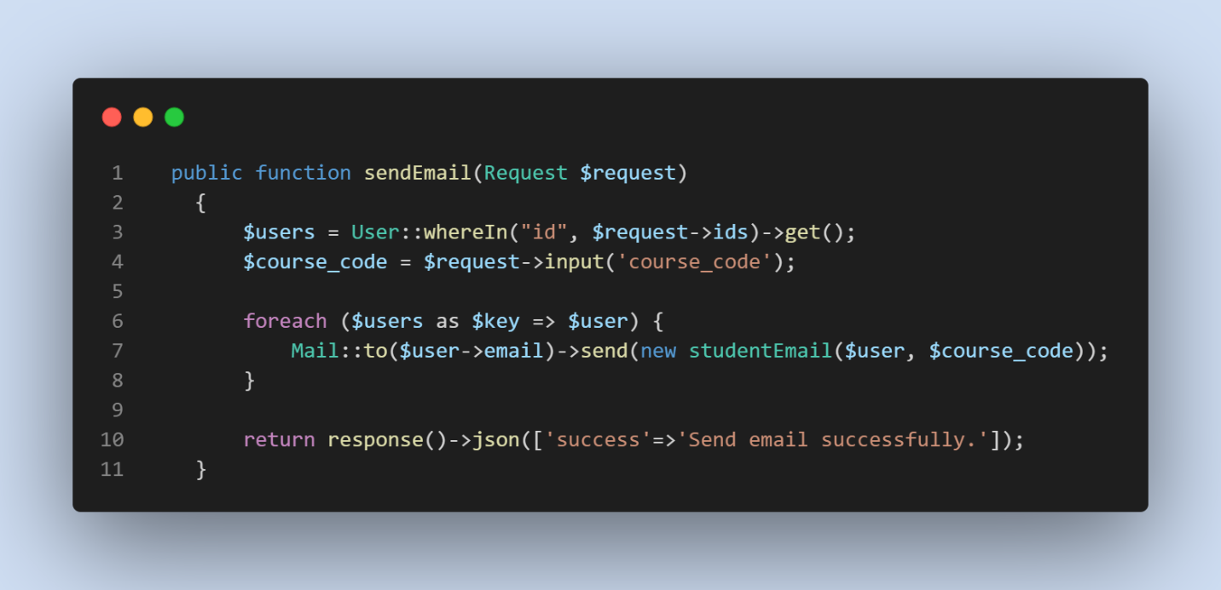

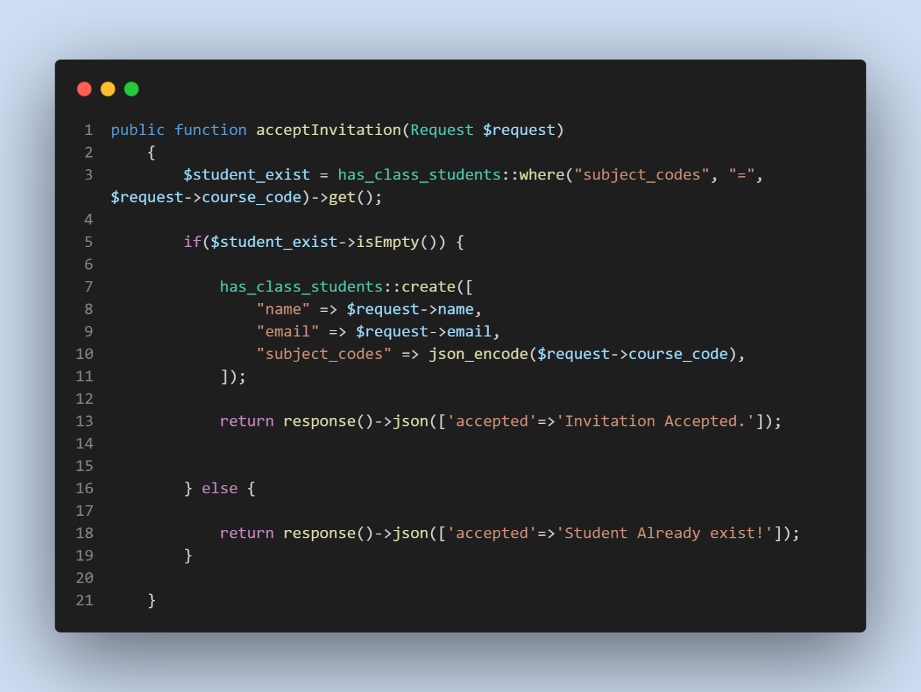

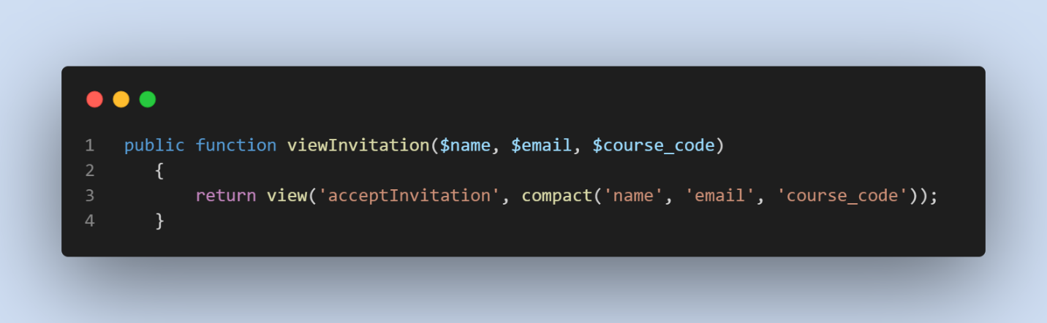

**Blade / Views**

* studentEmail.blade.php
* Google Email format

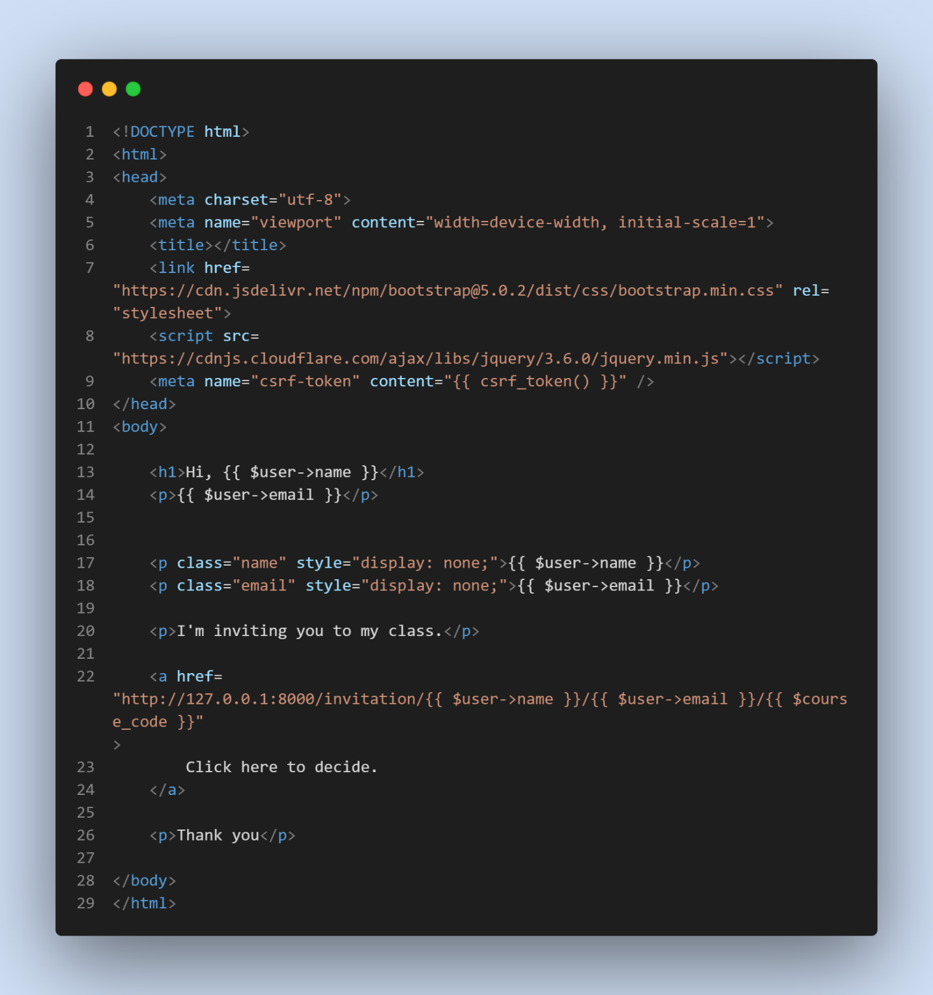

* acceptInvitation.blade.php
* Decide Invitation

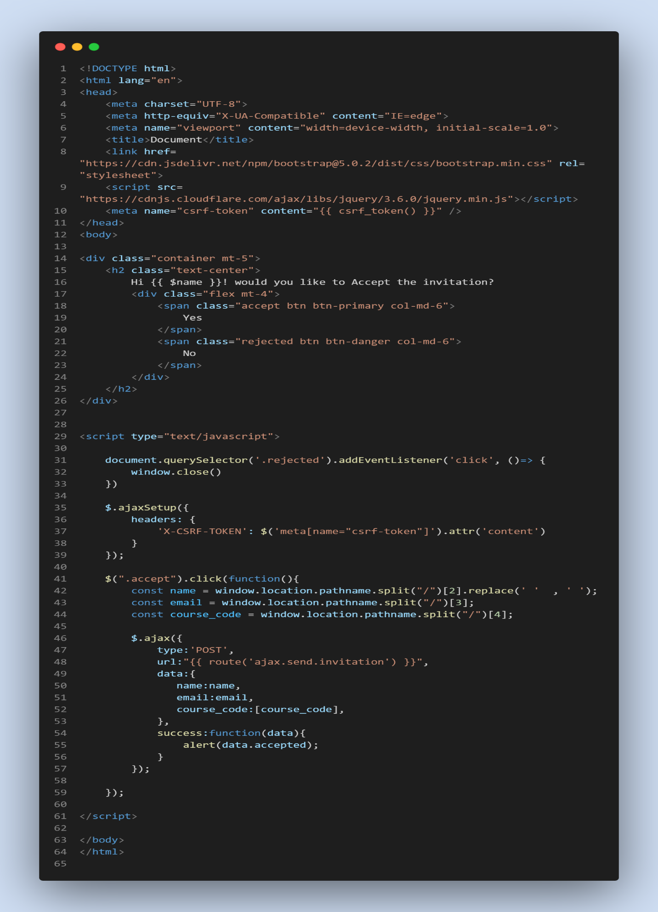

**Mail**

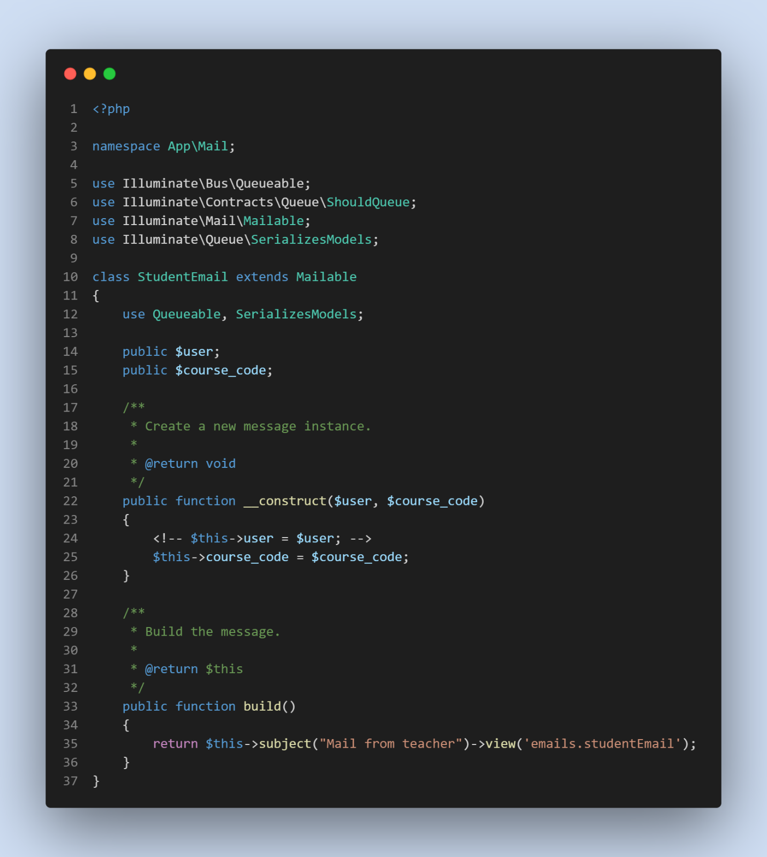

**OUTPUT**

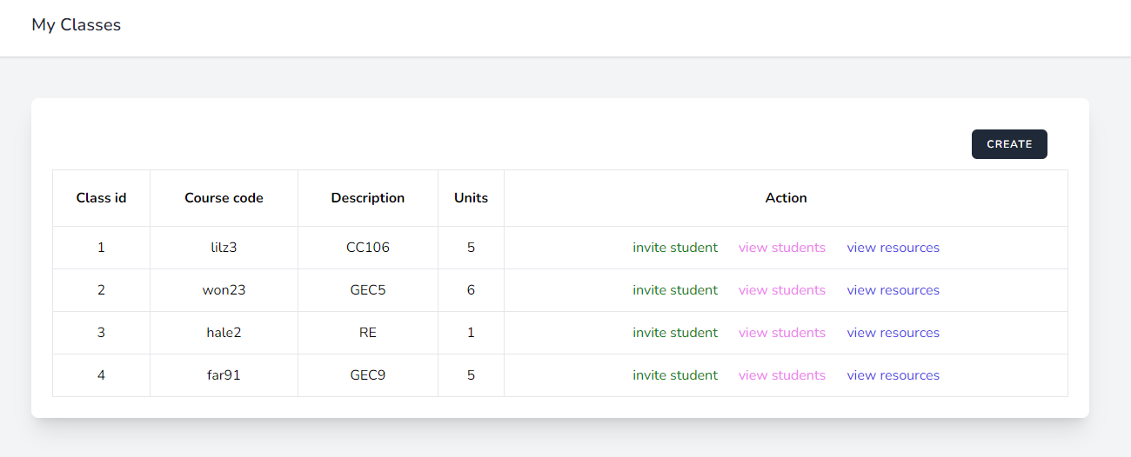

-------------

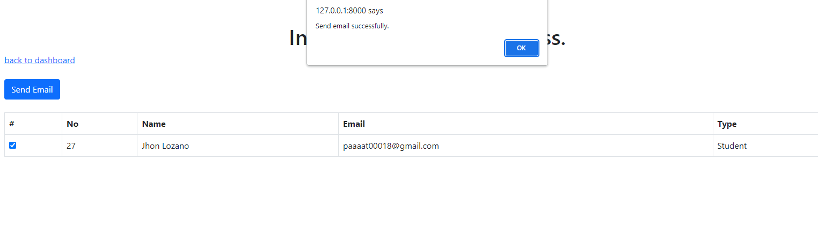

------------

--------------

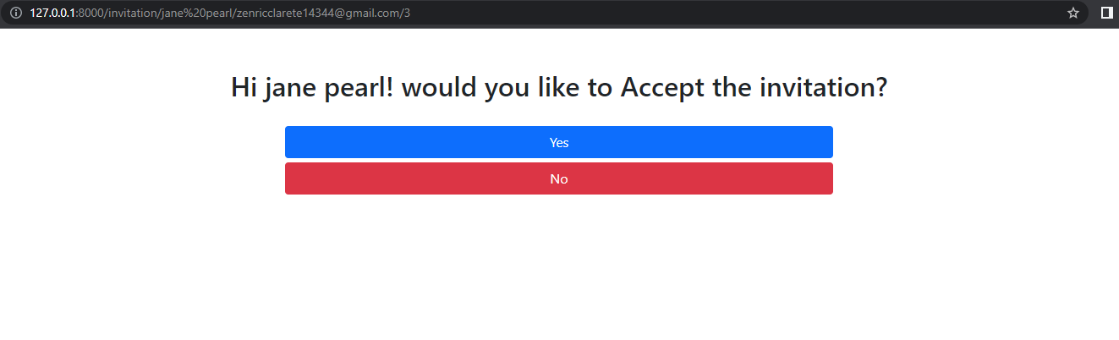

**2.  Create a way for a teacher to upload resources that can be shared to the whole class.  
      - Allowed formats: pdf, ppt, docx, xlsx**

**Routes**

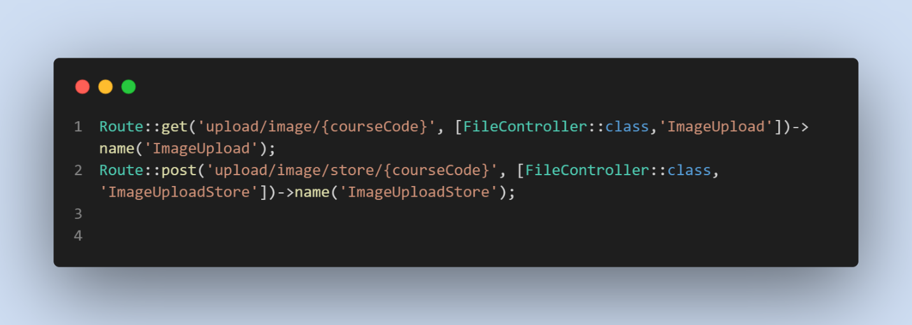

**Controller**

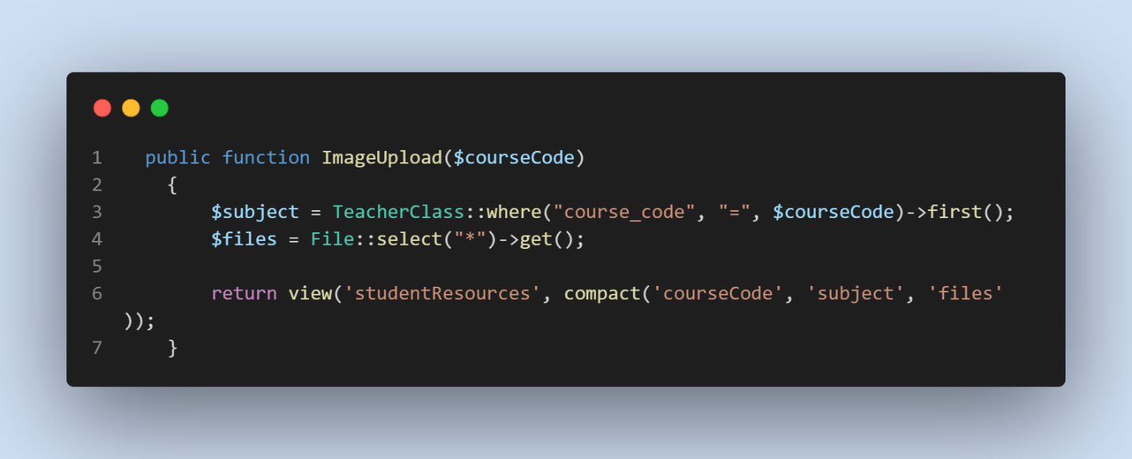

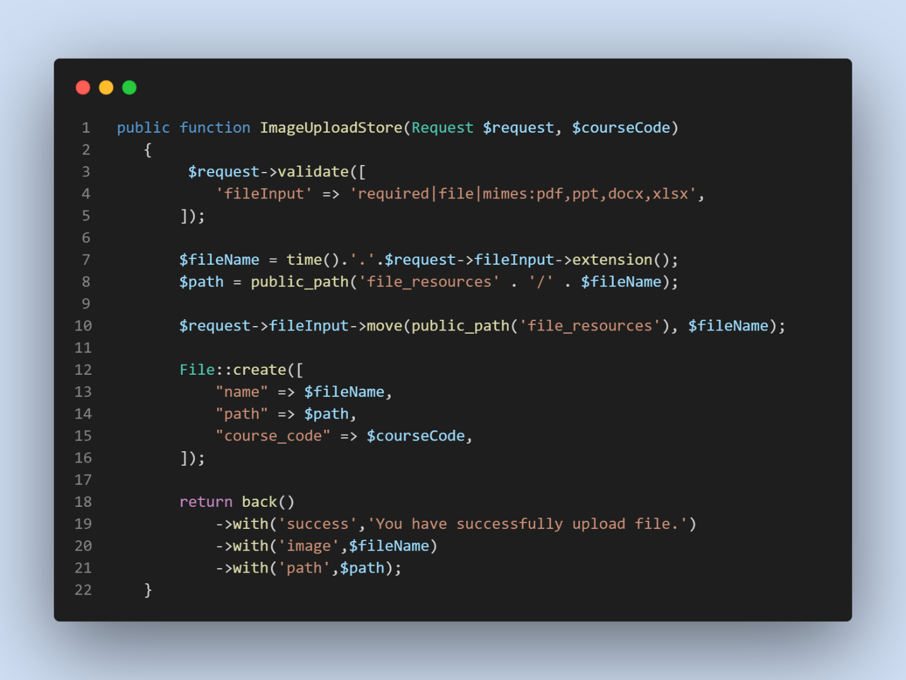

**View / Blade**

* **s**tudentResource.blade.php

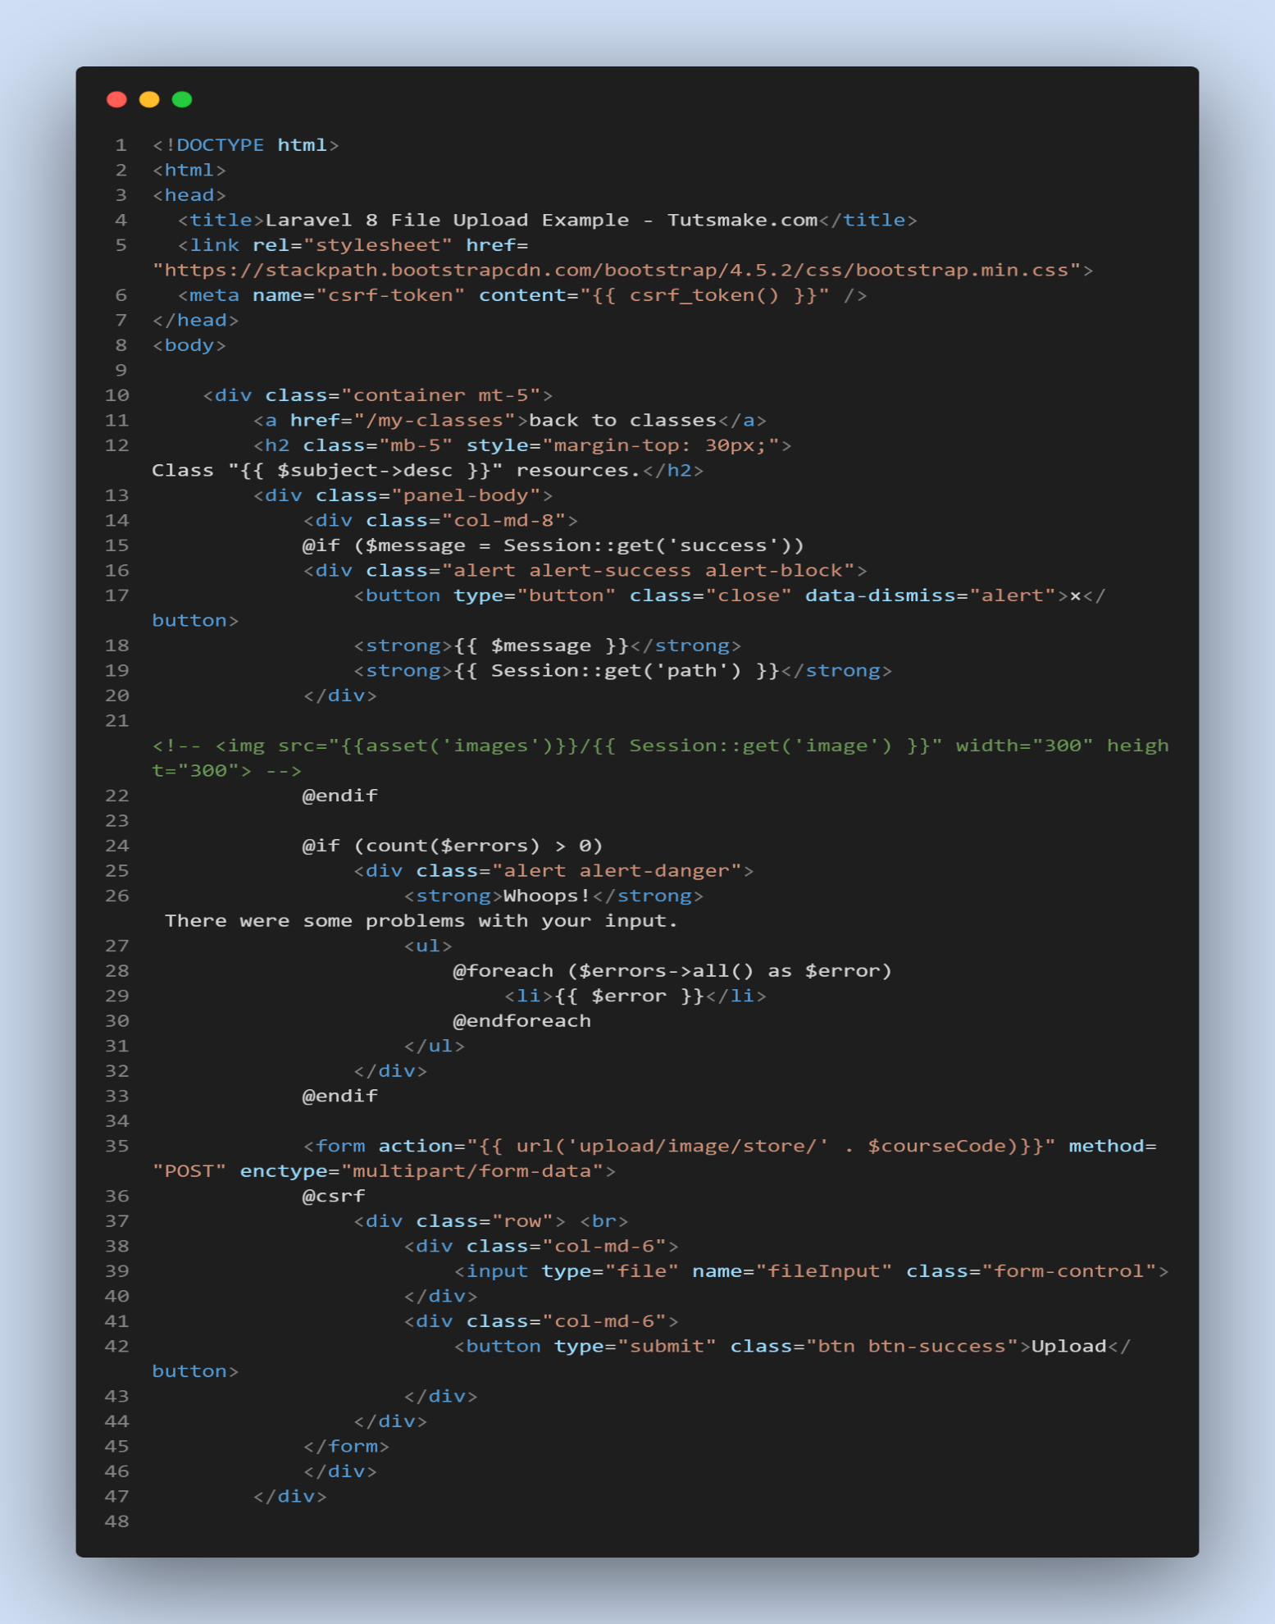

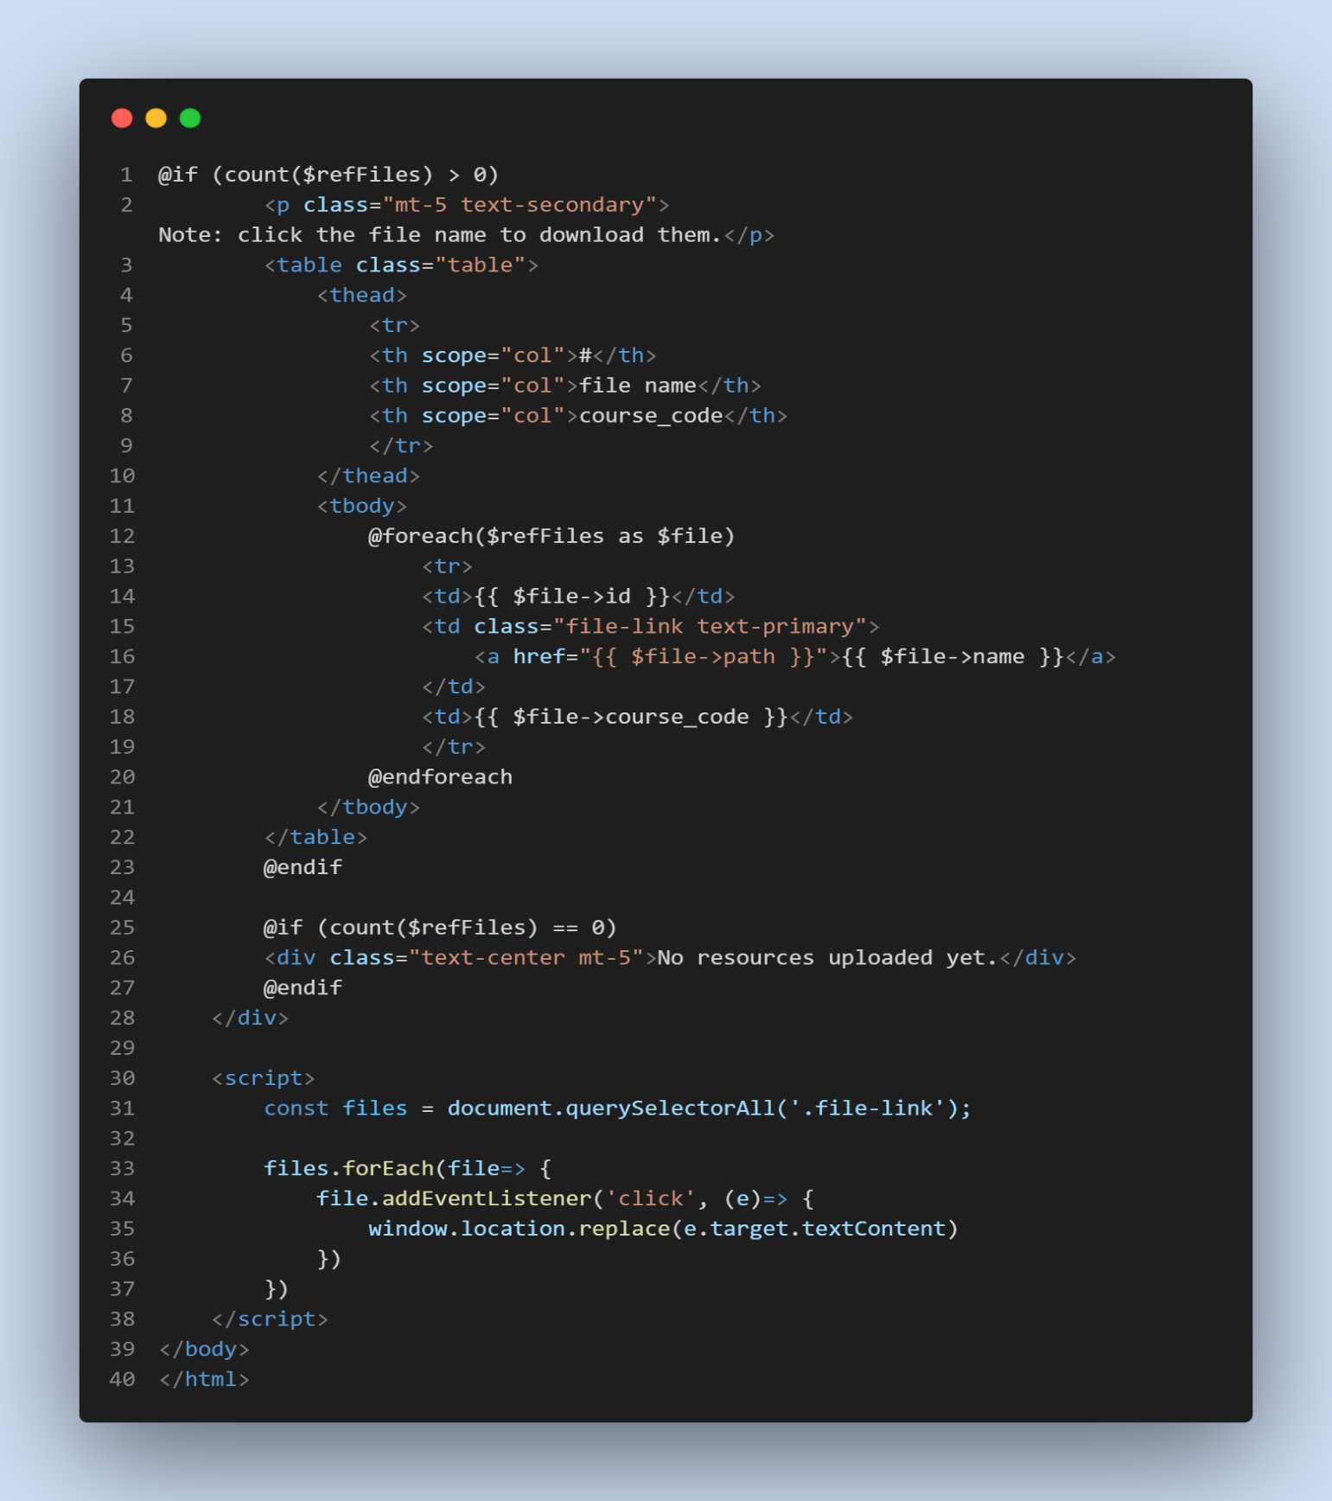

**DB**

* “**Files**” Table

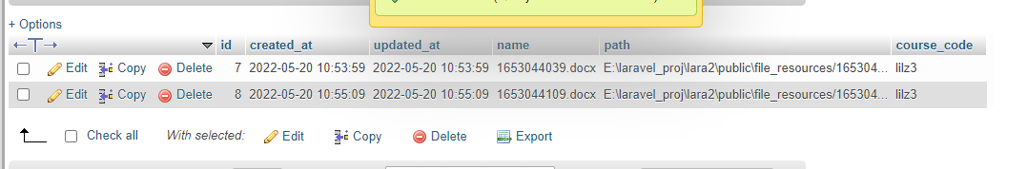

**OUTPUT**



------------

