**Java Technical Test**

Create a Restful webservice to request products in category 600001506 that have a price reduction.

**Project Introduction**

This project is build using maven build tool and developed in **Java** **8** and **Spring boot** framework. It has following features;

1) Java 8 features (Stream API, Lambda etc.)

2) Lombok tool (which minimized the boilerplate code)

3) Rest Template (is used to create applications that consume RESTful Web Services)

4) Swagger2 (is for documenting RESTful services)

5) Dev tools (used for development purpose to auto load the code changes without manual restart)

5) Filter design pattern (which filters products based on criteria of price label and sorting reduction price

**Project Setup:**

1. Clone and checkout the repository from githum.com using eclipse from the price-reduction-branch - <https://github.com/Zensar-Sanjay/price-reduction-branch>
2. **Lombok Configuration into Eclipse**

Since, the project uses Lombok tool, Lombok will work if we put Lombok on the project classpath. But to make it work with eclipse, we need to first do couple of steps to install it in eclipse:

Please follow steps and guidline from below link

<https://howtodoinjava.com/automation/lombok-eclipse-installation-examples/#lombok-eclipse>

**Or** do the following

2.1. Download Lombok Jar File

<https://projectlombok.org/downloads/lombok.jar>

2.2. Start Lombok Installation

Once the jar downloaded in Local repository, go to the jar location from command prompt and run the following command java -jar lombok-1.16.18.jar and we should be greeted by Lombok installation window provided by Lombok

2.3. Give Lombok Install Path

Now click on the “Specify Location” button and locate the eclipse.exe path under eclipse installation folder

2.4. Finish Lombok Installation

Now we need to finally install this by clicking the “Install/Update” button and we should finish installing Lombok in eclipse and we are ready to use its hidden power.

1. Build the project using command: **mvn clean package install**
2. Once the project is built and all dependencies are resolved
3. Run the project

Either

**Go to Eclipse -> Project -> Right click on class, PriceReductionRestServiceApp.java -> Run as Java Application**

Or

using command line - java -jar **price-reduction-rest-api-1.0.0.jar** (this jar is found in project/target folder)

It will start the spring context and start the application

1. Open the browser of your choice and hit the URL

<http://localhost:8080/product-price-service/swagger-ui.html>

1. Now the swagger page is open, and it is ready for use

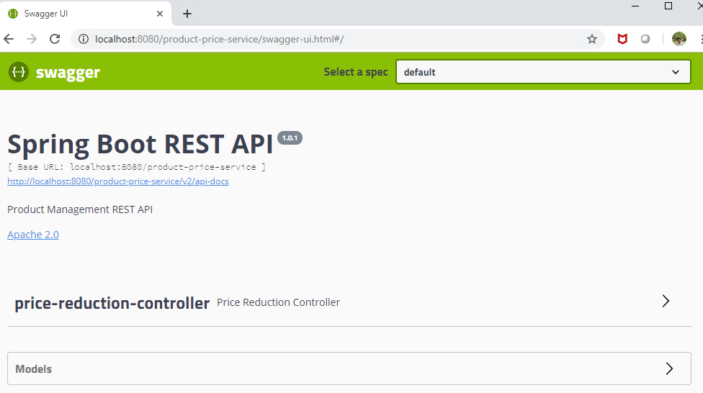

1. Click on interface **“Price Reduction Controller**”
2. Then click on "**Try it out**"
3. Select the required **parameters**,

**categoryId**: 600001506

labelType (optional) and sortBy (optional)

1. Click on “**Execute**”

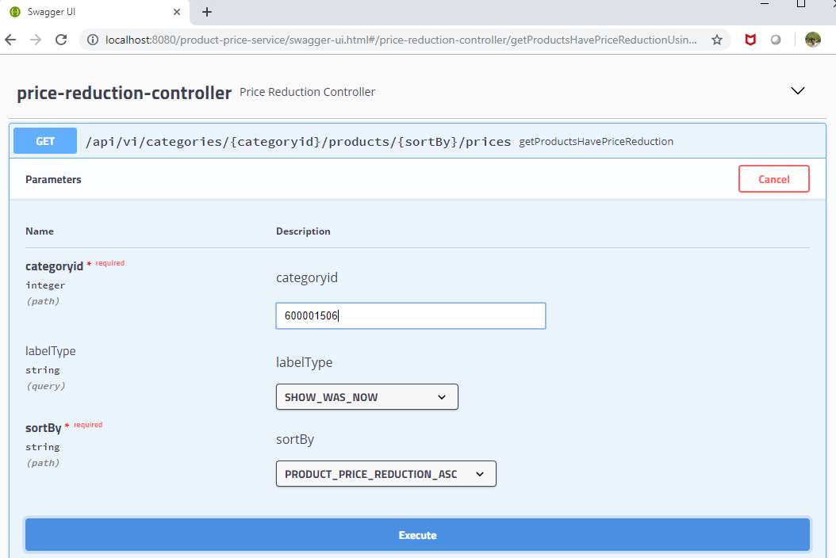

1. Combination of above parameters will give the output accordingly.

**Additional Activities:**

**Code Average Analysis** is done using tool, **EclEmma**

Below is screenshot for Java code coverage;

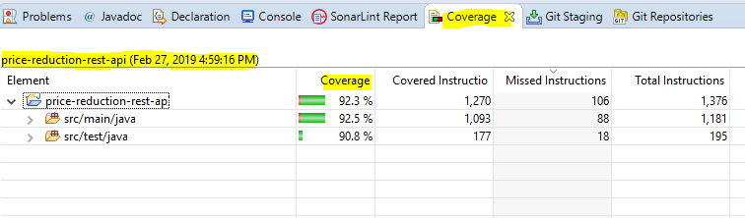

**SonarLint**: used for continuous inspection of code quality thus code is free from all sonar vulnerabilities and warnings.

Below is screenshot for SonarLint report;

