**ITCS 208 Object Oriented Programming**

Assignment Week 2 (Due 29 January 2018)

Name: _____________________Section: ____ ID: ____________

6088063

1

Krittamet Kiattikulwattana

Instructions:

* Assignment must be uploaded to the My Courses system <https://mycourses.ict.mahidol.ac.th> by due date
* For questions that need to write a program, you also need to zip all the code files, rename the zip file to your student id, and upload it to the My Courses system.

**Exercise 1**: Explain the difference between an object and a class. And give an example of objects and classes.

**Answer**

Class is a sheet containing multiple lines of code use to create and/or modify object which type of the object is the class name. Moreover, constructor is needed to complete the process. Object is a box containing all attributes which we define in class.

**Exercise 2:** What’s wrong with the following program?

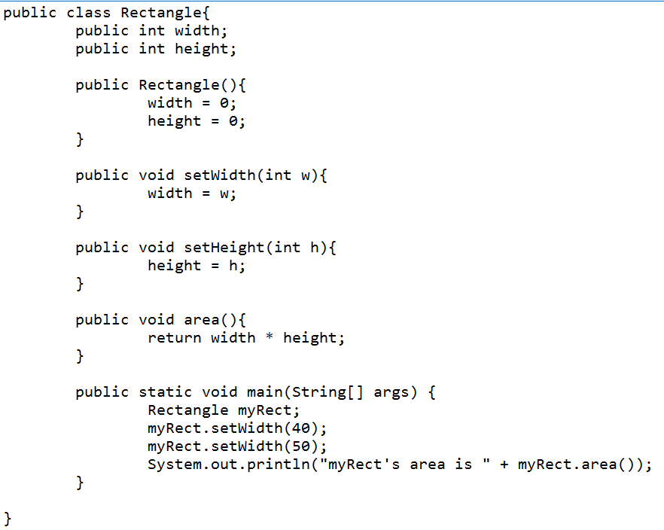

**Answer.** *(Hint there are two problems in this code)*

1. The area class has return value so we have to change void to int.
2. The myRect object must change to Rectangle myRect = new Rectangle; because we must initialize it as an object.

**Exercise 3:** Fix the Rectangle program shown in Exercise 2, and show the output of this program.

**Answer** (please show your output here)

myRect’s area is 200

**Exercise 4.** BankAccount Class is provided below.

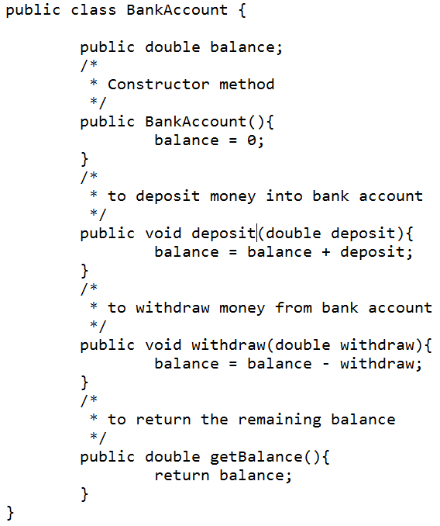

Write a BankAccountTester class whose main method constructs a bank account, deposits $1,000, withdraws $500, withdraws another $400, and then prints the remaining balance. Submit your source code and show the output of your program here.

**100.0**

**Exercise 5.** Implement class Car with the following properties. A car has a certain fuel efficiency (measured in km/litters) and a certain amount of fuel in the gas tank. The efficiency is specified in the constructor, and the initial fuel level is 0. Supply a method drive that simulates driving the car for a certain distance, reducing the amount of gasoline in the fuel tank. Also supply method getGasInTank, returning the current amount of gasoline in the fuel tank, and addGas, to add gasoline to the fuel tank. Sample usage:

Car myCar = new Car(20); // 20 kilometers per litter

myCar.addGas(40); // Add gasoline 40 litters

myCar.drive(100); // Drive 100 kilometers

double gasLeft = myCar.getGasInTank();

// get gas remaining in tank

You may assume that the drive method is never called with a distance that consumes more than the available gas. And write a CarTester class that tests all methods.

***Hint:***

Example of constructor and three methods:

public Car (double efficiency)

public void drive(double distance)

public double getGasInTank()

public void addGas(double litter)

**Exercise 6.** **(Optional, this is a challenge question… just for fun ^_^)**

6.1 Modify the BankAccount class in Exercise 4 to store an information of the account owner. Suppose only a student can open this bank account. And one account can have only one owner. This BankAccount class contains two instance variables: balance and owner (of the class Student created in Exercise 6). Add getOwner() method.

*Hint:*

// attributes

private double balance;

private Student owner;

// constructor

public BankAccount(double balance, Student owner)

// method

public student getOwner(){}

6.2 Try to print the name and email of the account owner from a BankAccount instance.

*Hint:*

myAccount.getOwner().getName(),

myAccount.getOwner().getEmail()

6.3 In BankAccount class, Create new public methods getOwnerName(), getOwnerEmail(), and toString() that returns string “Account [owner=?, email=?, balance=?]”

For example,

public String getOwnerName(){

Return owner.getName();

}