

|  |  |  |  |
| --- | --- | --- | --- |
| Course Code | : | AIT102 | |
| Course Name | : | Python and TensorFlow Programming | |
| Lecturer | : | Ashwaq Qasem | |
| Academic Session | : | 2024/04 | |
| Assessment Title | : | Group project-BetterDino | |
| Submission Due Date | : | Sunday, 7 July 2024, 11:59 PM | |
| Prepared by |  |  | |
| : | Student ID | Student Name |
|  | SWE2209270 | Bertrand Christopher |
|  |  | SWE2209 | Chen JiaWei |
|  |  | SWE2209270 | Pisco Fane |
|  |  | SWE2209276 | William Joshua Evan |
|  |  |  |  |
| Date Received | : |  | |
|  |  |  | |
| Feedback from Lecturer:  Mark: | | | |

**Own Work Declaration**

I/We acknowledge that my/our work will be examined for plagiarism or any other form of academic misconduct, and that the digital copy of the work may be retained for future comparisons.

I/We confirm that all sources cited in this work have been correctly acknowledged and that I/we fully understand the serious consequences of any intentional or unintentional academic misconduct.

In addition, I/we affirm that this submission does not contain any materials generated by AI tools, including direct copying and pasting of text or paraphrasing. This work is my/our original creation, and it has not been based on any work of other students (past or present), nor has it been previously submitted to any other course or institution.

Signature:

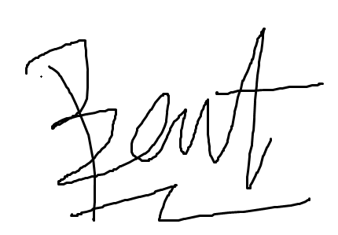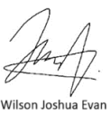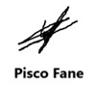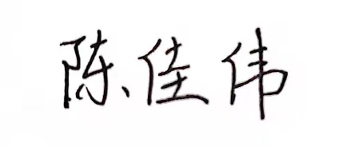

Bertrand Christopher Chen JiaWei

Date: 07/07/2024

# MARKING RUBRICS

|  |  |  |  |  |  |  |  |
| --- | --- | --- | --- | --- | --- | --- | --- |
| **Component**  **Title** |  | **Group Project** | | | **Percentage (%)** | **100** | |
| **Criteria** |  | **Score and Descriptors** | | |  | **Weight (%)** | **Marks** |
| **Excellent**  **(10)** | **Good**  **(8-9)** | **Average**  **(6-7)** | **Need**  **Improvement**  **(3-5)** | **Poor (1-2)** |
| **Presentation** | The presentation is well organized with  clear structure, good logic and solid content | The presentation  is completed with  required content. | The presentation is completed with most required content. | The presentation is not well organized. | very poor  presentation or no  presentation is submitted. | **10** |  |
| **Criteria** | **Excellent (25-30)** | **Good**  **(22-24)** | **Average (17-21)** | **Need**  **Improvement**  **(7-16)** | **Poor (1-6)** |  |  |
| **Program**  **Functionality** | The program meets  the listed  specifications  and does what it  was designed to do with no issues. | The program meets the listed  specification s and works most of the time with some issues. | The program meets the  listed main  specifications and works  most of the time with some issues. | The program does  not meet the listed  specifications or  works intermittently. | The program does not work at all | **30** |  |
| **Criteria** | **Excellent (13-15)** | **Good**  **(11-12)** | **Average (8-10)** | **Need**  **Improvement**  **(4-7)** | **Poor (1-3)** |  |  |
| **Code Quality** | The code is well organized with  perfect style (e.g., the code is non-  repetitive, methods  and variables are named  appropriately,  control and logical structures are used appropriately, etc.). | The code is well  organized and has  minor style issue. | The code is completely  organized and has minor style issue. | The code is poorly  organized  or has major style issue | The code is a total mess. | **15** |  |
| **Level of Effort** | The program is very  challenging and  ambitious and  TensorFlow programming is used. | The program  is  moderately ambitious and takes some effort. | The program is a sense of  ambitious and takes some effort. | The program  is  simple but is well designed. | The program is too simple  and is poorly designed | **15** |  |
| **Team work** | Show clear evidence to assume  alternate roles as a group  leader and a group member  demonstrated in practice | Able to demonstrate in  practice the  ability to assume  alternate roles as a group  leader and a  group member to achieve the same goal | Able to demonstrate  in practice the ability to assume  alternate roles as a  group leader and  group members with some  effect(s) and  require minor improvements. | Attempt to demonstrate in  practice the ability to  alternate roles as a group leader and group  members but with limited  effect and  require improvements | No clear evidence of  ability to assume  alternate roles as a group leader and group  members  demonstrated in practice | **15** |  |
| **Communication**  **Skills** | Start, maintain and end a presentation naturally. Use  appropriate eye  contact and body  language. Take turn  to talk with respect. | Start, maintain and end a  presentation in a friendly  manner.  Maintain good eye contact.  Take turn to talk with respect | Take the  initiative to start  a presentation. Appropriate eye contact.  Take turn to talk | Take part in presentation  when initiated by others.  Limited eye Contact.  Interfere presentation | . Less interest to participate in  presentation  No eye contacts.  Always  disrupt presentation | **15** |  |
| **TOTAL** | | | | | | **100** |  |