ZENVEST
Credit. Investment. Real Estate. One Platform.
Ecosystem Prospectus & Partnership Framework
An Open Financial Ecosystem for Credit, Investment & Real Estate Partners
A Zenza Technology Product
Zenza Technology is a Zenza Inc. company
Prepared for: Prospective Partners & Investor Review
Status: Draft v1.0 | Classification: Confidential
Date: July 2026

Table of Contents

Executive Summary 3
1. The Problem & Vision 4
2. The ZenVest Model — How It Works 5
3. Risk & Governance Framework 7
4. Partner Tracks 9
4.1 For Credit Partners 9
4.2 For Investment Partners 9
4.3 For Real Estate Partners 10
4.4 For Future & Adjacent Partners 11
4.5 Partner Comparison at a Glance 11
5. Investor Track 12
6. Revenue Model — Day-One Monetization 14
7. Phased Roadmap & MVP Definition 16
8. Team & Structure 18
9. Appendix 19

Executive Summary
ZenVest is an open financial ecosystem, not a closed product. It gives everyday Nigerians — salary earners, first-time investors, seasoned professionals, and Gen Z users alike — a single place to access credit, build an investment portfolio, and participate in real estate, while never asking any single partner to be everything at once.
Nigeria's financial landscape is fragmented by design: credit sits with lenders and microfinance institutions, investment products sit with asset managers and capital market operators, and real estate sits with brokers and property managers — each licensed, regulated, and specialized in its own lane. ZenVest does not try to become all three. It becomes the trusted layer that connects users to the best licensed partner in each lane, unifies the experience into one dashboard, and — critically — builds the bridge between credit and investment that none of these players can build alone: the ability to use credit to invest, and use investment returns to responsibly settle credit.
This document is deliberately structured for multiple audiences. Credit partners, investment partners, and real estate partners each have different goals, different regulatory positions, and different reasons to say yes — Section 4 speaks to each of them directly, in their own language, with their own value proposition. Section 5 speaks to investors. Every reader should be able to find their section and understand exactly what ZenVest is asking of them and what they stand to gain.

The Open Ecosystem Thesis
ZenVest is intentionally not exclusive to any one credit provider, one asset manager, or one real estate company. Naming three early conversation partners — Ver Technology (credit), ARM Holding and Cardinal Stone (investment), and Bankz Homes (real estate) — is a starting point for structuring the model, not a ceiling on it. The long-term vision is an open marketplace where multiple qualified partners compete within each category, the way multiple banks plug into Visa's rails or multiple sellers plug into a marketplace — user choice and partner competition make the ecosystem stronger, and remove the single-point-of-failure risk of depending on one partner per pillar.

Revenue From Day One
ZenVest is built to generate revenue from its first live transaction, not after years of scale. Onboarding fees, credit facilitation fees, investment transaction fees, and real estate closing fees are all live from the MVP stage — see Section 6 for the full model. This is deliberate: investors should see a platform with real, diversified fee income from day one, not a growth story that defers monetization.

1. The Problem & Vision

1.1 The Problem
Financial opportunity in Nigeria is scattered across disconnected systems. A salary earner who wants credit goes to a lender. If they want to invest, they go to a completely different app or broker. If they want to own property — even a fraction of one — they need a relationship with a real estate company most people don't have access to. None of these systems talk to each other, and none of them are designed with the first-time investor in mind.
The result is a generation of potential investors — Gen Z and young professionals especially — who are financially capable but underserved: informed enough to want more than a savings account, but without an accessible, trustworthy, single place to learn, decide, and act. Too often, disposable income that could compound into real wealth over a decade goes instead toward everyday consumption — not because people don't want to invest, but because investing has never been made as easy, immediate, or well-explained as spending.
At the same time, the institutions best positioned to serve these users — credit providers, asset managers, real estate companies — are each optimized for their own lane. A lender is excellent at underwriting risk but has no investment product to offer. An asset manager is excellent at structuring investment products but struggles to reach and educate a mass-market, often younger audience cost-effectively. A real estate company is excellent at sourcing and managing property but has no way to offer fractional ownership to a large pool of small investors without new infrastructure.

1.2 The Vision
ZenVest exists to be the connective tissue between these worlds — a single, trusted, AI-informed platform where a user can access credit, build an investment portfolio across real estate, ETFs, bonds, shares, and stable-value assets, and move fluidly between the two: using credit to invest when it makes sense, and using investment returns to settle credit responsibly.
ZenVest's role is deliberately not to replace any of its partners. It does not originate credit, does not manage property, and does not manage funds. It is the orchestration layer: the AI-informed risk and matching engine, the unified user experience, and the financial literacy foundation that makes a genuinely complex, heavily regulated set of products accessible to “the regular man” — whether that's someone in a Big 4 firm, a bank, a seasoned business owner, or a 22-year-old with their first paycheck.
The Gen Z Insight
The money that would have gone toward a shawarma, a dress, or a bottle of perfume becomes an investment instead — and, when used responsibly, credit becomes a tool to invest bigger and build faster, not a trap. ZenVest's product and its financial literacy layer are both built around this insight: make the right decision the easy decision.

1.3 Why This Beats a Single-Category App
- Robinhood and Bamboo-style apps give users a way to invest, but stop there — no credit, no real estate, no bridge between what a user owns and what a user can responsibly borrow against it.
- Credit-only apps (salary advances, BNPL) give users access to money but no path to turning that credit into long-term wealth.
- Real estate platforms give users fractional property access but keep it siloed from the rest of a user's financial life.
- ZenVest is the only model that treats credit, investment, and real estate as one connected financial identity for the user — informed by one AI risk profile, protected by one set of guardrails, and growing from one dashboard.

2. The ZenVest Model — How It Works
The diagram below shows the core structural idea: ZenVest sits between users and an open set of licensed partners across three pillars, unifying the experience while each partner continues to operate within its own license, expertise, and regulatory standing.
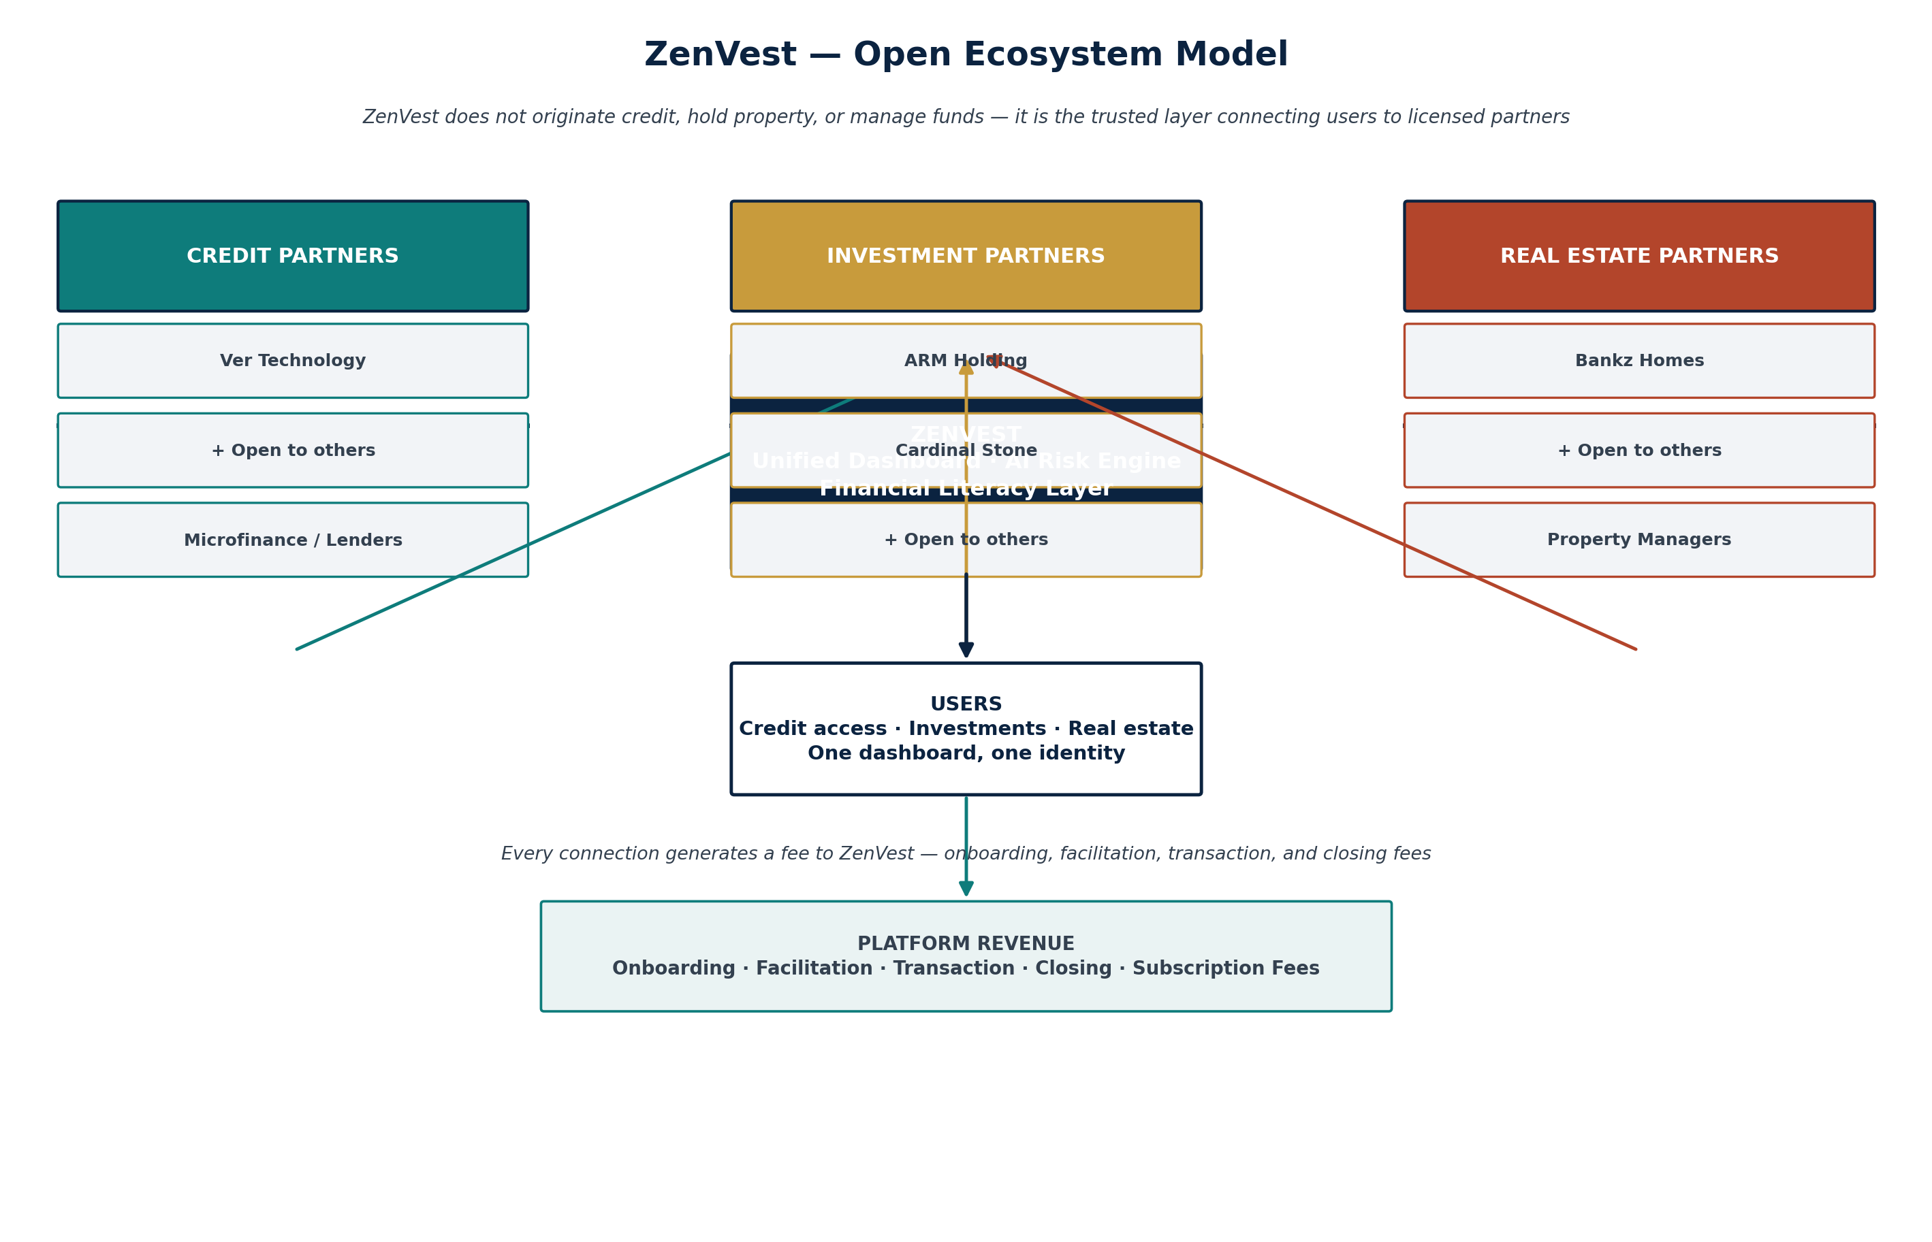
Figure 1 — The ZenVest open ecosystem model

2.1 What ZenVest Is — and Is Not
 | Description
Is | An orchestration and distribution layer — one dashboard, one identity, one AI risk profile across credit, investment, and real estate.
Is Not | A licensed lender, a licensed fund/asset manager, or a real estate company. Those are the partners' domains.
Is | An open marketplace — multiple partners can operate within each pillar, competing on rate, product, and service.
Is Not | Exclusive to any single partner. Naming Ver Technology, ARM, Cardinal Stone, or Bankz Homes reflects early conversations, not a closed ecosystem.
Is | A financial literacy platform first, and a transaction platform second — informed decisions are the product, transactions are the outcome.
Is Not | An investment adviser making specific buy/sell recommendations — see Section 3 for how ZenVest stays on the right side of that line.

2.2 The Three Pillars
Pillar | What It Covers
Credit | Salary-backed loans, credit facilities, bill payment on credit, credit/bill cards — originated and underwritten by licensed credit partners, risk-scored with ZenVest's AI layer.
Investment | Real estate (co-ownership/co-lease), ETFs, stablecoins, bonds, shares and equity-based investments — structured and executed by licensed investment partners, matched to user risk profile and goals.
Real Estate | Property sourcing, brokerage, and management — co-own and co-lease products that turn real estate from a large, illiquid, relationship-gated asset class into something a first-time investor can access in fractions.

2.3 The Bridge — Credit ↔ Investment
The most differentiated part of ZenVest is the ability for a user to move between credit and investment: using an approved credit facility to fund an investment, and using investment returns or holdings to settle credit. This is, functionally, a form of securities-backed or asset-backed lending — a well-precedented model globally, but one that requires real discipline in how it is introduced. Section 3 sets out the risk framework that governs the bridge in detail; the summary principle is simple:
Guiding Principle for the Bridge
The bridge is the last major feature to switch on, not the first. Credit and investment each launch and prove themselves independently, generating real usage and risk data, before the bridge between them is activated — and even then, only with asset-class-specific, conservative loan-to-value limits, never a single blanket ratio.

2.4 The AI Layer
- Credit risk scoring — combining bureau data, alternative data, and (where a user consents) their ZenVest investment behavior into a more complete risk picture than a credit-only lender can build alone.
- Investment performance & suitability modeling — matching investment products to a user's risk profile, goals, and time horizon; surfacing performance and risk information clearly rather than opaquely.
- Guardrail automation — stop-loss and take-profit-style tools adapted per asset class (see Section 3.2), automated alerts, and early-warning signals on credit-investment exposure.
- Financial literacy personalization — adapting educational content to what a specific user needs to understand before they're offered a more complex product.
Note: ZenVest's AI models inform and guide; they do not replace the licensed judgment of investment partners or credit underwriters, and are explicitly designed to avoid crossing into regulated investment-advice territory without the appropriate license — see Section 3.4.

3. Risk & Governance Framework
ZenVest operates at the intersection of two of the most heavily regulated, highest-stakes categories in consumer finance: credit and investment. This section exists because the single biggest risk to ZenVest's users, partners, and reputation is not competition — it's a poorly designed guardrail. Every principle below is a direct design constraint on what gets built, not a compliance afterthought.

3.1 Asset-Class-Specific Loan-to-Value Limits
A loan cannot be valued against collateral using a single blanket ratio when the collateral can be a government bond, a stablecoin, or a fractional stake in a Lagos property — these have wildly different liquidity and volatility profiles. ZenVest's credit-investment bridge uses conservative, asset-class-specific LTV limits, set from real performance data gathered after Phases 1 and 2 (see Section 7), not from launch-day assumptions.
Collateral Type | Indicative LTV Posture | Liquidity
Bonds / fixed income | Higher (most conservative-risk collateral) | High
ETFs / diversified equity | Moderate | High
Individual shares | Lower | Medium
Stablecoins | Lowest / case-by-case, pending regulatory clarity | Medium-High
Real estate co-ownership stake | Not eligible as credit collateral in Phase 1–2; reassessed once a secondary transfer mechanism exists | Low

3.2 Stop-Loss and Take-Profit — Not One Mechanism, Two
Stop-loss and take-profit only work as literally described for assets with a continuous, tradeable market price — ETFs, shares, bonds, stablecoins. For those, ZenVest supports standard automated threshold orders.
Real estate does not have a continuous market price, and a fractional stake cannot be sold at 2am the way a stock can. For real estate, ZenVest instead offers a listing/realization-request mechanism: a user can list their stake for sale to other platform investors at a target price, or trigger a structured buy-back conversation with the real estate partner. This is designed and communicated to users as a distinct tool from stop-loss/take-profit, never described or marketed as equivalent liquidity.

3.3 Real Estate Requires a Legal Wrapper
Co-owning property through an app is not just a UX problem — fractional ownership needs to be legally real, typically via an SPV or REIT-style structure per property or property pool, not just a balance in ZenVest's database. This is a natural area of deep collaboration with investment partners like ARM, whose core business is structuring investment vehicles — the likely cleanest division of labor is: the real estate partner sources and manages the property, an investment partner structures and legally wraps the investment vehicle, and ZenVest distributes it to users and services the ongoing relationship.

3.4 Staying on the Right Side of “Advice”
Nigeria (like most markets) regulates investment advice as its own licensed activity. ZenVest's AI models are designed to inform, educate, and surface options and risk information — not to issue specific personalized buy/sell recommendations, which is the licensed domain of the investment partner. This distinction is a legal one, not just a design preference, and should be reviewed with capital markets counsel before any AI-generated content is shown to users in a way that could be read as advice.

3.5 Partner Integration Maturity
Not every partner can offer the same level of technical integration on day one. A newer, smaller credit or real estate partner may only be capable of manual reconciliation and batch data exchange at first, while a more institutional investment partner may offer real-time APIs. ZenVest's roadmap and MVP scope per partner should be set honestly against each partner's actual integration maturity, not against an idealized API that may not exist yet — see Section 7.

3.6 Financial Literacy as Risk Mitigation
The financial literacy layer running through ZenVest is not just a product differentiator aimed at Gen Z — it is a genuine risk control. A user who understands what leverage means, what a stop-loss actually protects against, and why real estate liquidity is different from a stock is a materially safer user of a credit-investment bridge than one who isn't. Literacy content should be a required, not optional, gate before a user is offered access to leveraged or bridge features.

4. Partner Tracks
This section is written to be read section-by-section by the specific partner it addresses. A credit partner should be able to read Section 4.1 alone and understand exactly what's being proposed; the same is true for investment and real estate partners in their own sections.

4.1 For Credit Partners
(e.g., Ver Technology and other licensed lenders / microfinance institutions)

Your Position Today
You already originate and underwrite credit — likely to salary earners, likely at meaningful but limited scale, with customer acquisition and portfolio risk as your two biggest constraints on growth.

What ZenVest Offers You
- A pre-qualified user funnel — users arrive with a ZenVest financial profile already informed by their investment behavior and engagement, not a cold application.
- A richer risk signal than bureau data alone — with user consent, investment behavior and portfolio data give you a more complete underwriting picture, potentially improving approval accuracy and reducing default risk.
- A new, structurally lower-risk repayment channel — users can settle credit from investment returns/holdings under the bridge framework, rather than relying solely on salary repayment.
- Revenue share on facilitation fees generated through the platform, on top of your own interest/fee income on the credit you originate.
- Distribution without having to build investment or real estate capability yourselves.

What ZenVest Asks of You
- API or batch data integration for loan origination, servicing status, and repayment (matched to your current technical maturity — see Section 3.5).
- Competitive, transparent rates and terms shown clearly to users — ZenVest's credibility depends on partner terms being genuinely fair.
- Compliance standing (valid lending license) and a willingness to work within ZenVest's risk framework, particularly around the bridge (Section 3.1).

What You Stand to Gain
A meaningfully larger, better-informed borrower base without a proportional increase in acquisition cost, a new fee revenue stream, and a front-row seat in a platform designed to become the primary financial relationship for a large, underserved segment of the market.

4.2 For Investment Partners
(e.g., ARM Holding, Cardinal Stone, and other licensed asset managers / capital market operators)

Your Position Today
You have structured, well-governed investment products and institutional-grade infrastructure, but reaching and converting a mass-market, often younger, first-time investor audience cost-effectively is a persistent distribution challenge.

What ZenVest Offers You
- Access to a new distribution channel purpose-built for first-time and mass-market investors, with a financial literacy funnel that “warms up” users before they reach your product shelf — arriving more informed and more ready to commit than typical cold acquisition.
- Aggregated demand — ZenVest can pool smaller ticket sizes from many users into transaction volumes that are more efficient for you to service.
- A genuine role in structuring new product categories — particularly fractional real estate investment vehicles (Section 3.3), where your capital markets structuring expertise is the missing piece for Bankz-Homes-style real estate partners.
- AUM growth from a segment that is currently underserved by traditional wealth management channels, with long runway as these users' incomes and portfolios grow over time.

What ZenVest Asks of You
- Product access — API or structured data feed for the investment products you want distributed through ZenVest (ETFs, bonds, funds, structured real estate vehicles).
- Fair, transparent fee structure disclosed clearly to users.
- Collaboration on suitability and risk-appropriate product matching, so ZenVest's AI layer reflects your actual product risk profiles accurately.
- Willingness to explore new product structures together, particularly around fractional/structured real estate investment vehicles.

What You Stand to Gain
A scalable, technology-native distribution arm without the cost of building and marketing a consumer app yourselves, a new AUM growth channel in an underserved segment, and — for real estate structuring specifically — a first-mover position in a fractional property investment category that doesn't yet have an established leader in this market.

4.3 For Real Estate Partners
(e.g., Bankz Homes and other real estate brokerage / management companies)

Your Position Today
You buy, sell, rent, and manage property for a fee, with deal sizes and sales cycles that are capital-intensive and often slow, and a buyer pool limited to those who can transact at full property price.

What ZenVest Offers You
- Access to a fractional-investment capital pool — instead of needing one buyer for a whole property, ZenVest can bring many smaller investors to a single deal, increasing transaction velocity.
- A new co-ownership and co-lease product line, opening a category of buyers who were previously priced out entirely.
- Continuity of your management fee model — you continue managing the property; ZenVest and its investment partners handle the investment-vehicle and distribution side.
- Marketing and distribution reach into a large user base actively looking for investment opportunities, reducing your dependency on traditional lead generation.

What ZenVest Asks of You
- Property vetting standards and transparent documentation, since ZenVest's users are trusting the platform with these deals.
- Cooperation on legal structuring (SPV/REIT-style vehicles, likely alongside an investment partner — Section 3.3) so fractional ownership is legally sound, not just an app balance.
- Clear, disclosed fee structure and realistic timelines communicated to users.

What You Stand to Gain
Faster transaction velocity on deals that might otherwise sit on the market, a new fractional/co-ownership revenue line on top of your existing brokerage and management business, and access to capital and demand you would not reach through traditional channels alone.

4.4 For Future & Adjacent Partners
The ecosystem is intentionally extensible beyond the three founding pillars. Categories under consideration for later phases:
- Payment Service Providers / switches — for bill payment, card issuance, and settlement rails.
- Credit bureaus & alternative data providers — to strengthen the AI credit risk layer.
- Insurance partners — protecting credit facilities and investment holdings.
- Legal & SPV administration partners — supporting the real estate legal wrapper structures at scale.

4.5 Partner Comparison at a Glance
 | Credit Partner | Investment Partner | Real Estate Partner
Primary Goal | Portfolio growth, lower CAC | AUM growth, distribution reach | Transaction velocity, new buyer pool
What They Bring | Underwriting, licensed lending | Structured products, capital markets expertise | Property sourcing & management
What ZenVest Brings Them | Pre-qualified funnel, richer risk data | Mass-market distribution, literacy funnel | Fractional capital pool, new demand
Revenue to ZenVest | Facilitation fee (% of loan) | Transaction fee (% per trade/placement) | Closing fee (% of deal)
Regulatory Anchor | Lending license | SEC / capital markets license | Real estate brokerage license

5. Investor Track
This section speaks directly to investors evaluating ZenVest as an opportunity — what the platform is building toward, what's being asked, and what's on offer.

5.1 Why Now
- Nigeria's investment and credit markets are digitizing fast, but remain fragmented across single-category apps — no platform has credibly combined credit, multi-asset investment, and real estate into one trusted experience.
- A large, digitally native, underserved Gen Z and young professional population is actively looking for accessible ways to build wealth, evidenced by the growth of category leaders like Bamboo, Risevest, Cowrywise, and Chaka — each proving demand in one lane of what ZenVest combines.
- Zenza Technology already has a working model for this kind of orchestration-layer product: Zenza FID applies the same “don't replace the licensed institution, sit alongside it and add intelligence” philosophy in fraud intelligence — a credible signal that this team can execute the model.

5.2 Market Opportunity
Three addressable markets converge in ZenVest: the digital lending market (salary-earner and consumer credit), the retail investment market (ETFs, bonds, equities, and increasingly stablecoins), and the fractional/proptech real estate market — each growing independently in Nigeria, none yet meaningfully connected for the end user. ZenVest's addressable opportunity is the union of users who want more than one of these, which — given how interconnected financial decisions actually are — is most of the target market, not a niche within it.

5.3 What Makes This Defensible
- Network effects across three pillars — a user with credit, investment, and real estate activity on ZenVest is significantly harder for a single-category competitor to win away.
- The AI risk layer improves with usage across all three pillars simultaneously — a data advantage that a credit-only or investment-only competitor cannot replicate without also building the other two.
- The open-ecosystem model avoids single-partner dependency risk that would otherwise make this fragile — if one credit or investment partner underperforms or exits, others can be onboarded without rebuilding the platform.
- Financial literacy as a genuine product moat — not a marketing layer, but the mechanism that lets ZenVest responsibly offer more sophisticated (and higher-margin) products, like the credit-investment bridge, that competitors without a literacy foundation cannot safely offer.

5.4 The Ask
Full financial detail (funding stage, amount, use of funds, and projections) should be developed alongside a proper financial model once Phase 0 partner conversations are underway and real fee-volume assumptions can be grounded in signed or near-signed partner terms, rather than estimated in advance of them. What can be stated now: ZenVest is designed to show investors a platform with live, diversified, multi-pillar fee revenue from its MVP stage (Section 6), not a pre-revenue growth story — the funding ask should be sized to reach that live-revenue MVP milestone, plus 12–18 months of runway beyond it to prove the model with real partner and user data.

5.5 What Investors Gain
- Equity in a platform-economics business — diversified fee income across three regulated verticals is structurally more resilient than a single-category fintech.
- A team with a proven build pattern — Zenza Technology's existing FID platform demonstrates the same orchestration-layer thesis executed successfully in a different regulated vertical.
- A credible path to category leadership in a market segment (Gen Z / mass-market first-time investor, credit-to-invest bridge) that is not yet owned by an incumbent in Nigeria.
- Optionality — the open-ecosystem model means ZenVest's growth is not capped by any single partner's capacity, and new partner categories (Section 4.4) extend the platform's addressable market over time.

6. Revenue Model — Day-One Monetization
ZenVest is designed so that its MVP is already a revenue-generating platform, not a free product monetized later. The diagram below shows how fees flow from user activity across all three pillars into platform revenue from the first live transaction.
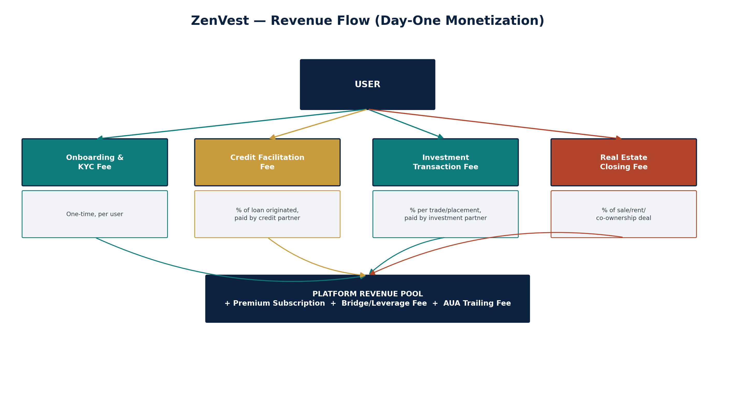
Figure 2 — ZenVest day-one revenue flow

6.1 Revenue Lines
Revenue Line | Structure | Pillar | Notes
Onboarding & KYC Fee | One-time, per user | All | Covers identity verification and onboarding cost; small, non-prohibitive
Credit Facilitation Fee | % of loan originated | Credit | Paid by the credit partner as a distribution/origination cost
Investment Transaction Fee | % per trade/placement | Investment | Paid by the investment partner or embedded in the product spread
Real Estate Closing Fee | % of sale/rent/co-ownership deal | Real Estate | Paid by the real estate partner on completed transactions
Premium Subscription | Monthly/annual, per user | Platform | Advanced AI insights, higher credit limits, priority support
Bridge / Leverage Fee | Interest spread or flat fee | Bridge | Charged on credit-to-invest transactions once the bridge is live (Phase 3) — priced conservatively and transparently
Assets-Under-Administration Trailing Fee | Small % annually, trailing | Investment | Ongoing AI-driven portfolio monitoring and reporting, later stage

6.2 Why This Generates Revenue Immediately
- Fee-based, not spread-based, as the primary model — ZenVest earns a percentage of value moved through the platform from day one, rather than needing to build and season its own balance sheet first.
- Multiple independent revenue lines mean MVP revenue does not depend on all three pillars launching simultaneously — Phase 1 (investment-led MVP, Section 7) already generates transaction fee revenue before credit or real estate partners are fully integrated.
- Partners are motivated to pay facilitation/closing fees because they are paying for distribution and qualified demand they would otherwise have to acquire themselves at a higher cost — the fee is priced against that alternative cost, not arbitrarily.

6.3 Fee Sensitivity & Fairness
Every fee line above should be benchmarked against what each partner currently pays for equivalent customer acquisition or distribution, and priced so that partners are structurally better off working with ZenVest than acquiring these users independently. This is the actual sales pitch to every partner category in Section 4: the fee is smaller than what you're already spending to get a comparable, less-informed user.

7. Phased Roadmap & MVP Definition
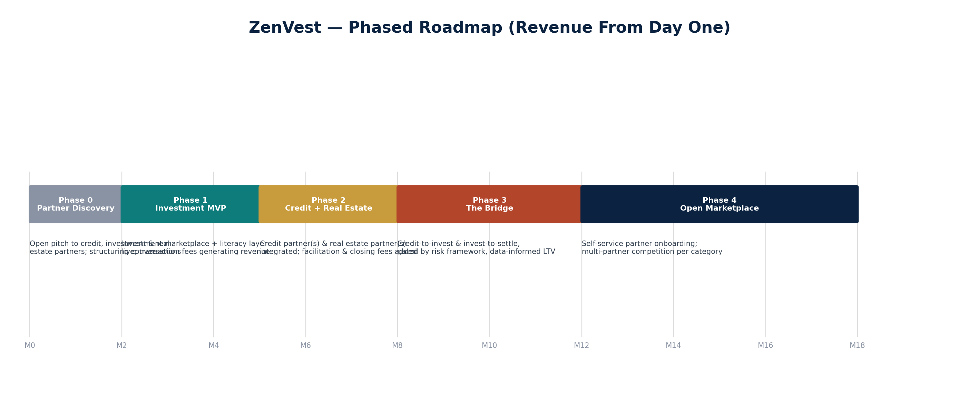
Figure 3 — Phased roadmap, revenue-generating from Phase 1

7.1 Phase 0 — Partner Discovery (Open Pitch)
- Structured conversations with credit, investment, and real estate partners — not limited to Ver Technology, ARM, Cardinal Stone, or Bankz Homes; this document is designed to be shared with any qualified partner in each category.
- Regulatory counsel engagement to confirm the correct licensing posture for ZenVest itself (likely an aggregator/technology license position rather than a licensed financial institution — to be confirmed with capital markets and lending counsel).
- Finalize which 1–2 partners per pillar move first, based on integration maturity (Section 3.5) and terms.

7.2 Phase 1 — Investment-Led MVP
Investment is the recommended first pillar to launch: it carries lower operational risk than credit (no default/collections exposure) and lower structuring complexity than real estate (no SPV/legal wrapper needed for standard ETF/bond/share products). This gets ZenVest to live transaction-fee revenue fastest.
- Investment marketplace live with one or more investment partners — ETFs, bonds, shares.
- Financial literacy layer live and required before a user can transact — the core risk-mitigation and differentiation feature from day one.
- AI suitability matching (risk profile to product), not yet full performance-prediction modeling.
- Onboarding/KYC fee and investment transaction fee both live — real revenue from Phase 1.

7.3 Phase 2 — Credit + Real Estate Integration
- Credit partner(s) integrated — facility origination, servicing, facilitation fee live.
- Real estate partner(s) integrated — co-ownership/co-lease products live, closing fee live, legal wrapper structures established alongside an investment partner.
- AI credit risk model live, incorporating platform investment-behavior data (with user consent).

7.4 Phase 3 — The Bridge
- Credit-to-invest and invest-to-settle-credit features activated, strictly within the asset-class-specific LTV framework (Section 3.1), informed by real Phase 1–2 performance data.
- Stop-loss/take-profit (liquid assets) and listing/realization-request (real estate) guardrails fully live.
- Bridge/leverage fee revenue line activated.

7.5 Phase 4 — Open Marketplace at Scale
- Self-service partner onboarding — new credit, investment, and real estate partners can apply to join each category, moving from a hand-picked partner set to a genuinely open marketplace.
- Multiple competing partners per category, giving users real choice and keeping partner terms competitive.
- New adjacent partner categories (Section 4.4) introduced.

8. Team & Structure
ZenVest sits under Zenza Technology (a Zenza Inc. company), alongside Zenza FID. As a substantially larger and more heavily regulated product than FID, ZenVest's team and advisory needs are correspondingly broader.

8.1 Additional Expertise Needed Beyond the Core Engineering Team
- Capital markets / securities regulatory counsel — for investment partner structuring, the advice-vs-information boundary (Section 3.4), and SEC Nigeria positioning.
- Lending / consumer credit regulatory counsel — for the credit pillar and the bridge mechanism specifically.
- Real estate / SPV structuring counsel — for the fractional ownership legal wrapper (Section 3.3).
- Credit risk / actuarial expertise — to design the AI credit model and the asset-class LTV framework on sound quantitative footing, not guesswork.
- Partnerships lead — given the explicitly multi-partner, open-ecosystem model, someone whose full-time job is running parallel conversations across credit, investment, and real estate partner categories.

8.2 Relationship to Zenza FID
ZenVest and Zenza FID are separate products under Zenza Technology, but there is a natural long-term synergy worth noting: a fraud-intelligence layer built for financial institutions (FID) and a credit-investment platform serving those same institutions' customers (ZenVest) sit on the same side of the trust equation. No integration between them is assumed at this stage, but the shared philosophy — sit alongside licensed institutions, add intelligence, don't replace them — is the same thread running through both products.

9. Appendix

9.1 Glossary
Term | Definition
LTV | Loan-to-Value — the ratio of a credit facility to the value of the collateral backing it
Bridge | ZenVest's credit-investment feature allowing credit to fund investment and investment to settle credit
SPV | Special Purpose Vehicle — a legal entity created to hold a specific asset (e.g., one property) on behalf of multiple investors
REIT | Real Estate Investment Trust — a regulated structure for pooled real estate investment
AUA | Assets Under Administration
KYC | Know Your Customer — identity verification required for financial onboarding
Co-ownership | Fractional ownership of a property by multiple investors, typically via an SPV/REIT-style wrapper

9.2 Document Use Note
This document is intentionally modular. Section 4 is written so that any single subsection (4.1, 4.2, or 4.3) can be shared on its own with a prospective partner in that category without needing the rest of the document — though the full document gives any reader the complete picture of how their piece fits into the whole.

