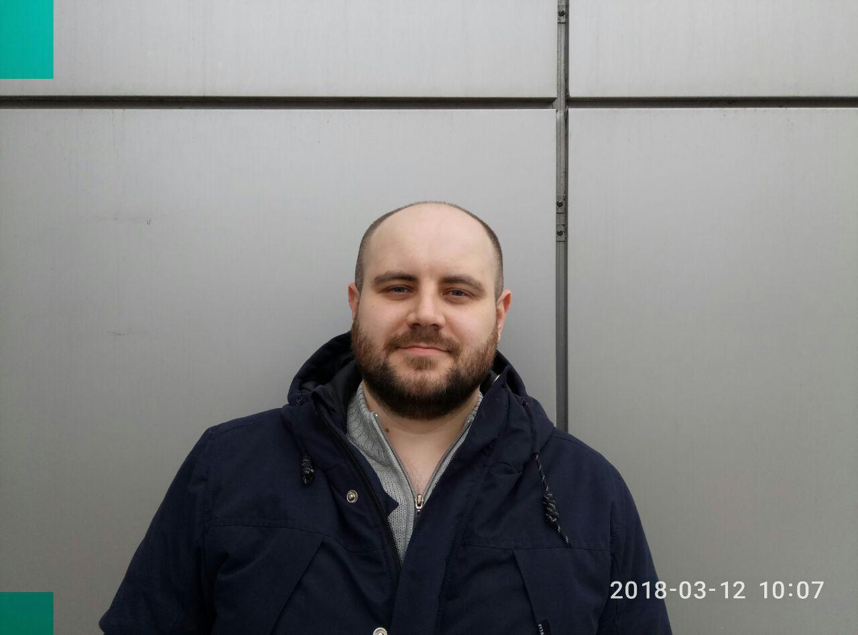**KELHANKIN ANDREI**

**Junior Front-End developer**

**Date of birth: 16 dec 1987**

**Phone: +38(055)22-44-737**

**E-mail: avkelhankin@gmail.com**

[**Portfolio**](https://zenzelya.github.io/)**,** [**GitHub**](https://github.com/Zenzelya)**,** [**Telegram**](https://t.me/Kelhankin) **<-click it**

**OBJECTIVE :** I’m an developer with six-month experience. I fulfill the tasks quickly and efficiently, and take full accountability for what I have done, including the enhancement of punch-points, malfunctions. Implementing my skills in absorbing and useful projects is of great interest for me. Let’s work as one team!

**SUMMARY:** 0**-**6 month of experience in Junior Front-End developer.

More than 5 years’ experience in Mobile Telecommunications. Experience searching technical solutions and agreement it with customer.

**TECHNICAL SKILLS:** HTML5, CSS3, JavaScript(ES6).

Working with framework Bootstrap, JQuery library.

Responsive and cross-browser layout, pixelPerfect.

Using BEM methodology, Git, Photoshop, React, Redux

**WORK EXPERIENCE:** Company: SNT

Duration: since 01.07.2016

Role: design engineer

Project description: Mobile Telecommunications

**EDUCATION:** GoIT | FrontEnd developer course

Donetsk National Technical Tniversity, Telecommunications

Master engineering degree of Telecommunications

**LANGUAGE SKILLS:** Ukrainian, Russian – native

English - intermediate