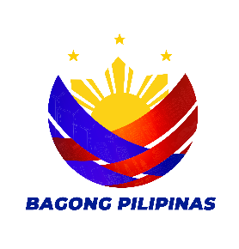

Republic of the Philippines
Province of La Union
Municipality of Rosario
Barangay Rabon

Office of the Punong Barangay

___________________________________ __________________________________

BARANGAY CERTIFICATION

TO WHOM IT MAY CONCERN:

This is to certify that {{resident.fullName}} legal age, {{resident.civilStatus}} is a resident of this barangay. And is personally known to me be a person of Good Moral Character and Integrity, {{certificate.subjectPronoun}} is a law abiding Citizen.

It is further certified that there is no information that the subject person is a member of any organization and or association that is subversive in nature or one that seeks to overthrow the duly constituted Government of the Philippines.

This certification is issued upon the request of the herein person for legal intents and purposes.

Issued this {{certificate.dayOrdinal}} day of {{certificate.month}}, {{certificate.year}} at Barangay Rabon, Rosario, La Union.

Prepared by: Certified by:

{{officials.secretary}} {{officials.punongBarangay}}
Barangay Secretary Punong Barangay

{{officials.punongBarangay}}
Punong Barangay

SANGGUNIANG BARANGAY
MEMBER
{{sangguniangBarangay.member0}}
{{sangguniangBarangay.member1}}
{{sangguniangBarangay.member2}}
{{sangguniangBarangay.member3}}
{{sangguniangBarangay.member4}}
{{sangguniangBarangay.member5}}
{{sangguniangBarangay.member6}}

{{officials.skChairperson}}
Sk Chairperson

{{officials.treasurer}}
Barangay Treasurer

{{officials.secretary}}
Barangay Secretary

RES.CERT.NO.__________
ISSUED ON:____________
ISSUED AT:_____________

