
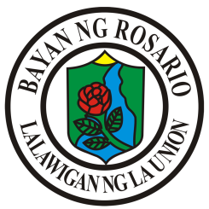
Republic of the Philippines
Province of La Union
MUNICIPALITY OF ROSARIO
Barangay Rabon

Office of the Punong Barangay

BARANGAY CERTIFICATE OF RESIDENCY

TO WHOM IT MAY CONCERN:

This is to certify that {{resident.fullName}} of legal age, ({{certificate.singleMark}})single ({{certificate.marriedMark}})married ({{certificate.widowMark}})widow , Filipino Citizen, and a bonafide resident herein Purok {{resident.purok}}, Barangay Rabon, Rosario, La Union

This certification is issued upon request of the said herein person for whatever legal intents and purposes it may serve.

Issued this {{certificate.dayOrdinalLower}} day {{certificate.month}} {{certificate.year}} at Barangay Rabon, Rosario, La Union.

Certified by:

HON. {{officials.punongBarangay}}
Barangay Captain

