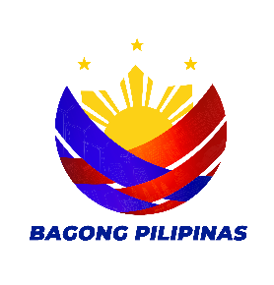

Republic of the Philippines
Province of La Union
Municipality of Rosario
Barangay Rabon

Office of the Punong Barangay

___________________________________ __________________________________

BARANGAY CERTIFICATION

TO WHOM IT MAY CONCERN:

This is to certify that CRIMARK C. RIVERA legal age, single/married/widow is a resident of this barangay. And is personally known to me be a person of Good Moral Character and Integrity, She / He is a law abiding Citizen.

It is further certified that there is no information that the subject person is a member of any organization and or association that is subversive in nature or one that seeks to overthrow the duly constituted Government of the Philippines.

This certification is issued upon the request of the herein person for legal intents and purposes.

Issued this 17TH day of February, 2026 at Barangay Rabon, Rosario, La Union.

Prepared by: Certified by:

ANGELINA Y. MARQUEZ EDUARDO G. BALANON
Barangay Secretary Punong Barangay

EDUARDO G. BALANON
Punong Barangay

SANGGUNIANG BARANGAY
MEMBER
Fe M. Cabunias
Mario G. Rivera
Alberto R. Galvan
Reynante M. Marquez
Remedios R. Rivera
Arturo C. Rivera
Maricris C. Boado

MIA ROSE. G. RIVERA
Sk Chairperson

JOCELYN B. ORTIZ
Barangay Treasurer

ANGELINA Y. MARQUEZ
Barangay Secretary

RES.CERT.NO.__________
ISSUED ON:____________
ISSUED AT:_____________


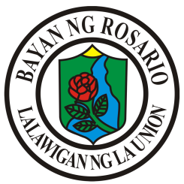
Republic of the Philippines
Province of La Union
MUNICIPALITY OF ROSARIO
Barangay Rabon

Office of the Punong Barangay

BARANGAY CERTIFICATE OF RESIDENCY

TO WHOM IT MAY CONCERN:

This is to certify that CORAZON B. GENESE of legal age, (/)single ()married ( )widow , Filipino Citizen, and a bonafide resident herein Purok 5, Barangay Rabon, Rosario, La Union

This certification is issued upon request of the said herein person for whatever legal intents and purposes it may serve.

Issued this 13th day January 2026 at Barangay Rabon, Rosario, La Union.

Certified by:

HON. EDUARDO G. BALANON
Barangay Captain

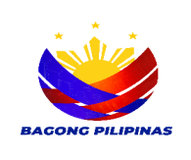

Republic of the Philippines
Province of La Union
Municipality of Rosario
Barangay Rabon
Office of the Punong Barangay

CERTIFICATE OF INDIGENCY

To Whom It May Concern;

This is to certify that ________________________________as per records available in this office, a bonafide resident of this Barangay.

Further said person belongs to an Indigent family and has no stable source of income.

Any help or assistance to her by the duly constituted authorities is greatly appreciated.

Given this ______ day of_______________, 2026 At Barangay Rabon, Rosario, La Union, for all legal intents and purposes it may serve.

Certified by:
Hon. EDUARDO G. BALANON
Punong Barangay

