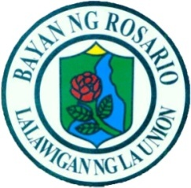

Republic of the Philippines
Province of La Union
Municipality of Rosario
Barangay Rabon
Office of the Punong Barangay


CERTIFICATION OF COHABITATION

To whom it may concern.
This is to certify that ROSEMARIE BAMBA, born on July 22, 2002, and DARWIN L. LAMARCA, born on APRIL 11, 2003, have been living as a spouses in good faith, taking on all of the tasks and responsibilities that follow with being in the relationship, cohabiting the same household at Purok 6, Rabon, Rosario, La Union, and both holding themselves out to the community as spouses since 2021.
This certification is issued upon request of the said herein person for whatever legal intents and purposes it may serve.

Issued this 9TH day September, 2026 at Barangay Rabon, Rosario, La Union.

Certified by:

HON. EDUARDO G. BALANON
Barangay Captain

