[COURSE CODE - COURSE NAME]
INTERNAL ASSESSMENT
SRM LABRESERVE: LAB ROOM AND SYSTEM BOOKING
WITH CONFLICT-FREE SCHEDULING AND APPROVAL WORKFLOW
A PROJECT REPORT
PROJECT BASED LEARNING
Submitted by
HARISH V
[Reg No: RA2311003050007]
Under the guidance of
[GUIDE NAME]
([Designation], Computer Science & Engineering)
In partial fulfilment of the requirements for the degree of
BACHELOR OF TECHNOLOGY
in
COMPUTER SCIENCE AND ENGINEERING

DEPARTMENT OF COMPUTER SCIENCE AND ENGINEERING
FACULTY OF ENGINEERING AND TECHNOLOGY
SRM INSTITUTE OF SCIENCE AND TECHNOLOGY
TIRUCHIRAPPALLI – 621 105
OCTOBER 2026
TABLE OF CONTENTS
S.NO | TITLE | PAGE
1 | INTRODUCTION | 4
1.1 | Introduction | 4
1.2 | Problem Statement | 4
1.3 | Objectives | 4
1.4 | Scope and Project Outcome | 5
2 | SYSTEM OVERVIEW | 6
2.1 | Existing Approach and Limitations | 6
2.2 | Proposed Booking Approach | 6
2.3 | Hardware and Software Requirements | 6
3 | SYSTEM ARCHITECTURE | 8
3.1 | Architecture and Components | 8
3.2 | Users, Roles and Use Cases | 9
3.3 | Data Model | 11
3.4 | Project Workflow | 13
4 | IMPLEMENTATION PROCESS | 17
4.1 | Development Environment | 17
4.2 | Database, Migrations and Seed Data | 17
4.3 | Booking Rules and Conflict Detection | 17
4.4 | Individual Access by System | 18
4.5 | User Interface and Role Screens | 21
4.6 | Access Tracking, Approvals and Reports | 23
4.7 | Save My Practical Planner | 26
4.8 | Security Implementation | 27
5 | TESTING AND DEMONSTRATION | 29
5.1 | Project-Ready Verification | 29
5.2 | Booking, Conflict and Approval Tests | 30
5.3 | Individual System Booking Tests | 31
5.4 | Concurrency Demonstration | 31
5.5 | Manual Demonstration Checks | 31
6 | RESULTS AND DISCUSSION | 33
6.1 | Test Results | 33
6.2 | Response-Time Measurements | 33
6.3 | Objectives and Outcome | 34
7 | CONCLUSION AND FUTURE ENHANCEMENT | 36
7.1 | Conclusion | 36
7.2 | Future Enhancement | 36
8 | REFERENCES | 37
APPENDIX A | KEY COMMANDS | 38
APPENDIX B | PRACTICAL EVIDENCE CHECKLIST | 38

1 INTRODUCTION

1.1 Introduction
Laboratories in a university are shared resources. Computer science labs, workshops and research instruments are used by many classes and project teams, and every use has to be scheduled so that two groups do not arrive at the same room at the same time. When requests are handled through phone calls, paper registers or chat messages, nobody has one reliable view of what is free, who asked for what, and who approved it.
SRM LabReserve is a web application that moves this process online for SRM Institute of Science and Technology, Tiruchirappalli. A student or research scholar chooses a date and time, sees which rooms and which individual systems are free, and sends a booking request with a reason. A lab coordinator reviews the request and approves or rejects it, and the system stores who did what, when and why.
The implemented system uses a React front end, an Express REST back end and an SQLite database. The campus inventory in the prototype contains 22 bookable spaces, including six computer science labs of 70 systems each, an AR/VR lab and a Mac lab of 40 systems each, together with ten demonstration instruments. The booking rules are enforced on the server inside database transactions, so the browser cannot bypass them, and the behaviour is checked by 48 automated tests.

1.2 Problem Statement
Booking laboratory space by informal means leaves five problems unsolved. Students cannot see which lab is free before travelling to it. Two groups can request the same lab for the same time. A whole computer lab is blocked even when one student needs a single machine. Approvals and cancellations are not recorded, so there is no accountability. Finally, the college cannot say how many students use the labs, or for what purpose.
The project therefore addresses the problem of publishing availability for every lab, preventing clashes, allowing a one-system booking in a lab with many systems, keeping a permanent history of every decision, and reporting usage in a form that can be filtered and exported.

1.3 Objectives
- Show the availability of lab rooms, numbered systems and equipment for any date and time.
- Prevent double bookings on the server, including when two requests arrive at the same moment.
- Let a student book one numbered system in a CS, AR/VR or Mac lab without blocking the rest of the lab.
- Give lab coordinators a queue in which requests are approved or rejected, with a required reason for rejection and for coordinator cancellation.
- Keep an audit history of every booking action with the actor, the time and a note.
- Restrict each role to the data and actions it needs, so that students see only their own bookings.
- Record the purpose, access type, headcount and project title of every request, and report usage with filters and CSV export.
- Verify the implementation with automated tests and measured request timings, and present it in a reproducible report.

1.4 Scope and Project Outcome
The project is an academic prototype rather than a production campus service. It runs locally, uses fictional demonstration accounts, and does not connect to SRM single sign-on, send email, or manage recurring timetables. Room capacities for labs without numbered systems, lab capabilities used by the planner, and the names of the six biotechnology specializations are illustrative values that the department would have to confirm.
The final outcome is a working booking system with sign-in and two roles, 22 rooms and 10 instruments, per-system booking on a ticket-style map, an approval workflow with audit history, a free-room finder, the Save My Practical planner, access tracking, reports with CSV export, 48 passing automated tests, and the timing measurements in Chapter 6. Limitations are stated where they apply.

2 SYSTEM OVERVIEW

2.1 Existing Approach and Limitations
In the usual arrangement a student asks a lab technician or faculty member, in person or by message, whether a lab is free. The answer depends on one person's memory or a paper register. There is no shared view, so two requests for the same lab can both be promised. The reasons for approvals are not kept, and a cancelled booking leaves no trace. A lab with 70 computers is usually booked as a whole, even when one student needs a single machine for an hour.
A shared spreadsheet or calendar improves visibility, but it does not enforce rules. Two people can write to the same slot at the same moment, nothing separates a student from a coordinator, a request cannot be pending until it is approved, and a single system cannot be reserved separately from the room. These gaps are the reason the rules are placed in a server that owns the data.

2.2 Proposed Booking Approach
The proposed system keeps every rule on the server. A request is stored as pending and holds its time slot at once. The overlap check and the insert happen inside one SQLite transaction, and the check is repeated when a coordinator approves the request. A booking is for one room or instrument on one Indian Standard Time day, starts in the future and lasts at most eight hours. A booking that starts exactly when another ends is allowed.
For labs with numbered systems the project adds a second level. A group booking reserves the whole lab, while individual access reserves one numbered system. A whole-lab booking and a system booking block each other, but two system bookings for different systems do not. The system map shows every system as available, booked, yours or unavailable without saying who booked it. Roles, ownership checks, an audit history and filtered reports complete the design.

2.3 Hardware and Software Requirements
Category | Component | Purpose
Development computer | Intel Core i5-13450HX (10 cores, 16 threads), 15.7 GB RAM | Runs the server, build and tests
Operating system | Windows 11 Pro (build 26200) | Execution environment
Runtime | Node.js 24.21.0 | Express server, built-in SQLite and test runner
Back end | Express 5.3.0 | REST API and static file serving
Database | SQLite through node:sqlite, WAL mode | Relational storage, foreign keys, transactions
Front end | React 19.3.1, Vite 7.3.7, lucide-react 0.468 | User interface and production build
Typography | DM Sans and Manrope (local packages) | Fonts served locally, no internet needed
Browser | Chromium-based browser | Interface checks at desktop and phone width
Version control | Git and GitHub (github.com/ZeonArc/booking) | Source history and publication

3 SYSTEM ARCHITECTURE

3.1 Architecture and Components
The architecture has three parts. The React single-page application runs in the browser and shows the dashboard, the lab catalogue, the booking form, the system map, the approval queue and the reports. It talks to one Express server over same-origin REST requests that carry JSON and a session cookie. The server checks the session and the role, validates the input and reads or writes the SQLite database. The same server also delivers the built front end, so one command starts the whole system.
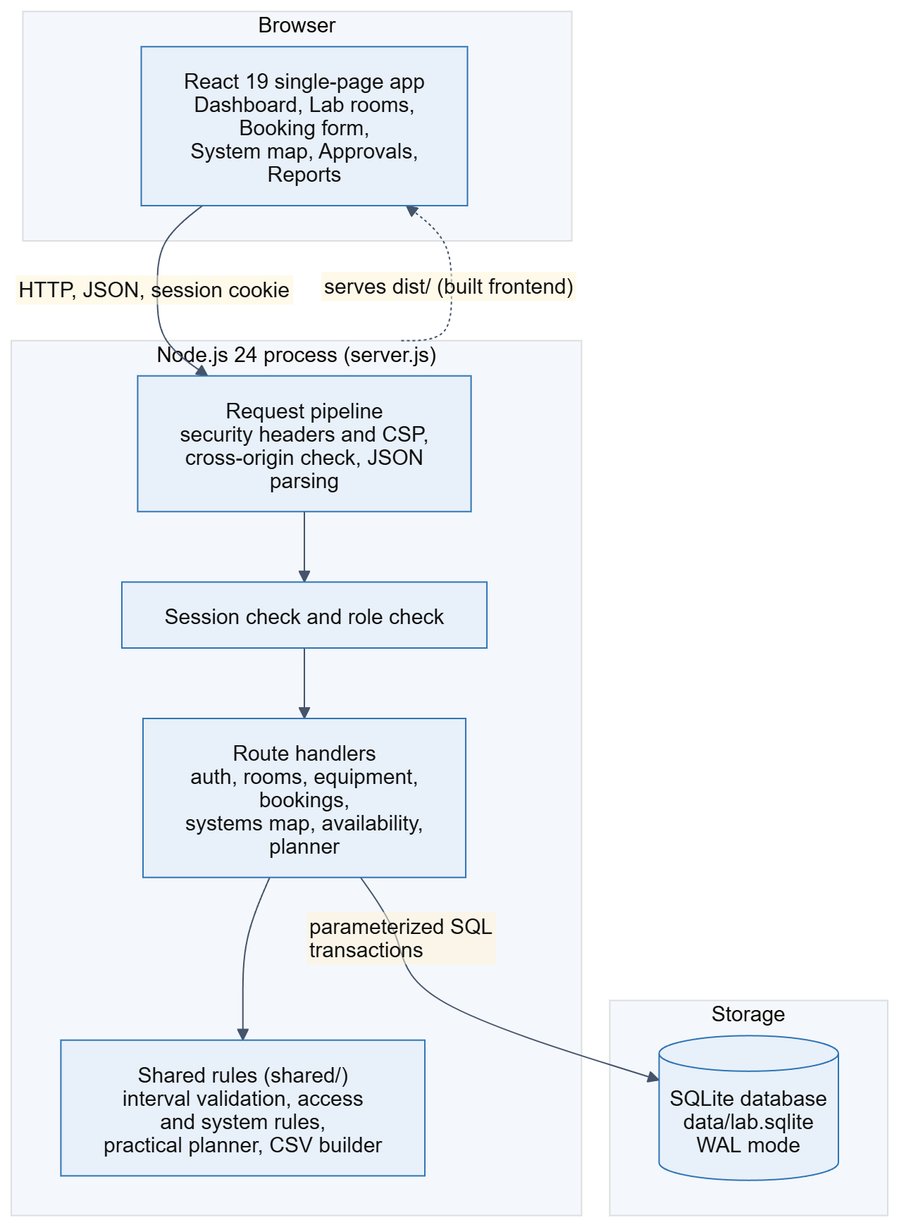
Figure 1. Architecture of SRM LabReserve: browser, Express server pipeline and SQLite database.
Inside the server, every request passes through the same pipeline: security headers and a content security policy, a cross-origin check, JSON parsing, a session lookup and a role check. The route handlers then call shared rule modules (interval validation, access and system rules, the practical planner and the CSV builder) and use parameterized SQL. Because the rules live in modules under the shared folder, the browser and the server use the same definitions.
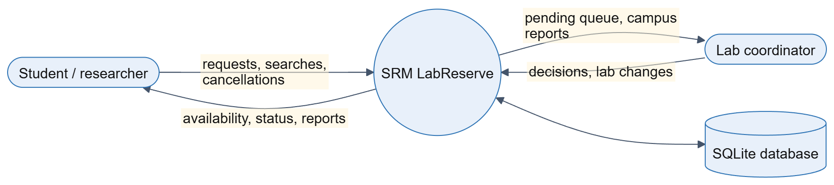
Figure 2. Level 0 data flow diagram: students and coordinators exchange requests and decisions with the system.

3.2 Users, Roles and Use Cases
The system has two internal roles. A student or research scholar (role researcher) can browse, request bookings, and see and cancel their own bookings. A lab coordinator (role manager) can do everything a student can, and can also approve, reject or cancel any booking, manage labs and inventory, and see every booking. A visitor can only register and sign in. Registration always creates a student, so a user cannot make themselves a coordinator. Figure 3 shows the thirteen use cases and the table below summarizes them.
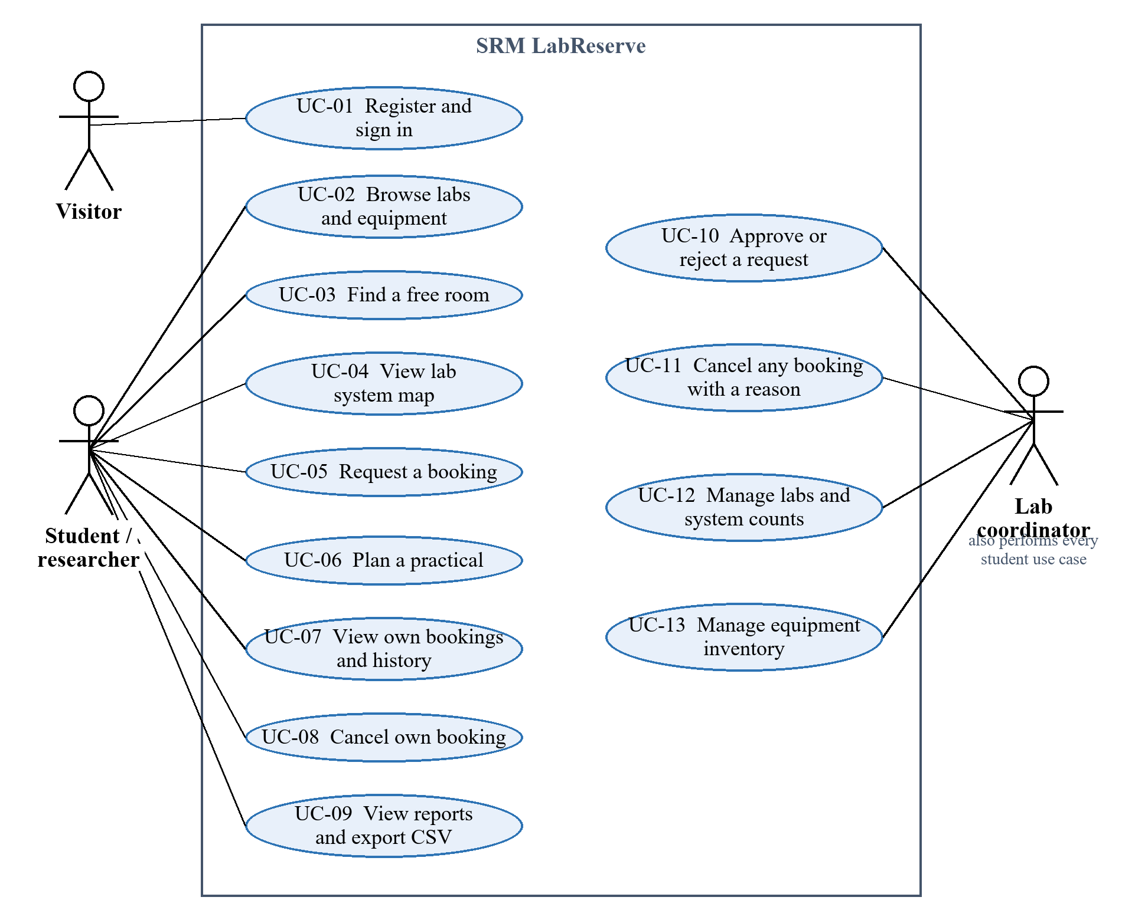
Figure 3. Use case diagram of the booking system.
ID | Use case | Actor | Key rule
UC-01 | Register and sign in | Visitor | Password of at least 10 characters; 10 failures lock sign-in for 15 minutes
UC-02 | Browse labs and equipment | Student | Maintenance and unavailable items cannot be booked
UC-03 | Find a free room | Student | Lists free rooms and labs that still have free systems
UC-04 | View lab system map | Student | Shows available, booked and own systems, never who booked
UC-05 | Request a booking | Student | Pending request holds the slot; overlap gives 409
UC-06 | Plan a practical | Student | Ranked options; nothing is booked by searching
UC-07 | View own bookings | Student | Own bookings and history only
UC-08 | Cancel own booking | Student | Not allowed after the booking has ended
UC-09 | View reports, export CSV | Student, Coordinator | Only records the user may see
UC-10 | Approve or reject | Coordinator | Conflict check repeated; rejection needs a reason
UC-11 | Cancel with a reason | Coordinator | Reason is required and shown to the student
UC-12 | Manage labs and systems | Coordinator | Cannot lower systems below an active booking
UC-13 | Manage equipment | Coordinator | Quantity, status and details validated

3.3 Data Model
The database has five working tables and one bookkeeping table. Rooms and instruments share the equipment table, and a kind column separates them, so both use the same booking and audit engine. Individual systems are not stored as rows. A lab keeps a count of its systems, and a booking stores the number of the system it holds, or nothing when it holds the whole room. Foreign keys are switched on, statuses and counts have CHECK constraints, and an index on equipment, status and times supports the conflict check.
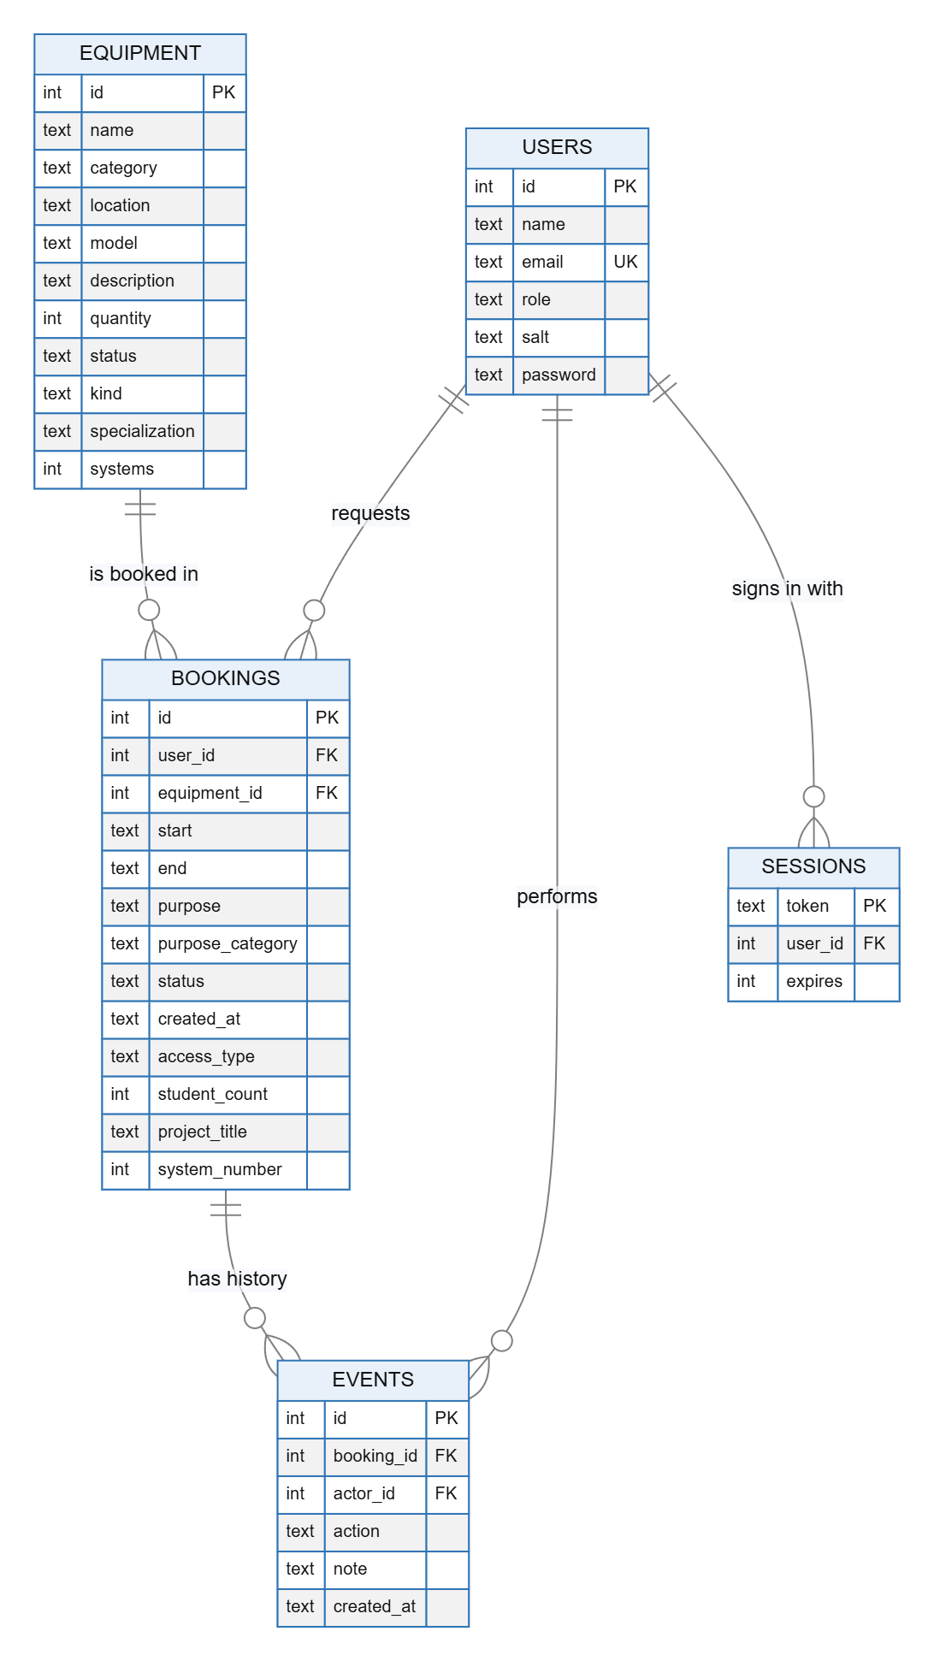
Figure 4. Entity relationship diagram of the SQLite database.
Table | Key data and constraints
users | Integer key, unique email, name, role limited to researcher or manager, random salt and scrypt hash
equipment | Rooms and instruments: name, category, location, reference code, status, kind, specialization, systems (0 to 500)
bookings | User and equipment keys, UTC start and end, reason, purpose category, status, access type, headcount (1 to 200), project title, system number
events | Audit history: booking, actor, action, note and timestamp. Never deleted by the API
sessions | Random token, user and expiry time (8 hours)
migrations | Names of the one-time upgrades that have already run

3.4 Project Workflow
- A student signs in and opens Lab rooms, the free-room finder or Save My Practical to find a suitable lab and time.
- For individual access in a CS, AR/VR or Mac lab, the student opens the system map and selects an available system.
- The browser sends the request. The server checks the session, validates the input and starts a transaction.
- The server looks for an overlapping pending or approved booking of the same room, or of the same system, and refuses the request with 409 if one exists.
- Otherwise the booking is stored as pending, an audit event is written, and the slot is held.
- A coordinator opens Approvals, reads the reason, requester, headcount and system, and approves or rejects. Approval repeats the conflict check.
- The student sees the new status. Either side can cancel until the booking ends, and the slot is released while the record stays in the history.
- Reports and CSV export summarize requests, reserved hours, headcounts and project work for the records each user may see.
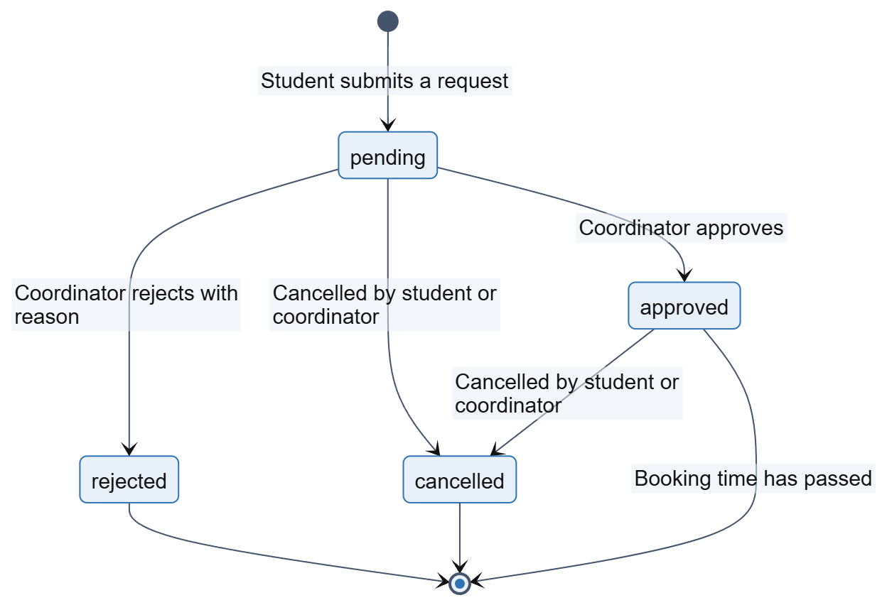
Figure 5. Booking lifecycle: the four booking states and the actions that move between them.
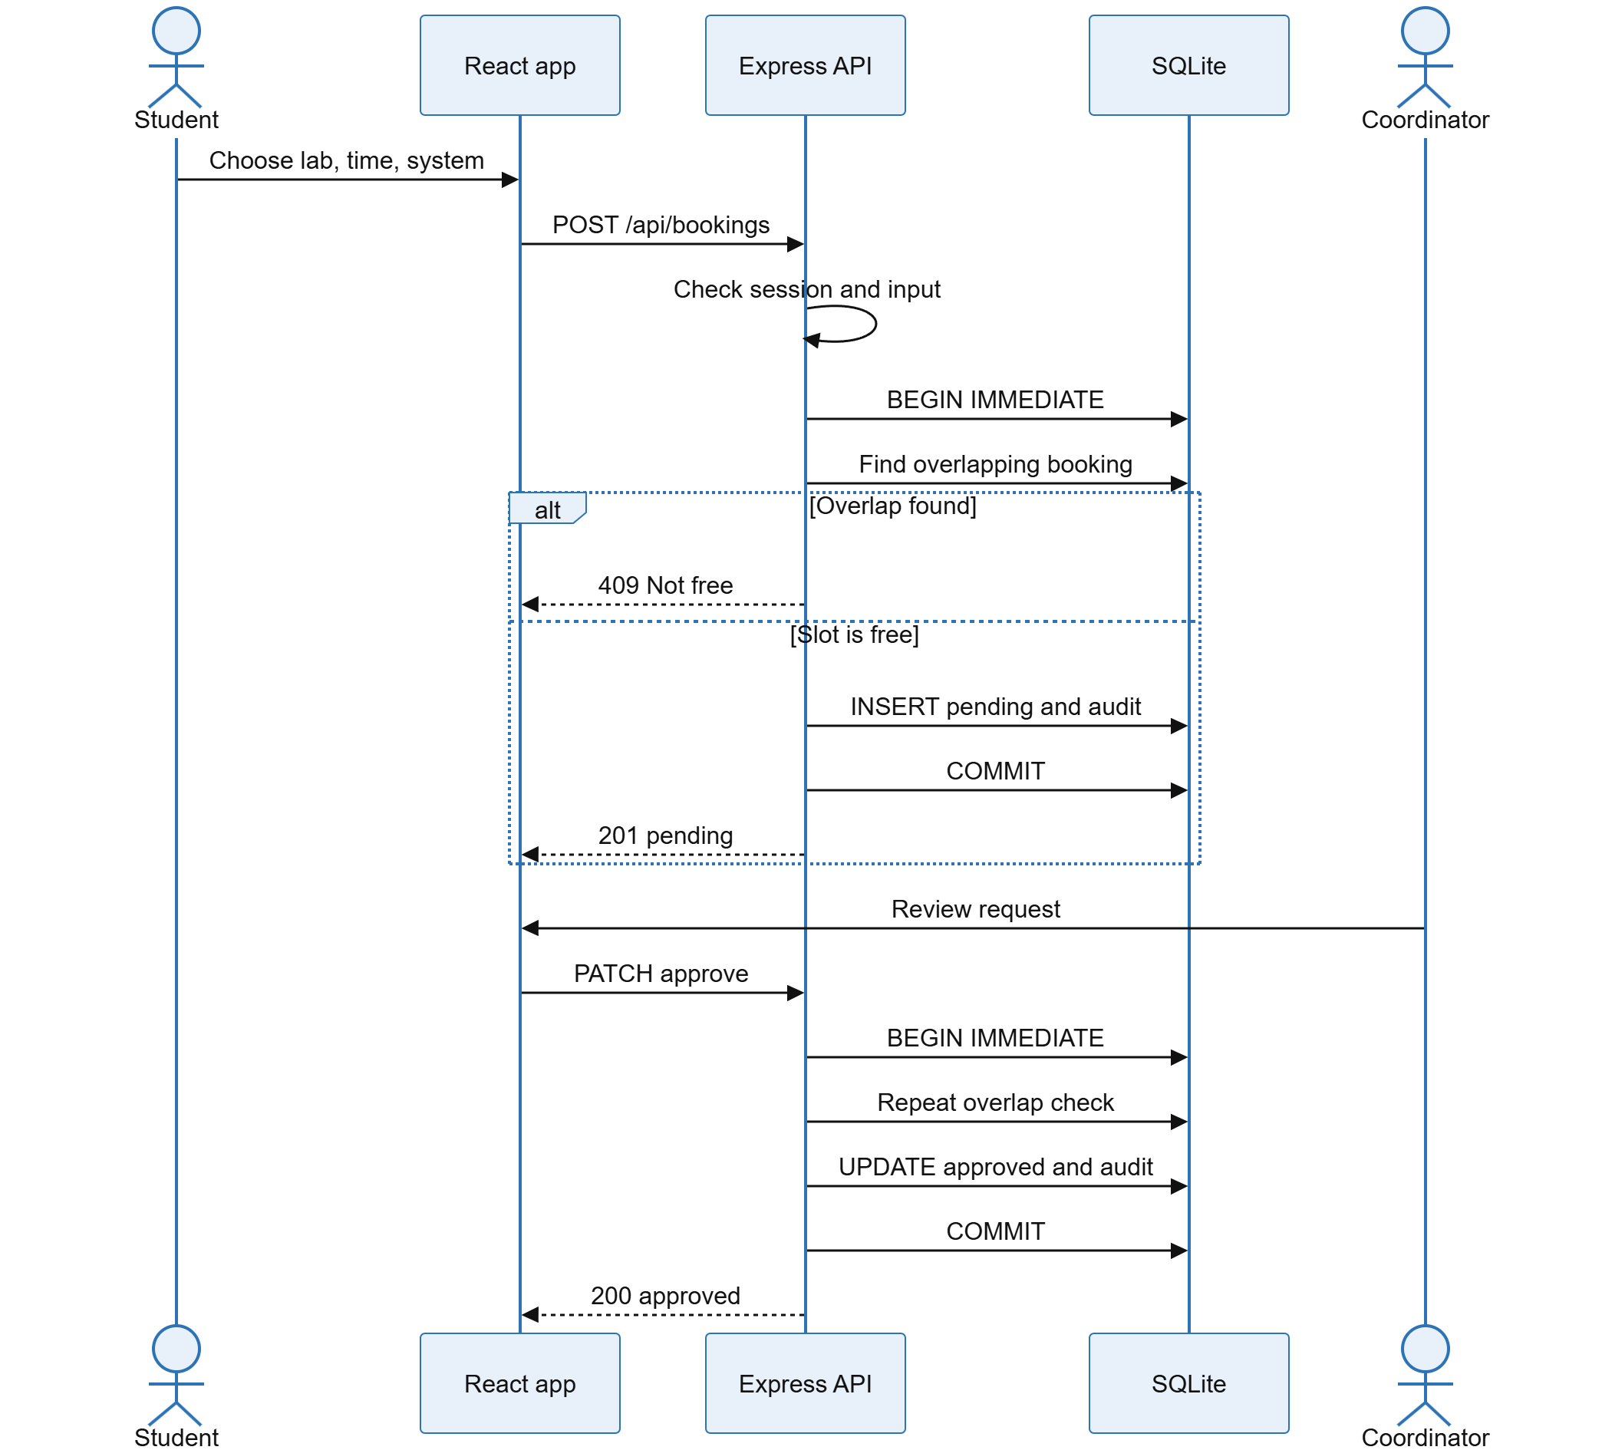
Figure 6. Sequence of a booking request and its approval.
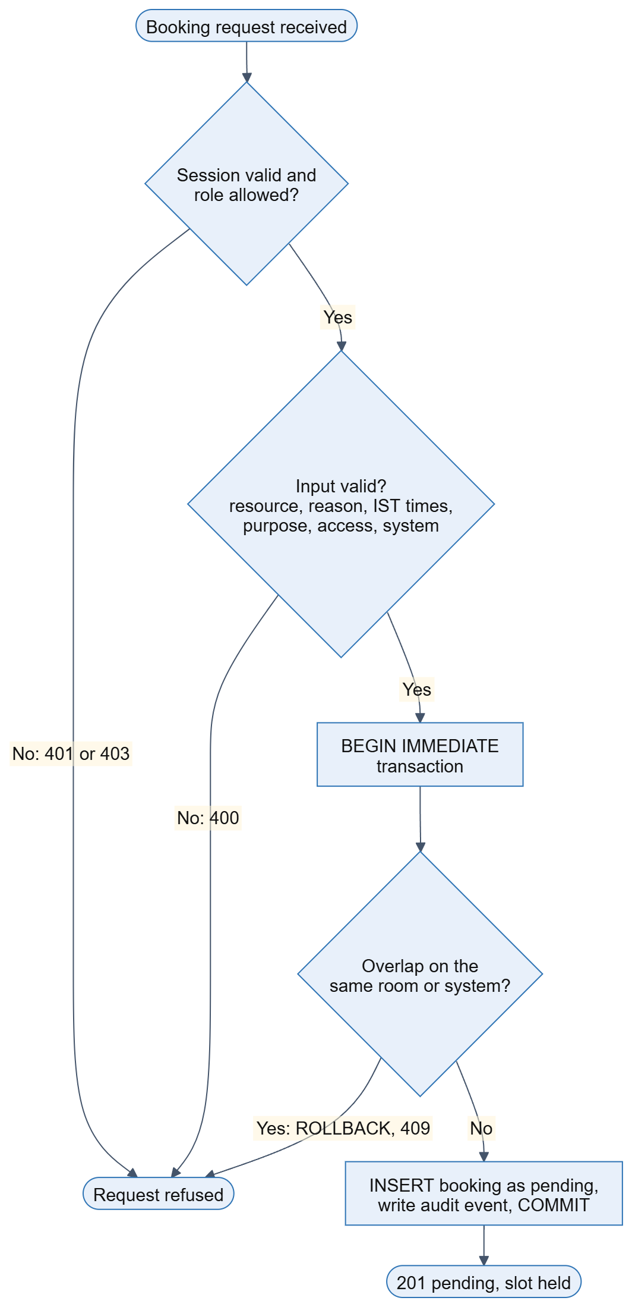
Figure 7. Flow chart of the server steps for a booking request.
The table below states what a new request conflicts with. A whole-room request or an equipment request conflicts with every active booking of that room. A system request conflicts only with a whole-room booking or with another booking of the same system, so different students can use different systems at the same time.
New request | Conflicts with (pending or approved, overlapping in time)
Whole room or equipment | Any active booking of that room, including single-system bookings
One system, for example system 12 | A whole-room booking, or another booking of system 12
Starts exactly when another ends | Nothing: adjacent bookings are valid
Rejected or cancelled booking | Nothing: the slot has been released

4 IMPLEMENTATION PROCESS

4.1 Development Environment
The project was developed and run on Windows 11 with Node.js 24, which provides the JavaScript runtime, the built-in SQLite module, the cryptography functions and the test runner, so no database server or extra test tool is installed. Dependencies are installed with npm. Vite builds the React front end into a dist folder, and the Express server serves that folder together with the API from one address. The server listens on the loopback address only, on port 3000 by default, and the first start creates the database file. The source is kept in a public GitHub repository.

4.2 Database, Migrations and Seed Data
The schema is created with IF NOT EXISTS statements when the server starts, with foreign keys on and write-ahead logging enabled. Later features were added as additive migrations. A migrations table records each one that has run, so every upgrade is applied once: the SRM location names, the 22 rooms, the six biotechnology labs, the access columns and, most recently, the system counts. An upgrade never replaces existing bookings and never invents a value for old records, which is why bookings made before access tracking show Not recorded for their headcount.
A new database is seeded with three fictional accounts (a student, a coordinator and a second student), ten demonstration instruments and six example equipment bookings. The supplied workstation counts are applied by the one-time migration lab-systems-v1: 70 systems for each of CS Lab 1 to 6, and 40 each for the AR/VR Lab and the Mac Lab. Because the migration runs only once, a later edit by a coordinator is never overwritten, and a test reopens the database to prove this.

4.3 Booking Rules and Conflict Detection
Two intervals overlap when new_start < existing_end and new_end > existing_start. The server applies this test to pending and approved bookings of the same room, and for system bookings it adds the condition that the other booking is a whole-room booking or has the same system number. Times are stored in UTC and shown in IST, and both ends of a booking must fall on the same IST date. The check and the insert run inside a BEGIN IMMEDIATE transaction. SQLite then allows only one writer at a time, so two simultaneous requests cannot both pass the check.
Rule | How it is enforced
Booking reason | Required, 5 to 500 characters
Time window | ISO time with a zone, in the future, same IST day, at most 8 hours
Purpose category | One of seven fixed categories; Project work needs a title of 3 to 120 characters
Access type and headcount | Individual means exactly one student; group is for rooms only; 1 to 200 students
System number | Required for individual access in a lab with systems; whole number from 1 to the lab's count
Resource status | Maintenance or unavailable resources refuse new requests and approvals
Status changes | Approve and reject apply to pending bookings only; past bookings cannot change
Reasons | Rejection and coordinator cancellation require a written reason

4.4 Individual Access by System
Individual access in a lab that has numbered systems books one system. The lab record holds its number of systems, the booking holds the system number, and a shared rule function checks that the number is a whole number within range and rejects a system number everywhere else. The server exposes a system map for any room and time. It returns one entry per system with the status free, booked, yours or blocked, where blocked means that the whole lab is booked or in maintenance. It sends no names and no booking details.
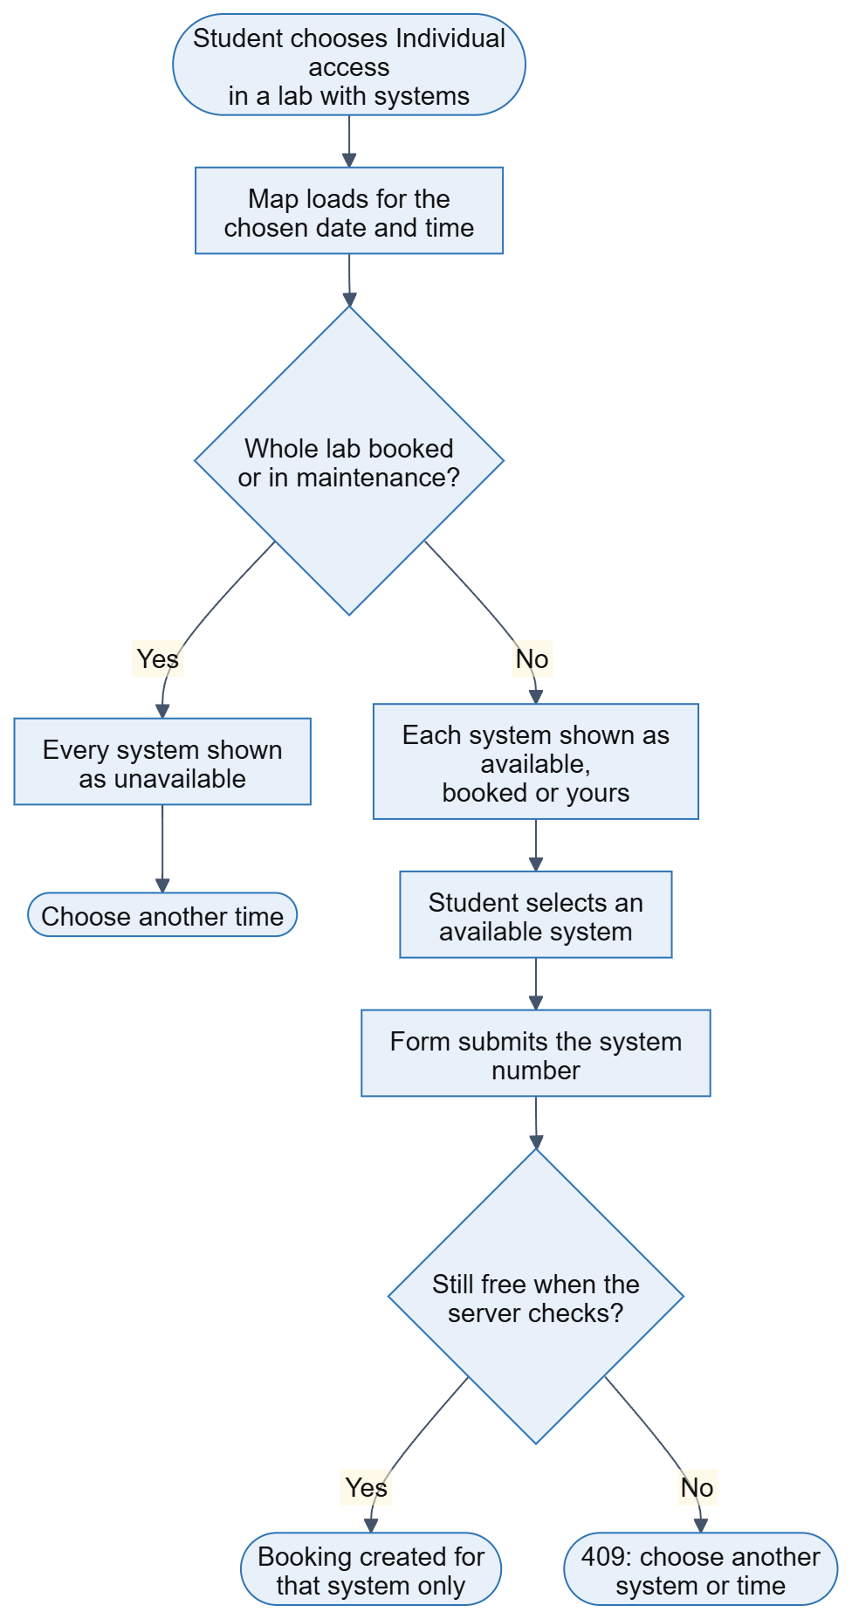
Figure 8. Flow of choosing a system on the map and booking it.
In the browser the map is drawn like a ticket view. A front-of-lab bar sits above rows of numbered systems, split into two groups of five by an aisle, with a legend for available, booked, your booking and selected. Booked systems cannot be clicked. The View systems dialog on each lab card lets a student pick a date and time, see how many systems are free and choose Book system, which opens the booking form with that system already chosen. Figure 9 shows the dialog for CS Lab 3, where 18 of the 70 systems are booked for the chosen hour.
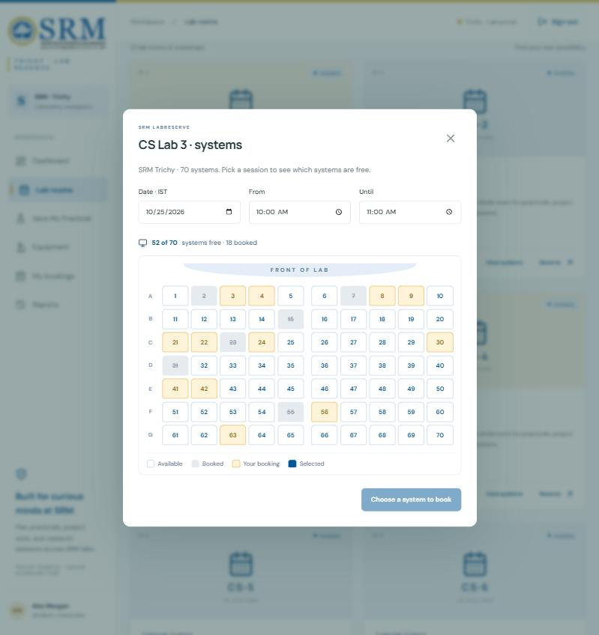
Figure 9. System map of CS Lab 3 for one hour: 52 of 70 systems free.
The same map appears inside the booking form when individual access is chosen for such a lab, and the form refuses to submit until a system is selected (Figure 10). If the student changes the time and the chosen system is no longer free, the choice is cleared. The dashboard timeline marks a partly booked lab with a hatched slot, the free-room finder lists labs that still have free systems with their count, and the booking lists, details and CSV export show the system number.
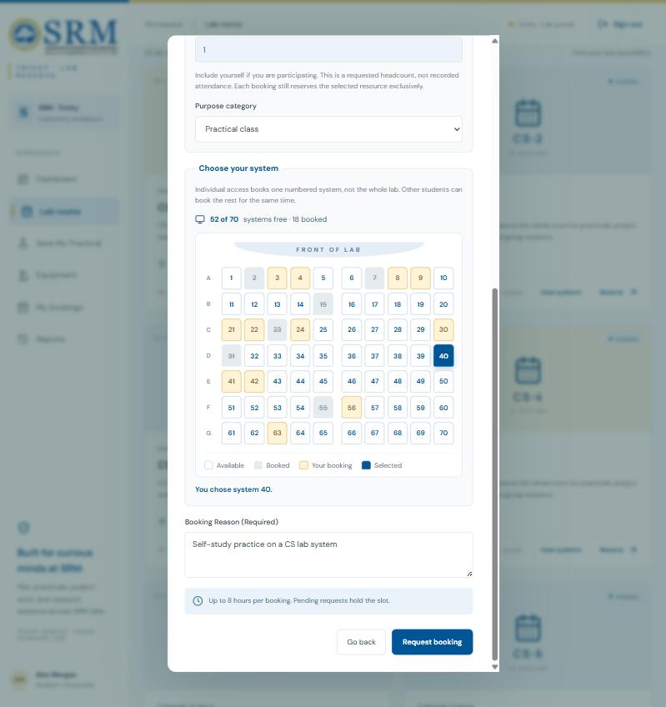
Figure 10. Booking form with individual access and system 40 selected.

4.5 User Interface and Role Screens
The interface uses the SRM blue, white and gold palette and the official logo, served locally. The sign-in page (Figure 11) lets a visitor register or sign in, and offers demonstration buttons. After sign-in the dashboard (Figure 12) shows the room counts, the pending and approved totals, and a daily availability timeline for all rooms. The Lab rooms page (Figure 13) lists the catalogue with the free-room finder, the system count of each lab and the View systems button.
The page is kept in the address (for example #/lab-rooms), so the browser Back and Forward buttons and a refresh keep the user's place. If a session expires, the next action returns the user to sign-in with a message. Forms are labelled, dialogs use the native focus handling, a skip link and a marked current page help keyboard users, animations are short and are switched off when the system asks for reduced motion, and the layout adapts down to phone width.
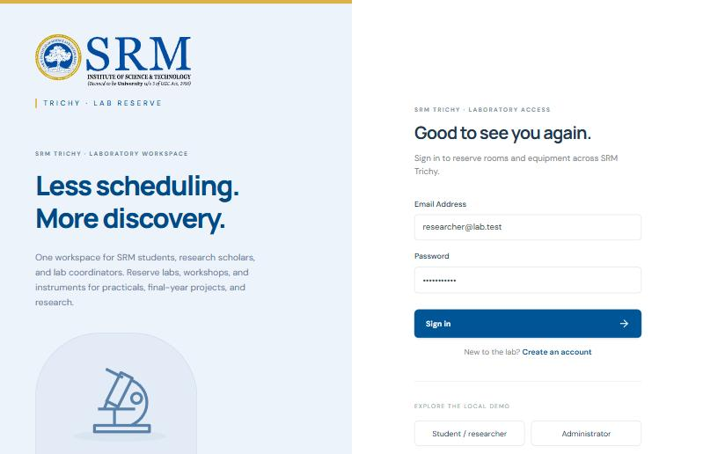
Figure 11. Sign-in page.
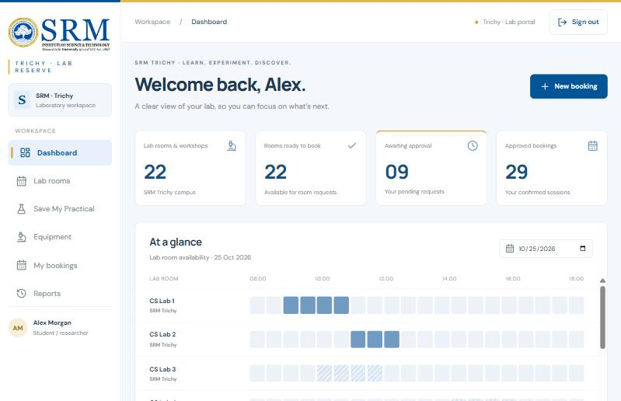
Figure 12. Student dashboard with the availability timeline. Hatched slots show partly booked labs.
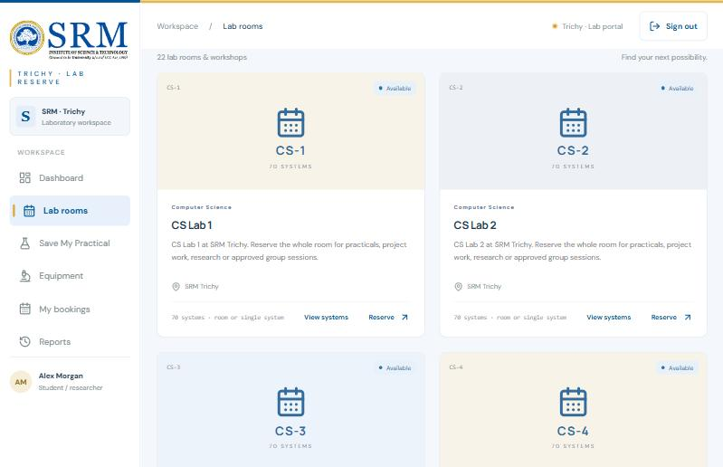
Figure 13. Lab rooms catalogue with system counts and View systems buttons.

4.6 Access Tracking, Approvals and Reports
Every booking records who needs the resource: the access type, the requested headcount, a project title for project work, and the duration, which the form previews while the times are chosen. The booking lists add access-type and purpose filters, and summary cards total the requests, pending requests, requester accounts, student participations and reserved hours for individual access, group access and project work (Figure 14). The notes under the cards explain how to read the numbers, because participation totals add up each request's headcount and the project work card overlaps the two access-type cards.
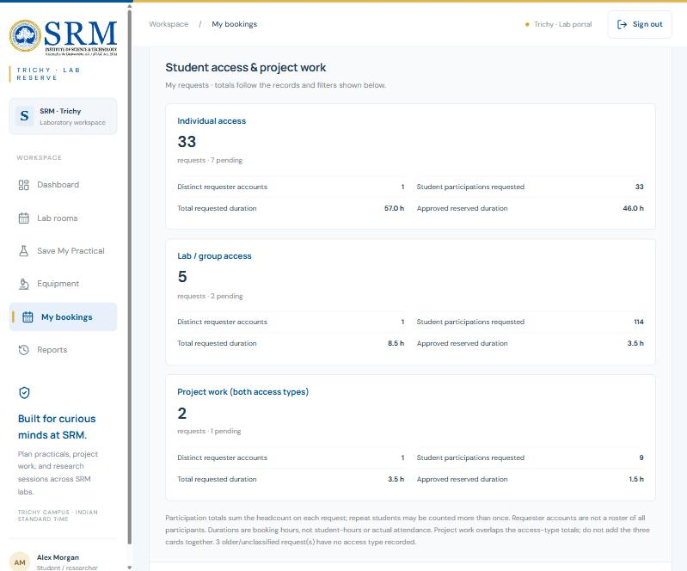
Figure 14. Access summary cards on the My bookings page.
The booking table (Figure 15) shows the access type, headcount, duration, project title and, for individual bookings, the system number of each request. A coordinator sees every booking and a pending queue. The review dialog (Figure 16) shows the reason, requester, headcount and system before the coordinator confirms an approval, and a rejection or cancellation cannot be confirmed without a reason. Every decision is written to the audit history with the actor and time.
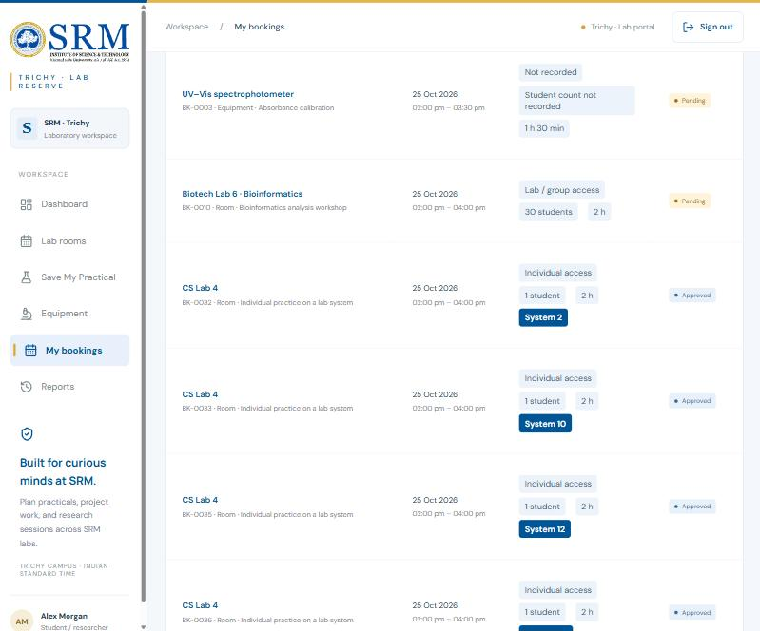
Figure 15. Booking list with access details and system numbers.
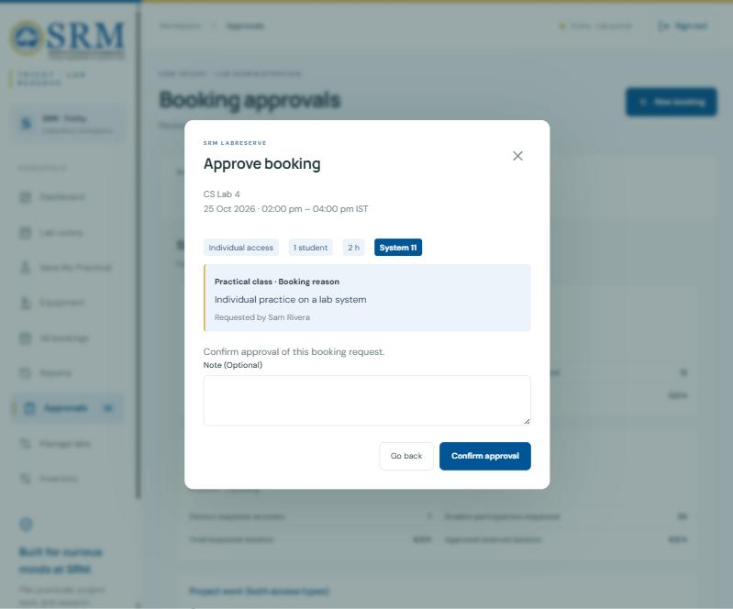
Figure 16. Coordinator review dialog for a system booking.
The Reports page (Figure 17) filters by date, resource type, status, purpose and access type, totals the approved reserved hours, and downloads the visible rows as a CSV file. Exports contain only the records the signed-in user may see, and cells that start with a formula character are prefixed so that a spreadsheet cannot run them. The CSV has columns for access type, student count, project title, duration and system number.
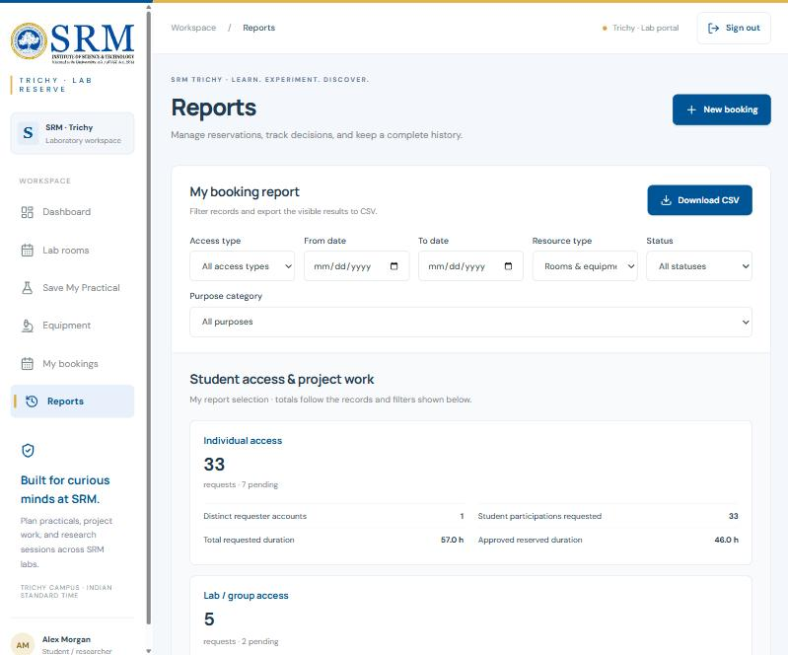
Figure 17. Reports page with filters, summary cards and CSV download.

4.7 Save My Practical Planner
Save My Practical helps a teacher whose planned lab is not free. The teacher enters the activity, class size, date, time and an optional preferred lab. The planner keeps the labs that support the activity, then the labs that are big enough, then the labs that are free, and ranks the result by nearest time, preferred lab and fewest unused seats, trying nearby times in 30-minute steps. It shows up to six options with the reasons, and a chosen option prefills the ordinary booking request. Searching never creates a booking. For labs with numbered systems the capacity used by the planner is the supplied system count.
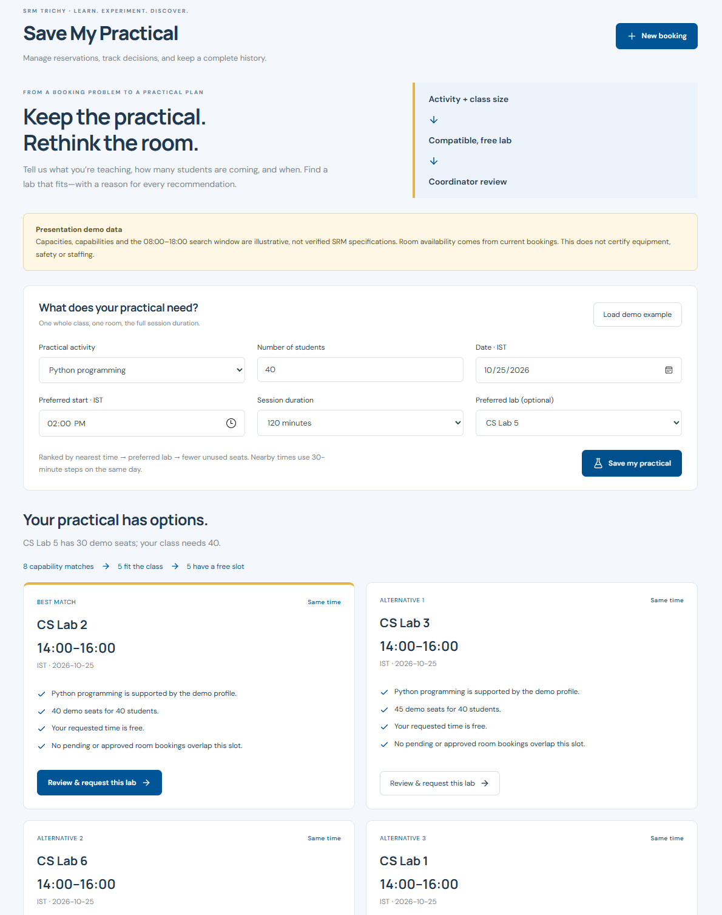
Figure 18. Save My Practical with ranked lab suggestions (demonstration data).

4.8 Security Implementation
Threat | Defence in the implementation
Stolen password data | Passwords are stored only as scrypt hashes with a random salt for each user; comparison is timing-safe
Password guessing | Ten failed sign-ins from one address lock sign-in for 15 minutes
Session theft | Random 256-bit tokens in HttpOnly, SameSite=Strict cookies that expire after 8 hours; optional Secure flag
Cross-site requests | Write requests from another origin are rejected
Hidden buttons as security | Roles and booking ownership are enforced on the server for every route
SQL injection | Every query that uses user data is parameterized
Script injection | React escapes text and a strict content security policy blocks third-party scripts
Spreadsheet formula injection | CSV cells beginning with =, +, - or @ are neutralized
Leaks between students | Students receive only their own bookings; the availability feed and system map omit names and reasons
Race conditions | The overlap check and insert share one BEGIN IMMEDIATE transaction; approval checks again

5 TESTING AND DEMONSTRATION

5.1 Project-Ready Verification
The project is verified in three steps: npm run build must complete without errors, npm test must pass, and npm start must serve the application on port 3000. The automated tests start a real HTTP server on a temporary database, sign in as different users and send real requests, so the checks cover the same code paths as a browser. They never touch the real database file. The run recorded for this report executed 48 tests in 6.19 seconds, and all 48 passed (Figure 19).
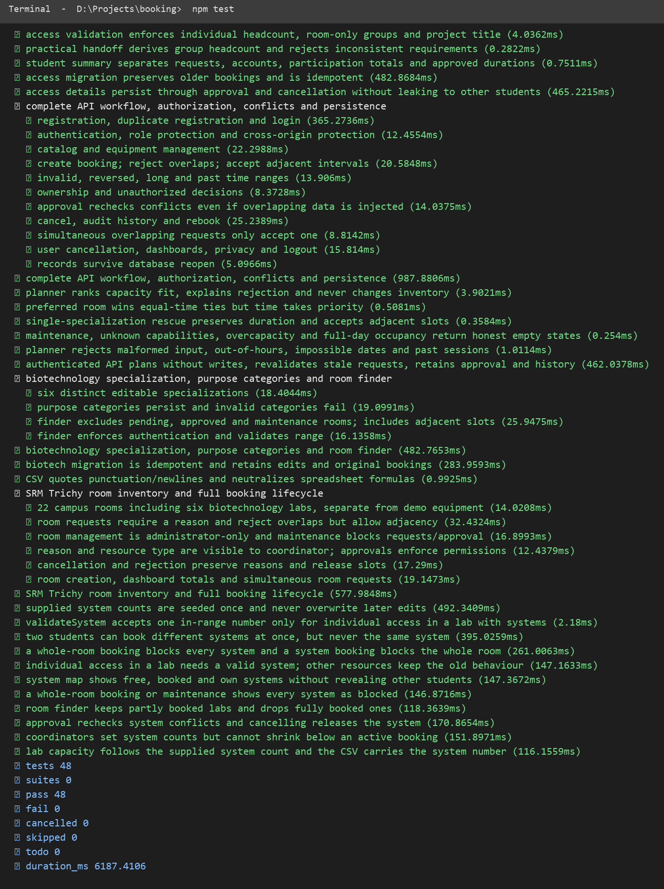
Figure 19. Output of npm test: 48 tests, 48 passed.

5.2 Booking, Conflict and Approval Tests
The booking tests register users, reject duplicate registrations and wrong passwords, and check that a student cannot reach coordinator routes or another student's booking. They create a booking, reject an overlapping request, accept an adjacent one, and reject reversed, past, over-long and cross-day times. A conflict is injected directly into the temporary database to prove that approval repeats the check and returns 409. Cancellation and rejection reasons, the audit history, rebooking of a released slot, and the survival of records after the database is reopened are verified as well.

5.3 Individual System Booking Tests
The system tests confirm that the supplied counts are seeded once and survive a restart, that a system number is accepted only for individual access in a lab with systems, and that two students can hold different systems at the same time but not the same one. They show that a whole-room booking blocks every system and that a system booking blocks a whole-room request, and that adjacent times never conflict. The system map is checked for free, booked and own statuses, for blocked states during a whole-lab booking or maintenance, and for the absence of any user detail in its response. Further tests cover the room finder, the approval re-check for systems, the coordinator limit on lowering a system count, and the CSV column.

5.4 Concurrency Demonstration
A script sent 20 simultaneous requests for the same system and the same hour, split between two students, and repeated this for five different systems. Exactly one request succeeded each time and the other 19 were refused with HTTP status 409. Across the 100 simultaneous requests, 5 bookings were created, one per system, and 95 were refused. No request returned any other status.
System | Simultaneous requests | Created (201) | Refused (409)
61 | 20 | 1 | 19
62 | 20 | 1 | 19
63 | 20 | 1 | 19
64 | 20 | 1 | 19
65 | 20 | 1 | 19

5.5 Manual Demonstration Checks
The table below lists the checks used in the live demonstration with their expected results. Where an automated test covers the same behaviour it is named in the last column.
ID | Steps | Expected result | Automated test
TC-01 | Book CS Lab 1 from 10:00 to 11:00, then request 10:30 to 11:30 | Second request is refused | api, rooms
TC-02 | Then request 11:00 to 12:00 | Accepted: adjacent booking | api, rooms
TC-03 | Two students book system 12 for the same hour | Second is refused; system 13 is accepted | systems
TC-04 | Group-book CS Lab 2, then try one of its systems | Refused while the group booking is active | systems
TC-05 | Coordinator rejects a request without a reason | Refused: reason required | api, rooms
TC-06 | Student opens another student's booking | 403 forbidden | api, access
TC-07 | Sign out and call a protected page | Returns to sign-in | api
TC-08 | Leave the session to expire, then press a button | Returns to sign-in with a message | manual
TC-09 | Put a lab into maintenance | New requests and approvals are blocked | rooms, systems
TC-10 | Export a CSV with a title starting with = | Cell is prefixed, not run as a formula | presentation

6 RESULTS AND DISCUSSION

6.1 Test Results
Test file | Tests | Passed | What it checks
api.test.js | 12 | 12 | Accounts, roles, overlaps, approval re-check, privacy, persistence
rooms.test.js | 7 | 7 | 22-room inventory, reasons, maintenance, cancellation history
presentation.test.js | 7 | 7 | Specializations, purpose categories, room finder, CSV safety, migration
practical.test.js | 6 | 6 | Planner ranking, ties, empty results, no booking from a search
access.test.js | 5 | 5 | Access rules, headcount, summaries, CSV columns, migration, privacy
systems.test.js | 11 | 11 | System counts, system and room conflicts, map, finder, limits
Total | 48 | 48 | All tests passed; the run took 6.19 seconds
All 48 tests passed with none failed, cancelled or skipped. Two earlier tests were updated when the system feature was added, because their expectations changed on purpose: individual access in a lab with systems now needs a system number, and a lab's planner capacity is its system count. Both changes are described in the documentation.

6.2 Response-Time Measurements
Request timings were measured against an in-memory copy of the application, over the loopback address, on the development computer described in Section 2.3. After ten warm-up requests, each operation was repeated 100 times (60 times for operations that create bookings), and the time covers the request, the server work and the reading of the JSON reply. The numbers describe this prototype with a small database. They are not a capacity test.
Operation | Runs | Mean (ms) | Median (ms) | Min (ms) | Max (ms)
List rooms | 100 | 0.97 | 0.82 | 0.50 | 3.08
Free-room finder | 100 | 0.76 | 0.68 | 0.56 | 2.15
System map, 70 systems free | 100 | 0.61 | 0.53 | 0.44 | 1.85
System map, 60 systems booked | 100 | 0.68 | 0.61 | 0.49 | 2.52
My bookings list | 100 | 1.03 | 0.91 | 0.68 | 3.47
Create a booking | 60 | 0.90 | 0.76 | 0.60 | 3.11
Refused clash (409) | 60 | 0.84 | 0.67 | 0.56 | 4.16

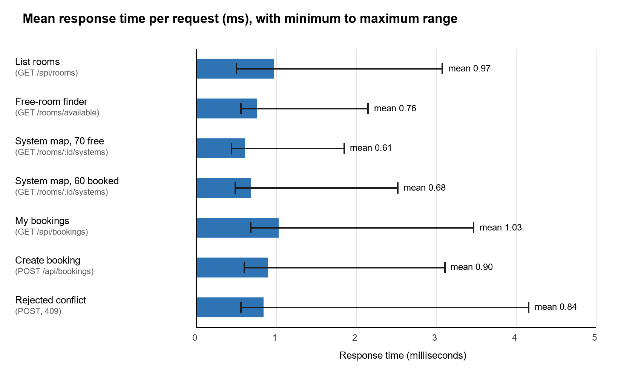
Figure 20. Mean response time per operation, with the minimum to maximum range.
Every measured operation had a mean response time between 0.61 ms and 1.03 ms, and the slowest single request took 4.16 ms. Drawing the system map of a 70-system lab took about 0.61 ms when empty and 0.68 ms with 60 systems booked, so the map does not need caching. A refused clash cost about the same as a successful booking (0.84 ms against 0.90 ms), which shows that the conflict check is a cheap indexed query. Because the test runs on the same computer, real use over a campus network will add network time that is not included here.

6.3 Objectives and Outcome
Objective | Evidence | Section
Show availability for any date and time | Dashboard timeline, room finder, system map | 4.4, 4.5
Prevent double bookings | Transactional check; 95 of 100 simultaneous requests refused correctly | 4.3, 5.4
Book one system without blocking the lab | System map, seat-level conflict rules, 11 system tests | 4.4, 5.3
Coordinator approval with reasons | Approvals queue, review dialog, required reasons | 4.6
Audit history of every action | events table, booking activity list | 3.3, 4.6
Role and ownership separation | Server-side checks, privacy tests | 4.8, 5.2
Usage reporting | Access summaries, Reports page, CSV export | 4.6
Verification and measurement | 48 passing tests, timing table | 5.1, 6.2
The results show that every objective in Section 1.3 was met within the limits of the prototype. The measured behaviour is consistent with the design: conflicts are decided by the database transaction, not by timing, so the outcome of the concurrency test was the same in all five rounds.

7 CONCLUSION AND FUTURE ENHANCEMENT

7.1 Conclusion
SRM LabReserve covers the whole booking cycle for laboratory rooms, individual systems and equipment: finding what is free, requesting with a reason, preventing clashes, approving or rejecting, cancelling when needed, and keeping the history. Letting one student book a single system in a 70-system lab, while the rest of the lab stays open, uses the labs better than blocking the whole room. The rules are enforced in the server and the database, not only in the interface, and the 48 automated tests verify them.
The concurrency demonstration showed that 100 simultaneous requests produced exactly five bookings, one for each system, and that all 95 others were refused. The measured response times stayed below four milliseconds even for the slowest request. The system is an academic prototype: its capacities for labs without numbered systems are illustrative, student counts are requested headcounts and not attendance, and the SRM sign-in and notification services are not connected.

7.2 Future Enhancement
- Confirm room details, capacities and equipment-to-room links with the departments, and replace the illustrative values.
- Connect SRM single sign-on and faculty accounts instead of local accounts.
- Send email or SMS notifications for decisions, cancellations and reminders.
- Support recurring bookings and import class timetables so that regular practicals are reserved automatically.
- Add check-in and check-out, so that real usage and attendance can be measured instead of only planned time.
- Offer a calendar view and a calendar feed for approved bookings.
- Move to PostgreSQL with backups, monitoring and load testing before wider use, and run the timing measurements again over a network.

8 REFERENCES
1. React Documentation (react.dev).
2. Express 5 Documentation (expressjs.com).
3. Node.js Documentation: node:sqlite, node:crypto and node:test modules (nodejs.org).
4. SQLite Documentation: transactions, write-ahead logging and foreign keys (sqlite.org).
5. Vite Documentation (vite.dev).
6. OWASP Cheat Sheet Series: password storage and session management (owasp.org).
7. RFC 7914: The scrypt Password-Based Key Derivation Function (rfc-editor.org).
8. Project source code, tests and documentation: github.com/ZeonArc/booking.
9. Course material, SRM Institute of Science and Technology.

APPENDIX A: KEY COMMANDS
Command | Purpose
git clone https://github.com/ZeonArc/booking.git | Obtain the project
npm install | Install the dependencies
npm run build | Build the front end into dist
npm start | Start the server on port 3000
npm run dev | Front-end development server (needs npm start as well)
npm test | Run all 48 automated tests
node --test tests/systems.test.js | Run only the lab system tests
node presentation/demo-server.mjs | In-memory demonstration with sample bookings on port 3001
$env:PORT='3100'; npm start | Start on another port (PowerShell)

APPENDIX B: PRACTICAL EVIDENCE CHECKLIST
Figure | Evidence | Section
1 | Architecture of the system | 3.1
2 | Level 0 data flow | 3.1
3 | Use case diagram | 3.2
4 | Entity relationship diagram | 3.3
5 | Booking lifecycle | 3.4
6 | Request and approval sequence | 3.4
7 | Server flow for a booking request | 3.4
8 | Choosing a system on the map | 4.4
9 | System map of CS Lab 3 | 4.4
10 | Booking form with a selected system | 4.4
11 | Sign-in page | 4.5
12 | Dashboard and timeline | 4.5
13 | Lab rooms catalogue | 4.5
14 | Access summary cards | 4.6
15 | Booking list with system numbers | 4.6
16 | Coordinator review dialog | 4.6
17 | Reports page | 4.6
18 | Save My Practical | 4.7
19 | npm test output | 5.1
20 | Measured response times | 6.2

Note: Figures 1 to 8 are diagrams drawn from the design of the project; Figures 9 to 18 are screenshots of the running application with demonstration data; Figure 19 is the real output of npm test; Figure 20 is plotted from the measured request timings.

