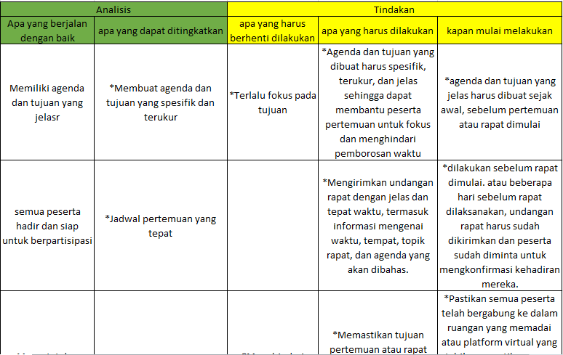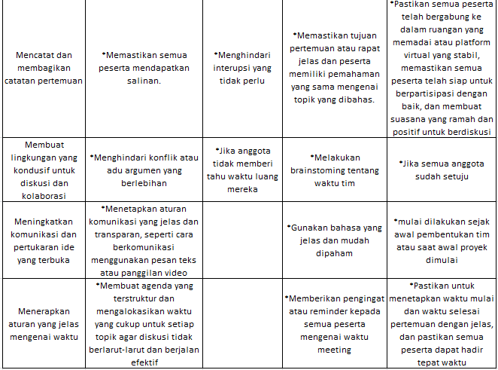 **Tabel Retrospektif**

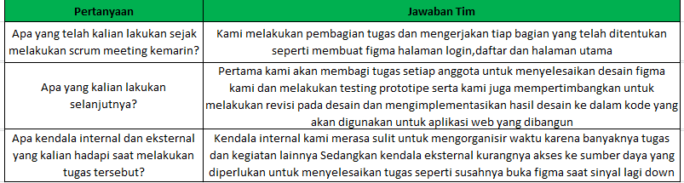**Tabel Report daily scrum meeting**