HOME SOC LAB

Successful RDP Brute-Force Detection
Incident Report
Detection validation using Kali Linux, Windows 11 and Wazuh
Project | HOME SOC LAB
Scenario | Controlled Successful RDP brute-force simulation
Status | Detection successfully validated
Test date | 22 August 2026

1. Executive Summary
A controlled brute-force authentication attack was performed against the Windows 11 SOC machine from the Kali Linux machine. The attack generated multiple failed authentication attempts, which were successfully detected by Wazuh. Following the failed attempts, a successful Remote Desktop Protocol (RDP) authentication was established.
The successful authentication was confirmed through:
- Windows Security Event ID: 4624
- Logon Type: 10
- Wazuh Rule: 92657
- Detection: Successful Remote Logon Detected
This demonstrates that the HOME SOC Lab can detect both the failed authentication phase and the subsequent successful remote authentication phase.

2. Lab Environment
Component | Role | Host-Only IP
Kali Linux | Attack simulation / RDP test source | 192.168.56.105
Windows 11 | Target / Windows Security telemetry source | 192.168.56.106
Wazuh | SIEM / detection and alerting | Wazuh server in lab
Network safety: the lab uses a Host-Only adapter for the attack path between the VMs. The test was bounded to the Windows VM and was not directed at the user's host machine.

3. Objective
- Validate that remote RDP authentication failures generate Windows Event ID 4625.
- Confirm that the source IP is preserved as the Kali VM address rather than 127.0.0.1.
- Validate Wazuh's native failed-login and multiple-login-failure detections.
- Validate Wazuh’s Successful login from an unrecognized IP
- Collect evidence for the HOME SOC LAB incident report before developing a custom correlation rule.

4. Attack Simulation
RDP was enabled on the Windows 11 VM and TCP/3389 was verified as reachable from Kali over the Host-Only network. A single manual failed login was first used to validate telemetry. After confirming that Windows recorded Event ID 4625 with the Kali source address, a bounded Hydra test was performed using six deliberately incorrect passwords.
Target: 192.168.56.106:3389 (RDP)
Source: 192.168.56.105 (Kali Linux)
Test volume: 6 intentionally failed authentication attempts
Tool: Hydra, constrained to the small lab test list
Next , after that phase when we got hands of the Password for the User by bruteforcing , we performed an RDP session , which was Successful and was detected by Wazuh , with EventID = 4624 and logon type = 10

5. Detection & Telemetry
Telemetry | Rule / Event | Severity | Observed Result
Windows Security | 4625 | Authentication failure | Observed; source network address mapped to Kali
Windows Security | 4624 | Successful Login | Observed : Source network address mapped to Kali
Wazuh | 60122 | Level 5 | 6 alerts: Logon Failure - Unknown user or bad password
Wazuh | 60204 | Level 10 | 1 alert: Multiple Windows Logon Failures

6. Incident Timeline
- RDP connectivity verified from Kali to the Windows VM.
- One controlled failed RDP authentication confirmed Windows Event ID 4625 and the Kali source address.
- Six bounded failed authentication attempts were generated with Hydra.
- Windows Security recorded the failed authentication activity.
- Wazuh generated six Rule 60122 alerts.
- Wazuh generated Rule 60204 (Level 10) for multiple Windows logon failures.
- After multiple Failed Login , there was a Successful RDP Login detected by Wazuh with EventID 4624 and Logon Type 10 .
- The IP belonged to the controlled Kali Source Address
- Evidence was captured for the project report and detection-engineering baseline.

7. Evidence / Findings
The Wazuh Events view showed the following detection sequence:
- Six Rule 60122 events: "Logon Failure - Unknown user or bad password".
- One Rule 60204 event: "Multiple Windows Logon Failures" at Level 10.
- One Rule 92653 event : “User: WORKGROUP\vboxuser logged using Remote Desktop Connection (RDP) from ip:192.168.56.105” at level 3
- The earlier single-login validation confirmed Source Network Address = 192.168.56.105.
Screenshot placeholder — insert Wazuh Events screenshot showing Rules 60122 and 60204.
Screenshot placeholder — insert Windows Event Viewer screenshot showing Event ID 4625 and the Kali source address.

8. Detection Analysis
The test demonstrates a complete detection chain. Individual authentication failures are represented by Rule 60122, while Wazuh's Rule 60204 provides a higher-severity indication that multiple Windows logon failures occurred. And the very next Rule Id 92657 detected a Remote logon , and Rule ID 92653 detected a Successful RDP .

9. MITRE ATT&CK Mapping
Technique | Name | Relevance
T1110 | Brute Force | Repeated authentication failures were simulated to validate brute-force detection.
T1021.001 | Remote Services: RDP | RDP was the authentication service used for the controlled lab test.

10. Impact / Risk
In a production environment, repeated failed RDP authentication attempts can indicate password guessing, credential stuffing, or an attempt to gain unauthorized remote access. And the very next moment a Successful login from the same IP indicate a possible compromise of the System . The controlled lab activity caused no intended impact to production systems; it was performed solely to validate security monitoring.

11. Response / Containment
- The RDP authentication activity was conducted within the isolated HOME SOC LAB environment.
- The Windows 11 SOC VM was monitored through Wazuh throughout the exercise.
- The activity was intentionally generated for detection and investigation validation and was not directed at the host machine.
- The successful RDP authentication was identified and documented using Windows Event ID 4624 / Logon Type 10 and Wazuh Rule 92657.
- In a real-world incident, the SOC analyst should validate the source IP, affected account, and subsequent activity following the successful login.
- If the successful authentication is determined to be unauthorized, appropriate containment actions would include protecting or disabling the affected account, blocking the malicious source, terminating the active RDP session, and isolating the affected endpoint if required.
- Further investigation should review post-login process creation, Sysmon telemetry, persistence mechanisms, and other endpoint activity to determine whether additional compromise occurred.

12. Evidences

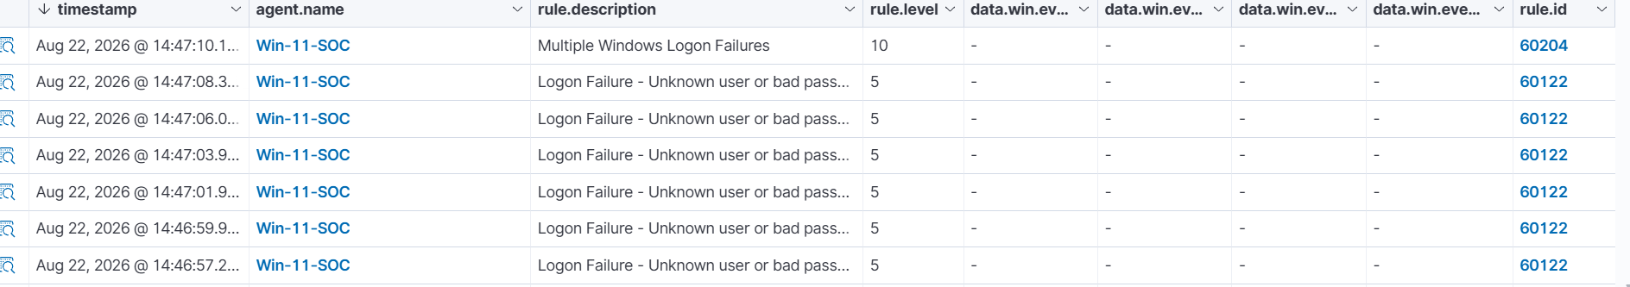
Successful Login Detected
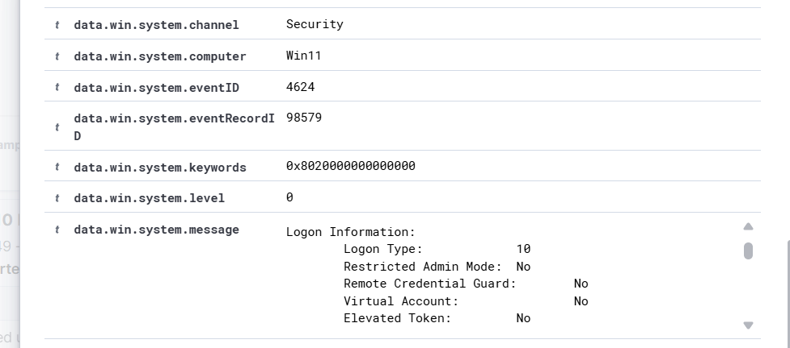

13. Conclusion
The HOME SOC Lab successfully demonstrated a controlled authentication attack scenario in which repeated failed authentication attempts were followed by a successful RDP authentication.
Wazuh successfully detected the failed authentication activity and the subsequent successful remote logon, while Windows Event ID 4624 with Logon Type 10 provided endpoint-level confirmation of the RDP session.
Stage completed:
Brute Force → Multiple Failed Logins → Successful RDP Authentication

