# TABLE OF CONTENTS

TABLE OF CONTENTS i

ABSTRACT iv

CHAPTER 1 1

1.0 INTRODUCTION 1

CHAPTER 2 3

2.0 SYSTEM ANALYSIS 3

2.1 Problem Recognition 4

2.2 Problem definition 5

2.3 Overview of Existing Manual System 6

2.4 Overview of the proposed system 7

2.5 Objectives of the proposed system 8

2.6 Scope of the system 9

2.7 Areas that will be handled by the system 10

2.8 Benefits of the proposed system 11

2.9 Preliminary study 12

2.10 Preliminary Investigation 13

2.11 Results of Preliminary Study 14

2.12 Methods used in fact finding 16

2.12.1 Interview 16

2.12.2 Advantages of interview 16

2.12.3 Disadvantages of interview 16

2.12.4 Questionnaires 16

2.12.5 Advantages of Questionnaires 17

2.12.6 Disadvantages of Questionnaires 17

2.12.7 Feasibility Study 17

2.12.8 Schedule Feasibility 18

2.12.9 Advantages of schedule Feasibility 18

2.12.10 Disadvantages of Schedule Feasibility 18

2.12.11 Operational Feasibility 20

2.12.12 Advantages of Operational Feasibility 20

2.12.13 Disadvantages of Operational Feasibility 20

2.12.14 Technical Feasibility 20

2.12.15 Advantages of Technical Feasibility 20

2.12.16 Disadvantages of Technical Feasibility 21

2.12.17 Economical Feasibility 21

2.12.18 Advantages of Economic Feasibility 21

2.12.19 Disadvantages of Economic Feasibility 21

2.12.20 Requirement Specification 22

2.12.21 Output Specification 22

2.12.22 Output Devices Required 23

2.12.23 Input Specification 23

2.12.24 Input devices required 23

2.14 File Structure 24

2.15 File Organization Methods 24

2.16 Processing Specification 25

2.17 Hardware and Software Requirements 25

2.17.1 Hardware Requirements 25

2.17.2 Software Requirements 26

CHAPTER 3 28

3.0 DETAILED SYSTEM DESIGN 28

CHAPTER 4 30

4.0 SYSTEM CONSRTUCTION 30

CHAPTER 5 32

5.0 SYSTEM TESTING, DEBUGGING AND IMLPEMENTATION 32

5.1SYSTEM TESTING 33

CHAPTER 6 34

6.0 USER MANUAL 34

6.1 System Requirements 34

6.2 Loading the System 35

6.3 Handling Errors 39

6.4 Exiting Program 39

40

RECOMMENDATION 40

CONCLUSION 40

APPENDICES 41

Appendix 1: ABBREVIATIONS USED 41

Appendix 2: TECHNINAL SYMBOLS USED 42

Appendix 3: TERMINOLOGIES USED 43

BIBLIOGRAPHY 44

# ABSTRACT

The Uzima Borehole Drilling System serves as a comprehensive solution tailored to optimize the operational efficiency of Uzima Borehole Drilling Company, a prominent service provider in Kenya's borehole drilling sector. Developed utilizing Microsoft Access, the system offers an intuitive interface aimed at facilitating the seamless management of client information, service provision, fee calculation, and reporting. Its core functionality encompasses client management, encompassing detailed record-keeping of client data including contact information and borehole location details. The system also incorporates a robust service catalogue, cataloguing the diverse range of services offered by the company, each associated with pertinent details such as descriptions and costs. Clients can effortlessly submit service requests through the system, triggering automated fee calculation mechanisms that factor in predefined fee structures for various services, including survey fees, local authority fees, drilling services, pump installations, plumbing services, and maintenance. Furthermore, the system enables the calculation of taxes where applicable, based on designated tax rates and total charges incurred by clients. Comprehensive reporting capabilities empower the generation of detailed reports shedding light on the company's operational performance, financial metrics, and service utilization patterns, offering valuable insights for strategic decision-making and operational optimization.

# 

# CHAPTER 1

# 1.0 INTRODUCTION

The Uzima Borehole Drilling System marks a significant milestone in the evolution of Uzima Borehole Drilling Company, a venerable institution at the forefront of Kenya's borehole drilling industry. For years, Uzima has been synonymous with excellence, reliability, and innovation in providing essential water solutions to industrial, commercial, and domestic clients across the nation. In its unwavering commitment to excellence, Uzima recognizes the imperative of leveraging cutting-edge technology to optimize its operations, enhance customer service, and adapt to the dynamic demands of the modern marketplace.

Against this backdrop, the Uzima Borehole Drilling System emerges as a transformative solution meticulously designed to revolutionize the company's operational landscape. Developed utilizing the versatile Microsoft Access platform, this system embodies a fusion of technological sophistication and operational pragmatism, serving as the cornerstone of Uzima's quest for operational excellence and customer-centricity.

The genesis of the Uzima Borehole Drilling System can be traced to the imperative of addressing the multifaceted challenges inherent in the management of client information, service provision, fee calculation, and reporting within the company. Historically, Uzima has grappled with the complexities of manual record-keeping, fragmented data management systems, and labour-intensive administrative processes, which, while effective in their time, have become increasingly untenable in the face of burgeoning demand and evolving industry standards.

Recognizing the critical need for a comprehensive, integrated, and technologically advanced solution, Uzima embarked on a visionary journey to develop a bespoke database system that would not only streamline its operations but also serve as a catalyst for innovation, growth, and sustainability. The Uzima Borehole Drilling System represents the culmination of this journey—a testament to the company's unwavering commitment to excellence, innovation, and customer satisfaction.

At its core, the Uzima Borehole Drilling System is imbued with a singular purpose: to empower Uzima to deliver unparalleled value to its clients by optimizing every facet of its operations. From the seamless management of client information and service requests to the automated calculation of fees, taxes, and reporting, the system embodies a holistic approach to operational efficiency, transparency, and accountability.

Furthermore, the Uzima Borehole Drilling System transcends its functional utility to become a strategic asset and a catalyst for organizational transformation. By harnessing the power of data-driven insights, the system equips Uzima with the tools and capabilities to anticipate market trends, identify emerging opportunities, and make informed decisions that drive sustainable growth and competitive advantage.

As we embark on this journey of exploration and discovery, this introductory chapter sets the stage for a comprehensive examination of the Uzima Borehole Drilling System . Through a nuanced exploration of its purpose, scope, significance, and organizational context, we seek to unravel the intricacies of this transformative solution and elucidate its profound implications for Uzima Borehole Drilling Company and the broader borehole drilling industry.

# CHAPTER 2

# 2.0 SYSTEM ANALYSIS

In this chapter, we delve into the systematic analysis of the Uzima Borehole Drilling System, elucidating its functional requirements, data flow, user roles, and system architecture. Through a rigorous examination of the system's key components and interactions, we aim to gain a comprehensive understanding of its operational dynamics and underlying design principles.

**Functional Requirements** The analysis commences with a thorough delineation of the functional requirements of the system, encompassing the core functionalities and features essential for its effective operation. These requirements are derived from an in-depth understanding of the company's business processes, user needs, and industry standards. Key functional requirements include client management, service cataloguing, service request processing, fee calculation, tax computation, reporting, and data analysis.

**Data Flow** Next, we elucidate the data flow within the system, delineating the movement of information between different components and modules. This analysis entails mapping the flow of data from its point of origin, such as client registration or service request submission, through various processing stages, including fee calculation, tax assessment, and reporting. By visualizing the data flow, we gain insights into the system's information architecture and identify potential bottlenecks or inefficiencies.

**User Roles and Permissions** An integral aspect of system analysis involves defining user roles and permissions to ensure secure access and proper data governance. This entails identifying distinct user roles within the organization, such as administrators, operators, and clients, and delineating their respective permissions and privileges. By establishing role-based access control mechanisms, the system can enforce data security and integrity while facilitating efficient collaboration and workflow management.

**System Architecture** Finally, we examine the system architecture, elucidating the underlying framework and components that enable its functionality. This analysis encompasses the identification of key modules, databases, interfaces, and technologies employed in the system's design. By evaluating the system architecture, we ascertain its scalability, reliability, and performance characteristics, laying the foundation for future enhancements and optimizations.

In summary, the system analysis chapter provides a comprehensive overview of the Uzima Borehole Drilling System , elucidating its functional requirements, data flow, user roles, and system architecture. Through this analytical lens, we gain valuable insights into the operational dynamics and design principles that underpin the system's functionality, paving the way for its successful implementation and utilization within Uzima Borehole Drilling Company.

# 2.1 Problem Recognition

**Storage**: One of the key challenges identified is the efficient utilization of storage resources within the Uzima Borehole Drilling System. As the system accumulates vast amounts of data related to client information, service records, fee calculations, and reports, there is a pressing need to optimize storage mechanisms to ensure scalability and cost-effectiveness. Inefficient data storage practices may lead to bloated databases, increased storage costs, and degraded system performance over time. Addressing this challenge requires implementing robust data compression techniques, archival strategies, and database optimization practices to maximize storage efficiency while minimizing resource utilization.

**Accuracy:** Another critical concern revolves around the accuracy of data within the system, particularly in the context of fee calculations, tax assessments, and reporting functionalities. Inaccurate data entry, computational errors, or inconsistencies in data processing workflows may compromise the integrity of financial records, leading to billing discrepancies, regulatory compliance issues, and customer dissatisfaction. To mitigate this risk, the system must incorporate stringent data validation checks, error detection mechanisms, and reconciliation processes to ensure the accuracy and reliability of financial transactions and reports. Additionally, user training and procedural guidelines are essential to foster a culture of data accuracy and accountability among system users.

**Economy:** The economic viability of the Uzima Borehole Drilling System is a paramount consideration, given the company's imperative to optimize operational costs and maximize profitability. Cost-effective system design, licensing agreements, and infrastructure investments are crucial to ensure that the system remains financially sustainable over the long term. Excessive expenditure on hardware, software licenses, or maintenance contracts may erode the system's economic viability and impede the company's ability to allocate resources towards strategic initiatives. Therefore, a comprehensive cost-benefit analysis and ongoing cost management strategies are imperative to strike the right balance between functionality and affordability within the system.

**Speed:** The speed and responsiveness of the system represent a fundamental determinant of user satisfaction and productivity. Slow system performance, latency issues, or bottlenecks in data processing workflows may impede operational efficiency and hinder timely decision-making. To address this challenge, the system must leverage efficient indexing techniques, query optimization algorithms, and caching mechanisms to accelerate data retrieval and processing tasks. Furthermore, scalability considerations, such as vertical and horizontal scaling, should be incorporated into the system architecture to accommodate growing data volumes and user loads without sacrificing performance. By prioritizing speed and responsiveness, the system can enhance user experience, foster productivity, and drive operational excellence within Uzima Borehole Drilling Company.

# 2.2 Problem definition

The Uzima Borehole Drilling System faces several challenges that need to be addressed to ensure its effectiveness and efficiency. These challenges can be defined as follows:

1. Data Storage: The system struggles with efficiently managing and storing large volumes of data, including client information, service records, and financial transactions. Inadequate storage management practices may lead to increased storage costs, performance degradation, and scalability issues over time.
2. Data Accuracy: There are concerns regarding the accuracy and reliability of data within the system, particularly in areas such as fee calculations, tax assessments, and financial reporting. Inaccurate data entry, computational errors, and inconsistencies in data processing workflows pose risks of billing discrepancies, regulatory non-compliance, and customer dissatisfaction.
3. Economic Viability: The system's economic sustainability is a pressing concern, as excessive expenditure on hardware, software licenses, and maintenance contracts may strain the company's financial resources. Ensuring cost-effectiveness and optimizing return on investment are essential to maintaining the system's viability and supporting the company's long-term growth objectives.
4. System Speed and Responsiveness: Slow system performance and latency issues hinder user productivity and operational efficiency. Delays in data retrieval, processing, and report generation impede timely decision-making and may impact customer service levels. Improving system speed and responsiveness is critical to enhancing user experience and driving organizational performance.

Addressing these challenges requires a comprehensive approach that encompasses technological, organizational, and procedural interventions. By identifying and prioritizing these problem areas, the Uzima Borehole Drilling System can develop targeted strategies and solutions to overcome these challenges and achieve its operational objectives effectively.

# 2.3 Overview of Existing Manual System

Prior to the implementation of the Uzima Borehole Drilling System, Uzima Borehole Drilling Company relied on a manual system to manage its operations. The existing manual system comprised a combination of paper-based records, spreadsheets, and traditional filing systems. The following provides an overview of the key components and processes of the existing manual system:

Client Management: Client information, including names, addresses, contact details, and borehole location details, was stored in physical files or spreadsheets. Client registration and updates were conducted manually through paper forms, which were then filed and stored in cabinets.

Service Provision: Service requests, such as borehole drilling, pump installation, plumbing, and maintenance, were initiated by clients through in-person or telephone inquiries. Service requirements and specifications were documented manually by company staff using paper forms or notes.

Fee Calculation: Fee calculation for services rendered was performed manually by staff based on predetermined fee structures and pricing guidelines. This process involved referencing printed fee schedules, performing manual calculations, and issuing invoices or receipts to clients.

Reporting: Reporting and data analysis tasks were predominantly manual and labour-intensive. Company staff compiled data from various sources, such as client records, service logs, and financial documents, to generate reports on revenue, expenses, and operational performance.

Data Entry and Record-keeping: Data entry tasks, including updating client information, recording service requests, and maintaining financial records, were conducted manually using pen and paper or spreadsheet software. These records were then stored in physical filing systems or electronic spreadsheets.

Communication and Coordination: Communication and coordination between different departments and staff members relied heavily on verbal communication, written notes, and face-to-face interactions. This informal communication process sometimes led to delays, miscommunication, and inefficiencies.

Security and Data Integrity: Security measures for protecting sensitive client information and maintaining data integrity were primarily manual and relied on physical safeguards, such as locked cabinets and restricted access to certain files. However, the risk of data loss, theft, or unauthorized access was inherently higher in a manual system.

Overall, the existing manual system at Uzima Borehole Drilling Company was characterized by inefficiencies, redundancies, and limitations inherent in manual processes. While it served the company adequately in the past, the system's reliance on manual data entry, paper-based records, and decentralized information management posed challenges in terms of scalability, accuracy, and operational efficiency. Recognizing the need for modernization and digital transformation, Uzima embarked on the development and implementation of the Uzima Borehole Drilling System to address these challenges and propel the company towards greater success in the digital age.

# 2.4 Overview of the proposed system

The proposed Uzima Borehole Drilling System represents a comprehensive digital solution designed to streamline and optimize the operational processes of Uzima Borehole Drilling Company. Leveraging the capabilities of Microsoft Access, the system introduces a range of functionalities and features aimed at enhancing efficiency, accuracy, and customer satisfaction. The following provides an overview of the key components and functionalities of the proposed system:

Client Management: The proposed system centralizes client information within a secure database, allowing for efficient management of client details, including names, addresses, contact information, and borehole location details. Client registration, updates, and inquiries are facilitated through user-friendly interfaces, enabling seamless communication and interaction with clients.

Service Catalog: A comprehensive catalog of services offered by the company is integrated into the system, providing detailed descriptions, pricing information, and specifications for each service. Clients can browse through the service catalog, select the desired services, and submit service requests electronically, streamlining the service provisioning process.

Service Request Processing: Service requests submitted by clients are automatically processed within the system, triggering workflows for scheduling, resource allocation, and task assignment. Automated notifications and alerts keep clients informed about the status of their requests, enhancing transparency and communication throughout the service delivery process.

Fee Calculation: The system automates fee calculation for services rendered based on predefined fee structures and pricing guidelines. Fee calculation algorithms factor in various parameters, such as service type, service duration, and client category, ensuring accuracy and consistency in billing. Invoices and receipts are generated electronically, minimizing manual intervention and reducing the risk of errors.

Tax Computation: Where applicable, the system computes taxes on behalf of clients, taking into account relevant tax rates and regulations. Tax calculations are performed automatically during fee calculation processes, simplifying compliance with tax laws and regulations and ensuring accurate representation of financial transactions.

Reporting and Data Analysis: The proposed system offers robust reporting and data analysis capabilities, allowing for the generation of comprehensive reports on various aspects of the company's operations. Reports encompass key metrics such as revenue, expenses, service utilization, and client satisfaction, providing valuable insights for strategic decision-making and performance evaluation.

Security and Data Integrity: Security measures are implemented to safeguard sensitive client information and maintain data integrity within the system. Role-based access control mechanisms restrict access to authorized users, while encryption and audit trails enhance data security and accountability. Regular backups and disaster recovery protocols mitigate the risk of data loss or corruption, ensuring the resilience and reliability of the system.

Overall, the proposed Uzima Borehole Drilling System represents a significant advancement in the digital transformation journey of Uzima Borehole Drilling Company. By automating manual processes, centralizing data management, and providing advanced analytical capabilities, the system empowers the company to deliver superior services, optimize resource utilization, and drive sustainable growth in the competitive borehole drilling market.

# 2.5 Objectives of the proposed system

**Efficiency Enhancement:** The primary objective of the proposed Uzima Borehole Drilling System is to enhance operational efficiency within Uzima Borehole Drilling Company. By automating manual processes, streamlining workflows, and facilitating seamless communication and coordination, the system aims to reduce administrative overhead, minimize turnaround times, and optimize resource utilization across all facets of the company's operations.

**Accuracy Improvement:** The system seeks to improve the accuracy and reliability of data management, fee calculations, tax assessments, and reporting processes. By implementing robust data validation checks, error detection mechanisms, and automated calculations, the system aims to eliminate errors, inconsistencies, and discrepancies in financial transactions and reporting, thereby enhancing the overall integrity of the company's operations.

**Customer Satisfaction:** Another key objective of the proposed system is to enhance customer satisfaction by providing a seamless and user-friendly experience for clients interacting with Uzima Borehole Drilling Company. Through intuitive interfaces, transparent communication channels, and timely service delivery, the system aims to foster positive relationships with clients, improve service quality, and exceed customer expectations.

**Cost Optimization:** The system aims to optimize costs and maximize return on investment for Uzima Borehole Drilling Company by streamlining processes, reducing manual intervention, and minimizing wastage of resources. By automating fee calculations, tax assessments, and reporting tasks, the system helps to eliminate redundant processes, mitigate the risk of errors, and optimize financial performance, ultimately contributing to the company's bottom line.

**Data Analysis and Decision Support:** The proposed system aims to provide robust data analysis and decision support capabilities to facilitate informed decision-making and strategic planning within Uzima Borehole Drilling Company. By generating comprehensive reports, analyzing key performance indicators, and providing actionable insights, the system empowers company management to identify trends, capitalize on opportunities, and address challenges proactively, thereby driving organizational growth and competitiveness.

**Security and Compliance:** Ensuring data security and compliance with regulatory requirements is a critical objective of the proposed system. By implementing stringent access controls, encryption mechanisms, and audit trails, the system aims to safeguard sensitive client information, protect against unauthorized access or data breaches, and maintain compliance with relevant data protection regulations and industry standards.

Overall, the objectives of the proposed Uzima Borehole Drilling System align with the company's strategic goals of operational excellence, customer satisfaction, financial sustainability, and data-driven decision-making. By addressing these objectives, the system aims to position Uzima Borehole Drilling Company as a leader in the borehole drilling industry, capable of delivering superior services and achieving sustainable growth in the digital age.

# 2.6 Scope of the system

The scope of the proposed Uzima Borehole Drilling System encompasses the following key areas and functionalities:

Client Management: The system will facilitate the efficient management of client information, including names, addresses, contact details, and borehole location details. It will support client registration, updates, and inquiries, providing a centralized repository for storing and accessing client data.

Service Provision: The system will support the cataloguing and provisioning of various services offered by Uzima Borehole Drilling Company, including borehole drilling, pump installation, plumbing services, pump maintenance, and other related services. Clients will be able to submit service requests, view service options, and track the status of their requests through the system.

Fee Calculation: The system will automate fee calculation processes for services rendered by the company, based on predefined fee structures and pricing guidelines. It will factor in parameters such as service type, service duration, client category, and other relevant factors to ensure accurate and consistent billing.

Tax Computation: Where applicable, the system will compute taxes on behalf of clients, taking into account relevant tax rates and regulations. Tax calculations will be integrated into fee calculation processes, ensuring compliance with tax laws and regulations and accurate representation of financial transactions.

Reporting and Data Analysis: The system will provide robust reporting and data analysis capabilities, allowing for the generation of comprehensive reports on various aspects of the company's operations. Reports will cover key metrics such as revenue, expenses, service utilization, client satisfaction, and other relevant indicators, providing valuable insights for decision-making and performance evaluation.

Security and Data Integrity: The system will implement security measures to safeguard sensitive client information and maintain data integrity. Role-based access control mechanisms, encryption, audit trails, and other security features will be employed to protect against unauthorized access, data breaches, and ensure compliance with relevant data protection regulations and industry standards.

User Interface and Experience: The system will feature intuitive user interfaces and user-friendly functionalities to enhance user experience and facilitate adoption. Clients, company staff, and administrators will have access to tailored interfaces and functionalities based on their roles and permissions, enabling efficient interaction and collaboration within the system.

It's important to note that while the proposed system aims to address the aforementioned functionalities, it may not encompass every aspect of Uzima Borehole Drilling Company's operations. The scope may evolve over time to accommodate changing business requirements, technological advancements, and stakeholder feedback, ensuring that the system remains relevant, effective, and aligned with the company's strategic objectives.

# 2.7 Areas that will be handled by the system

The Uzima Borehole Drilling System will handle various areas within Uzima Borehole Drilling Company's operations, including:

1. Client Management: The system will manage client information, including registration, updates, and inquiries, facilitating efficient communication and interaction with clients.
2. Service Provisioning: It will handle the cataloging and provisioning of services offered by the company, such as borehole drilling, pump installation, plumbing services, and pump maintenance, ensuring timely and accurate service delivery.
3. Fee Calculation: The system will automate fee calculation processes for services rendered, ensuring accurate billing based on predefined fee structures and pricing guidelines.
4. Tax Computation: Where applicable, the system will compute taxes on behalf of clients, ensuring compliance with tax laws and regulations and accurate representation of financial transactions.
5. Reporting and Data Analysis: It will provide comprehensive reporting and data analysis capabilities, enabling stakeholders to generate insights into various aspects of the company's operations, such as revenue, expenses, service utilization, and client satisfaction.
6. Security and Data Integrity: The system will implement security measures to protect sensitive client information, maintain data integrity, and ensure compliance with relevant data protection regulations and industry standards.
7. User Interface and Experience: It will offer intuitive user interfaces and user-friendly functionalities tailored to the needs of clients, company staff, and administrators, enhancing user experience and facilitating efficient interaction and collaboration within the system.

Overall, the system will handle critical areas of Uzima Borehole Drilling Company's operations, providing a centralized platform for managing clients, services, fees, taxes, reports, and ensuring security, accuracy, and efficiency across all facets of the business.

# 2.8 Benefits of the proposed system

The proposed Uzima Borehole Drilling System offers a wide range of benefits to Uzima Borehole Drilling Company, its clients, and stakeholders:

1. Enhanced Operational Efficiency: Automation of manual processes streamlines operations, reduces turnaround times, and optimizes resource utilization, leading to improved efficiency across all facets of the company's operations.
2. Improved Accuracy and Reliability: Automated calculations and data validation checks minimize errors, inconsistencies, and discrepancies, ensuring accurate billing, tax assessment, and reporting, thereby enhancing the overall integrity of financial transactions and records.
3. Better Customer Experience: Seamless communication channels, transparent service provision, and timely updates enhance customer satisfaction, fostering positive relationships with clients and increasing loyalty and retention rates.
4. Cost Savings: Reduction in administrative overhead, elimination of redundant processes, and optimization of resource allocation lead to cost savings for the company, improving financial performance and profitability.
5. Data-Driven Decision Making: Comprehensive reporting and data analysis capabilities provide valuable insights into key performance indicators, enabling informed decision-making, strategic planning, and performance evaluation.
6. Increased Security and Compliance: Implementation of robust security measures safeguards sensitive client information, protects against unauthorized access or data breaches, and ensures compliance with relevant data protection regulations and industry standards.
7. Scalability and Flexibility: The system's modular architecture and scalability allow for future expansions, customization, and adaptation to evolving business requirements, ensuring long-term viability and relevance.
8. Streamlined Communication and Collaboration: Centralized data management and intuitive user interfaces facilitate seamless communication and collaboration among clients, company staff, and administrators, improving coordination and workflow efficiency.
9. Enhanced Productivity: Reduction in manual tasks, elimination of paperwork, and streamlined processes free up time and resources, enabling staff to focus on value-added activities, innovation, and customer service.
10. Competitive Advantage: By embracing digital transformation and leveraging advanced technology, Uzima Borehole Drilling Company gains a competitive edge in the market, positioning itself as a leader in the borehole drilling industry and attracting new clients and opportunities.

Overall, the proposed Uzima Borehole Drilling System delivers tangible benefits that drive operational excellence, customer satisfaction, financial performance, and strategic growth for Uzima Borehole Drilling Company.

# 2.9 Preliminary study

The preliminary study for the proposed Uzima Borehole Drilling System involved a comprehensive assessment of the current state of Uzima Borehole Drilling Company's operations, as well as an exploration of the potential benefits and feasibility of implementing a digital database system. The study encompassed the following key aspects:

Identification of Needs and Requirements: The preliminary study began with an in-depth analysis of the company's needs, challenges, and requirements. This involved gathering input from stakeholders, including company management, staff, and clients, to understand pain points, inefficiencies, and areas for improvement within the existing manual system.

Exploration of Digital Solutions: The study explored various digital solutions and technologies available in the market that could address the identified needs and requirements of Uzima Borehole Drilling Company. This included researching database management systems, software platforms, and information technology solutions tailored to the company's industry and operational context.

Assessment of Feasibility and Viability: The feasibility and viability of implementing a digital database system were evaluated based on factors such as technical requirements, resource availability, budget constraints, and organizational readiness. This involved conducting a cost-benefit analysis, assessing potential risks and challenges, and determining the return on investment associated with the proposed system.

Stakeholder Consultation and Engagement: Throughout the preliminary study, active engagement with stakeholders was prioritized to ensure alignment of goals, expectations, and priorities. Stakeholder feedback and input were solicited at various stages of the study to validate assumptions, gather insights, and garner support for the proposed digital solution.

Preliminary System Design and Conceptualization: Based on the findings of the preliminary study, a preliminary system design and conceptualization were developed to outline the key components, functionalities, and features of the proposed Uzima Borehole Drilling System . This included defining system requirements, architectural considerations, and user interface designs.

Risk Assessment and Mitigation Strategies: Potential risks and challenges associated with implementing the proposed system were identified and assessed, and mitigation strategies were developed to address them. This involved identifying technical, operational, and organizational risks and developing contingency plans to minimize their impact on the project's success.

Presentation of Findings and Recommendations: The findings of the preliminary study, including needs assessment, feasibility analysis, system design, and risk assessment, were compiled into a comprehensive report. Recommendations for moving forward with the implementation of the proposed system were presented to company management for review and approval.

Overall, the preliminary study served as a crucial first step in laying the groundwork for the development and implementation of the Uzima Borehole Drilling System . It provided valuable insights, informed decision-making, and set the stage for the successful execution of the project.

# 2.10 Preliminary Investigation

The preliminary investigation for the proposed Uzima Borehole Drilling System involved an initial exploration and assessment of the current operational landscape, as well as the identification of potential opportunities and challenges associated with implementing a digital database system. Here's an overview of the key components of the preliminary investigation:

Current Operational Analysis: The investigation began with a comprehensive analysis of Uzima Borehole Drilling Company's existing operational processes, workflows, and systems. This involved studying how client information was managed, service requests were processed, fees were calculated, and reporting was conducted within the company.

Stakeholder Interviews and Consultation: Interviews and consultations were conducted with key stakeholders, including company management, staff members, and clients. These discussions aimed to gather insights into pain points, challenges, and areas for improvement within the current operational setup, as well as to identify stakeholders' needs, preferences, and expectations for a potential digital solution.

Requirements Gathering: Requirements gathering sessions were held to document the specific needs, objectives, and functionalities desired for the proposed database system. This involved eliciting requirements from various stakeholders and prioritizing them based on their importance and feasibility.

Market Research and Technology Assessment: Research was conducted to explore available technologies, software solutions, and database management systems suitable for addressing Uzima Borehole Drilling Company's needs. This included evaluating the features, capabilities, and compatibility of different software platforms with the company's operational requirements and technical infrastructure.

Feasibility Analysis: A feasibility analysis was conducted to assess the technical, economic, and organizational feasibility of implementing a digital database system. This involved evaluating factors such as the availability of resources, budget constraints, technical requirements, scalability considerations, and potential return on investment.

Risk Assessment: Potential risks and challenges associated with implementing the proposed system were identified and assessed. This included technical risks, such as compatibility issues and data migration challenges, as well as operational risks, such as resistance to change and user adoption barriers. Mitigation strategies were developed to address these risks and minimize their impact on the project.

Cost-Benefit Analysis: A cost-benefit analysis was conducted to evaluate the potential benefits and costs associated with implementing the proposed system. This involved estimating the upfront costs of system development and implementation, as well as the potential long-term benefits, such as increased efficiency, improved customer satisfaction, and cost savings.

Presentation of Findings and Recommendations: The findings of the preliminary investigation, including the identified needs, opportunities, challenges, and recommendations for moving forward with the proposed system, were documented and presented to company management for review and approval.

Overall, the preliminary investigation provided valuable insights into the feasibility, benefits, and risks of implementing the Uzima Borehole Drilling System , laying the groundwork for further planning and development efforts.

# 2.11 Results of Preliminary Study

The results of the preliminary study for the proposed Uzima Borehole Drilling System revealed several key findings and insights that informed decision-making and project planning. Here are the results of the preliminary study:

* Operational Challenges: The study identified various challenges within Uzima Borehole Drilling Company's current operational processes, including manual data entry, inefficient communication channels, and lack of centralized information management. These challenges resulted in delays, errors, and inefficiencies in service provision, billing, and reporting.
* Stakeholder Needs and Requirements: Stakeholder interviews and consultations highlighted the need for a digital solution to streamline operations, improve accuracy, enhance customer service, and enable data-driven decision-making. Key requirements included centralized client management, automated fee calculation, seamless communication channels, and robust reporting capabilities.
* Feasibility and Viability: The feasibility analysis indicated that implementing a digital database system was technically feasible, given the availability of suitable technologies and resources. Economic feasibility was supported by the potential cost savings, efficiency gains, and improved revenue generation associated with the proposed system. Organizational feasibility was contingent on stakeholder buy-in, training, and change management efforts.
* Technology Assessment: Market research and technology assessment identified several suitable database management systems and software platforms that could meet the company's operational requirements. These platforms offered features such as data centralization, automation, reporting, and scalability, aligning with the company's needs for a modern and efficient solution.
* Risk Assessment and Mitigation: The risk assessment identified potential risks and challenges associated with implementing the proposed system, including technical issues, resistance to change, data security concerns, and budget constraints. Mitigation strategies were developed to address these risks, such as thorough testing, stakeholder engagement, security measures, and contingency planning.
* Cost-Benefit Analysis: The cost-benefit analysis demonstrated that the benefits of implementing the proposed system outweighed the costs over the long term. Potential benefits included increased operational efficiency, improved accuracy, enhanced customer satisfaction, and cost savings through reduced manual labor and error correction.
* Recommendations: Based on the findings of the preliminary study, recommendations were made to proceed with the development and implementation of the Uzima Borehole Drilling System . These recommendations included securing stakeholder buy-in, allocating resources for system development and training, establishing clear project objectives and milestones, and developing a comprehensive implementation plan.

Overall, the results of the preliminary study provided valuable insights into the feasibility, benefits, and risks of implementing the proposed system, laying the foundation for further planning and execution of the project.

# 2.12 Methods used in fact finding

## 2.12.1 Interview

This is where the data was collected by gathering information whereby the interviewer asks questions to the interviewee so as to gather some information.

## 2.12.2 Advantages of interview

* Provides in-depth insights: Interviews allow for open-ended questions and discussions, enabling the interviewer to gain comprehensive insights into stakeholders' perspectives, needs, and requirements.
* Clarification of responses: Interviewers can ask follow-up questions or seek clarification to ensure a thorough understanding of stakeholders' responses, helping to uncover nuances and underlying issues.
* Relationship building: Interviews offer an opportunity to build rapport and trust with stakeholders, fostering open communication and collaboration throughout the project.

## 2.12.3 Disadvantages of interview

* Time-consuming: Conducting interviews can be time-consuming, especially when multiple stakeholders are involved, and scheduling conflicts arise.
* Subjectivity: Responses may be influenced by factors such as bias, personal opinions, or social desirability, leading to subjective interpretations and potential inaccuracies.
* Limited scalability: Interviews may not be feasible for large-scale data collection, as they require individualized attention and personalized interactions with each stakeholder.

## 2.12.4 Questionnaires

Questions were also asked during research which involved the researcher preparing a special purpose document that allowed the researcher to collect and information and opinions from the people who received and responded to it.

## 2.12.5 Advantages of Questionnaires

* Cost-effective: Questionnaires are a cost-effective method of data collection, as they can be distributed to a large number of stakeholders simultaneously, without the need for face-to-face interactions.
* Anonymity and confidentiality: Questionnaires offer respondents anonymity and confidentiality, encouraging honest and candid responses, especially on sensitive topics.
* Standardization: Questionnaires allow for standardized data collection, ensuring consistency in the format and content of responses, which facilitates analysis and comparison.

## 2.12.6 Disadvantages of Questionnaires

* Low response rates: Response rates to questionnaires may be low, particularly if stakeholders perceive them as burdensome or irrelevant, leading to potential biases in the data.
* Lack of depth: Questionnaires often provide limited opportunities for follow-up or clarification, resulting in shallow responses that may not capture the complexity of stakeholders' perspectives.
* Limited flexibility: Questionnaires are constrained by the predefined set of questions and response options, limiting the ability to explore new or unexpected insights that may arise during data collection.

## 2.12.7 Feasibility Study

The researcher conducted a study to determine and evaluate system request whether it was worthwhile to proceed with the project

The importance for the study was to provide a clear statement of the purpose of the proposed system and its practicality

The study was centred on the following:

* Schedule Feasibility
* Operational Feasibility
* Technical Feasibility
* Economical Feasibility

## 2.12.8 Schedule Feasibility

This is a feasibility test that was carried out to establish the time frame required for each activity to start and end. It establishes whether the document of the proposed system will be accomplished within the available time.

## 2.12.9 Advantages of schedule Feasibility

* Identifies project timelines: Schedule feasibility assesses whether the project can be completed within the allocated time frame, providing clarity on project milestones and deadlines.
* Guides project planning: Understanding schedule feasibility helps project managers develop realistic schedules, allocate resources effectively, and prioritize tasks to ensure timely project completion.
* Mitigates schedule risks: By identifying potential scheduling conflicts, dependencies, and critical path activities, schedule feasibility enables proactive risk management and mitigation strategies.

## 2.12.10 Disadvantages of Schedule Feasibility

* Unrealistic expectations: Overly ambitious project timelines may lead to unrealistic expectations and increased pressure on project teams, potentially compromising quality and increasing the risk of project delays.
* Limited flexibility: Rigidity in adhering to predefined schedules may hinder the ability to adapt to changing requirements, unforeseen challenges, or external factors that impact project timelines.
* Complexity assessment: Assessing schedule feasibility may be complex, especially for large-scale projects with multiple dependencies, stakeholders, and external constraints, requiring careful analysis and coordination.

A sample of Schedule Feasibility that was used by the Analyst is as shown below

|  |  |  |  |  |  |  |  |  |  |  |
| --- | --- | --- | --- | --- | --- | --- | --- | --- | --- | --- |
| Month | | Jan | |  | Feb | March | April | May | June | July |
| 1 | SYSTEM ANALYSIS |  | |  | |  |  |  |  |  |
| 1.1 | Problem Definition |  | |  | |  |  |  |  |  |
| 1.2 | Overview of existing  Manual system |  | |  | |  |  |  |  |  |
| 1.3 | Overview of Proposed  Manual System |  | |  | |  |  |  |  |  |
| 2 | SYSTEM DESIGN |  | |  | |  |  |  |  |  |
| 2.1 | Design tools |  |  |  | |  |  |  |  |  |
| 2.2 | Input design |  |  |  | |  |  |  |  |  |
| 2.3 | Table Design |  |  |  | |  |  |  |  |  |
| 2.4 | Output Design |  |  |  | |  |  |  |  |  |
| 3 | SYSTEM CONSTRUCTION |  | |  | |  |  |  |  |  |
| 3.1 | Tables |  | |  | |  |  |  |  |  |
| 3.2 | Relationship |  | |  | |  |  |  |  |  |
| 3.3 | Forms(Input Screen) |  | |  | |  |  |  |  |  |
| 3.4 | Data manipulation |  | |  | |  |  |  |  |  |
| 3.5 | Reports(Output) |  | |  | |  |  |  |  |  |
| 3.6 | Navigation |  | |  | |  |  |  |  |  |
| 3.7 | Main menu screen |  | |  | |  |  |  |  |  |
| 3.8 | Splash screen |  | |  | |  |  |  |  |  |
| 3.9 | Implementation |  | |  | |  |  |  |  |  |
| 4 | DOCUMENTATION |  | |  | |  |  |  |  |  |
| 4.1 | Project write –up |  | |  | |  |  |  |  |  |
| 4.5 | User Manual |  | |  | |  |  |  |  |  |
| 4.7 | Report Structured |  | |  | |  |  |  |  |  |

## 2.12.11 Operational Feasibility

## 2.12.12 Advantages of Operational Feasibility

* User acceptance: Operational feasibility assesses stakeholders' willingness and ability to adopt and use the proposed system, ensuring alignment with user needs and preferences.
* Minimizes resistance to change: By involving stakeholders in the assessment process and addressing their concerns and requirements, operational feasibility helps mitigate resistance to change and fosters user buy-in.
* Enhances system effectiveness: Understanding operational feasibility enables project teams to tailor the system to meet user requirements, optimize usability, and maximize the system's effectiveness in supporting organizational objectives.

## 2.12.13 Disadvantages of Operational Feasibility

* Subjectivity: Assessing operational feasibility involves subjective judgments and interpretations of stakeholders' attitudes, behaviors, and preferences, which may vary among individuals or groups.
* Stakeholder engagement: Obtaining meaningful input from stakeholders and ensuring representation across diverse user groups may be challenging, requiring effective communication and engagement strategies.
* Resource constraints: Addressing operational feasibility considerations, such as training, support, and change management, may require additional resources and investment, potentially impacting project timelines and budgets.

## 2.12.14 Technical Feasibility

Technical Feasibility was studied to establish whether the technology was sufficient enough or could be upgraded for the new computerized system.

## 2.12.15 Advantages of Technical Feasibility

* Assess system compatibility: Technical feasibility evaluates whether the proposed system can be implemented using available technology infrastructure and resources, ensuring compatibility with existing systems and platforms.
* Identifies technical constraints: By identifying technical requirements, dependencies, and constraints, technical feasibility guides system design and development decisions, minimizing risks and ensuring successful implementation.
* Supports informed decision-making: Understanding technical feasibility enables project teams to make informed decisions regarding technology selection, architecture design, and implementation approaches, optimizing system performance and reliability.

## 2.12.16 Disadvantages of Technical Feasibility

* Technological complexity: Assessing technical feasibility may be complex, especially for projects involving advanced or emerging technologies, requiring specialized expertise and resources to evaluate technical requirements and constraints.
* Resource limitations: Technical feasibility considerations, such as hardware, software, and infrastructure requirements, may exceed available resources or budget constraints, necessitating trade-offs and compromises in system design or functionality.
* Integration challenges: Integrating the proposed system with existing systems, databases, or third-party applications may pose technical challenges, such as data migration, interoperability issues, or compatibility conflicts, requiring careful planning and coordination.

## 2.12.17 Economical Feasibility

This was done to determine the costs and benefits that could be ploughed back from the new proposed system.

During the study the researcher was able to estimate the cost of developing a new system against the benefits.

## 2.12.18 Advantages of Economic Feasibility

* Cost-benefit analysis: Economic feasibility evaluates the financial viability of the proposed system by comparing the costs of development, implementation, and maintenance with the expected benefits and returns over time.
* Informs resource allocation: Understanding economic feasibility helps project sponsors and stakeholders make informed decisions regarding resource allocation, budgeting, and investment priorities, ensuring optimal use of financial resources.
* Risk management: Economic feasibility analysis identifies potential cost overruns, revenue shortfalls, or other financial risks, enabling proactive risk management strategies to mitigate financial uncertainties and maximize return on investment.

## 2.12.19 Disadvantages of Economic Feasibility

* Uncertainty in cost estimation: Estimating project costs and benefits with accuracy may be challenging, especially in complex or dynamic environments, leading to potential inaccuracies or discrepancies in cost-benefit analyses.
* External factors: Economic feasibility assessments may be impacted by external factors such as market conditions, regulatory changes, or economic volatility, which are difficult to predict or control, introducing uncertainty and risk into financial projections.
* Long-term sustainability: Economic feasibility analyses may focus primarily on short-term costs and benefits, overlooking potential long-term implications, such as scalability, maintenance costs, and future upgrade requirements, which could impact the system's overall sustainability and return on investment.

## 2.12.20 Requirement Specification

The requirement specification for the Uzima Borehole Drilling System outlines the functional and non-functional requirements that the system must fulfill to meet the needs of stakeholders. This includes requirements related to client management, service provisioning, fee calculation, reporting, security, and user interface design. Examples of requirement specifications may include:

Functional Requirements:

* Ability to register new clients and manage client information.
* Automated calculation of fees based on predefined fee structures.
* Generation of invoices, receipts, and financial reports.
* Secure access control mechanisms to protect sensitive data.
* User-friendly interfaces for easy navigation and interaction.
* Non-Functional Requirements:
* Performance: The system should be responsive and capable of handling multiple concurrent users without significant delays.
* Reliability: The system should operate reliably without frequent downtime or system failures.
* Security: The system should implement robust security measures to protect against unauthorized access, data breaches, and cyber threats.
* Scalability: The system should be scalable to accommodate future growth and increased user demand.
* Usability: The system should be intuitive and easy to use, requiring minimal training for users to navigate and perform tasks effectively.

## 2.12.21 Output Specification

The output specification defines the types of outputs generated by the system in response to user interactions or system processes. This includes reports, invoices, receipts, alerts, and other forms of output that provide information to users. Examples of output specifications may include:

* Client Registration Confirmation: Upon successful registration, the system generates a confirmation message or email to notify the client of their registration status.
* Fee Calculation Results: After calculating fees for services rendered, the system generates invoices or receipts detailing the breakdown of fees and total amounts owed by clients.
* Financial Reports: The system generates financial reports summarizing revenue, expenses, and other financial metrics over specified time periods.
* Security Alerts: In the event of a security breach or unauthorized access attempt, the system generates alerts to notify administrators and take appropriate action.
* User Interface Elements: The system generates user interface elements such as menus, buttons, forms, and dialog boxes to facilitate user interaction and navigation.

## 2.12.22 Output Devices Required

Output devices required for the Uzima Borehole Drilling System include:

* Computer monitors: To display graphical user interfaces, reports, and other visual output to users.
* Printers: To generate hard copies of reports, invoices, receipts, and other documents for record-keeping and distribution.
* Email servers: To send electronic notifications, confirmations, and alerts to users via email.
* Mobile devices: To access system outputs remotely, such as through mobile applications or responsive web interfaces.

## 2.12.23 Input Specification

The input specification defines the types of inputs accepted by the system from users or external sources. This includes client information, service requests, fee parameters, and other data required for system operation. Examples of input specifications may include:

* Client Registration Form: Input fields for clients to enter their personal information, contact details, and borehole location details during the registration process.
* Service Request Forms: Input fields for clients to specify the type of service requested, desired service dates, and any additional requirements or preferences.
* Fee Calculation Parameters: Input fields for administrators to input parameters such as service type, duration, client category, and borehole depth for fee calculation purposes.
* User Authentication: Input fields for users to enter their credentials (e.g., username and password) to access the system.

## 2.12.24 Input devices required

Input devices required for the Uzima Borehole Drilling System include:

* Keyboards: To input text, numbers, and commands into the system.
* Mice or touchpads: To navigate graphical user interfaces, select options, and interact with on-screen elements.
* Scanners: To input physical documents or forms into the system for digitization and processing.
* Touchscreens: To input commands and interact with user interfaces directly using touch gestures, especially for mobile or kiosk-based interfaces.

# 2.14 File Structure

The file structure for the Uzima Borehole Drilling System involves organizing data into structured files or databases to facilitate efficient storage, retrieval, and manipulation of information. The file structure may consist of various types of files, directories, and databases organized hierarchically to represent different categories of data. For example:

Client Data: Files or database tables containing client information, such as names, addresses, contact details, and borehole location details.

Service Records: Files or database tables recording details of services provided to clients, including service type, duration, fees, and service dates.

Financial Records: Files or database tables storing financial data, such as invoices, receipts, payments, and financial reports.

System Configuration: Files or database tables containing system configuration settings, user profiles, access control lists, and other system-related data.

The file structure may be organized using a hierarchical directory structure, relational database schema, or other data organization methods to ensure data integrity, accessibility, and scalability.

# 2.15 File Organization Methods

The Uzima Borehole Drilling System may utilize various file organization methods to efficiently store and manage data. Some common file organization methods include:

* **Sequential Organization:** Data is stored sequentially in files or records, with each record containing a fixed or variable-length set of fields. Sequential access is used to retrieve records sequentially from the beginning to the end of the file. This method is suitable for applications with primarily sequential data processing requirements.
* **Indexed Organization:** Data is organized using index structures, such as B-trees or hash tables, to enable fast access to records based on key values. Indexes are used to locate records quickly, improving data retrieval performance for applications with frequent search and retrieval operations.
* **Hierarchical Organization:** Data is organized hierarchically into a tree-like structure, with parent-child relationships between data elements. This method is commonly used for organizing directory structures or representing hierarchical relationships between data entities.
* **Relational Organization:** Data is organized into tables with rows and columns, following the relational model of data organization. Relationships between tables are established using keys, such as primary keys and foreign keys, enabling efficient data retrieval and manipulation using SQL queries.

The choice of file organization method depends on factors such as the nature of the data, access patterns, performance requirements, and scalability considerations.

# 2.16 Processing Specification

The processing specification for the Uzima Borehole Drilling System outlines the steps and procedures involved in processing data within the system. This includes data input, validation, storage, retrieval, manipulation, and output. Processing specifications may include:

* Data Input: Procedures for capturing and entering data into the system, including input validation and error handling.
* Data Storage: Methods for storing data in files, databases, or other data storage structures, ensuring data integrity and security.
* Data Retrieval: Procedures for retrieving data from storage based on user queries or system processes, including search algorithms and access control mechanisms.
* Data Manipulation: Algorithms and procedures for manipulating data, such as sorting, filtering, aggregating, and transforming data to meet user requirements.
* Data Output: Procedures for presenting processed data to users in a meaningful format, including report generation, visualization, and user interface design.

The processing specification defines the sequence of operations and algorithms used to process data within the system, ensuring efficient and reliable data processing and management.

# 2.17 Hardware and Software Requirements

## 2.17.1 Hardware Requirements

The hardware requirements for the Uzima Borehole Drilling System depend on factors such as the scale of operation, the number of users, and the complexity of the system. However, here are the general hardware components that may be required:

1. Server:

High-performance server hardware to host the database management system (DBMS) and application server.

Sufficient processing power (CPU) and memory (RAM) to handle concurrent user requests and data processing tasks efficiently.

Redundant storage (e.g., RAID arrays) for data reliability and fault tolerance.

1. Storage Devices:

Sufficient storage capacity to store the database files, application files, and system backups.

High-speed storage devices (e.g., Solid State Drives) for improved data access and system performance.

Backup storage devices and systems for data protection and disaster recovery.

1. Networking Equipment:

Network infrastructure components such as routers, switches, and firewalls to facilitate communication between client devices and the server.

High-speed internet connectivity to ensure smooth access to the system from remote locations, if applicable.

1. Client Devices:

Desktop computers, laptops, or mobile devices for accessing the system's user interface.

Sufficient processing power and memory to run web browsers or client applications smoothly.

Display monitors, keyboards, and pointing devices for user interaction.

1. Peripherals:

Printers for generating hard copies of reports, invoices, and other documents.

Scanners for digitizing physical documents or forms for input into the system.

## 2.17.2 Software Requirements

The software requirements for the Uzima Borehole Drilling System include:

1. Operating System:

Server Operating System: Depending on the choice of server hardware and database management system, the server may run an operating system such as:

* Windows Server
* Linux (e.g., Ubuntu Server, CentOS)
* Unix (e.g., FreeBSD)

1. Database Management System (DBMS):

A robust DBMS to manage the storage, retrieval, and manipulation of data within the system. Commonly used DBMS options include:

* Microsoft SQL Server
* Oracle Database
* MySQL
* PostgreSQL

1. Web Server:

If the system includes a web-based user interface, a web server software is required to host and serve web pages to client devices. Popular web server options include:

* Apache HTTP Server
* Nginx
* Microsoft Internet Information Services (IIS)

1. Security Software:

Antivirus and malware protection software to safeguard server and client devices against security threats.

Firewall software or hardware to protect the network from unauthorized access and cyber attacks.

1. Backup and Recovery Software:

Backup and recovery software for scheduling and managing backups of system data and configurations, ensuring data integrity and disaster recovery capabilities.

# 

# CHAPTER 3

# 3.0 DETAILED SYSTEM DESIGN

The detailed system design of the Uzima Borehole Drilling System encompasses the architectural, functional, and interface specifications required for the development and implementation of the system. This chapter outlines the key components, modules, and interactions within the system, as well as the user interfaces and data structures utilized.

**System Architecture:**

The system architecture of the Uzima Borehole Drilling System follows a client-server model, with a centralized server hosting the database management system (DBMS) and application logic, and client devices accessing the system through a web-based interface or client applications. The server-side components include the database server, web server, and application server, while client-side components comprise web browsers, desktop computers, laptops, and mobile devices.

**Functional Modules:**

The system comprises several functional modules to support different aspects of borehole drilling services, client management, billing, reporting, and administrative tasks. These modules include:

1. Client Management: Allows for the registration, updating, and management of client information, including personal details, contact information, and borehole specifications.
2. Service Provisioning: Facilitates the scheduling, tracking, and management of borehole drilling services, surveying, pump installations, plumbing, and maintenance.
3. Fee Calculation: Automates the calculation of fees based on predefined fee structures, client categories, service types, borehole depth, pump types, and other parameters.
4. Reporting and Analytics: Provides tools for generating various types of reports, financial statements, and analytics dashboards to monitor business performance, revenue generation, and service utilization.
5. Security and Access Control: Implements robust security measures, including user authentication, role-based access control (RBAC), encryption, and auditing, to ensure data confidentiality, integrity, and availability.

**User Interfaces:**

The user interfaces of the Uzima Borehole Drilling System are designed to be intuitive, user-friendly, and accessible from different devices and platforms. The system includes:

1. Web-based Interface: A responsive web interface accessible via standard web browsers, allowing clients, administrators, and staff members to access the system from desktop computers, laptops, tablets, and mobile devices.

2. Client Portal: A dedicated client portal where clients can register, submit service requests, view project statuses, receive notifications, and access billing and payment information.

3. Administrative Dashboard: An administrative dashboard providing administrators with centralized control and monitoring capabilities, including user management, service scheduling, fee management, and reporting functionalities.

**Data Structures:**

The data structures utilized within the Uzima Borehole Drilling System include relational database tables, entity-relationship diagrams (ERDs), and normalized data schemas. Key data entities include clients, services, fees, invoices, payments, pumps, plumbing components, and maintenance records. Relationships between entities are defined using primary and foreign keys to ensure data integrity and enforce referential integrity constraints.

Overall, the detailed system design of the Uzima Borehole Drilling System lays the foundation for the development, implementation, and operation of a robust, scalable, and user-friendly system that meets the needs of clients, staff, and administrators involved in borehole drilling services.

# 

# CHAPTER 4

# 4.0 SYSTEM CONSRTUCTION

During the system construction phase, the Uzima Borehole Drilling System was developed and implemented according to the detailed design specifications outlined in Chapter 3. Software development commenced with the creation of core system components, including the database schema, server-side logic, and user interface elements. Developers wrote code to implement functional modules, user interfaces, and business logic while adhering to coding standards and version control practices.

The database was set up by database administrators, who designed and configured the database management system (DBMS) to store and manage the system's data. They created database schema, tables, indexes, constraints, and relationships based on the defined data model and entity-relationship diagrams (ERDs). Database performance, security, and scalability parameters were optimized to ensure efficient data storage and retrieval.

Components were integrated to form the complete system. Application logic was connected to the database backend, communication channels were established between client and server components, and data flow and synchronization were ensured across system modules. Integration testing was performed to validate interactions between components and identify any compatibility issues or performance bottlenecks.

Testing was a crucial phase during system construction to ensure that the developed system met specified requirements and functioned correctly. Various testing techniques, such as unit testing, integration testing, and system testing, were employed to validate system functionality, data accuracy, and performance. Bug fixes and optimizations were applied based on testing results to ensure the system's reliability and stability.

The system was used in the construction of Table, Forms, Queries and Reports.

**An example of a table that was created is as shown below**

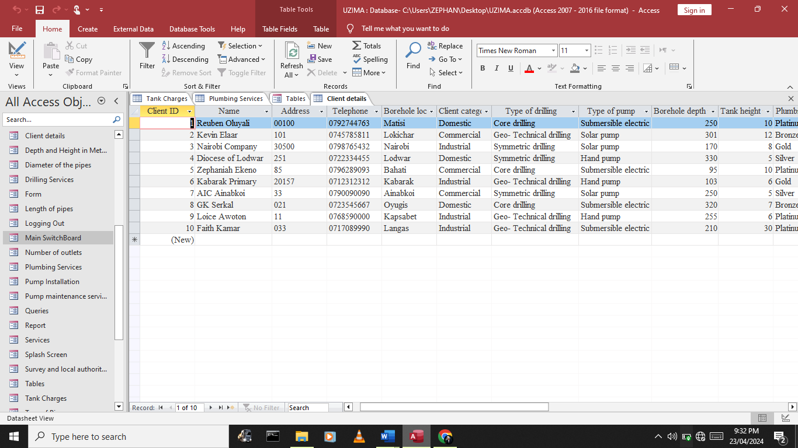

**An example of a form created is as shown below**

**An example of a query created is as shown**

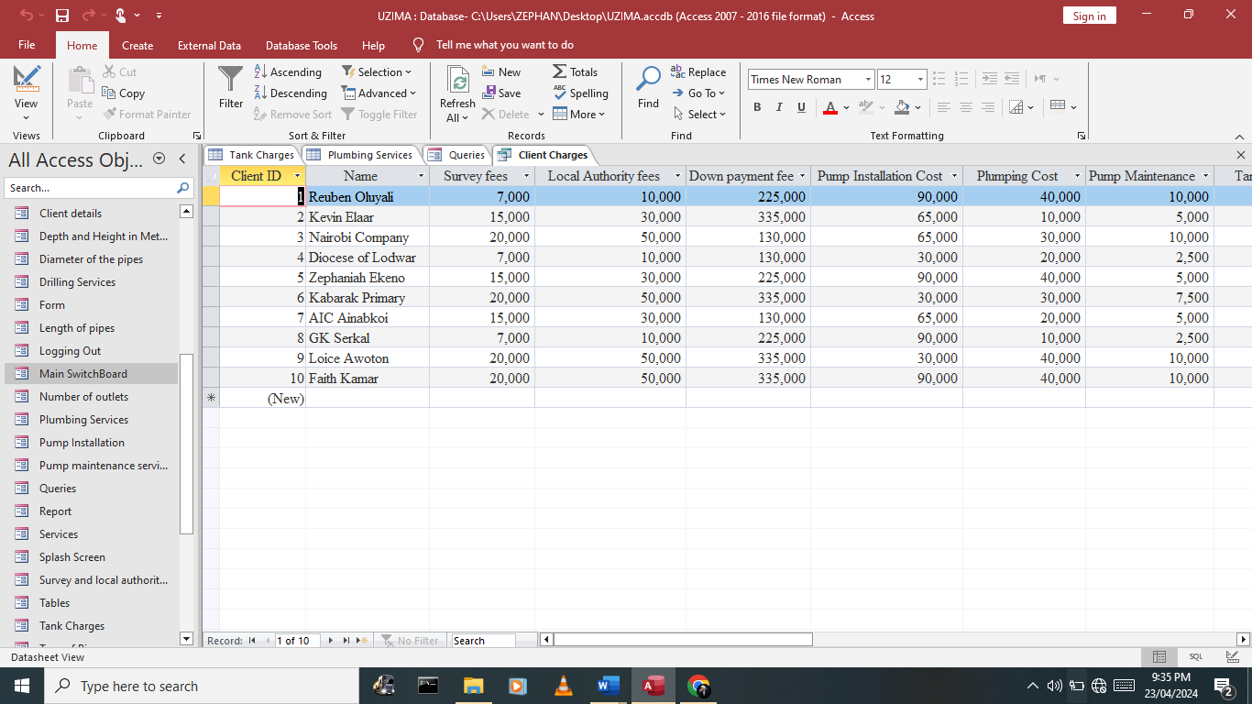

**An example of a report created is as shown below**

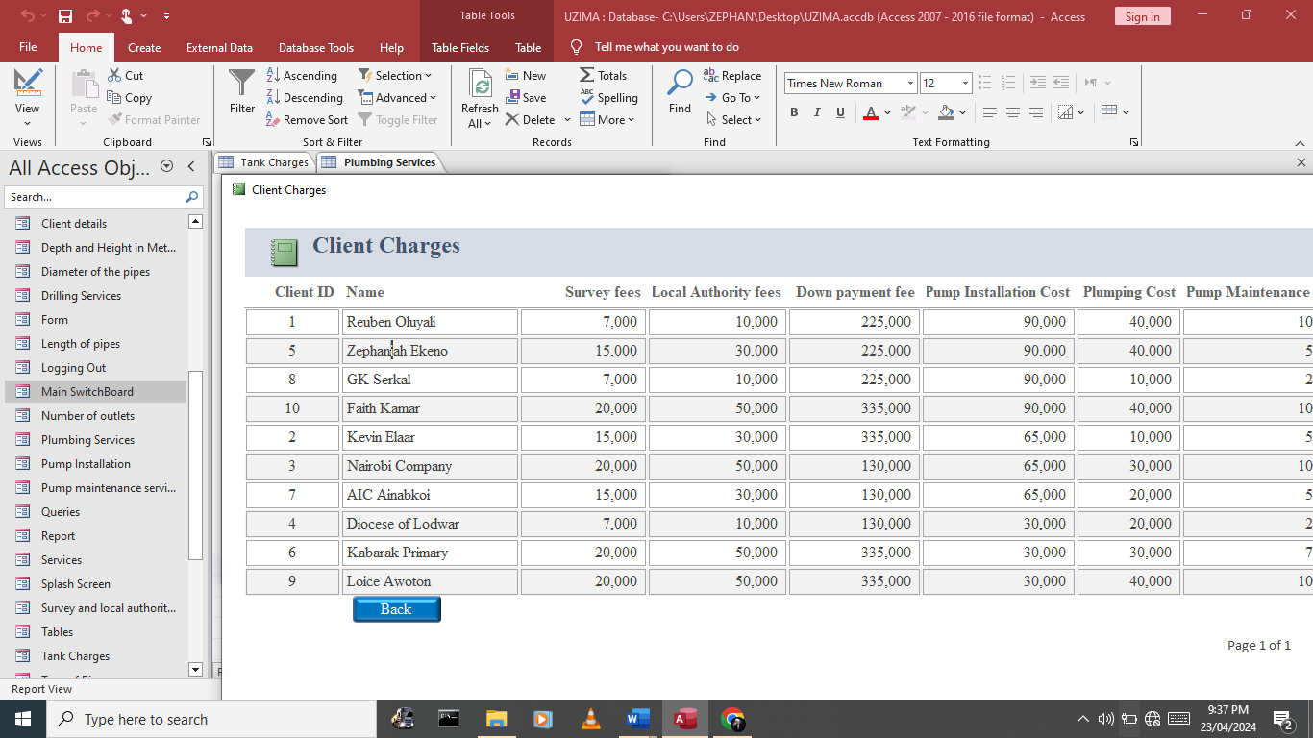

# CHAPTER 5

# 5.0 SYSTEM TESTING, DEBUGGING AND IMLPEMENTATION

During the system testing, debugging, and implementation phase, rigorous testing procedures were carried out to ensure the functionality, reliability, and performance of the Uzima Borehole Drilling System before deployment.

**System Testing:**

A comprehensive testing strategy was employed to validate the system's behaviour and functionality under various conditions. Unit testing was performed on individual modules to verify their correctness and identify any defects. Integration testing was conducted to test the interactions between different system components and ensure seamless data flow. System testing involved executing end-to-end scenarios to assess the system's overall performance and behaviour in real-world scenarios. This phase also included testing for usability, security, and compatibility with different devices and web browsers.

**Debugging:**

Throughout the testing phase, any issues or defects identified were thoroughly investigated and resolved through debugging processes. Developers used debugging tools and techniques to isolate and troubleshoot software bugs, logic errors, and system glitches. Debugging efforts were focused on identifying root causes, implementing fixes, and verifying that the issues were effectively resolved. Close collaboration between developers, testers, and stakeholders ensured timely resolution of issues and continuous improvement of system quality.

**Implementation:**

Following successful testing and debugging, the Uzima Borehole Drilling System was prepared for implementation and deployment. This involved finalizing system configurations, data migration, and setup procedures to transition the system from development to production environment. Implementation tasks included installing necessary software components, configuring server settings, and deploying the application to production servers. Training sessions were conducted for system administrators, staff members, and end-users to familiarize them with the system's features, functionalities, and usage guidelines.

**User Acceptance Testing (UAT):**

Before final deployment, user acceptance testing (UAT) was conducted to validate the system against user requirements and expectations. End-users actively participated in UAT sessions, evaluating the system's usability, functionality, and performance based on predefined test cases and scenarios. Feedback from UAT sessions was collected, analyzed, and incorporated into the system to address any remaining issues or enhancements identified by users.

**Rollout and Deployment:**

Once UAT was successfully completed and all issues were resolved, the Uzima Borehole Drilling System was officially deployed for production use. Deployment activities included scheduling downtime, performing final data backups, and transitioning users to the new system. System administrators monitored the deployment process closely to ensure a smooth transition and minimize disruption to ongoing operations. Post-deployment support and monitoring mechanisms were established to address any issues that may arise and ensure continued system stability and performance.

# 5.1SYSTEM TESTING

During the system testing phase, extensive testing procedures were carried out to evaluate the functionality, reliability, and performance of the Uzima Borehole Drilling System prior to its deployment. The testing process involved a series of steps to verify that all system components and features met the specified requirements and performed as expected. Unit testing was conducted on individual modules to validate their correctness and identify any defects or inconsistencies in the code. Integration testing was then performed to assess the interactions between different modules and ensure seamless data flow throughout the system. System testing involved executing end-to-end scenarios and user workflows to evaluate the system's behaviour in real-world situations. Various testing techniques, such as black-box testing, white-box testing, and regression testing, were employed to uncover any defects, errors, or performance issues. Testing also included checks for usability, accessibility, security vulnerabilities, and compatibility with different devices and web browsers. Test cases were meticulously designed to cover all aspects of system functionality, including client registration, service provisioning, fee calculation, reporting, and administrative tasks. Test results were documented, and any identified issues were logged, prioritized, and addressed by the development team through debugging and corrective measures. Continuous communication and collaboration between testers, developers, and stakeholders ensured that all identified issues were effectively resolved, and the system was thoroughly validated before proceeding to implementation.

# CHAPTER 6

# 6.0 USER MANUAL

The user manual was developed in order to help any person to use the system with as little guidance as possible.

# 6.1 System Requirements

**Hardware Resources**

During the system construction, there were requirements needed for the system to be efficient.

|  |  |
| --- | --- |
| **COMPONENT** | **TYPE OF MODEL** |
| Printer | LaserJet printer |
| Computer | Del, Lenovo, Acer and Hp |
| Storage Media | Hard disk, 40GB HDD  64 MB RAM |

**Software Resources**

The software requirements for Uzima Borehole Drilling System are;

1. Microsoft Office 2007
2. Windows XP Operating System
3. Antivirus

# 6.2 Loading the System

To load the system then do the following

* Double click the icon on the desktop written Uzima Borehole Drilling System
* A welcoming screen appears which enables you to navigate the system



**Main Menu**

* After the welcoming screen, the Main Switchboard appears on the screen.
* The main Switchboard contains the following details.

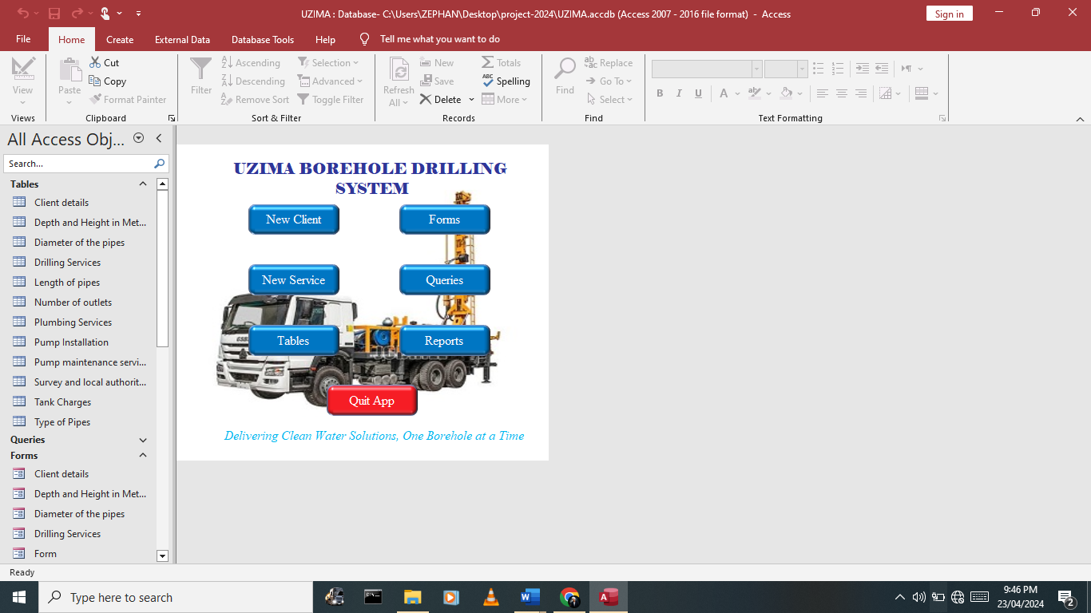

1. **Tables**
2. **Forms**
3. **Queries**
4. **Reports**
5. **New Service**
6. **New Client**
7. **Quit Application**

**Running the Program**

Click the button written tables

1. **Running tables**

A sub switchboard appears which contains all the tables created i.e.

* Client Details Table
* Plumbing Services Table
* Depth and Height in Meters Table
* Pump Installation Table
* Diameter of the pipes Table
* Pump Maintenance Services Table
* Drilling Services Table
* Survey and Local Authority Fees Table
* Lenth of Pipes Table
* Tank Charges Table
* Number of Outlets Table
* Types of Pipes Table

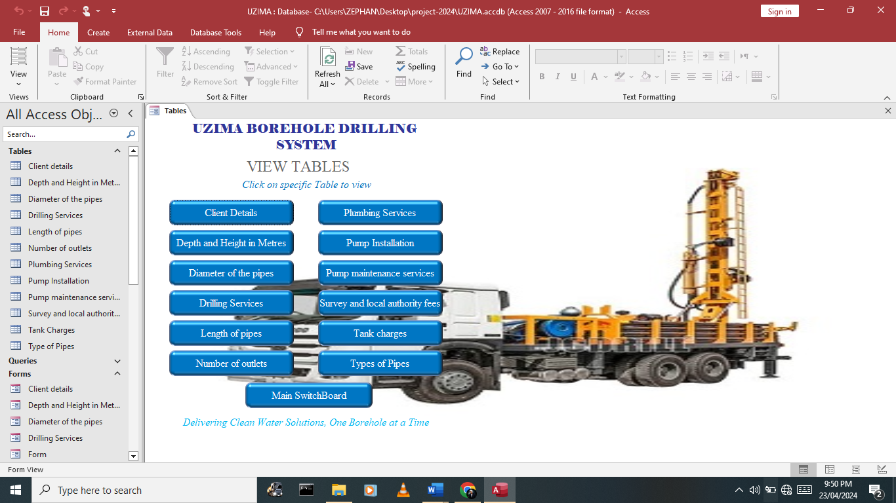

Click the button written Forms

1. **Running Forms**

A sub-switchboard appears which contains all the forms created i.e.

* Client Details Form
* Plumbing Services Form
* Depth and Height in Meters Form
* Pump Installation Form
* Diameter of the pipes Form
* Pump Maintenance Services Form
* Drilling Services Form
* Survey and Local Authority Fees Form
* Lenth of Pipes Form
* Tank Charges Form
* Number of Outlets Form
* Types of Pipes Form

The forms created contain command buttons which are used to direct the user on the specific place and what to do i.e. save record, Open Record, Close Record, Delete Record, go to last Record, Add New Record and print record commands.

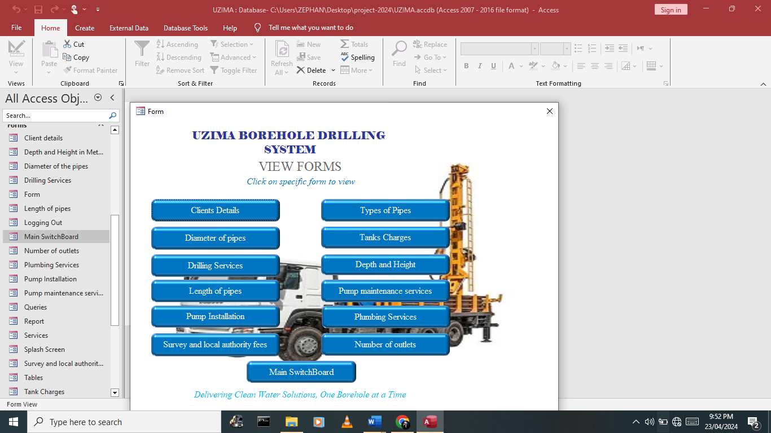

1. **Running Queries**

A sub switchboard appears which contains all the Queries extracted i.e.

* Client Charges Query
* Tax Paid Query
* Client Total Amount Query
* Total Company Revenue Query
* Survey and Local Authority Fees Query
* Total Plumbing Charges Query

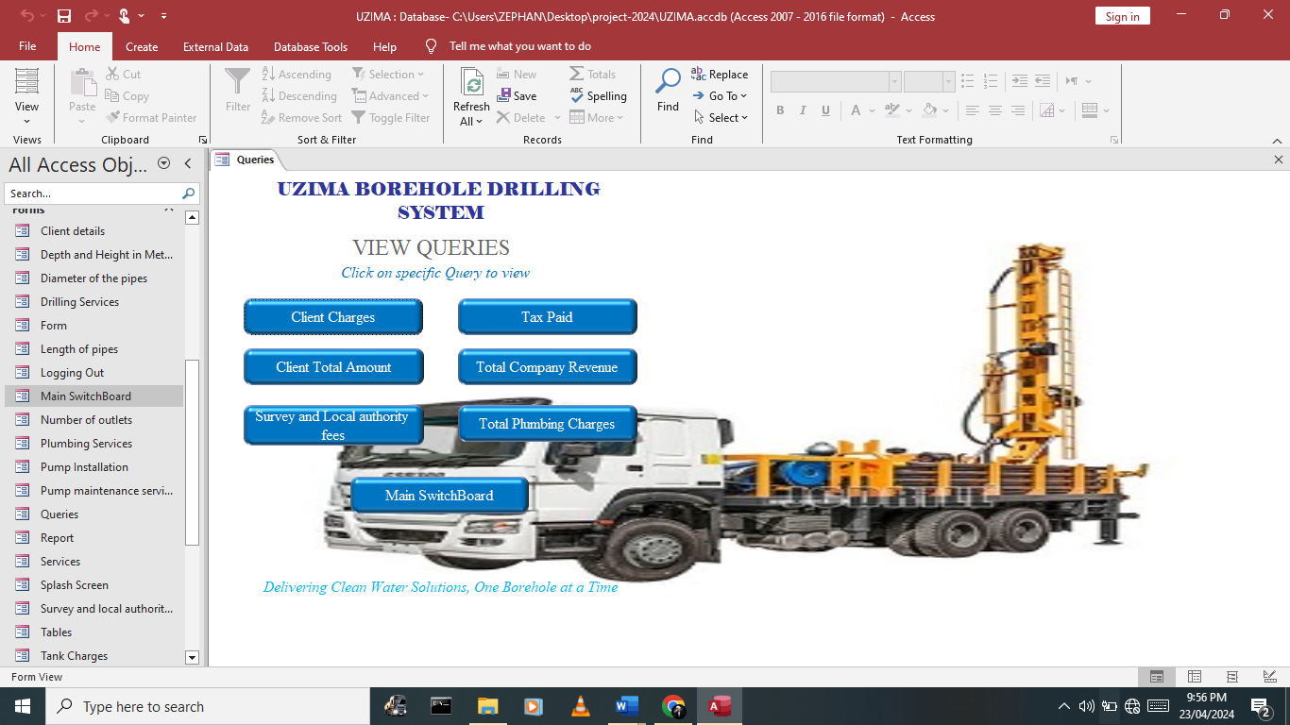

Click on the command button written Reports

**Running Reports**

A sub switchboard appears which contains all the reports i.e.

* Client Charges Report
* Tax Paid Report
* Client Total Amount Report
* Total Company Revenue Report
* Survey and Local Authority Fees Report
* Total Plumbing Charges Report

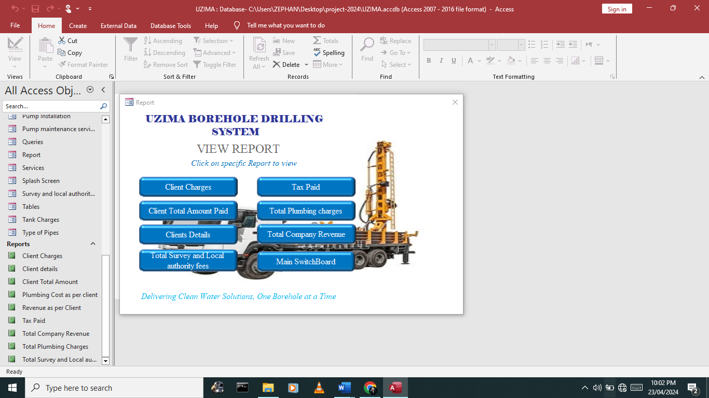

# 6.3 Handling Errors

Pay attention to any error messages or notifications displayed on the screen, as they may provide valuable information about the nature of the problem.

Attempt to troubleshoot the error by retrying the action.

When the errors occur when running the system, an appropriate self-guiding prompt will appear. Respond to it accordingly.

# 6.4 Exiting Program

To exit the program, click on the Quit application Command on the main switchboard and the system logs ff to close the program. The exiting process is as shown below

# 



# RECOMMENDATION

Based on the implementation and usage of the Uzima Borehole Drilling System , the following recommendations are suggested for further improvement and enhancement:

1. Continuous Monitoring: Implement a system for continuous monitoring and performance evaluation to identify any potential issues or areas for optimization.
2. User Feedback Mechanism: Establish a feedback mechanism to gather input from users regarding their experiences with the system, allowing for ongoing improvements based on user needs and preferences.
3. Training and Support: Provide regular training sessions and user support to ensure that users are proficient in using the system's features and functionalities effectively.
4. Security Enhancements: Enhance security measures, such as implementing multi-factor authentication, encryption, and regular security audits, to safeguard sensitive data and protect against cyber threats.
5. Integration with External Systems: Explore opportunities to integrate the system with other external systems or services to streamline workflows, improve data exchange, and enhance overall efficiency.

# CONCLUSION

In conclusion, the Uzima Borehole Drilling System represents a significant advancement in streamlining and managing borehole drilling services effectively. Through careful design, development, and implementation, the system provides a comprehensive platform for client management, service provisioning, fee calculation, reporting, and administrative tasks. By leveraging technology and automation, the system facilitates efficient and transparent processes, enhances data accuracy and accessibility, and improves overall service delivery. Moving forward, ongoing monitoring, user feedback, and continuous improvement efforts will be essential to ensure that the system continues to meet the evolving needs of clients, staff, and stakeholders in the borehole drilling industry.

# APPENDICES

## Appendix 1: ABBREVIATIONS USED

1. DBMS: Database Management System
2. CPU: Central Processing Unit
3. RAM: Random Access Memory
4. ERD: Entity-Relationship Diagram
5. RBAC: Role-Based Access Control
6. UAT: User Acceptance Testing

## Appendix 2: TECHNINAL SYMBOLS USED

|  |  |  |
| --- | --- | --- |
| |  | | --- | |  | | Donates the beginning and end of the program  Used to donate an input or output operation  Indicates data processing in place  Used to specify a condition  Used as a connecting point  Used to indicate the direction of flow of the program Logic  Donates the beginning and end of program  Off page connector  Off page Connector  Used in storage of data |

## Appendix 3: TERMINOLOGIES USED

1. Borehole: A narrow shaft drilled in the ground for purposes such as extracting water, oil, or gas.
2. Survey Fees: Charges incurred for assessing and determining the viability of drilling a borehole at a specific location.
3. Local Authority Fees: Fees payable to the local governing body for regulatory approvals and permits related to borehole drilling.
4. Symmetric Drilling: A method of drilling used to extract core samples for geological analysis.
5. Core Drilling: A method of borehole drilling used to extract cylindrical samples of the earth's subsurface.
6. Geo-Technical Drilling: Drilling aimed at investigating the physical properties and conditions of soil and rock formations.
7. Submersible Electric Pump: A pump designed to be submerged in water and used for pumping water from boreholes.
8. Solar Pump: A pump powered by solar energy, commonly used for pumping water in remote areas without access to electricity.
9. Hand Pump: A manually operated pump used for extracting water from boreholes by hand-operated lever or handle.
10. Plumbing Services: Services related to the installation, maintenance, and repair of piping systems for water supply and drainage.
11. Pump Maintenance: Maintenance activities aimed at ensuring the proper functioning and longevity of water pumps installed in boreholes.

# 

# BIBLIOGRAPHY

**Class: Form 1**

Book Title: Longhorn computer studies book 1

Authors S. Mburu

G. Chemwa

Publishers: Longhorn publishers

Year of Publication: 2014

**Class: Form 2**

Book Title: Longhorn computer studies book 2

Authors S. Mburu

G. Chemwa

Publishers: Longhorn publishers

Year of Publication: 2013

**Class: Form 3**

Book Title: Longhorn computer studies book 3

Authors S. Mburu

G. Chemwa

Publishers: Longhorn publishers

Year of Publication: 2015

**Class: Form 4**

Book Title: Longhorn computer studies book 4

Authors S. Mburu

G. Chemwa

Publishers: Longhorn publishers

Year of Publication: 2015