HipMRI 3D Prostate Segmentation Feasibility Review
COMP3710 Hard difficulty 3D Improved U Net with residual units and deep supervision
Dataset  HipMRI 3D NIfTI volumes | Difficulty  Hard | Target  Prostate Dice at least 0.70
Baseline  Plain 3D U Net | Proposed  3D Improved U Net | Split  Patient disjoint; seed 42
User need scope and decision requested
A radiotherapy contouring specialist needs a reviewable 3D draft of prostate and organ-at-risk boundaries. The engineering question is whether volumetric context, residual units and deep supervision reduce apex, base, cross-slice discontinuity and bladder or rectum boundary errors enough to justify higher GPU memory and runtime. I request confirmation that this Hard HipMRI 3D scope and resource plan are appropriate before full training.
Method and acceptance criteria
The comparison uses a plain 3D U-Net baseline and a 3D Improved U-Net with volumetric residual units and decoder deep supervision. Both use one saved patient-level train, validation and test manifest. Acceptance evidence is: zero patient overlap; aligned NIfTI image-mask volumes; held-out prostate Dice at least 0.70; per-class Dice/IoU, peak VRAM and per-patient inference time; and 3-5 real failure cases with false-positive and false-negative overlays.
Preliminary feasibility evidence
Local synthetic-NIfTI tests currently verify recursive image-mask pairing, missing-pair rejection, 3D shape and affine validation, deterministic patient-disjoint splitting, finite 3D forward/backward passes, residual deep-supervision outputs, validation-only checkpoint selection and held-out metric fields. This establishes the software path only. HipMRI data audit, GPU smoke measurement and final Dice values are not yet claimed.
Risks budget and fallback
Main risks are 3D volume memory demand, small foreground regions, NIfTI orientation errors, slow I/O and failed cluster jobs. The next experiment is a short Rangpur GPU smoke run on audited volumes to set patch geometry, batch size and mixed-precision settings, followed by matched Slurm runs. If the improved model does not improve real held-out boundary failures at acceptable cost, the plain 3D U-Net remains the fallback recommendation.
Questions for tutor confirmation
1. Confirm the Hard HipMRI 3D Improved U-Net scope and patient-level evaluation protocol. 2. Confirm whether the prostate Dice >= 0.70 target is assessed with background reported separately. 3. Confirm the expected GPU budget, patch strategy and midpoint evidence required before full training.

Completed 2D Segmentation Evidence
OASIS brain MRI slice segmentation completed before the HipMRI 3D stage
The 2D stage is complete and provides a verified segmentation pipeline, trained checkpoint and held-out visual evidence. The next stage changes dataset and clinical target: HipMRI volumetric prostate segmentation using matched plain and improved 3D U-Nets.
Completed 2D result
Dataset  OASIS brain MRI slices | Training  80 epochs on A100 | Best validation DSC  0.9770 at epoch 29 | Test foreground mean DSC  0.9694
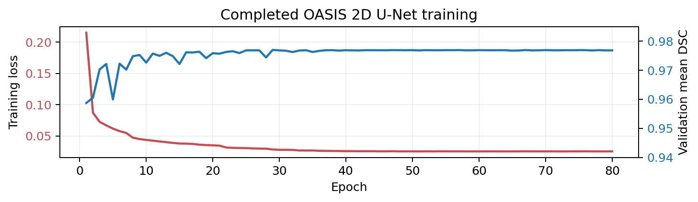
Figure 1. Training loss decreases while validation mean DSC stabilises near 0.977.
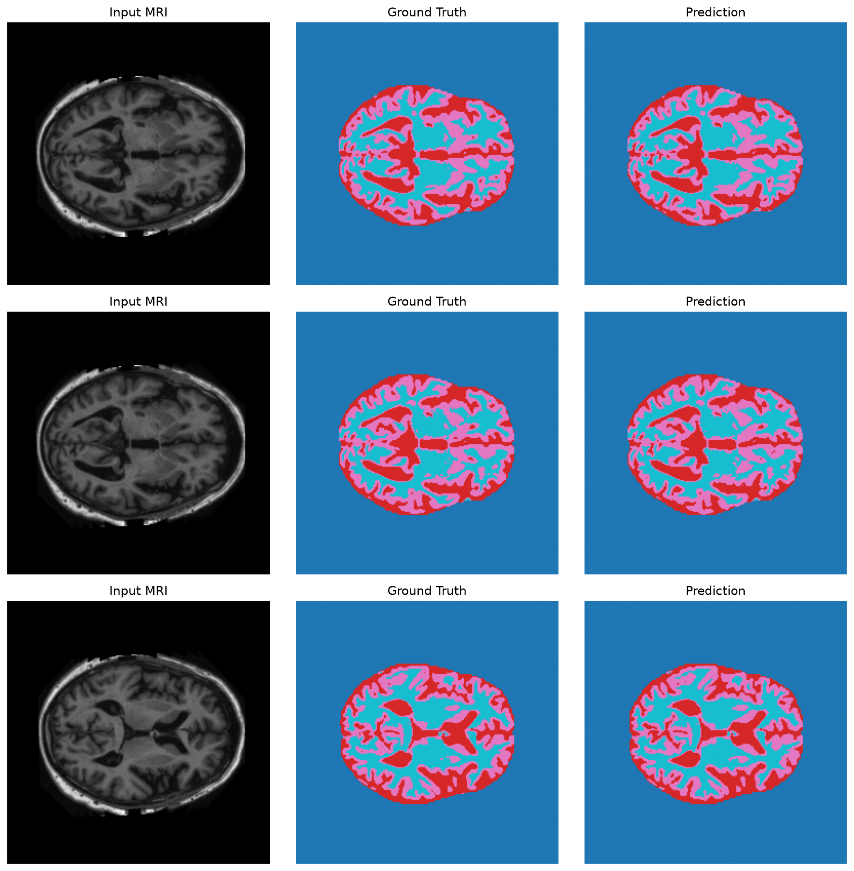
Figure 2. Held-out OASIS examples: input MRI, ground truth and 2D U-Net prediction.
Held-out per-class DSC: background 0.9993; foreground classes 1-3 0.9648, 0.9648 and 0.9786. All foreground classes exceed the earlier 2D target of 0.90. These are not HipMRI prostate results.

HipMRI 3D Stage
Current implementation evidence and next experiment
Why move from 2D to 3D
Independent 2D slices cannot directly enforce continuity across the prostate base, middle and apex. The 3D stage uses volumetric context and tests whether residual units plus deep supervision improve difficult boundaries enough to justify the additional memory and runtime.
Stage | Status | Evidence
2D OASIS U-Net | Complete | 80-epoch history, checkpoint, held-out DSC and prediction panel retained.
3D data pipeline | Implemented | Recursive NIfTI pairing; shape, affine, finite-intensity and integer-label validation.
Patient split | Implemented | Seed-42 train/validation/test manifest with zero-overlap checks.
3D models | Implemented | BaselineUNet3D and residual ImprovedUNet3D with two deep-supervision heads.
Automated verification | 8 tests pass | Pairing, invalid-data rejection, patient split, forward/backward, loss and evaluation logic.
Real HipMRI training | Next | Data audit, Rangpur GPU smoke run, then matched baseline and improved full runs.
Planned fair comparison
Audit HipMRI  volumes | Freeze patient  manifest | GPU smoke  run | Train both  3D models | Held-out metrics  and failure panels
Acceptance evidence for the 3D stage
Both models will use the same patient-disjoint manifest. Final evidence will report prostate Dice (target at least 0.70), per-class Dice/IoU, peak VRAM, per-case inference time and 3-5 held-out base/apex or boundary-leakage cases. Checkpoint selection uses validation data only.
Resource risk and fallback
A short smoke run will determine patch size, batch size and mixed precision before full Slurm jobs. If the improved model does not reduce real held-out errors at acceptable cost, the plain 3D U-Net remains the fallback.
Tutor confirmation requested
Please confirm the HipMRI label encoding, whether background is excluded from reported Dice, recommended patch and batch settings, compute budget, and required logs, checkpoints and failure panels.

