**VALLEY VIEW UNIVERSITY**

**INSTITUTE OF COMPUTER SCIENCE**

**DEPARTMENT OF COMPUTER SCIENCE**

**A PROJECT SUBMITTED IN PARTIAL FULFILLMENT OF THE REQUIREMENT FOR THE BACHELOR OF SCIENCE (BSC) IN COMPUTER SCIENCE DEGREE**

**TOPIC:**

**SOUNDWAVE MUSIC WEB-BASED APPLICATION**

**BY: ZEPHANIAH OLLENNU**

**ID: 221CS01000636**

**DECLARATION**

This is to certify that the I, Zephaniah Ollennu worked to complete the research that forms the basis of this thesis. In order to partially fulfill the requirements for the Bachelor of Science in Computer Science degree, the student and his supervisor certify that the work contained in this thesis is the result of the research that was undertaken by the student as part of his final project work.

# CHAPTER ONE

GENERAL INTRODUCTION

1. INTRODUCTION

Soundwave is based a web application which enables users to stream music. Music is one of the best ways to relieve pressure in stressful modern society life. The purpose of this project is to develop a player which can play the mainstream file format. To browse and query the storage space as well as operation of playing can be realised. Meanwhile, this web based application can play, pause and select songs with latest button and next button according to sets requirement as well as set up songs.

1.1 SUBJECT AND FIELD OF STUDY

Our product is a web based application player that allows users to listen to their music libraries using a server program on their home computer and a web based client to connect to that server and stream the music.

1.2 STUDY OBJECTIVES

The study objectives are categorized into two:

1.2.1 GLOBAL OBJECTIVES

Our global objective for this project is to reach to the music lovers globally to hear voices from all around the world. This is will allow other regional zones to get access to their preferred region.

1.2.2 SPECIFC OBJECTIVES

The functionalities of this project are as follows:

1. Offers search options based on a variety of criteria. Performer, Album Type, Track, etc. Track, music, and performer user information is likewise managed online by the music portal.
2. It keeps track of all Album, User, Track, etc. information. Control the album's information.
3. Displays the performer's information and description, along with the album kind.
4. In order to manage the Performer and Album more effectively.
5. It has to do with keeping track of Track's data and transactions. Control the performer's information.
6. Improvements in editing, adding, and updating Records lead to proper resource management of performer data.
7. Maintain the Track Integration data for all Music records.

1.3 PROBLEM STATEMENT

Managing the album, performer, track, user, and music information is a difficulty for any company, large or small. Since the needs of Performers vary depending on the Online Music Portal, we create custom employee management solutions that are tailored to your managerial needs. This is intended to aid with strategic planning and will help you make sure that your company has the appropriate amount of knowledge and information for your future objectives. Additionally, our systems provide remote access features that will let you manage your workforce whenever you want, anywhere. This is great for executives who are constantly on the go and are busy. In the end, these solutions will enable you to manage resources more effectively.

**LITERATURE REVIEW**

**2.0 Overview**

This chapter contains a thorough analysis of research web-based applications about study and existing systems which will be reviewed as well as their features.

2.1 Systems Reviewed

Spotify Web Application

Spotify is a proprietary Swedish audio streaming and media services provider founded on 23 April 2006 by Daniel Ek and Martin Lorentzon .Online and Offline built web application for streaming music on any device

Apple Music Web Application

This is an online web application which works for only Apple devices. It is uses the apple Api to to stream music which therefore makes it online

Deezer Web Application

This is an online web application which allows any kind of artiste to upload music to cloud where it is reachable and accessible but countless number of people.

Soundcloud Web Application

SoundCloud is an open web platform for both listeners and creators. Anyone can still listen for free and anyone can still upload tracks, as long as they own all the rights to do so.

Audiomack Web Application

Audiomack is a youth-driven, artist-first music web streaming platform that allows creators to share unlimited music and podcast content for free. It focuses exclusively on new, independent, and up-and-coming artists. They are not a full-catalog streaming service like Spotify and Apple Music, and do not plan to ever become one.

**SCREENSHOT OF THE DESIGN INTERFACE**

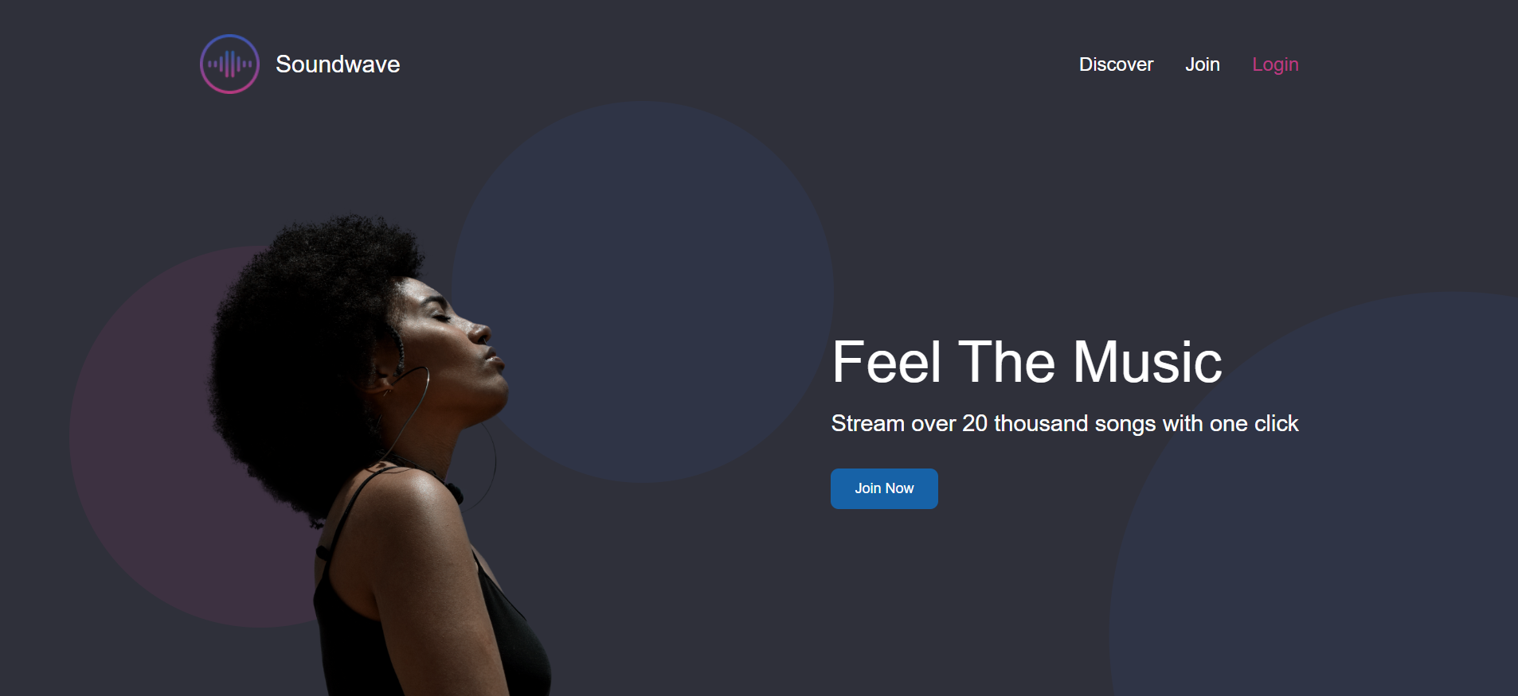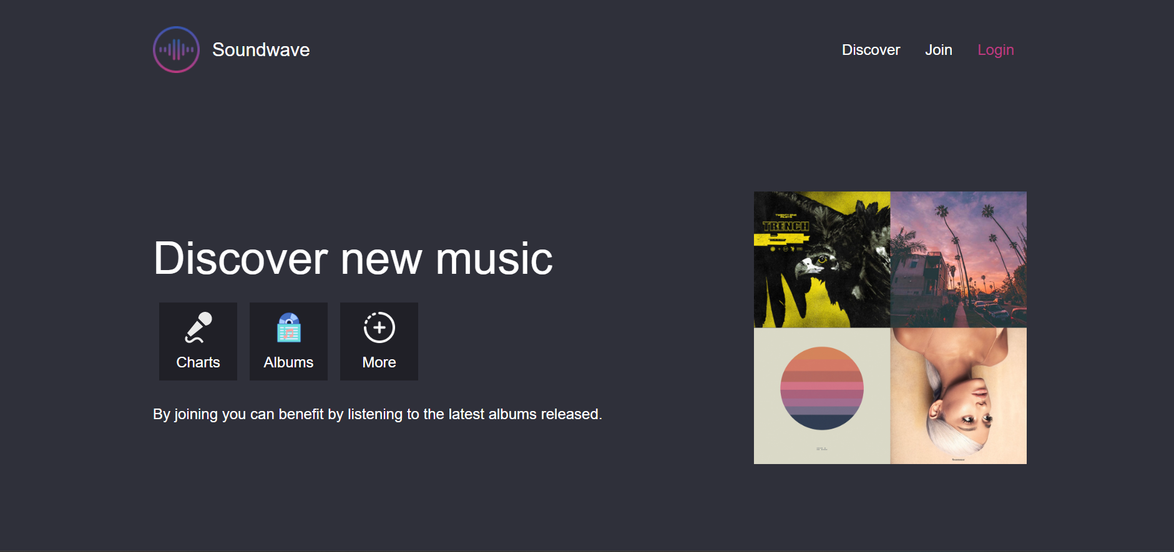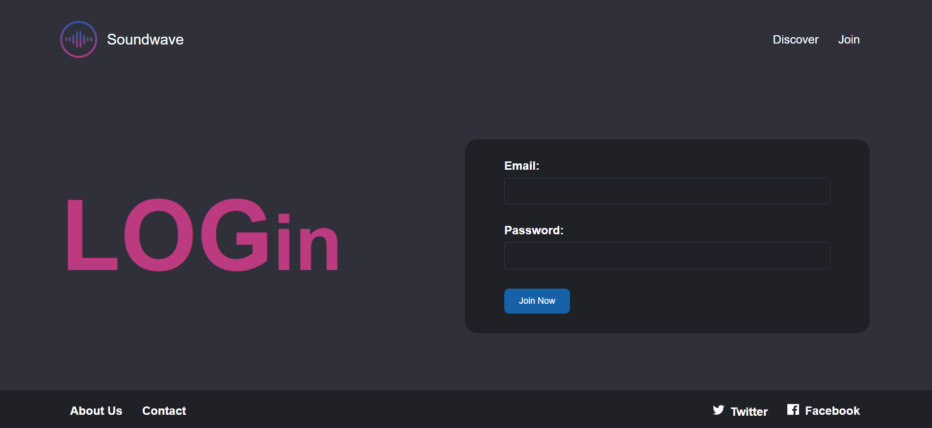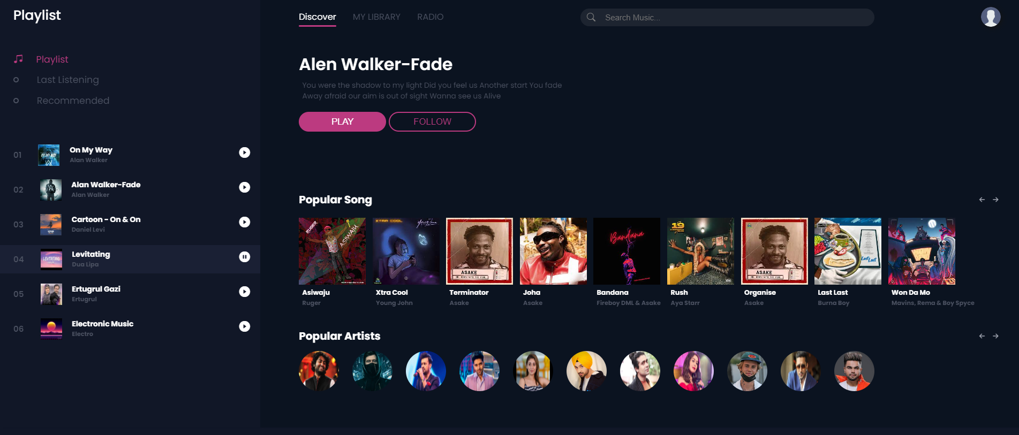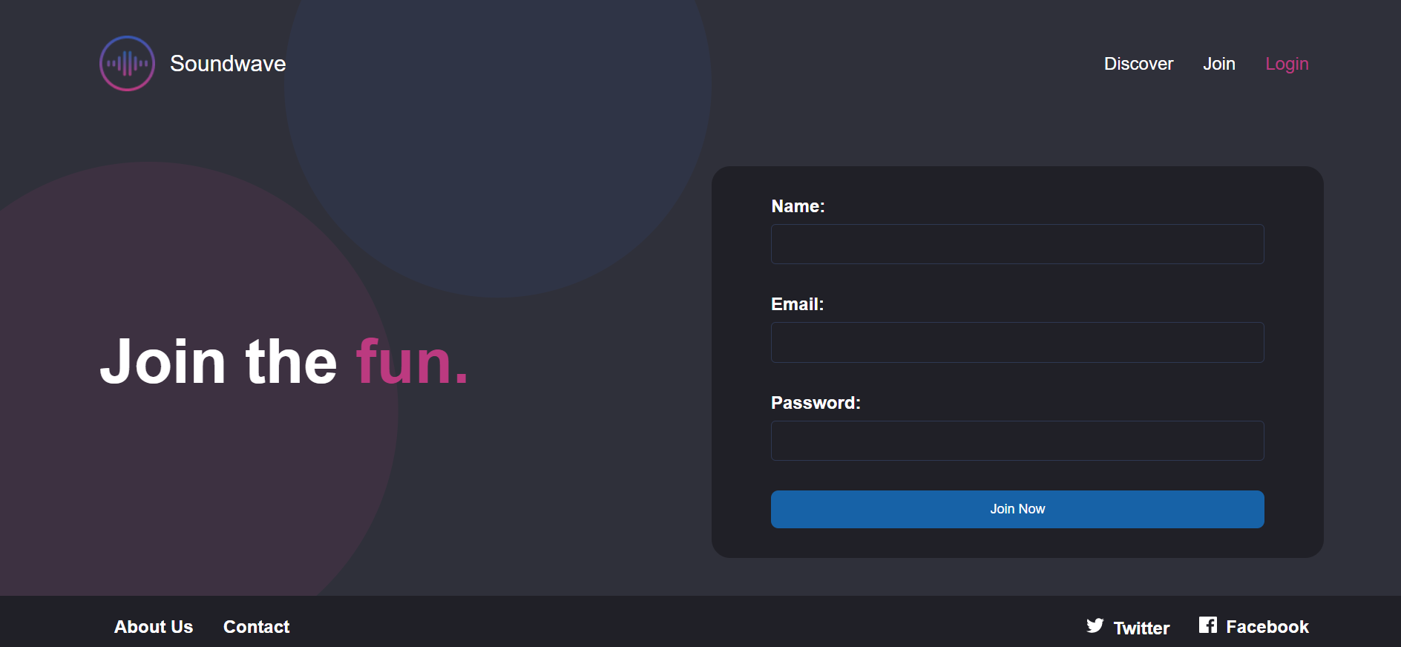

**3.0 LIMITATION AND FUTURE WORKS OF THE SYSTEM**

**LIMITATIONS:**

**1. Soundwave will display ads to charge free users.**

**As we've already mentioned, advertisements support the free version. Between the songs, these users must endure audio advertising. The listener is annoyed by this, especially when an advertisement interrupts one of their favorite songs or a podcast. The only option to remove the intrusive adverts is to upgrade to the premium version, which may be pricey as it will be coming soon to later versions.**

**2.** **Soundwave provides free users with poor sound quality.**

**Free users receive poor sound quality, much like advertising. On desktop and mobile devices, the maximum bitrate at which free users may stream music is 128 kbps. In contrast, the premium edition allows for 320kbps audio streaming on both desktop and mobile devices. You might hear music that is of noticeably higher quality if you decide to upgrade to the premium version. This done in order to control the cost burdens that Soundwave will have to take.**

**3. Soundwave is web-based, an internet connection is necessary.**

**Although Soundwave is a prominent participant, there are strong rivals in the music business. The main disadvantage of Soundwave is that it always needs an internet connection, as opposed to other music streaming services. There is no option to listen to music offline unless you are purchasing the premium edition and saving tracks. In contrast, the rivals enable offline listening without requiring a premium version upgrade.**

**FUTURE WORKS OF THE SYSTEM**

**1.** **Soundwave will be accessible across several platforms.**

**An app will be created for mobile users, regardless of whether you use iOS or Android. Additionally, both machines running Apple macOS and Microsoft Windows will support the Soundwave application. Even from Linux, Open Pandora, Xbox, and PlayStation, users can access Soundwave. Soundwave will have a competitive advantage in the music industry because to its compatibility.**

**2. Soundwave will provide access to the enormous music collection.**

**Users of Soundwave can choose between free and paid versions. Nevertheless, Soundwave subscribers will have access to enormous music libraries. The users may definitely discover something they like, from tunes to podcasts. Additionally, Soundwave has about 3.2 million podcasts, and a large number are added every day. Additionally, users can save up to 10,000 songs on five separate devices by purchasing to the premium edition. The saved playlists are accessible for offline listening.**

**3.Podcasts and music downloads will be made available**

**Users who choose Soundwave Premium can individually save up to 10,000 songs on five separate devices. Any of the albums or playlists can be saved for offline listening. In addition, Premium shows no advertising at all. The same songs that you can listen to on your laptop can also be listened to at any time on your phones. No longer restricted to shuffle, you may now access Radio and skip tracks.**