Game KI Documentation  
  
A-Star in Unreal Engine by Ole Ortmann  
  
Project Goal:

The Goal was to create a project in which the user can send an agent across a grid that the player can influence. The player can toggle the walkability of single grid tiles and then can give the agent on the field a goal to walk to. The Agent will then use the a-star algorithm to find the shortest way to the goal around the obstacles.

Ein Bild, das Screenshot, Design enthält.

The agent

Structure:

It is my second attempt at making a star pathfinding so I came up with the following structure.

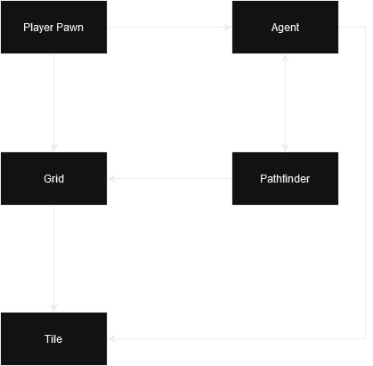

The player can set up the unwalkable tiles on the grid and then set a goal to the agent. The agent will call the findPath() function of the pathfinder actor. For one agent isn’t strictly necessary, but for multiple agents a separate pathfinder class is useful if the calculations can be time sliced. Also, it decapsulates the pathfinding from the rest of the agents behavior that it might have in a game. So the agents main function in this project is just to hand over the current tile and the new goal to the pathfinder and then walk when it gets a path back.

Difficulties on the way

In the unreal blueprint system there are no 2 dimensional arrays. So all arrays in the grid are stored in a one dimensional one and just accessed via calculations with the row and column numbers.

Ein Bild, das Screenshot, Reihe, Diagramm, Schaltung enthält.

At the start this lead to problems with the borders of the grid. To the pathfinder the the last tile in a row and the first tile in the next row were next to each other So it had to be prevented that grids out of bounds could be accessed.

Furthermore, to save memory, the grid tiles did not save their neighbors but instead accessed the tile in the next/previous column/row.

This has lead to increased calculation time for the pathfinding since the access of neighboring tiles took many operations. For paths that are hard for the a star, calculation times over one second weren’t unusual. So I changed the access of the neighbors. Now each tile saves references to its eight surrounding neighbors and those references are set at the start of the game after the grid was built. It has decreased calculation times by a lot.