- Make sure your Unreal Project uses Unreal Engine 5.1 or higher and uses unreals Enhanced Input System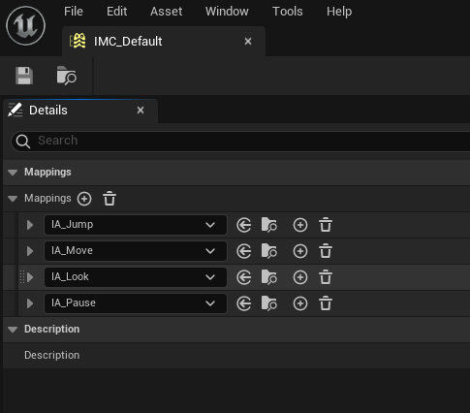
- Download from Fab marketplace
- Create Plugins folder in Project if it doesn't exit yet. 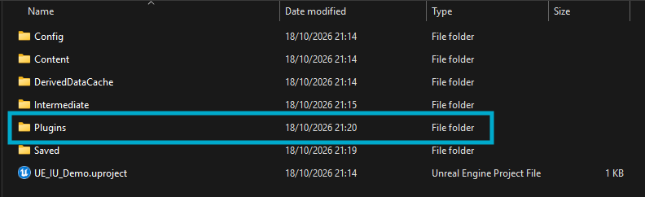
- Move InputUtilities into the Plugins Folder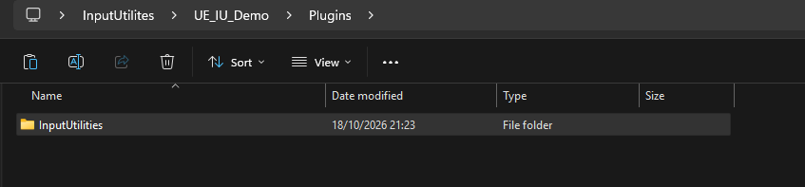
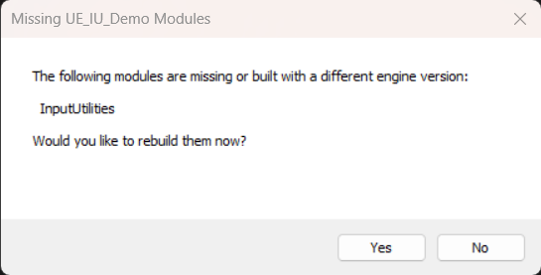
- Click “Yes” on both warnings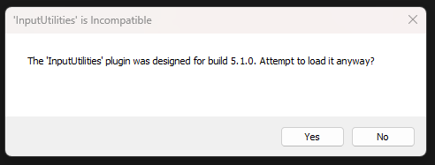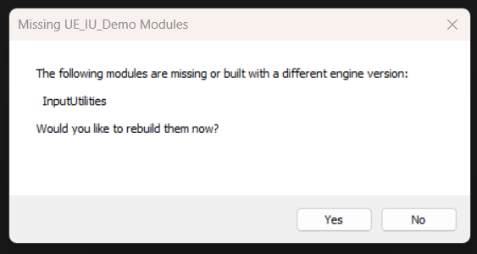
- Content can now be found under All/Plugins/InputUtilities