How to use Widget Prompt
- Drag WBP_WidgetInputPrompt onto your own widget.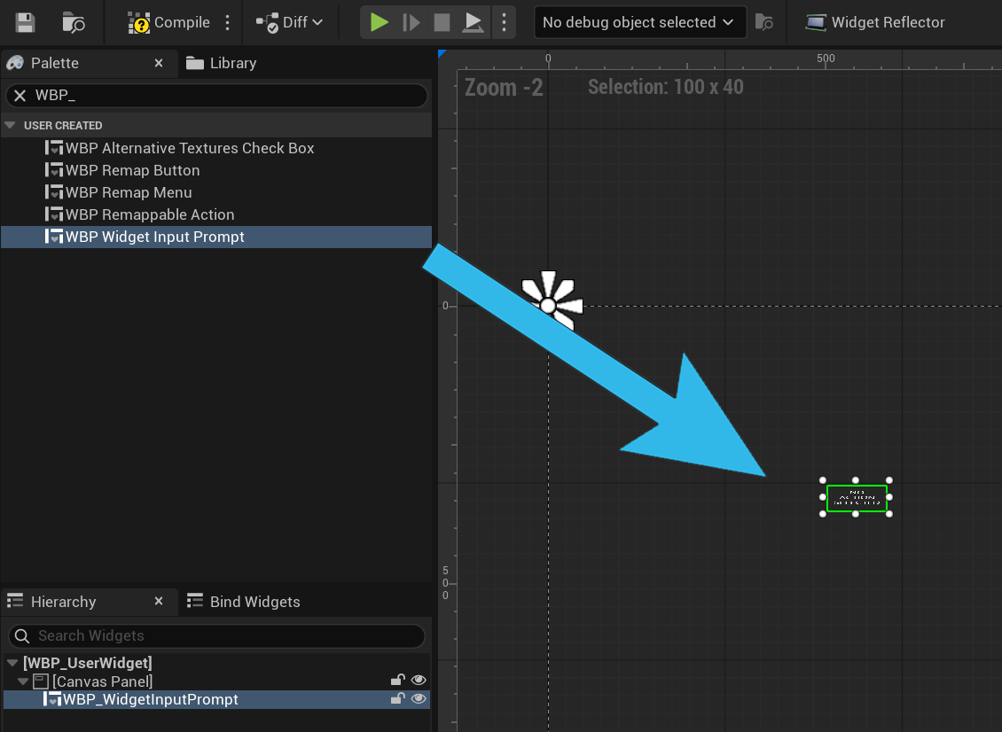
- Configure in the details panel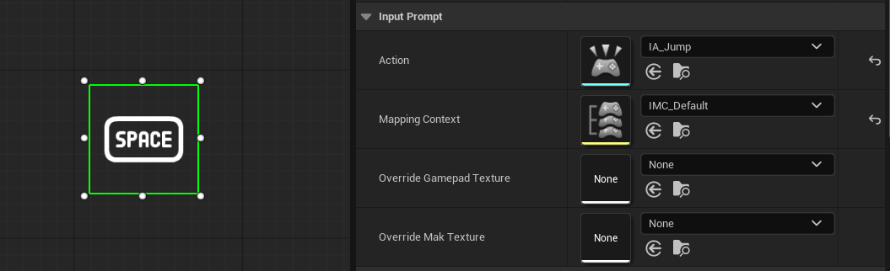
- Override textures are used for mappings like WASD