How to use World Prompt
World Prompt is used to display an input prompt in 3D space. It can be used as an actor in the world or as an attached actor in another actor.
- BP_WorldPrompt can be found under: All/Plugins//InputUtilities/WorldInputPrompt 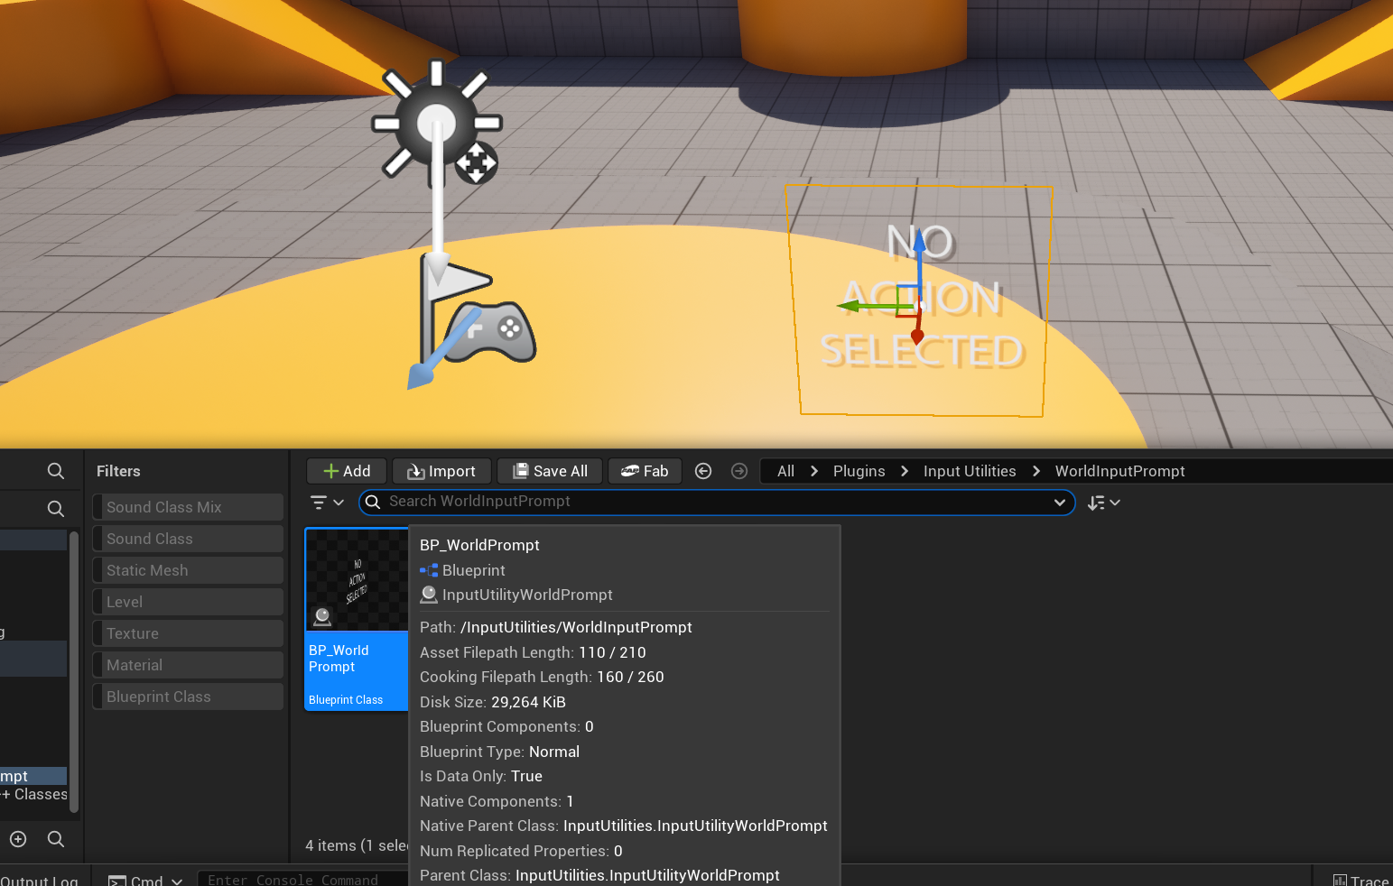
- Configure in the details panel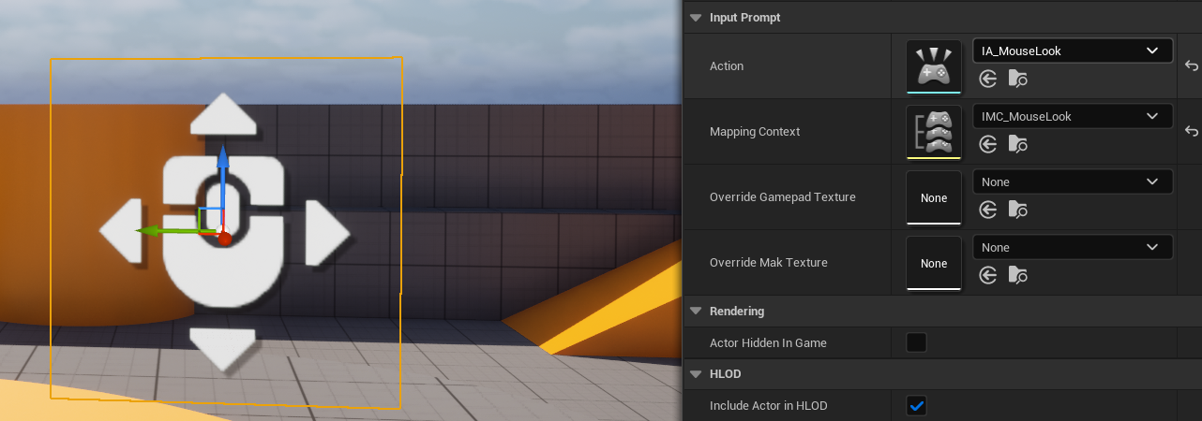
- Override textures are used for mappings like WASD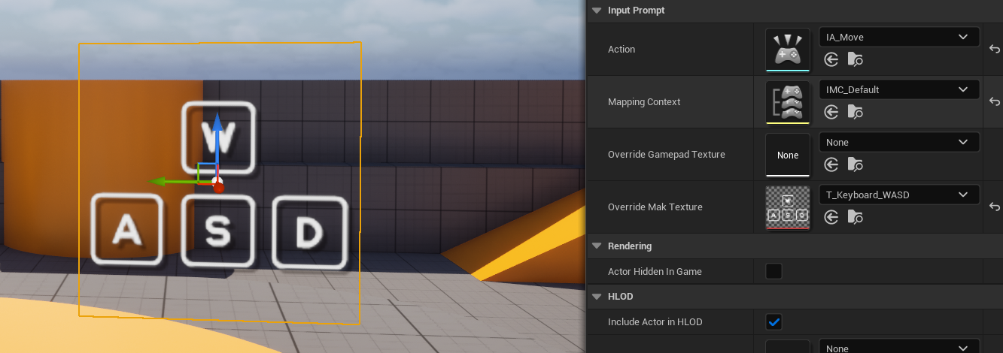
- Tint and alpha can be modified over the “Color” parameter in planes material in BP_WorldPrompt or a child class