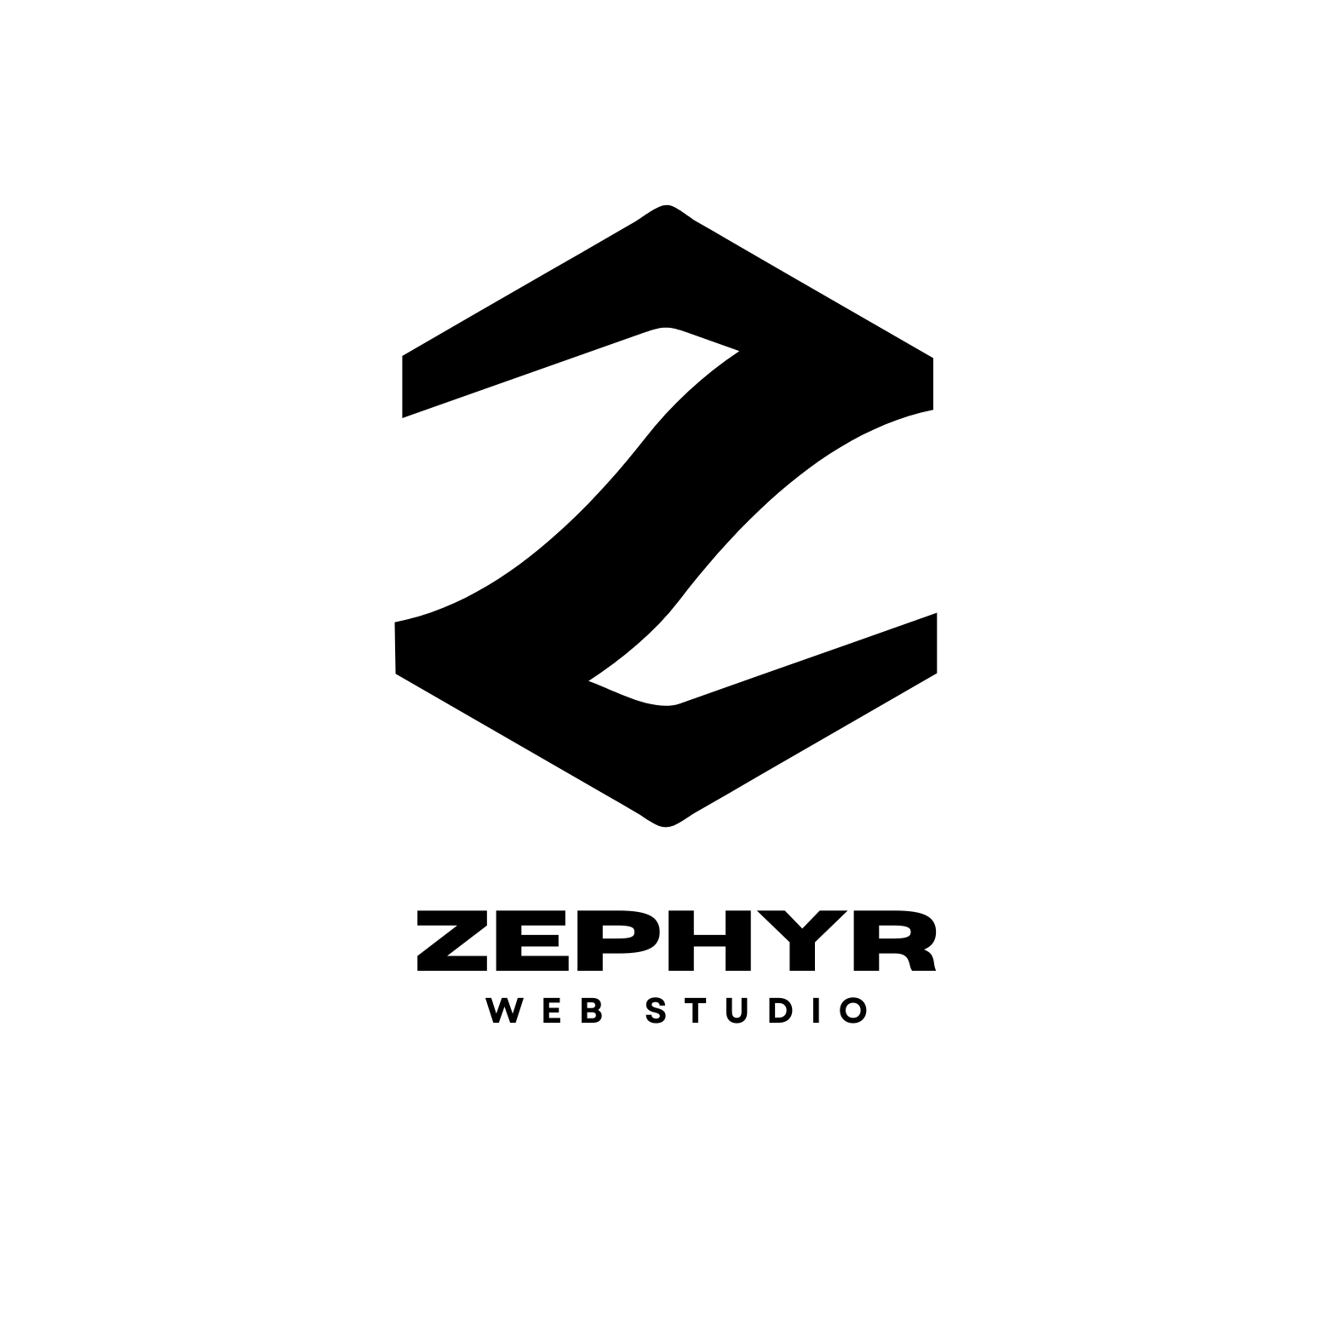
Looking to Upgrade
Your Website?

Get Free Consultation Today!

OUR SERVICES
🎨 Web Design
Bespoke user experiences (UX), custom themes, interactive mockups, and mobile-responsive layout guides tailored to your brand identity.
💻 Web Development
High-performance websites, portals, and dashboards engineered with React, Next.js, and TypeScript, backed by cloud hosting and databases.
📱 App Development
High-velocity cross-platform mobile apps for iOS & Android, equipped with live tracking, video calling, and secure payment systems.
Work with us • www.zephyrwebstudio.dev

ABOUT US
We are a website service provider that pushes the boundaries of traditional web development. Our edgy approach to web design sets us apart, and our team of talented developers is dedicated to bringing your vision to life. Get in touch. Let us help you make an impact and leave a lasting impression.

WHY CHOOSE US
2+  years of industry experience | 40+  brand partners
15+  team members | 100%  Customer Satisfaction

OUR FEATURES
CORE CAPABILITIES  • UI/UX Design  Custom brand templates, interfaces, and user journey mockups.  • SEO Optimization  Semantic markup structures engineered to rank highly on search engines.  • Mobile Optimization  Fluid responsive layouts for seamless browsing on phones and tablets.  • Interactive Forms  Custom inputs, customer enquiry flows, and contact portals. | ADVANCED SOLUTIONS  • Voice & Video Call  Integrated real-time audio and video communications in-app.  • Media Galleries  Premium banner slides, lightboxes, and inline video integrations.  • AWS Integration  Cloud servers setup, secure databases, and storage infrastructure.  • 1-Year Support  Full developer support and corrections included for a whole year.

WEB DESIGNING PROCESS
01 | Advance Payment  The process begins with a 50% advance payment from the client for website design.
02 | Content Submission  You need to send all content related to your business.
03 | Website Work  The website work will begin according to your business requirements and will be completed in 4-5 working days.
04 | Final Payment & Website Live  After the remaining balance is paid, the website is live and amendments can be made.
05 | Corrections  Website corrections will be done by the company as per your need for one whole year.

OUR PRICING
Silver Plan  - Single-page responsive website  - School intro & contact info  - Basic photo gallery  - Contact/Inquiry form  - Quick updates for announcements  - News/Notice scrolling section  - 1 round of text/image revision | Gold Plan  - Up to 5 pages  - Custom school branding/colors  - Staff/faculty showcase  - Events calendar  - Document download section  - News & Updates section  - Announcement pop-ups  - Photo or event gallery  - Google Maps, FAQ  - Blog/Noticeboard area  - 2 rounds of revisions
The listed prices do not include the cost of the domain name.
Every extra page will cost ₹300 for each page

OUR PRICING (CONTINUED)
★ PREMIUM ★
Platinum Plan
✔ Up to 10 custom pages
✔ All Gold features included
✔ Student portal
✔ Parent resources/downloads
✔ Achievements and alumni showcase
✔ Class timetable section
✔ Integrated calendar with events/holidays
✔ Enquiry/Admission form with custom fields
✔ Social media integration
✔ Staff directory with photos & contacts
✔ On-page SEO optimization
✔ Testimonials & feedback section
✔ Priority support
✔ 3 rounds of revisions
The listed prices do not include the cost of the domain name.
Every extra page will cost ₹300 for each page

CONTACT US
📞 +91 85498 40238
+91 72093 33695
+91 7050 218002
✉ forwork.zephyrwebstudio@gmail.com
📷 @zephyrwebstudio (Instagram)
𝕏 @zephyrwebstudio (X / Twitter)
📺 @zephyrwebstudio (YouTube)
📍 Bangalore, India

⚡ 24 x 7 Support ⚡

