Assignment 1 Sales Board

# Setting up Application, modifying Identity and modelling Database

This encompasses setting up the application from scratch, creating database model files and scaffolding items.

1. Set up git repository and started MVC application.
2. I then chose to start with modelling the database by creating classes for Items, Sales and Saleitems.
   1. I created the Items class before getting side-tracked by trying to include multiple items under 1 user.
3. In order to do this I created an applicationUser class for my new custom fields.
4. I then modified the ApplicationContext.cs to support custom user data from the applicationUser class above.
   1. Made 1 custom field with no entry yet – To Do.
5. Having successfully made a migration with new users I added the Items class and migrated.
   1. After I fixed Items model to reference Zephyr_ApplicationUser I then migrated.
   2. This allowed me to add an item that is linked to a user by their ID.
6. Now I have my Identity and other DBSets in the one context, I then started to add some custom fields to the Identity.
   1. I added the following custom fields to the identity user: first name, last name, age, state, city, postcode, street, images. See Figure 1.1 For an image of the identity fields.
7. Next is to do the Items table.
   1. The items table includes the following fields: Id, SellerId (foreign key to Identity), Item, Itemdesc, Category, Price, Quantity, Itemimage, Postdate. See Figure 1.2 for image of Items class.
8. Then Sales table.
   1. Sales has the following: Id, ItemId, BuyerId, Quantity. See Figure 1.3 for image of Sales class.
9. Finally, Saleitems. This table is like Orderitems, it will handle item purchases with cart.
   1. Saleitems has the following: Id, CartId, Item, Quantity. See Figure 1.4 for image of class.
10. Time for migrations. I migrated the content in the following order. See Figure 1.5.
    1. Identity
    2. Items
    3. Sales
    4. Saleitems
11. I then tested all the tables with two users, added some items and included some sales. This was achieved using the in-built database tool as I have not scaffolded my data yet, which is the next step.
12. Lastly for this development, I created an entity framework scaffold of the Items class.

# Shopping Cart

This encompasses setting up the shopping cart.

1. New session helper with commands to set a key value pair in session and retrieve pairs from key.
2. Next, I made a view model with Item data.
3. Next, I made a new controller called CartController to handle loading item data.

# Appendix

Figure 1.

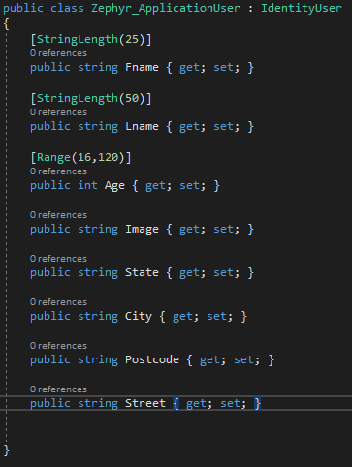

Figure 2.

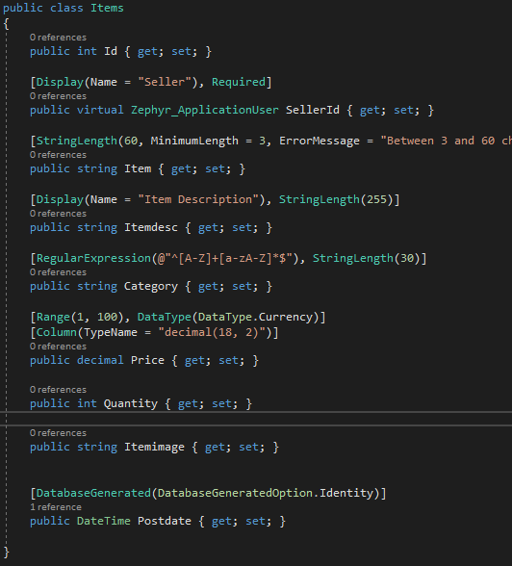

Figure 1.3

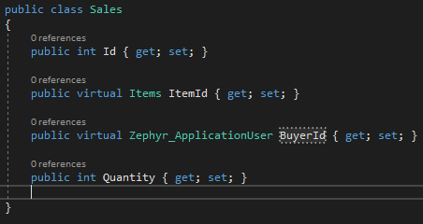

Figure 1.4

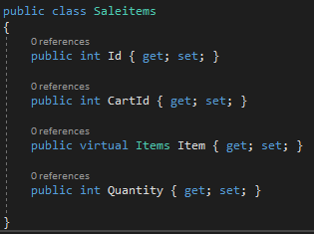

Figure 1.5

