Hangman Project

Table of Contents

Test-driven Development (TDD) 1

Development before beginning test cases 1

Requirements 1

Test Cases 1

Refactoring 3

Code Smells 3

# Test-driven Development (TDD)

This project has been built following a Test-Driven Development approach. This approach utilizes planned test cases that must be passed before continuing to the next test case. Throughout the project, code will be developed to pass each test case one after another, however it is likely that with the development of code for new test cases, older tests will have to be run again. When running older tests some issues may arise that indicate code smells. These will then be addressed, and solutions developed for them.

## Development before beginning test cases

I want this application to utilize a UI for display and input, therefore before I begin developing to pass test cases, I decided to construct a blank Tkinter window.

## Requirements

The project test cases are derived from the following requirements.

1. One word will be generated randomly
2. Player will be presented with a number of blank spaces representing the missing letters the player needs to find.
3. If the player’s chosen letter exists in the answer, then all places in the answer where that letter appear will be revealed.
4. Every time the player guesses a letter wrong, the player’s life will be deducted.
5. The player must find the missing word before the player’s life becomes zero.

## Test Cases

The following is the series of test cases in order of their initial development. There is a likely chance that code will need to be refactored throughout development which will be documented within each test case.

**Test Case: 1**

**Description:** Generates a random English word to the Tkinter window.

**Test Steps:**

1. Generates a random word
2. Check if the generated word is a correct English word in lowercase
3. Word is displayed in Tkinter window

**Expected Result:** The word will be printed in console and displayed to Tkinter window.

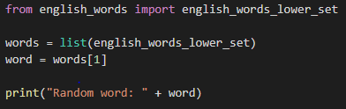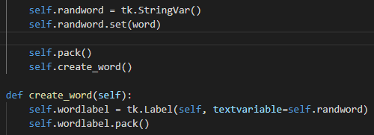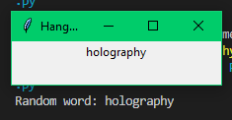

Figures 1. and 2. In the code images above, it shows that the random word is being generated from a python library and I am selecting 1 of these words. I am then printing the word to the console and also creating a wordlabel to hold the random word.. Figure 3. Shows the random word generated in the Tkinter window and in console.

**Actual Result:** The word is displayed in lowercase in the Tkinter window and printed to the console.

**Pass / Fail:** Pass – While the code passed on the first attempt, there is still refactoring to be done.

**Refactoring Test Case 1**

**Refactor Reason:** The random generation of the word should be within a defined function so that it is encapsulated and may be expanded on later, also I realized it would be better if the word was uppercase.

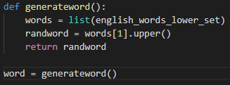

Before / After: We can see the code is now within a defined function which returns the word when called.

**Test Case: 2**

**Description:** Make letters display hidden and show only Underlines on screen.

**Test Steps:**

1. Make the word hidden
2. Display an underscore for each letter in the word
3. Display the hidden word to the screen

**Expected Result:** The word shall be hidden and displayed on screen as underscores only.

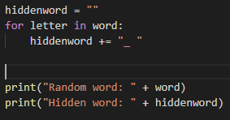 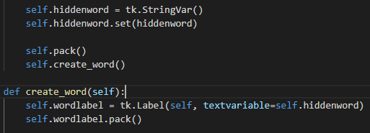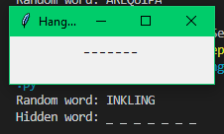

The code figures above show how the hidden word is generated by looping through the random word and placing underscores and spaces.

**Actual Result:** The word displayed

**Pay / Fail:** Fail

**Refactoring Test Case 2**

**Refactor Reason:** The hiddenword code for this test case should also be encapsulated.

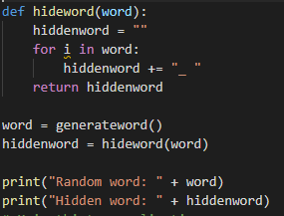

**Before / After:** The hiddenword code is now encapsulated, allowing for ease of change in the future.

**Test Case: 3**

**Description:** User can enter a guess letter. This letter will be displayed to the screen to show their entry.

**Test Steps:**

1. User types in their letter
2. User presses confirm
3. The entered letter displays on the screen in uppercase

**Expected Result:** After the user confirms their letter entry, it will be displayed to the screen as uppercase.

(images)

Figures 1. And

**Actual Result:** The word is displayed in lowercase in the Tkinter window and printed to the console.

**Pass / Fail:** Pass – While the code passed on the first attempt, there is still refactoring to be done.

**Refactoring Test Case 3**

**Refactor Reason:** The random generation of the word should be within a defined function so that it is encapsulated and may be expanded on later, also I realized it would be better if the word was uppercase.

1. Make words invisible and display as underlines to the screen
   1. An underscore is shown for each and every letter
2. User can input letters 1 at a time to display

Only allow letters

Future work:

Base word length on difficulty

|  |  |  |  |  |  |
| --- | --- | --- | --- | --- | --- |
| # | Test Case | Expected Result | Actual Result | Pass / Fail | Additional Notes |
| 1 | Generate a random word | Correct word is generated and displayed correctly |  |  |  |
|  |  |  |  |  |  |

# Refactoring

## Code Smells

A code smell is a front-end / surface indication that usually corresponds to a deeper problem in the system. This section will clearly detail found code smells and the implementation of their fix.

**Code Smell 1**

**Code Smell reason:** Hiddenword is a string and is immutable in python, therefore when it comes to revealing the hiddenword string, the letters cannot be altered. Therefore hiddenword must become a list but tkinter can only display string variables, therefore we must convert the string to a list to allow for modifying, then back to a string to display it on Tkinter.

Code affected:

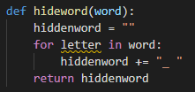

The hideword function must altered to make hiddenword a list.

Refactoring Before / After:

This was wrong

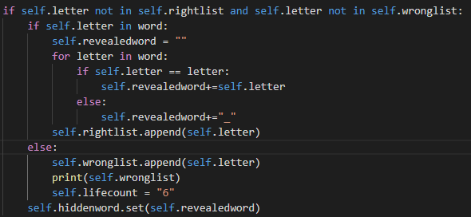

This is fixed

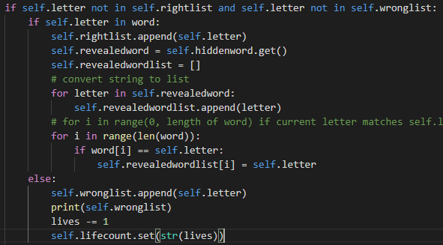

String was immutable so therefore I had to convert to string where needed.



Spaced out the word

