C++程序设计实验报告7

计算机１２０２ 张艺瀚 ２０１２３８５２

实验要求
（1）定义一个基类Animal，有私有整型成员变量age，构造其派生类dog，在其成员函数SetAge（int n）中直接给age赋值，看看会有什么问题，把age 改为公有成员变量，还回有问题吗？编程试之。
源程序：
#include <iostream>
using namespace std;

class Animal
{
public:
int age;
};

class dog: public Animal
{
public:
void SetAge(int n);
};
void dog::SetAge(int n)
{
age = n;
}

int main()
{
dog snoopy;

int a;
cout << "Please input age of snoopy: ";
cin >> a;
snoopy.SetAge(a);
cout << "Age of snoopy is: " << snoopy.age << endl;

return 0;
}

运行结果：
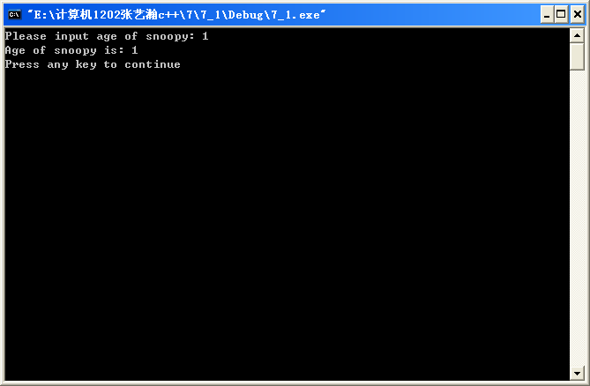
（2）定义一个基类BaseClass,有整型变量Number，构造其派生类DerivedClass，观察构造函数和析构函数的执行情况。
源程序：
#include <iostream>

using namespace std;

class BaseClass
{
public:
BaseClass(int n);
~BaseClass();
int Number;
};
BaseClass::BaseClass(int n)
{
Number = n;
cout << "BaseClass's concstructor called!" << endl;
}
BaseClass::~BaseClass()
{
cout << "BaseClass's destructor called!" << endl;
}

class DerivedClass: public BaseClass
{
public:
DerivedClass(int n);
~DerivedClass();
};
DerivedClass::DerivedClass(int n): BaseClass(n)
{
cout << "DerivedClass's constructor called!" << endl;
}
DerivedClass::~DerivedClass()
{
cout << "DerivedClass's destructor called!" << endl;
}

int main()
{
DerivedClass obj(1);

cout << obj.Number << endl;

return 0;
}
运行结果：
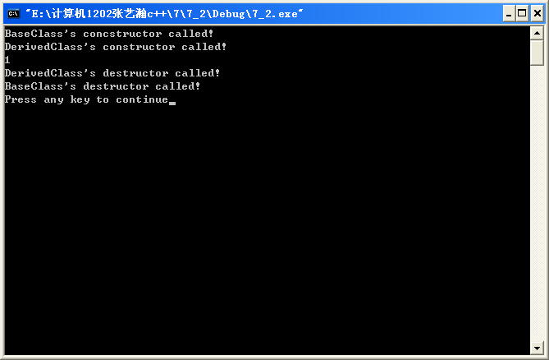

（3）定义一个车（vehicle）基类，具有Maxspeed、Weight等成员，Run、Stop等成员函数，由此派生出自行车（bicycle）类、汽车（motorcar）类。自行车（bicycle）类有高度（Height）等属性，汽车（motorcar）类有座位数（SeatNun）等属性。从bicycle和motorcar派生出摩托车（motorbicycle）类，在继承过程中，注意把vehicle设置为虚基类。如果不把vehicle设置为虚基类，会有什么问题？编程试之。
源程序：
#include <iostream>

using namespace std;

class vehicle
{
public:
vehicle(int v, int g);
~vehicle();
void Run();
void Stop();
private:
int Maxspeed;
int Weight;
};
vehicle::vehicle(int v, int g)
{
Maxspeed = v;
Weight = g;
cout << "Vehicle's constructor called!" << endl;
}
vehicle::~vehicle()
{
cout << "Vehicle's constructor called!" << endl;
}
void vehicle::Run()
{
cout << "Begin to run!" << endl;
}
void vehicle::Stop()
{
cout << "Stop!" << endl;
}

class bicycle: virtual public vehicle
{
public:
bicycle(int v, int g, int h);
~bicycle();
private:
int Height;
};
bicycle::bicycle(int v, int g, int h): vehicle(v, g)
{
Height = h;
cout << "Bicycle's constructor called!" << endl;
}
bicycle::~bicycle()
{
cout << "Bicycle's destructor called!" << endl;
}

class motorcar: virtual public vehicle
{
public:
motorcar(int v, int g, int n);
~motorcar();
private:
int SeatNum;
};
motorcar::motorcar(int v, int g, int n): vehicle(v, g)
{
SeatNum = n;
cout << "Motorcar's constructor called!" << endl;
}
motorcar::~motorcar()
{
cout << "Motorcar's destructor called!" << endl;
}

class motorcycle: public bicycle, public motorcar
{
public:
motorcycle(int v, int g, int h, int n);
~motorcycle();
};
motorcycle::motorcycle(int v, int g, int h, int n):
vehicle(v, g), bicycle(v, g, h), motorcar(v, g, n)
{
cout << "Motorcycle's constructor called!" << endl;
}
motorcycle::~motorcycle()
{
cout << "Motorcycle's destructor called!" << endl;
}

int main()
{
motorcycle MC(1, 2, 3, 4);

return 0;
}
运行结果：
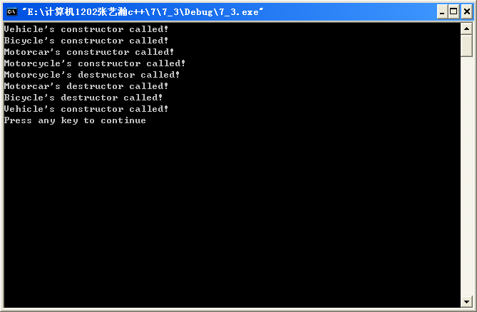
心得体会：

通过这次是实验我学会了定义和使用类的继承关系，定义派生类，熟悉了不同继承方式下对基类成员的访问控制，并能够利用虚基类解决二义性问题，达到了实验要求。

