C++程序设计实验报告8

计算机１２０２ 张艺瀚 ２０１２３８５２

实验要求
（1）定义Point类，有坐标_x，_y两个成员变量；对Point类重载“＋＋”(自增)、“――”(自减)运算符，实现对坐标值的改变。
源程序：
#include <iostream>
using namespace std;

class Point
{
public:
Point(double x, double y);
~Point(){}
void ShowOrdinate();
Point& operator ++();
Point operator ++(int);
Point& operator --();
Point operator --(int);
private:
double _x;
double _y;
};
Point::Point(double x, double y)
{
_x = x;
_y = y;
}
void Point::ShowOrdinate()
{
cout << "(" << _x << ", " << _y << ")" << endl;
}
Point& Point::operator ++()
{
_x += 1;
_y += 1;

return *this;
}
Point Point::operator ++(int)
{
Point old = *this;
++(*this);

return old;
}
Point& Point::operator --()
{
_x -= 1;
_y -= 1;

return *this;
}
Point Point::operator --(int)
{
Point old = *this;
--(*this);

return old;
}

int main()
{
Point p(1.2, 3.4);

cout << "The initial ordinate: ";
p.ShowOrdinate();
cout << "Now _x++ _y++, output new ordinate: ";
p++;
p.ShowOrdinate();

return 0;
}
运行结果：
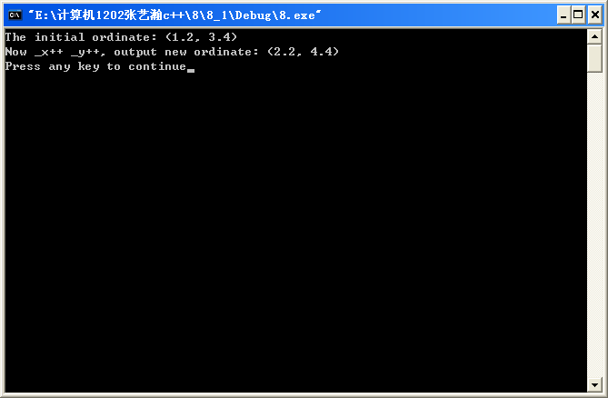
（2）定义一个车(vehiele)基类，有Run、Stop等成员函数，由此派生出自行车(bicycle)类、汽车(motorcar)类，从bicycle和motorcar派生出摩托车(motorcycle)类，它们都有Run、Stop等成员函数。观察虚函数的作用。
源程序：
#include <iostream>

using namespace std;

class vehicle
{
public:
vehicle();
~vehicle();
virtual void Run();
virtual void Stop();
};
vehicle::vehicle()
{
cout << "Vehicle's constructor called!" << endl;
}
vehicle::~vehicle()
{
cout << "Vehicle's constructor called!" << endl;
}
void vehicle::Run()
{
cout << "This vehicle begins to run!" << endl;
}
void vehicle::Stop()
{
cout << "This vehicle stops!" << endl;
}

class bicycle: virtual public vehicle
{
public:
bicycle();
~bicycle();
virtual void Run();
virtual void Stop();
};
bicycle::bicycle()
{
cout << "Bicycle's constructor called!" << endl;
}
bicycle::~bicycle()
{
cout << "Bicycle's destructor called!" << endl;
}
void bicycle::Run()
{
cout << "This bicycle begins to run!" << endl;
}
void bicycle::Stop()
{
cout << "This bicycle stops!" << endl;
}

class motorcar: virtual public vehicle
{
public:
motorcar();
~motorcar();
virtual void Run();
virtual void Stop();
};
motorcar::motorcar()
{
cout << "Motorcar's constructor called!" << endl;
}
motorcar::~motorcar()
{
cout << "Motorcar's destructor called!" << endl;
}
void motorcar::Run()
{
cout << "This motorcar begins to run!" << endl;
}
void motorcar::Stop()
{
cout << "This motorcar stops!" << endl;
}

class motorcycle: public bicycle, public motorcar
{
public:
motorcycle();
~motorcycle();
virtual void Run();
virtual void Stop();
};
motorcycle::motorcycle()
{
cout << "Motorcycle's constructor called!" << endl;
}
motorcycle::~motorcycle()
{
cout << "Motorcycle's destructor called!" << endl;
}
void motorcycle::Run()
{
cout << "This motorcycle begins to run!" << endl;
}
void motorcycle::Stop()
{
cout << "This motorcycle stops!" << endl;
}

int main()
{
vehicle V;
bicycle B;
motorcar MB;
motorcycle MC;

cout << endl;
V.Run();
V.Stop();
B.Run();
B.Stop();
MB.Run();
MB.Stop();
MC.Run();
MC.Stop();
cout << endl;

vehicle *p;

cout << "Now we call functions of objects by vehicle pointer:" << endl;
p = &V;
p->Run();
p->Stop();
p = &B;
p->Run();
p->Stop();
p = &MB;
p->Run();
p->Stop();
p = &MC;
p->Run();
p->Stop();
cout << endl;

return 0;
}
运行结果：
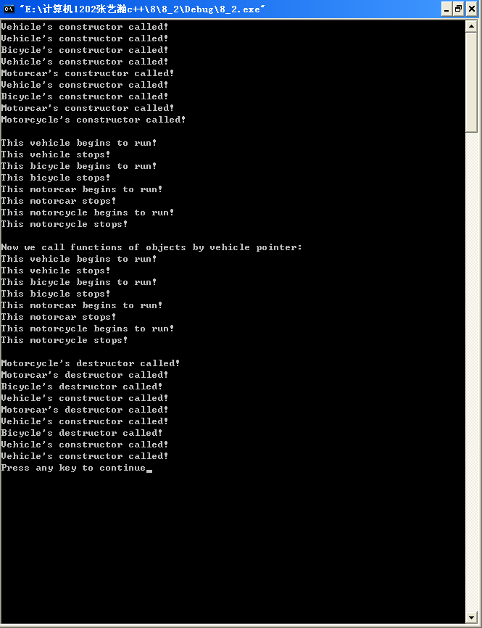
心得体会：
通过这次实验，我掌握了运算符重载的方法，并学习了使用虚函数实现动态多态性，达到了实验要求。

