Exploratory Data Analysis Report
Student Name: Hoang Gia Khanh Giap
Class Number: COS40007
Date: 02 October 2026
Dataset: House Prices - Advanced Regression Techniques (supplied train.csv)
Github Repository: https://github.com/Zephyrus000/COS40007

GenAI Declaration
I used OpenAI Codex to assist with commenting code, debugging, suggesting feature combinations, improving code readability, and structuring the exploratory analysis. All final code, interpretations, and conclusions are my own work after verification.

1. Dataset Overview
The supplied dataset contains residential sales from Ames, Iowa. Each row is one house sale, while the predictors describe site geometry, dwelling form, quality, age, floor and basement area, amenities, and sale conditions. These variables are relevant to building and property engineering because they represent capacity, condition, serviceability, and asset age.
Item | Result
Rows | 1,460
Columns | 81 total: 79 predictors, Id, and SalePrice
Target | SalePrice (integer, USD)
Primary problem | Regression
Supplemental classes | Four equal-frequency price bands using quartiles
Target summary | Mean $180,921; median $163,000; SD $79,443; range $34,900-$755,000

The four price bands use quartile boundaries at approximately $129,975, $163,000, and $214,000. Equal-frequency binning was selected because the target is right-skewed; equal-width bins would concentrate most houses in the lowest range. The resulting counts are 365 Entry, 367 Affordable, 366 Premium, and 362 Luxury properties.
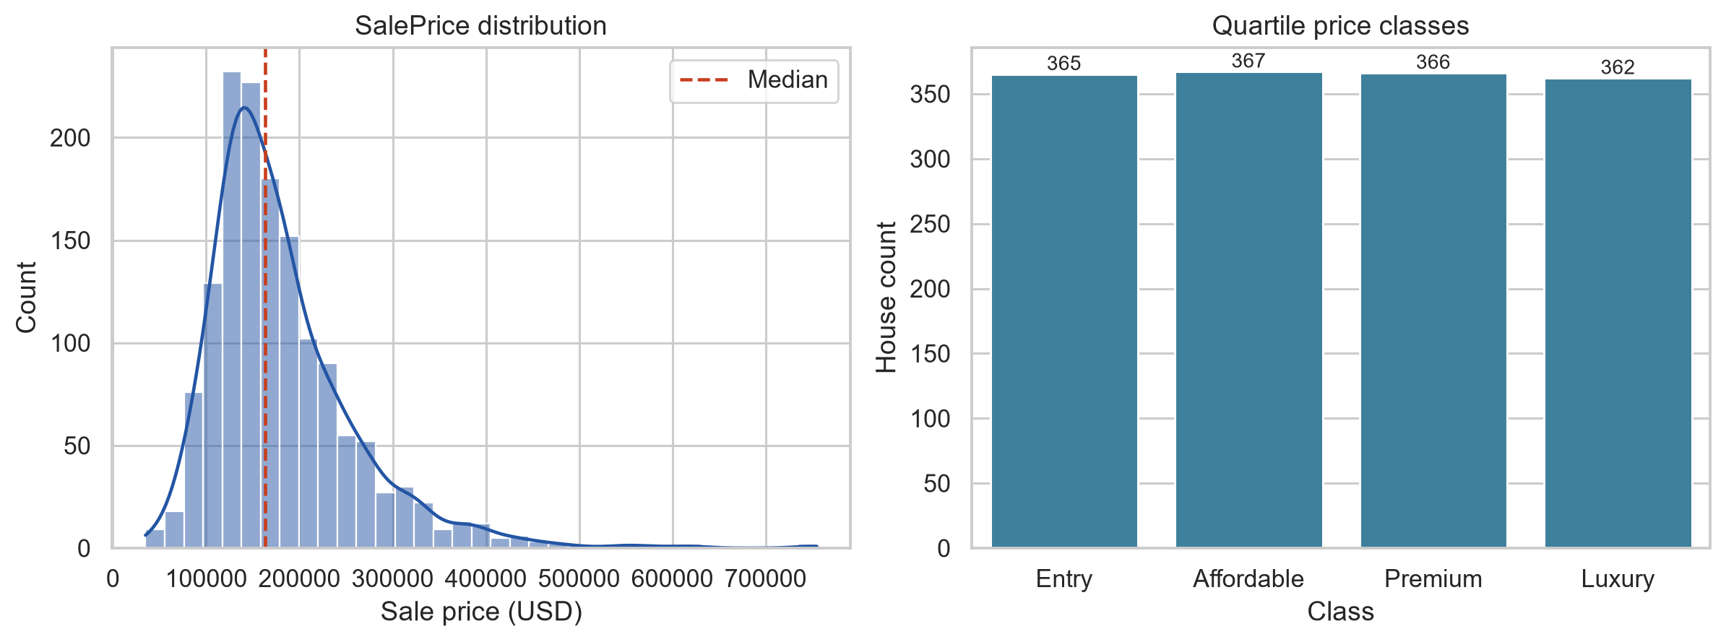
Figure 1. SalePrice is right-skewed, while quartile price bands are approximately balanced.

2. Data Quality Assessment
The dataset contains 7,829 missing cells (6.62%) across 19 columns. Missingness is concentrated in optional features. For example, a missing PoolQC, Alley, FireplaceQu, or Garage attribute frequently indicates that the physical feature is absent rather than that its value was lost.
Column | Missing | Percent
PoolQC | 1,453 | 99.52%
MiscFeature | 1,406 | 96.30%
Alley | 1,369 | 93.77%
Fence | 1,179 | 80.75%
MasVnrType | 872 | 59.73%
FireplaceQu | 690 | 47.26%
LotFrontage | 259 | 17.74%
GarageType | 81 | 5.55%
GarageYrBlt | 81 | 5.55%
GarageFinish | 81 | 5.55%

- Duplicates: 0 exact duplicates, including or excluding Id; no rows were removed.
- Outliers: the IQR rule flagged the most observations in EnclosedPorch (208), BsmtFinSF2 (167), and OverallCond (125). These variables are sparse or zero-inflated, so flags were retained instead of deleting valid houses.
- Two houses exceed 4,000 square feet of above-ground living area and have prices low relative to their size. They require sensitivity analysis because their unusual combination could reflect sale conditions, poor condition, location effects, or data error.
Preparation used semantics-aware imputation on a copy: structural absence categories were filled with None; missing masonry area and garage year were set to zero when the component was absent; LotFrontage used neighbourhood medians; remaining numeric and categorical gaps used median and mode values. This produced zero missing cells while retaining all 1,460 rows and leaving SalePrice unchanged.

3. Key Findings from Univariate Analysis
SalePrice, LotArea, GrLivArea, TotalBsmtSF, and 1stFlrSF are right-skewed because a small number of houses are much larger or more expensive than the majority. OverallQual is concentrated around ratings 5-7, GarageArea is comparatively symmetric, and YearBuilt has a long historical tail. Several amenity counts are zero-inflated because many properties do not contain the feature.
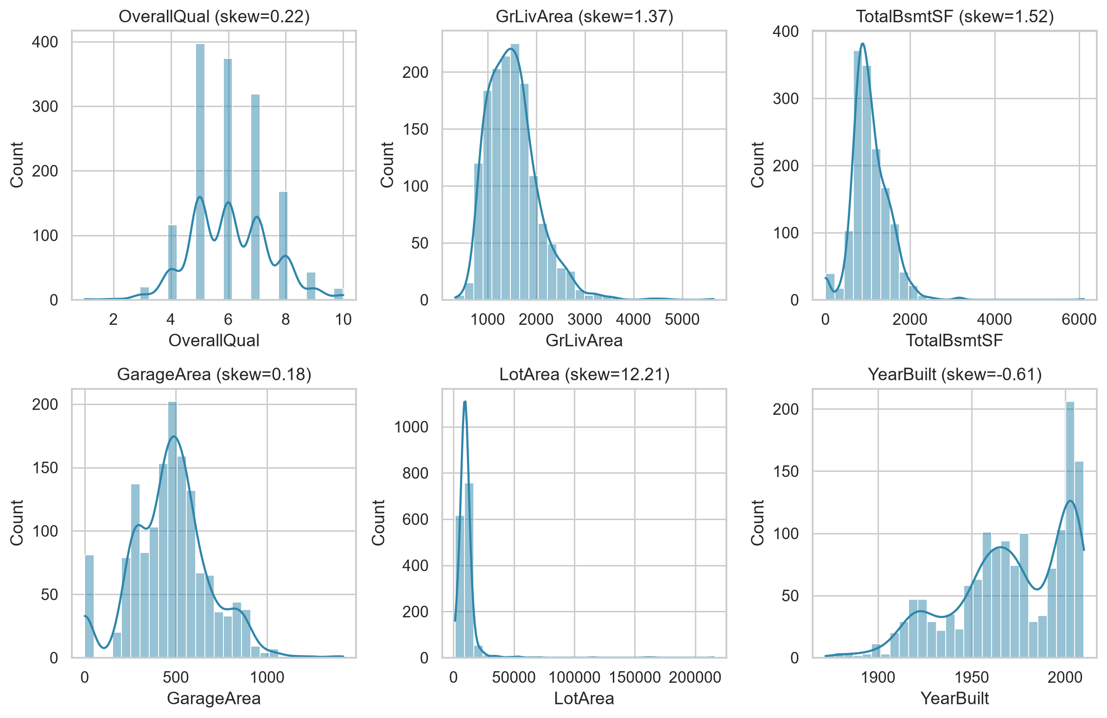
Figure 2. Six representative numerical predictor distributions; the notebook contains plots and summaries for all predictors.
Categorical predictors are also unevenly distributed. A small set of neighbourhoods, conventional house styles, and common sale conditions dominate, while rare levels contain limited evidence. A modelling pipeline should preserve these levels carefully and consider grouping only when supported by validation.

4. Key Findings from Multivariate Analysis
Feature | Correlation with SalePrice
OverallQual | 0.791
GrLivArea | 0.709
GarageCars | 0.640

OverallQual has the strongest linear association with sale price (0.791), followed by GrLivArea (0.709) and GarageCars (0.640). GarageArea (0.623), TotalBsmtSF (0.614), and 1stFlrSF (0.606) also show substantial positive relationships. Prices generally rise with quality and usable space, but the scatter widens for larger and higher-quality properties, indicating heteroscedasticity and interactions.
Predictor A | Predictor B | Absolute correlation
GarageCars | GarageArea | 0.882
YearBuilt | GarageYrBlt | 0.826
GrLivArea | TotRmsAbvGrd | 0.825
TotalBsmtSF | 1stFlrSF | 0.820

The strongest predictor-predictor relationship is between GarageCars and GarageArea (0.882). YearBuilt and GarageYrBlt (0.826), GrLivArea and TotRmsAbvGrd (0.825), and TotalBsmtSF and 1stFlrSF (0.820) also measure overlapping physical concepts. An unregularised linear model may therefore produce unstable coefficients unless redundant variables are combined or controlled.
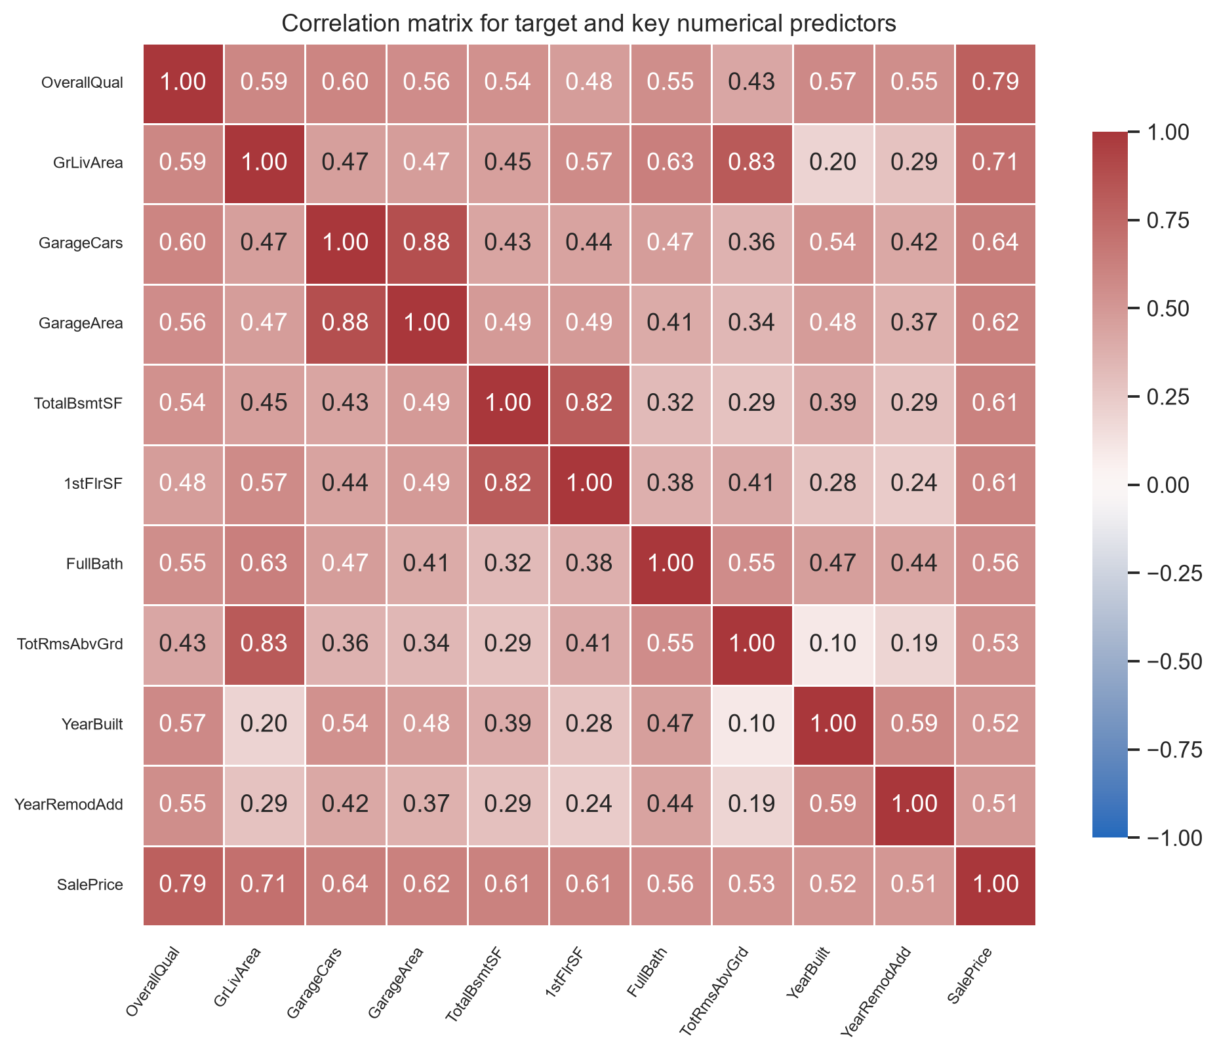
Figure 3. Focused Pearson correlation matrix for SalePrice and the ten strongest numerical predictors.

5. Initial Insights for Modelling
- Promising predictors: OverallQual, GrLivArea, GarageCars or GarageArea, TotalBsmtSF, 1stFlrSF, FullBath, YearBuilt, and YearRemodAdd.
- Preprocessing: semantic imputation, one-hot encoding for nominal categories, ordered encoding for quality ratings, and a log transformation of SalePrice.
- Scaling: necessary for regularised linear and distance-based models; not required for tree ensembles.
- Feature selection: avoid retaining every member of highly correlated measurement pairs without regularisation or engineering a representative composite.
- Candidate models: regularised linear regression as an interpretable baseline, followed by random forest and gradient boosting for nonlinearities and interactions.
All transformations should be fitted inside cross-validation folds to prevent leakage. RMSE and RMSLE are appropriate metrics, accompanied by residual analysis across price bands, neighbourhoods, and construction eras.

6. Engineering Interpretation
Quality, usable area, basement capacity, garage capacity, and age reflect physical capacity, condition, serviceability, and remaining asset life. Their positive correlations with price are therefore plausible. The correlations between garage spaces and area, room count and living area, basement and first-floor footprint, and house and garage construction year arise because paired variables describe the same subsystem.
The very large low-priced houses are unexpected if size is considered alone. Their prices may be reduced by poor condition, neighbourhood effects, atypical sale terms, or defects. This illustrates why a model must represent interactions rather than treating floor area as sufficient.
Potentially important missing features include renovation cost and scope, formal inspection results, energy performance, flood and hazard exposure, travel time, school accessibility, local market conditions at sale, and geospatial proximity to services or nuisances.

7. Challenges Encountered
- Distinguishing structural absence from unknown data before imputation.
- Handling mixed measurements, ordinal ratings, nominal categories, counts, and identifiers without applying one rule to every column.
- Interpreting IQR outliers in sparse amenities where unusual values may still be physically valid.
- Managing multicollinearity among measurements of the same building component.
- Assessing rare categories and extreme homes with limited comparable observations.
- Avoiding causal conclusions from correlation-only evidence.

8. Reflection Questions
Poor data quality can make a model unreliable by converting absence into an average feature, allowing outliers to dominate the loss, fragmenting equivalent categories, or leaking post-sale information. Controls should include traceable preprocessing, unseen-data validation, residual diagnostics, and sensitivity analysis for influential observations.
Historical prices may reflect unequal access to finance, amenities, infrastructure, and neighbourhood investment. Location can proxy for protected characteristics even when those characteristics are absent. If used in lending, taxation, insurance, or public investment, the model could reproduce historical inequity. Responsible use requires intended-use limits, subgroup and geographic error audits, human review, and clear separation between predicted market price and social value.

9. Next Steps
- Create a leakage-safe preprocessing pipeline with semantic imputation and appropriate categorical encoding, then audit errors by price band, neighbourhood, and construction period.
- Compare a regularised linear baseline with random forest and gradient boosting under repeated cross-validation.
- Evaluate log-transformed SalePrice and compare RMSE, RMSLE, and residual behaviour.
- Perform sensitivity analysis with and without the two extreme large-area sales, documenting the effect instead of deleting them by default.

10. GenAI Declaration
I used OpenAI Codex to assist with commenting code, debugging, suggesting feature combinations, improving code readability, and structuring the exploratory analysis. All final code, interpretations, and conclusions are my own work after verification.
The accompanying notebook contains the complete executable evidence: dataset loading, all outputs, missing-value analysis, boxplots for every numerical predictor, target preparation, univariate plots, full correlation heatmap, pairplot, preparation logic, and detailed interpretations.

