# Glossary

Pomodoro – A coupling of a Productivity Interval and an Activity Interval.

Productivity Interval – The first interval of a pomodoro which does not display an exercise. Takes up the majority of a pomodoro, idiomatically.

Activity Interval – The second interval of a pomodoro. Displays an exercise per the selected Activity Source.

Exercise – Describes a set of instruction and visual to appear in Activity Intervals.

Activity Source – Super-category, container for exercises.

Exercise Set – Unordered set of exercises. Provides a random exercise during Activity Intervals.

Workout – Order set of exercises. Exercises appear during Activity Intervals in the order which the Workout specifies.

Illo Configuration screen – Main settings page. Contains options for configuring the timer and Activity Sources.

Activity Sources screen – Displays the user’s Activity Sources. From here, a user may select an Activity Source to use for the timer, create new Activity Sources, or edit existing Activity Sources.

Activity Source Configuration screen – Configuration screen for a particular Activity Source. From here, the user may add exercises, remove exercises, reorder exercises, or rename the Activity Source.

|  |  |  |
| --- | --- | --- |
| Title: | Set Productivity Interval Duration | |
| **Description**: | This use case describes the process of setting the length of subsequent Productivity Intervals, as well as how invalid input is handled. | |
| **System Under Design:** | Illo | |
| **Primary Actor**: | Illo User | |
| **Participants**: |  | |
| **Goal**: | Configure the timer to use a particular Productivity Interval. | |
| **Following Use Cases**: | Restart timer | |
| **Invariant**: |  | |
| **Precondition**: | In Illo Configuration screen. | |
| **Success Postcondition**: | Subsequent pomodoros will use the specified Productivity Interval length | |
| **ACTOR**:  1. Actor selects the Productivity Interval length field.  3a. User attempts to enter an improperly formatted time duration (ex: 4:77).  3b. User enters properly formatted time duration.  3c. User exits configuration dialogue.  5a. User selects confirmation button (only possible if 4b is fulfilled).  5b. User exits configuration dialogue. | | **SYSTEM RESPONSE**:  0. Illo is in the configuration screen.  2. Illo presents configuration dialogue (TimePicker) with a keypad.  4a. Illo disables confirmation button.  Return to step 3.  4b. Illo enables confirmation button.  4b.1 Illo displays the new pomodoro length and current Activity Interval duration.  4c. Skip to step 7.  6a. Illo saves the value for Productivity Intervals.  6b. Skip to step 7.  7. Illo closes dialogue and returns to the Illo Configuration screen. |

|  |  |  |
| --- | --- | --- |
| Title: | Set Activity Interval Duration | |
| **Description**: | The use case describes the process of setting the length of subsequent Activity Intervals, as well as how invalid input is handled. | |
| **System Under Design:** | Illo | |
| **Primary Actor**: | Illo User | |
| **Participants**: |  | |
| **Goal**: | Configure the timer to use a particular activity interval. | |
| **Following Use Cases**: | Restart timer | |
| **Invariant**: |  | |
| **Precondition**: | In Illo Configuration screen. | |
| **Success Postcondition**: | Subsequent pomodoros will use the specified Activity Interval length | |
| **ACTOR**:  1. Actor selects the Activity Interval length field.  3a. User attempts to enter an improperly formatted time duration (ex: 4:77).  3b. User enters properly formatted time duration.  3c. User exits configuration dialogue.  5a. User selects confirmation button (only possible if 4b is fulfilled).  5b. User exits configuration dialogue. | | **SYSTEM RESPONSE**:  0. Illo is in the Illo Configuration screen.  2. Illo presents configuration dialogue (TimePicker) with a keypad.  4a. Illo disables confirmation button.  Return to step 3.  4b. Illo enables confirmation button.  4b.1 Illo displays the new pomodoro length and current Productivity Interval duration.  4c. Skip to step 7.  6a. Illo saves the value for Activity Intervals.  6b. Skip to step 7.  7. Illo closes dialogue and returns to the Illo Configuration screen. |

|  |  |  |
| --- | --- | --- |
| Title: | Set Activity Source | |
| **Description**: | This use case describes the process of setting the source of the exercises presented in subsequent activity intervals. | |
| **System Under Design:** | Illo | |
| **Primary Actor**: | Illo User | |
| **Participants**: |  | |
| **Goal**: | Change the source of exercises provided in future activity intervals | |
| **Following Use Cases**: | Restart timer | |
| **Invariant**: |  | |
| **Precondition**: | In Illo Configuration screen. | |
| **Success Postcondition**: | Subsequent Activity Intervals will present exercises from the selected Exercise Set/Workout. | |
| **ACTOR**:  1. Actor selects the Activity Source field.  3a. User selects an Activity Source.  3b. User exits screen.  5a. User selects confirm for selected Exercise Set.  5b. User selects cancel (in either case). | | **SYSTEM RESPONSE**:  0. Illo is in the Illo Configuration screen.  2. Illo presents the Activity Sources screen.  4a. Illo presents list of the exercises in selected Activity Source in order and show confirmation and cancellation buttons.  4b. Skip to step 7  6a. Illo saves the selected Activity Source, and sets the current Timer’s nextExercise() method to point to the next() method in the selected Activity Source.  6b. Illo exits confirmation menu. Return to step 2.  7. Illo closes dialogue and returns to the Illo Configuration screen. |

|  |  |  |
| --- | --- | --- |
| Title: | Restart Timer | |
| **Description**: | This use case describes the process starting the timer from the Illo Configuration screen. | |
| **System Under Design:** | Illo | |
| **Primary Actor**: | Illo User | |
| **Participants**: |  | |
| **Goal**: | Start a new loop of pomodoros with the currently set configurations. | |
| **Following Use Cases**: |  | |
| **Invariant**: |  | |
| **Precondition**: | In Illo Configuration screen. | |
| **Success Postcondition**: | The timer is restarted using the current configurations. | |
| **ACTOR**:  1. Actor selects the “Restart Timer” button.  3a. User selects “Confirm”.  3b. User cancels. | | **SYSTEM RESPONSE**:  0. Illo is in the Illo Configuration screen.  2. Illo presents a dialogue containing their current configurations and asks if they are sure that they would like to end the currently executing pomodoro. Confirmation and cancellation buttons are presented.  4a. Illo immediately ends the current pomodoro and restarts the timer at the specified productivity interval.  4b. Illo returns to the Illo Configuration screen.  5a. (This is the case where the user selected confirmation) Illo returns to the timer screen. |

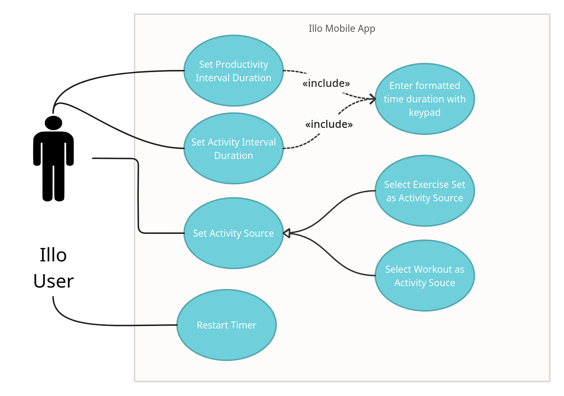  
*Diagram above shows a UML diagram for the above use cases.*

|  |  |  |
| --- | --- | --- |
| Title: | Make New Activity Source | |
| **Description**: | This use case describes the process of creating a new Activity Source (Workout or Exercise Set). | |
| **System Under Design:** | Illo | |
| **Primary Actor**: | Illo User | |
| **Participants**: |  | |
| **Goal**: | Create new Activity Source with the name and type specified by the user. | |
| **Following Use Cases**: | Edit Activity Source. | |
|  |  | |
| **Precondition**: | In Illo Configuration screen. | |
| **Success Postcondition**: | New Activity Source is created. | |
| **ACTOR**:  1. Actor selects the activity sources button.  3a. Actor selects the “+” button to add a source.  3b. Actor exits the Activity Sources Screen.  5a. Actor selects workout with a name filled.  5a.1 Actor selects workout without a name.  5b. Actor selects exercise set.  5b.1 Actor selects exercise set without a name.  5c. Actor cancels dialogue.  7a. Opens the “Edit Activity Source” Screen. See step 6a of use case **Edit Activity Source**  7b. Opens the “Edit Activity Source” Screen. See step 6a of use case **Edit Activity Source**.  8. User closes **Edit Activity Source** dialogue. | | **SYSTEM RESPONSE**:  0. Illo is in the Illo Configuration screen.  2. Illo opens the Activity Sources Screen, displaying the user’s activity sources.  4a. Illo prompts the actor if they would like to create a workout or exercise set and a field for a name.  4b. Illo returns to the configuration screen.  6a. Illo saves a new workout with the given name and prompts the actor to edit the new workout.  6a.1 Illo names the workout “New Workout *i”* where *i* is a number such that the name is unique, then proceed to step 6a.  6b. Illo saves a new workout with the given name and prompts the actor to edit the new exercise set.  6b.1 Illo names the workout “New Exercise Set *i”* where *i* is a number such that the name is unique, then proceed to step 6b.  6c. Proceed to step 9.  9. Illo returns to the Activity Sources screen. |

|  |  |  |
| --- | --- | --- |
| Title: | Edit Activity Source | |
| **Description**: | The use case describes accessing the “Edit Activity Source” Screen. | |
| **System Under Design:** | Illo | |
| **Primary Actor**: | Illo User | |
| **Participants**: |  | |
| **Goal**: | Manage the Exercises of a particular Activity Source. | |
| **Following Use Cases**: | Add Exercise to Activity Source, Remove Exercise from Activity Source, Rename Activity Source, Reorder Exercise in Workout. | |
| **Invariant**: |  | |
| **Precondition**: | In Illo Configuration screen or just created a new Activity Source. | |
| **Success Postcondition**: | The selected Activity Source is configured as the user wishes. | |
| **ACTOR**:  1. Actor selects the Activity Sources button.  3a. Actor selects the “Edit” button.  3b. Actor exits the Activity Sources Screen.  5a. Actor selects an Activity Source.  5b. Actor selects the “Cancel” button.  7. User edits Activity Source. See use cases Add Exercise to Activity Source, Remove Exercise from Activity Source, Rename Activity Source, and Reorder Exercise in Workout.  8. User closes Activity Source Configuration screen. | | **SYSTEM RESPONSE**:  0. Illo is in the Illo Configuration screen.  2. Illo opens the Activity Sources Screen, displaying the user’s activity sources.  4a. Illo toggles the “Edit” button to a “Cancel” button.  4b. Skip to step 9.  6a. Illo opens the Activity Source Configuration screen.  6b. Illo toggles the “Cancel” button to the “Edit” button. Return to step 2.  9. Illo saves changes to the Activity Source and returns to the Illo Configuration screen. |

whe

|  |  |  |
| --- | --- | --- |
| Title: | Add Exercise to Activity Source | |
| **Description**: | The use case describes adding an exercise to an activity source. | |
| **System Under Design:** | Illo | |
| **Primary Actor**: | Illo User | |
| **Participants**: |  | |
| **Goal**: | Add an Exercise to an Activity Source. | |
| **Following Use Cases**: | Add Exercise to Activity Source, Remove Exercise from Activity Source, Rename Activity Source, Reorder Exercise in Workout. | |
| **Invariant**: |  | |
| **Precondition**: | In Activity Source Configuration Screen. | |
| **Success Postcondition**: | The selected Activity Source contains the new exercise that the user selects. | |
| **ACTOR**:  1a. Actor selects the “plus” button.  1b. Actor exits the screen.  3a. Actor selects an exercise.  3b. Actor exits the dialogue. | | **SYSTEM RESPONSE**:  0. Illo is in the Activity Source Configuration screen for a particular Activity Source.  2a. Illo displays the exercises available to the actor.  2b. Illo returns to the Activity Sources screen.  4a. Illo appends the exercise to the end of the given Activity Source. Return to step 3.  4b. Illo returns to the Activity Source Configuration screen. |

whe

|  |  |  |
| --- | --- | --- |
| Title: | Remove Exercise from Activity Source | |
| **Description**: | The use case describes removing an exercise from an Activity Source. | |
| **System Under Design:** | Illo | |
| **Primary Actor**: | Illo User | |
| **Participants**: |  | |
| **Goal**: | Remove an Exercise from an Activity Source. | |
| **Following Use Cases**: | Add Exercise to Activity Source, Remove Exercise from Activity Source, Rename Activity Source, Reorder Exercise in Workout. | |
| **Invariant**: |  | |
| **Precondition**: | In Activity Source Configuration Screen. | |
| **Success Postcondition**: | The selected Activity Source no longer contains the specified exercise. | |
| **ACTOR**:  1a. Actor selects the “minus” button next to an existing exercise. .  1b. Actor exits the screen.  3a. Actor confirms.  3b. Actor cancels. | | **SYSTEM RESPONSE**:  0. Illo is in the Activity Source Configuration screen for a particular Activity Source.  2a. Illo asks for confirmation for removal of the exercise.  2b. Illo returns to the Activity Sources screen.  4a. Illo removes the selected exercise the Activity Source. Returns to the Activity Source Configuration screen.  4b. Illo returns to Activity Source Configuration screen. |

whe

|  |  |  |
| --- | --- | --- |
| Title: | Reorder Exercise in Activity Source | |
| **Description**: | The use case describes reordering an exercise in an Activity Source. | |
| **System Under Design:** | Illo | |
| **Primary Actor**: | Illo User | |
| **Participants**: |  | |
| **Goal**: | Reorder an Activity Source. | |
| **Following Use Cases**: | Add Exercise to Activity Source, Remove Exercise from Activity Source, Rename Activity Source, Reorder Exercise in Workout. | |
| **Invariant**: |  | |
| **Precondition**: | In Activity Source Configuration Screen. | |
| **Success Postcondition**: | The selected Activity Source has the new desired order. Note that this is entirely organizational in the case of an Exercise Set, but enforces order in the case of Workouts. | |
| **ACTOR**:  1a. Actor presses and holds an exercise.  1b. Actor exits the screen.  3a. Actor drops the exercise in between two exercises, at the start of the list of exercises, or at the end. | | **SYSTEM RESPONSE**:  0. Illo is in the Activity Source Configuration screen for a particular Activity Source.  2a. Illo moves the exercise with the press and hold gesture.  2b. Illo returns to the Activity Sources screen.  4a. Illo changes the index of the exercise to the new position within the Activity Source. Returns to the typical Activity Source Configuration screen. |

whe

|  |  |  |
| --- | --- | --- |
| Title: | Rename Exercise from Activity Source | |
| **Description**: | The use case describes renaming an activity source. | |
| **System Under Design:** | Illo | |
| **Primary Actor**: | Illo User | |
| **Participants**: |  | |
| **Goal**: | Remove an Exercise from an Activity Source. | |
| **Following Use Cases**: | Add Exercise to Activity Source, Remove Exercise from Activity Source, Rename Activity Source, Reorder Exercise in Workout. | |
| **Invariant**: |  | |
| **Precondition**: | In Activity Source Configuration Screen. | |
| **Success Postcondition**: | The selected Activity Source no longer contains the specified exercise. | |
| **ACTOR**:  1a. Actor selects name of the Activity Source.  1b. Actor exits the screen.  3a. Actor enters text and confirms.  3b. Actor cancels. | | **SYSTEM RESPONSE**:  0. Illo is in the Activity Source Configuration screen for a particular Activity Source.  2a. Illo prompts actor with a text entry field.  2b. Illo returns to the Activity Sources screen. End of branch.  4a. Illo renames the Activity Source to the entered text.  4b. Illo does not rename the Activity Source.  5. Illo returns to the Activity Source Configuration Screen. |

whe

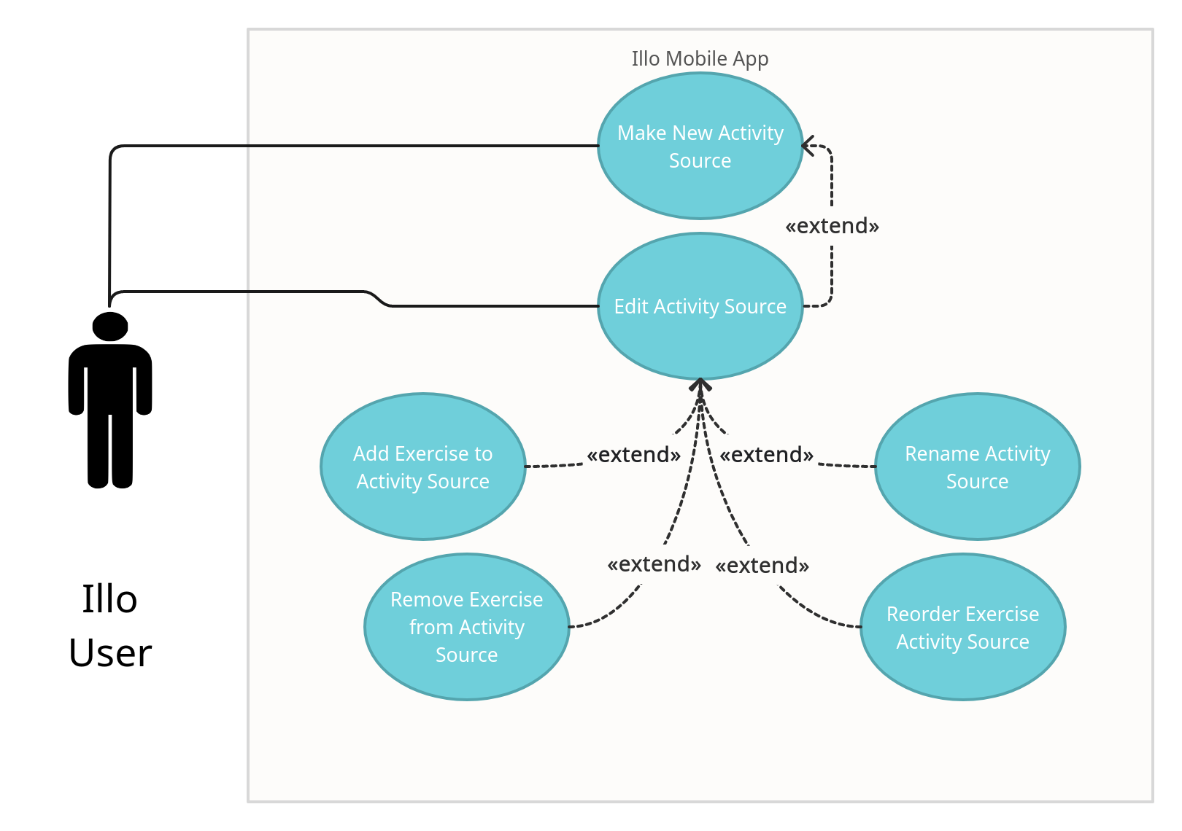

|  |  |
| --- | --- |
| **Title:** | **Access Permission Management** |
| **Description**: | This use case describes accessing the Permission Management Screen where the user may modify permissions. |
| **System Under Design:** | Illo |
| **Primary Actor**: | Illo User |
| **Participants**: |  |
| **Goal**: | Manage the permissions granted to the Illo application. |
| **Following Use Cases**: | Toggle Permission, Exit Permission Management |
| **Invariant**: |  |
| **Precondition**: | In Illo Settings screen. |
| **Success Postcondition**: | The user may view the permissions that are used by the Illo application. |

|  |  |
| --- | --- |
| **STEPS**:  1. Actor selects the Permissions button. | **SYSTEM RESPONSE**:  0. Illo is in the Settings Screen  2. Illo is in the Permission Management Screen, displaying a list of permissions the user may toggle. |

|  |  |
| --- | --- |
| **Title:** | **Toggle Permission** |
| **Description**: | The use case describes toggling a permission. |
| **System Under Design:** | Illo |
| **Primary Actor**: | Illo User |
| **Participants**: |  |
| **Goal**: | To toggle a permission. |
| **Following Use Cases**: |  |
| **Invariant**: |  |
| **Precondition**: | In Permission Management Screen. |
| **Success Postcondition**: | The permission toggled by the user has now been changed. |

|  |  |
| --- | --- |
| **STEPS**:  1a. Actor toggles an enabled permission.  1b. Actor toggles a disabled permission. | **SYSTEM RESPONSE**:  0. Illo is in the Permission Management Screen, displaying a list of permissions the user may toggle.  2a. Illo disables the selected permission.  Return to step 0.  2b. Illo enables the selected permission.  Return to step 0. |

|  |  |
| --- | --- |
| **Title:** | **Exit Permission Management** |
| **Description**: | This use case describes exiting the Permission Management Screen, returning to the Settings Screen |
| **System Under Design:** | Illo |
| **Primary Actor**: | Illo User |
| **Participants**: |  |
| **Goal**: | To exit the “Permission Management” Screen. |
| **Following Use Cases**: | Confirm Changes |
| **Invariant**: |  |
| **Precondition**: | In Permission Management Screen. |
| **Success Postcondition**: | In the Settings Screen. |

|  |  |
| --- | --- |
| **STEPS**:  1. Actor selects the “Exit” Button. | **SYSTEM RESPONSE**:  0. Illo is in the Permission Management Screen.  2a. Illo is in the Settings Screen.  2b. Illo displays a “Confirm Changes” pop-up. |

|  |  |
| --- | --- |
| **Title:** | **Confirm Permission Changes** |
| **Description**: | This use case describes exiting the Permission Management Screen, returning to the Settings Screen |
| **System Under Design:** | Illo |
| **Primary Actor**: | Illo User |
| **Participants**: |  |
| **Goal**: | To toggle a permission. |
| **Following Use Cases**: |  |
| **Invariant**: |  |
| **Precondition**: | In the Permission Management Screen with a “Confirm Changes” pop-up being displayed. |
| **Success Postcondition**: | In the Settings Screen. |

|  |  |
| --- | --- |
| **STEPS**:  1a. Actor selects the “Save Changes” Button.  1b. Actor selects the “Cancel Changes” Button. | **SYSTEM RESPONSE**:  0. Illo is displaying a “Confirm Changes” pop-up.  2a. Illo saves the permission changes and returns to the Settings Screen.  2b. Illo does not save the permission changes and returns to the Settings Screen. |

*Diagram above shows a UML diagram for the above use cases.*

|  |  |
| --- | --- |
| Title: | Return to Previous Interval |
| **Description**: | This use case describes the process of returning to the interval prior to the current one. |
| **System Under Design:** | Illo |
| **Primary Actor**: | Illo User |
| **Participants**: |  |
| **Goal**: | Load the workout interval that is prior to the one currently set. |
| **Following Use Cases**: |  |
| **Invariant**: |  |
| **Precondition**: | In the Timer Screen. |
| **Success Postcondition**: | The workout interval has been set to the one prior. |

|  |  |
| --- | --- |
| **ACTOR**:  1. Actor selects the “Reverse” button. | **SYSTEM RESPONSE**:  0. Illo is in the Timer Screen.  2. Illo loads the previous workout interval and displays the exercise associated with it at the top of the Timer Screen. |

|  |  |
| --- | --- |
| Title: | Start Interval Timer |
| **Description**: | This use case describes the process of starting the timer for the current interval. |
| **System Under Design:** | Illo |
| **Primary Actor**: | Illo User |
| **Participants**: |  |
| **Goal**: | Start the timer for the workout interval that is currently set. |
| **Following Use Cases**: | Pause Interval Timer. |
| **Invariant**: |  |
| **Precondition**: | In the Timer Screen. |
| **Success Postcondition**: | The interval timer has begun counting down. |

|  |  |
| --- | --- |
| **ACTOR**:  1. Actor selects the “Play” button. | **SYSTEM RESPONSE**:  0. Illo is in the Timer Screen.  2. Illo starts the current workout interval and displays the time counting down to zero. The “Play” button has been replaced by the “Pause” button. |

|  |  |
| --- | --- |
| Title: | Pause Interval Timer |
| **Description**: | This use case describes the process of pausing the timer for the current interval. |
| **System Under Design:** | Illo |
| **Primary Actor**: | Illo User |
| **Participants**: |  |
| **Goal**: | Pause the timer for the current workout interval. |
| **Following Use Cases**: |  |
| **Invariant**: |  |
| **Precondition**: | In the Timer Screen with the timer counting down. |
| **Success Postcondition**: | The interval timer has been paused. |

|  |  |
| --- | --- |
| **ACTOR**:  1. Actor selects the “Pause” button. | **SYSTEM RESPONSE**:  0. Illo is in the Timer Screen and the timer is counting down to zero.  2. Illo pauses the timer for the current interval and the “Pause” button has been replaced by the “Play” button. |

|  |  |
| --- | --- |
| Title: | Skip to Next Interval |
| **Description**: | This use case describes the process of skipping to the next workout interval. |
| **System Under Design:** | Illo |
| **Primary Actor**: | Illo User |
| **Participants**: |  |
| **Goal**: | Load the workout interval that is after the one currently set. |
| **Following Use Cases**: |  |
| **Invariant**: |  |
| **Precondition**: | In the Timer Screen. |
| **Success Postcondition**: | The current workout interval has been skipped and the next one is now displayed. |

|  |  |
| --- | --- |
| **ACTOR**:  1. Actor selects the “Skip” button. | **SYSTEM RESPONSE**:  0. Illo is in the Timer Screen.  2. Illo loads the next workout interval and displays the exercise associated with it at the top of the Timer Screen. |

|  |  |
| --- | --- |
| Title: | Display Interval Instructions |
| **Description**: | This use case describes the process of displaying the instructions associated with the current workout interval. |
| **System Under Design:** | Illo |
| **Primary Actor**: | Illo User |
| **Participants**: |  |
| **Goal**: | Display the instructions for the current workout interval. |
| **Following Use Cases**: |  |
| **Invariant**: |  |
| **Precondition**: | In the Timer Screen. |
| **Success Postcondition**: | Instructions are displayed to the user. |

|  |  |
| --- | --- |
| **ACTOR**:  1. Actor selects the “Instructions” button. | **SYSTEM RESPONSE**:  0. Illo is in the Timer Screen.  2. Illo displays a pop-up with the associated instructions for the current workout interval. |

*Diagram above shows a UML diagram for the above use cases.*