Timer Duration



The user can enter the desired time for the Activity interval. The Value is saved in User Data under the associated activity set data. This change is reported to the timer controller which resets the current timer and sets it to the applicable value meaning if the timer is in the same state as the changed interval type. The rest interval entered will only be saved to userdata, as it is not tied to a specific activity set. This change is reported to the timer controller which resets the current timer and sets it to the applicable value meaning if the timer is in the same state as the changed interval type.

Timer Usage



User can start the timer, which will validate with User Data for productivity interval, and validate for Activity interval, to be sure of the duration of the timer, then the timer will resume its valid time, or set to correct time and begin. User can pause the timer and it will stop the timer. User can press next and will start the next productive or activity interval, and validate the time and activity that is next up.

Design Sequence



The user can enter an integer value that corresponds to seconds. That value will set the activity duration in Set Data, a subclass of Userdata. The timer controller will reset after it receives the new activity duration. The user can enter an integer value that corresponds to seconds. This value will notify the timer controller which will reset after it receives the new productivity duration.

Permission Toggle

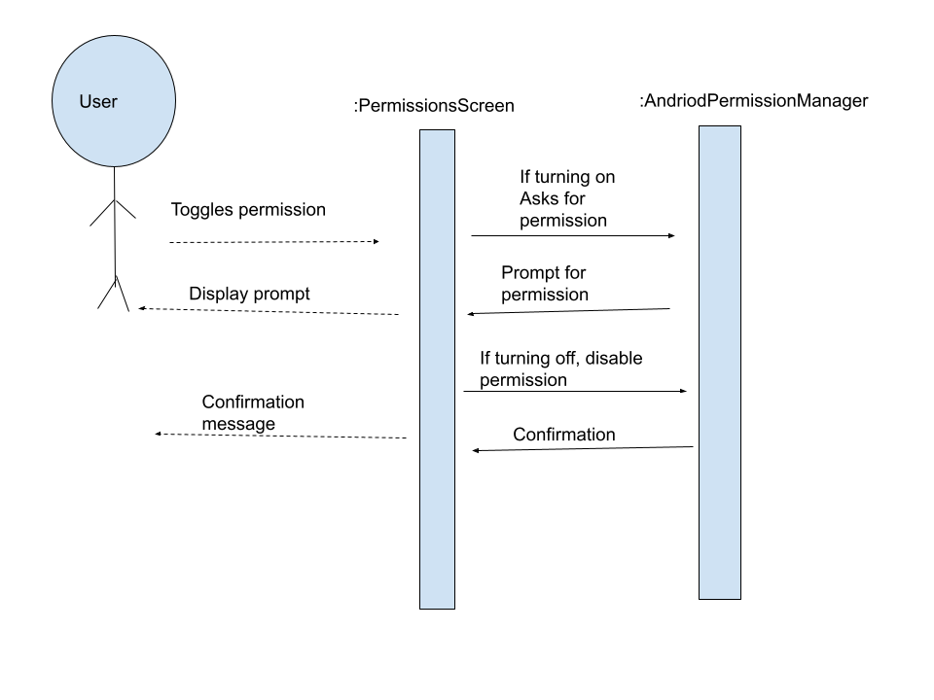

In this diagram, the user in on the permissions screen and clicks a toggle button to turn a permission off or on. We see that the input in the user clicking the toggle button, then it determines if the permission is being turned off or on. Depending on the answer, it asks the android permission manager to do different things. If turning on, it prompts the user to make sure they want to turn it on. If turning off, it simply disables the permission and returns confirmation.

Go to Permission Settings

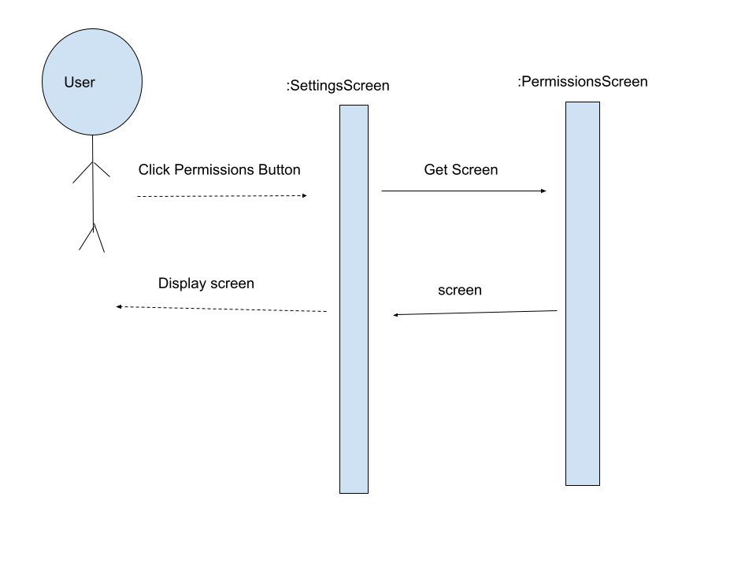

While on the settings screen, the user selects the Permission Settings button. Doing this will bring them to the Permissions screen gui. The app will have to generate the Permission Screen GUI object and display it.

Toggle permissions design sequence diagram

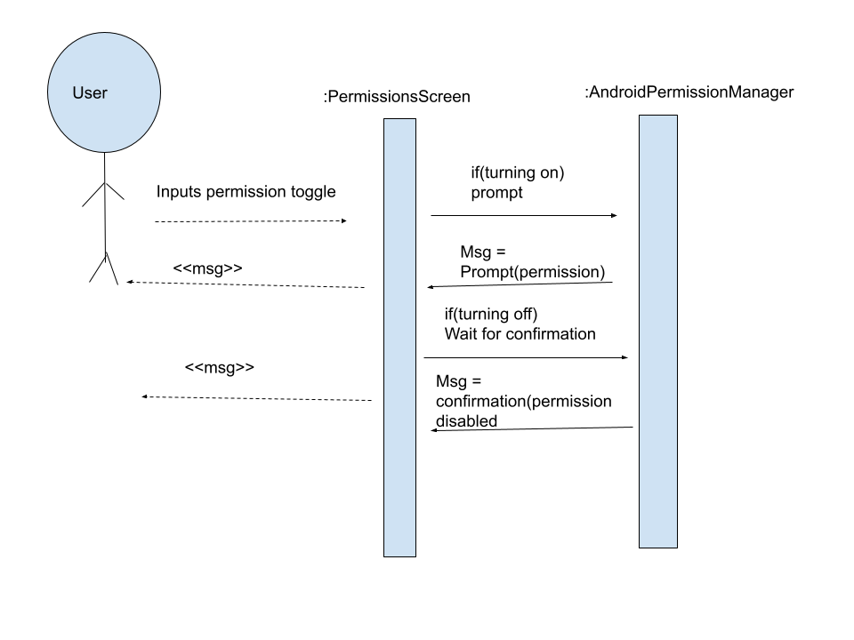

This is just a more technical view at the toggle permissions analysis diagram. The user is on the Permission Settings GUI and presses one of the permission toggle buttons. The app then checks if they’re turning the permission on or off, then acts accordingly. If its being turned on then it prompts the user for permission to turn it on. If it’s turning it off then it disables the permissions and returns confirmation that it has been turned off.

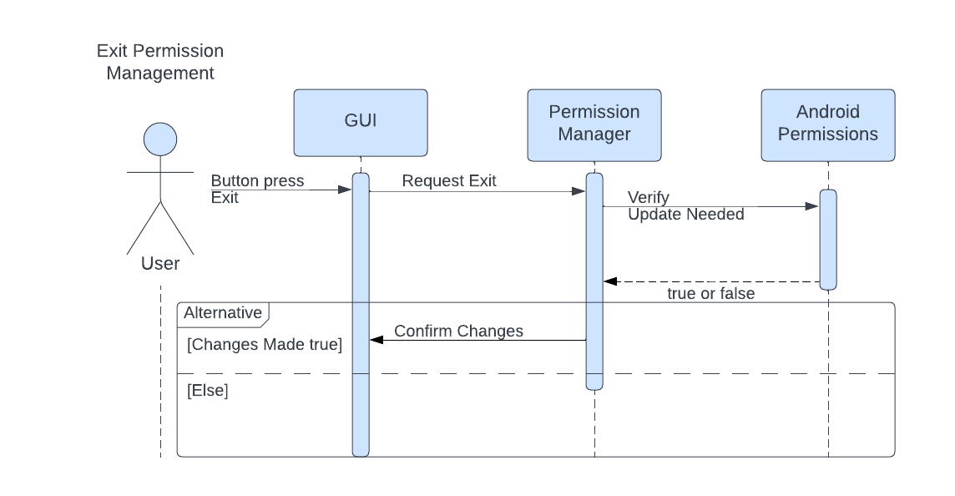

The user can press a button to exit from permission management. Once pressed by the user, the GUI sends a request to the Permission Manager to exit, this request is done to ensure that no other actions are required by the user before exiting. When the Permission Manager receives this requests it checks whether the user has made any changes by verifying current permissions with the saved Android permissions. If any are changed then Permission Manager will have the user confirm them. However, if none are changed then the Permission Manager will simply close out.

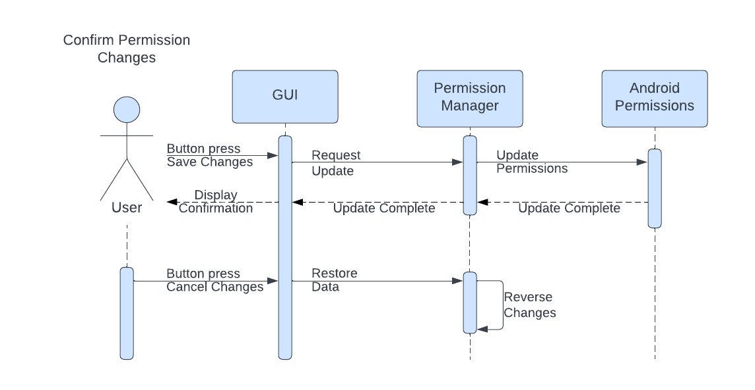

The user can press a button to save the changes made while in permission management. Once pressed by the user, the GUI sends the request to save the changes. Permission Manager receives this request and updates the saved Android Permissions. Once completed, a confirmation of the update being successfully is displayed to the user. The user can also press a button to cancel the changes they made. Once pressed by the user, the GUI sends a request to restore the permissions to their former state. When received by the Permission Manager, permissions are changed to reflect their initial state.

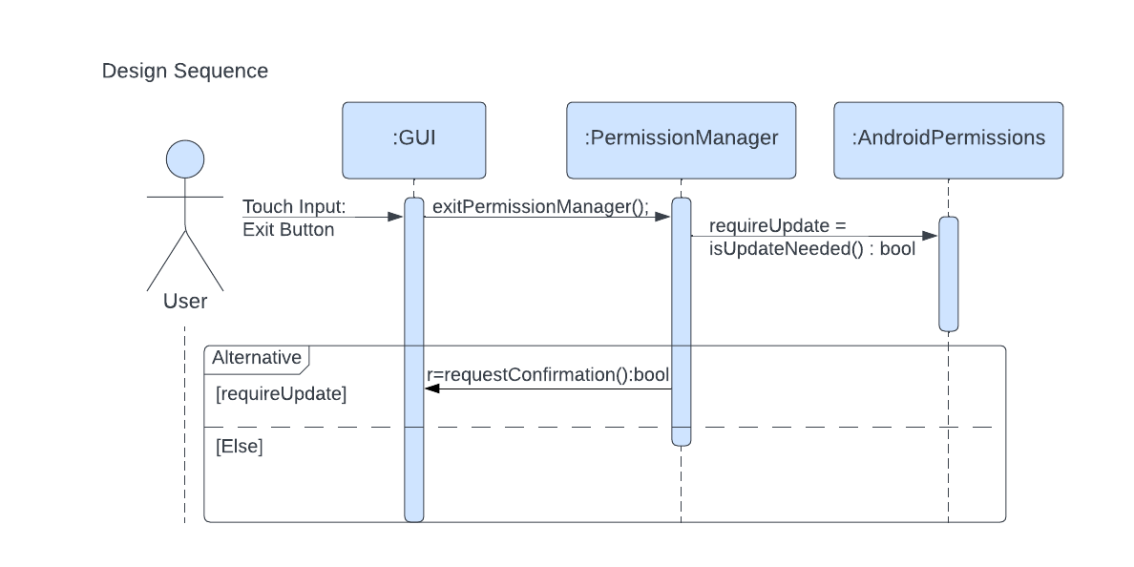

Through the GUI the user can provide touch input to call a function to exit from PermissionManager. This function will instruct PermissionManager to verify whether any changes were made and need to be reflected in AndroidPermissions. By using the isUpdateNeeded() function, a boolean value is returned and assigned to the ‘requireUpdate’ variable. If requireUpdate is true, PermissionManager will call a function that will begin the process of confirming whether or not the user would like to save their changes before exiting. Else, PermissionManager will simply exit.

Edit Activity Source

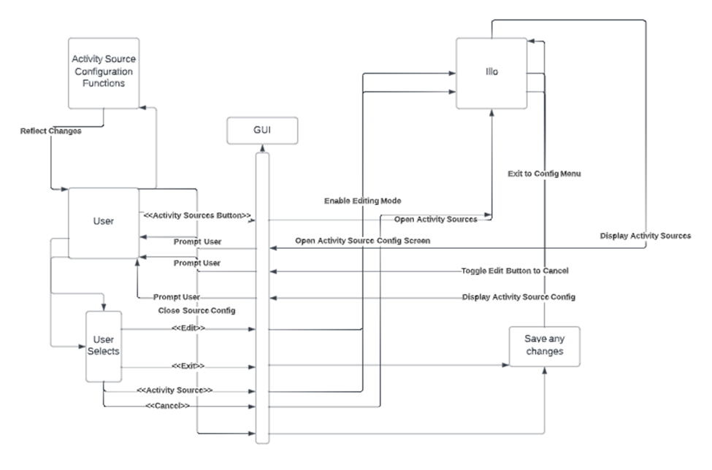

While Illo is on the Configuration Screen, the user may select the activity sources. The button press will be registered with the GUI and will alert the app of what to do. The system will open the Activity Sources Screen, and tell the GUI to display it. At this point, the user may choose to exit the screen, which will save the changes, and return to the Configuration Screen. Or, the user may select the “Edit” button. Selecting this button will toggle the edit button into a “Cancel” button. At this point, if it is pressed again, the button will be toggled back. But, if an activity source is selected, the Activity Source Configuration screen will be shown. Here, the user will be able to make various edits (covered by other use cases) to their Activity Source. Exiting the Activity Source Configuration will the changes to the activity source, and return the user to the Configuration Screen.

Remove Exercise from Activity Source

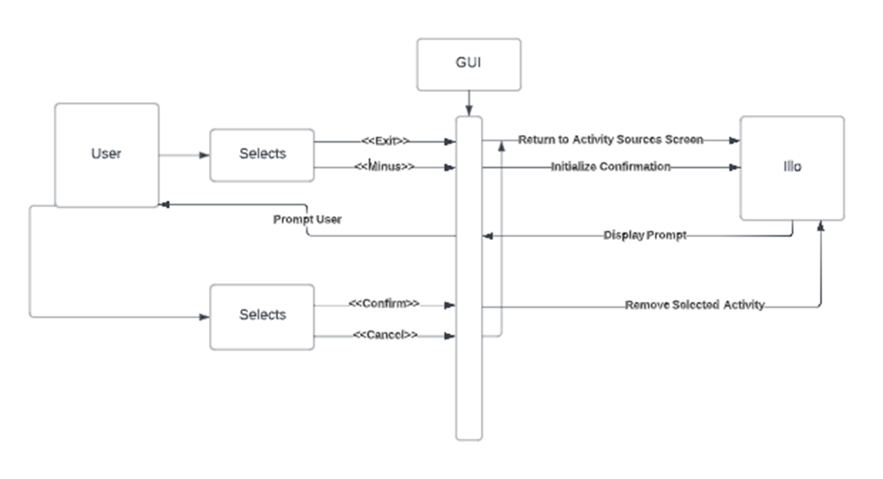

While Illo is in the Activity Source Configuration Screen, the user may select the “-“ button next to any existing exercise, otherwise, they may exit the screen. Exiting will return the user to the Activity Sources screen. However, if the minus is selected, the user will be prompted with a confirmation to remove the exercise. If this is confirmed, the exercise will be deleted, else, the user will be brought back to the Configuration Screen.

Design Sequence for above

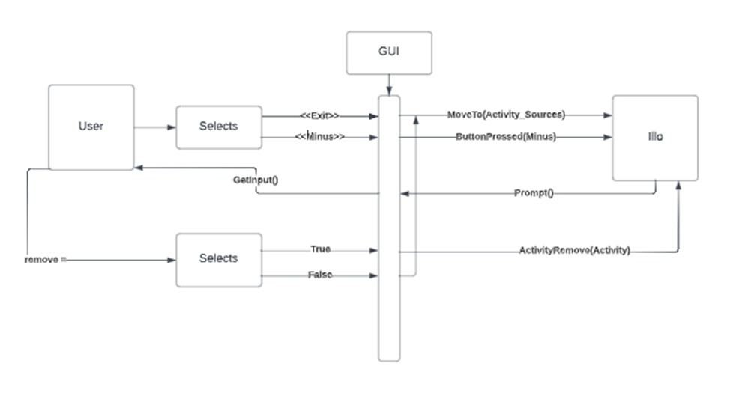

While Illo is in the Activity Source Configuration Screen, the user may interact with the “minus” button on the GUI corresponding to a specific exercise. Not doing so, and instead opting to leave the screen via various methods will return the user to the previous screen (Activity Sources Screen). Choosing to interact with this UI object will prompt the user with a confirmation window, their choice will be reported to the GUI, which will report it as either true or false to the system. If the answer is false, the user will be brought back to the configuration screen, otherwise, the exercise object selected will be removed from the Activity Source’s data structure.

**Use Case: Set Activity Source**

*Analysis Description*

| # | Subject | Subject Action | Parameters | Object Acted Upon |
| --- | --- | --- | --- | --- |
| 1 | User | selects | Activity Source field | Illo GUI |
| 2.1 | Illo GUI | retrieves | Activity Sources | Local DB Manager |
| 2.2 | Illo GUI | presents | User’s Activity Sources | User |
| 3 | User | selects | an ActivitySource | Illo GUI |
| 4.1 | Illo GUI | retrieves | Exercises[] from given Activity Source | Local DB Manager |
| 4.2 | Illo GUI | presents | Exercises[], confirm/cancel buttons | User |
| 5 | User | confirms | ActivitySource | Illo GUI |
| 6.1 | Illo GUI | retrieves | next() method from ActivitySource | Local DB Manager |
| 6.2 | Illo GUI | sets | The timer’s nextExercise() method to the retrieved next() method | Timer |
| 6.3 | Illo GUI | sends | Timer Configuration Screen | User |

Analysis Sequence for Above

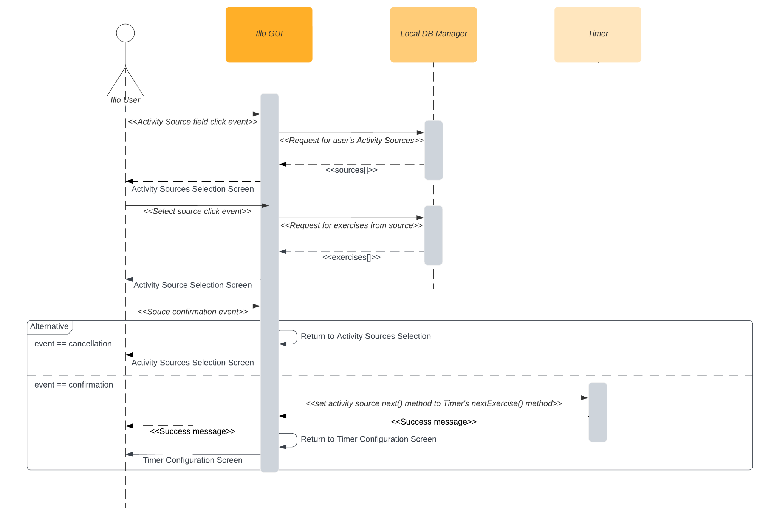

*Design Sequence Description*

| # | Subject | Subject Action | Parameters | Object Acted Upon |
| --- | --- | --- | --- | --- |
| 1 | User | *onClick()* | activitySourceField | Illo GUI |
| 2.1 | Illo GUI | *requestSources* |  | Local DB Manager |
| 2.2 | Illo GUI | renders | as: Activity Sources | User |
| 3 | User | *onClick()* | *as* | Illo GUI |
| 4.1 | Illo GUI | *exercises* |  | Local DB Manager |
| 4.2 | Illo GUI | presents | *exercises* | User |
| 5 | User | *onClick()* | Confirmation event | Illo GUI |
| 6.1 | Illo GUI | *setNext()* | *as.next()* | Timer |
| 6.2 | Illo GUI | sends user to | *t.configScreen()* | User |

Design Sequence for Above

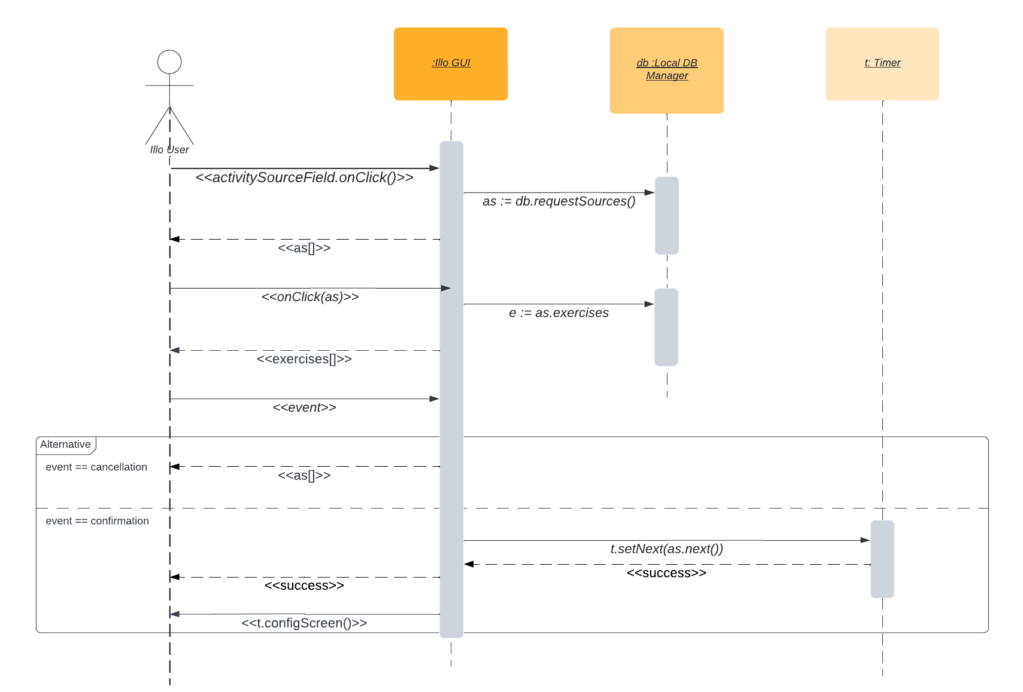

**Use Case: Make New Activity Source**

*Description*

| # | Subject | Subject Action | Parameters | Object Acted Upon |
| --- | --- | --- | --- | --- |
| 5 | User | enters | *Activity source name, activity source type (*Exercise set | Workout) | Illo GUI |
| 6.1 | Illo GUI | saves | new ActivitySource(*name, type)* | Illo Local DB |
| 6.2 | Illo GUI | generates | Edit-Exercises-Screen for new ActivitySource() |  |
| 6.3 | Illo GUI | presents | Success message for creation of new ActivitySource() | User |
| 6.4 | Illo GUI | sends to | To new edit screen for the activity source | User |
| The expected, but not necessary, behavior is that the user proceeds to edit the new Activity Source. See the **Edit Activity Source** use case. | | | | |

Analysis Sequence for Above

