Tests and Test Plan for Illo

# Test Cases

# Use Case Testing

# Written Test 1

**Title: Confirm Permission Changes**

Actors: User

Requirements: Illo is in Permission Management

Main Scenario:

1. User selects “Save Changes” Button

2. Illo Saves the permission changes and returns to the Settings screen

Alternatives:

1a. User selects the “Cancel Changes” Button

1a1. Illo does not save the permission changes and returns to the Settings Screen

# Written Test 2

**Title: Start Internal Timer**

Actors: User

Requirements: Illo is on the Timer Screen

Main Scenario:

1. User selects the “Play” button.

2. Illo starts the current workout interval.

3. Play Button is Replaced with a Pause button.

# Written Test 3

**Title: Exit Permission Management**

Actors: User

Requirements: Illo is in Permission Management

Main Scenario:

1. User Selects the “Exit” Button.

2. Illo returns to the Setting Screen

Alternatives:

1a. User has unsaved changes

1a1. Illo displays a “Confirm Changes” popup.

# Written Test 4

**Title: Toggle Permission**

Actors: User

Requirements: Illo is in Permission Management

Main Scenario:

1. User toggles an enabled permission

2. Illo disables the selected permission

Alternatives:

1a. User toggles a disabled permission

1a1. Illo enables the selected permission

# Written Test 5

**Title: Rename Exercise from Activity Source**

Actors: User  
Requirements: Illo is in the Activity Source Configuration Screen

Main Scenario

1. User selects name of the Activity Source

2. Illo prompts the user to enter text

3. User enters text and confirms

4. Illo renames the Activity Source to the text entered

5. Illo returns to the Activity Source Configuration Screen

Alternatives:

1a. User exits the screen

1a1. Illo returns to the Activity Sources screen

3a. User cancels

3a1. Illo does not rename the Activity Source

# Written Test 6

**Title: Set Activity Source**

Actors: User

Requirements: Illo is in the Configuration Screen

Main Scenario:

1. User selects the Activity Source field

2. Illo swaps to Activity Sources screen

3. User selects an Activity Source

4. Illo presents list of exercises in selected Activity Source

5. User selects confirm for selected Exercise Set

6. Illo saves the selected Activity Source, and sets the timer’s nextExercise() method to point to thenext() method in the Activity Source

7. Illo closes dialogue and returns to the Illo Configuration Screen

Alternatives

3a. User exits screen

3a1. Illo returns to the Configuration Screen

5a. User selects cancel

5a1. Illo exits the confirmation menu, returning to the Activity Sources screen.

# Unit Testing

# ActivitySource.addExercise() Test

@Testpublic void testAddExercise(){ *testAS*.addExercise(new Exercise("Exercise"+*TEST_SIZE*, null, null)); *assertTrue*("Add Exercise "+*TEST_SIZE*, *testAS*.exerciseBank.containsKey("Exercise"+*TEST_SIZE*)); // repeat names *testAS*.addExercise(new Exercise("Exercise"+*TEST_SIZE*, null, null)); *assertTrue*("Add Exercise "+*TEST_SIZE*+"_1", *testAS*.exerciseBank.containsKey("Exercise"+*TEST_SIZE*+"_1")); *testAS*.addExercise(new Exercise("Exercise"+*TEST_SIZE*, null, null)); *assertTrue*("Add Exercise "+*TEST_SIZE*+"_2", *testAS*.exerciseBank.containsKey("Exercise"+*TEST_SIZE*+"_2"));}

# **Class, Method**: ActivitySource, addExercise() **Description**: Tests the ability to add Exercises to an ActivitySource. Also checks the edge case of adding Exercises with names that are already contained by the ActivitySource. The goal is to ensure both that users may be able to add Exercises to their own ActivitySources and that Illo may build the default ActivitySources (“Freeweight Exercises”, “Muscular Stretches”, and “Hand Stretches”) at startup.

|  |  |
| --- | --- |
| **Test Inputs** | **Expected Outcome** |
| Add an Exercise to an AS | Exercise is in AS and accessible by key |
| Add an Exercise to an AS which already contains an Exercise of the same name | Exercise is in AS, but has a key of its name appended with “_i”, where ‘i’ is the number of Exercises with repeat keys in the AS. |

# ActivitySource.removeExercise() Test

@Testpublic void testRemoveExercise(){ *testAS*.removeExercise("Exercise0"); *assertFalse*("Remove Exercise0", *testAS*.exerciseBank.containsKey("Exercise0")); int currentSize = *testAS*.size(); *testAS*.removeExercise("Exercise0"); *assertEquals*(currentSize, *testAS*.size()); // size shouldnt change. // reset *testAS*.addExercise(new Exercise("Exercise0", null, null)); *testAS*.reorderExercise("Exercise0", 0);}

# **Class, Method**: ActivitySource, removeExercise() **Description**: Tests the ability to remove Exercises from an ActivitySource. Also checks the edge case of removing Exercises that are not present in the ActivitySource. The goal is to ensure that users are (eventually) able to edit their ActivitySources by removing undesired Exercises.

|  |  |
| --- | --- |
| **Test Inputs** | **Expected Outcome** |
| Remove an Exercise from an AS that is contained by the AS | Exercise is removed from the AS |
| Remove an Exercise an AS that is not contained by the AS | No Exercise is removed from the AS (checked by the size). |

# ActivitySource.reorderExercise() Test

@Testpublic void testReorder(){ ArrayList<Exercise> al = new ArrayList<>(); for(String k : *testAS*.exerciseBank.keySet()){ al.add(*testAS*.exerciseBank.get(k)); } Exercise popped = al.remove(10); al.add(0, popped); *testAS*.reorderExercise("Exercise10", 0); // check order int al_index = 0; for(String k : *testAS*.exerciseBank.keySet()){ *assertEquals*(al.get(al_index), *testAS*.exerciseBank.get(k)); al_index++; } // check move from beginning of AS to middle popped = al.remove(0); al.add(10, popped); *testAS*.reorderExercise("Exercise10", 10); al_index = 0; for(String k : *testAS*.exerciseBank.keySet()){ *assertEquals*(al.get(al_index), *testAS*.exerciseBank.get(k)); al_index++; } // check move to index outside of list (append to end) popped = al.remove(15); al.add(popped); *testAS*.reorderExercise("Exercise15", *TEST_SIZE*+20); al_index = 0; for(String k : *testAS*.exerciseBank.keySet()){ *assertEquals*(al.get(al_index), *testAS*.exerciseBank.get(k)); al_index++; } // check move from end of list to middle popped = al.remove(al.size()-1); al.add(15, popped); *testAS*.reorderExercise("Exercise15", 15); al_index = 0; for(String k : *testAS*.exerciseBank.keySet()){ *assertEquals*(al.get(al_index), *testAS*.exerciseBank.get(k)); al_index++; } // check move to same index *testAS*.reorderExercise("Exercise15", 15); al_index = 0; for(String k : *testAS*.exerciseBank.keySet()){ *assertEquals*(al.get(al_index), *testAS*.exerciseBank.get(k)); al_index++; }}

# **Class, Method**: ActivitySource, reorderExercise() **Description**: Tests the ability to shift an Exercise from one position in an AS to a new one. Other elements should shift around them. That objects at an equal to or greater index all shift up by one to make room for the moved Exercise. An ArrayList mirrors the desired behavior well – so that is what we test against. We also handle edge cases – indices outside of the “legal” range. Our goal is to allow great customization of ActivitySources, particularly Workouts. Workouts have a consistent order every usage, so being able to reorder the Exercises is critical to the UX. Users may also want to organize their other ActivitySources in particular ways, for organizational purposes.

|  |  |
| --- | --- |
| **Test Inputs** | **Expected Outcome** |
| Change an Exercise’s order | Exercise’s order is shifted in the AS. That is, if the AS is a Workout, this is the position in the order that the specified Exercise will appear. The other elements shift order around the moved Exercise. |
| Move an Exercise from the beginning/end of the AS to the middle | Edge case. Should behave as specified above |
| Move an Exercise to a negative index | Exercise gets moved to the first index of the AS |
| Move an Exercise to an index greater than the number of Exercises present. | Exercise gets moved to the last index of the AS |

The above three tests are all contained in **ActivitySourceTests** in the test directory of the Android Studio project. Running these tests with Android Studio’s “Run” tab gives the following output when passed (check the bottom left).

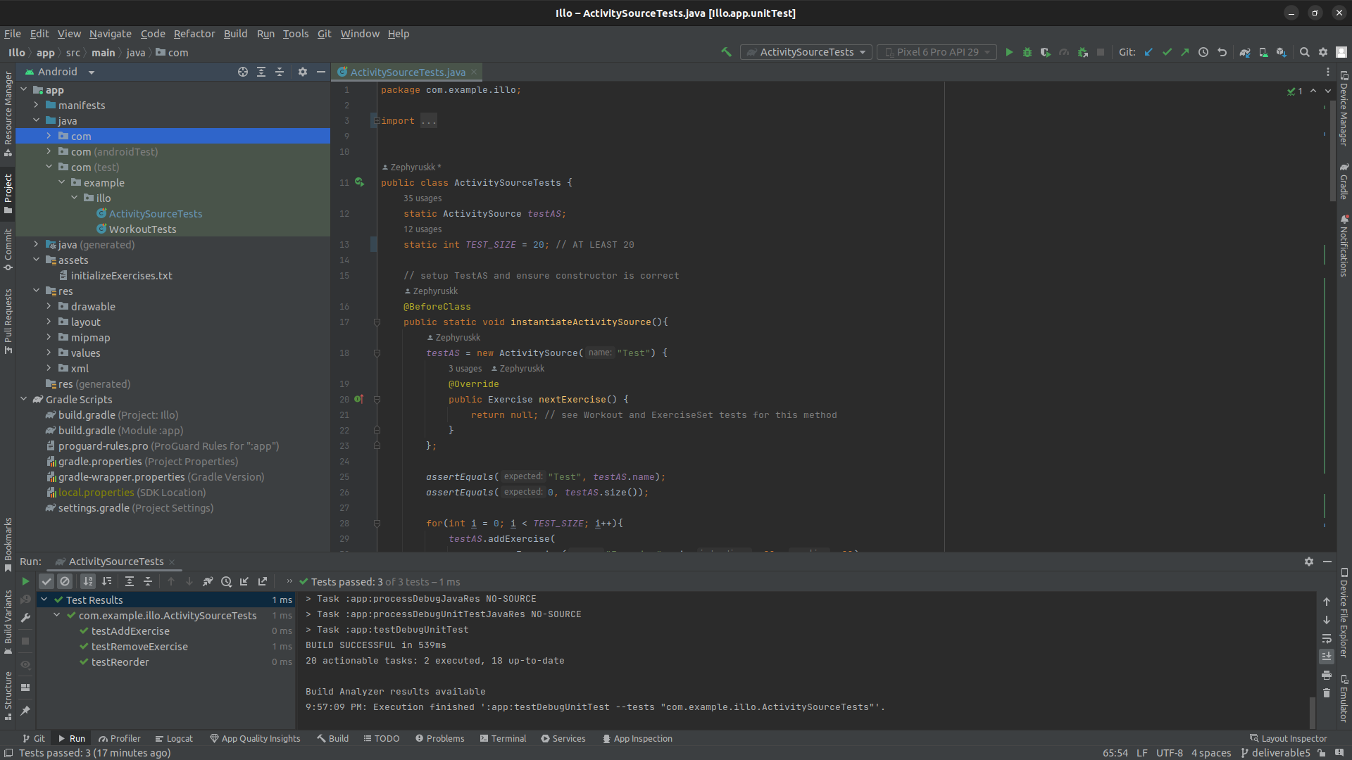

# Workout.incrementAtIndex() Test

# **Class, Method**: Workout, incrementAtIndex() **Description**: The design of Workouts is bases on the idea of order. Ensuring that that order is maintained properly is paramount. The goal of this test is to ensure that Workouts are always at the correct index – “atIndex”. Particularly, that when atIndex comes to exceed the size of the Workout, it wraps back to the beginning of the Workout here. incrementAtIndex() has parameter overrides. It can take no arguments and increment by 1, or take an int argument and increment by that many. The version with no arguments calls the single-argument version. They are tested together here.

@Testpublic void testIncrementAtIndex(){ int s = *testWO*.size(); int current = *testWO*.getAtIndex(); *testWO*.incrementAtIndex(-1); *assertEquals*(current, *testWO*.getAtIndex()); for(int i = 0; i<10; i++){ *testWO*.incrementAtIndex(); } *assertEquals*((current+10)%s, *testWO*.getAtIndex()); int big_change = (int) Math.*floor*(*TEST_SIZE*\*111.25); *testWO*.incrementAtIndex(big_change); *assertEquals*((current+10+big_change)%s, *testWO*.getAtIndex()); *testWO*.setAtIndex(0); *testWO*.incrementAtIndex(s); *assertEquals*(0, *testWO*.getAtIndex());}

|  |  |
| --- | --- |
| **Test Inputs** | **Expected Outcome** |
| Increment atIndex by 10 | At index should now be 10 more than it was before. Or, if this exceeds the size of the Workout, it should be original atIndex plus the change mod the size of the Workout. |
| Increment by a negative number | Edge case. atIndex does not change. |
| Increment by a number many times larger than the size of the | atIndex should wrap as expected. atIndex should become the original atIndex + the big change mod the size of the Workout. |
| Increment by the size of the Workout. | atIndex should stay the same. |

# Workout.nextExercise() Test

# **Class, Method**: Workout, nextExercise() **Description**: The design of Workouts is bases on the idea of order. Ensuring that that order is maintained properly is paramount. No matter how many times a Workout is looped through, it should produce the same order. That is, each Exercise should always correspond to a particular index or number. For this test, the order is inferred via the construction of the test Workout. Check the @BeforeClass instantiation in WorkoutTests.java to see more.

@Testpublic void testNextExercise(){ int s = *testWO*.size(); // loop throgh entire Workout for(int i = 0; i < s; i++){ *assertEquals*("Exercise"+i, *testWO*.nextExercise().getName()); } // loop many times (check for off by ones etc) for(int i = 0; i < s*20; i++){ *assertEquals*("Exercise"+i%20, *testWO*.nextExercise().getName()); } // check on single case *assertEquals*("Exercise0", *testWO*.nextExercise().getName()); // reset *testWO*.setAtIndex(0);}

|  |  |
| --- | --- |
| **Test Inputs** | **Expected Outcome** |
| Traverse the Workout step by step | Each Exercise should be in the order it appears in AS |
| Traverse the Workout many times | Still, order is maintained. When a Workout has been traversed, it returns to the zero’th index. |
| Traverse the Workout just once, from position i. | The Exercise at i should be returned. |

The above three tests are all contained in **WorkoutTests** in the test directory of the Android Studio project. Running these tests with Android Studio’s “Run” tab gives the following output when passed (check the bottom left), shown on the next page.

# 

# Alarm Activates

|  |  |
| --- | --- |
| Test Inputs | Expected Outcome |
| Timer Running | No Alarm |
| Timer Hits 0 and resets | Alarm runs once then stops |
| Timer is 0 | Alarm runs once then stops |

This test will make sure that the sound alarm will not interfere with the user’s manual input of timer duration.

To create this test:

1. separate test timer with varying lengths, (100sec, 10sec, 0sec)

2. Assertions that the alarm plays when the timer hits 0,

3. Assertion the alarm does not continue to run after once.

# Written Test 2

# Written Test 3

# Written Test 4

# Written Test 5