ILLO

DOMAIN MODEL

Root Digital

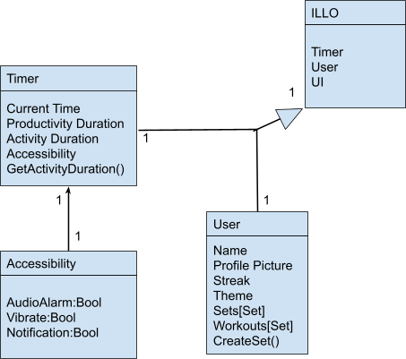

This model represents the overview of the application. ILLO is the superclass where the UI exists and can pull from all other classes. The Timer class takes care of the pomodoro timer, keeping track of the current state and time, and can if allowed by the Accessibility class notify the user through audio vibration or notification. The User class keeps track of all of the users data, their name and personalized theme and picture. The user class also maintains the users personalized workouts and sets. The User class can also create sets to their liking.

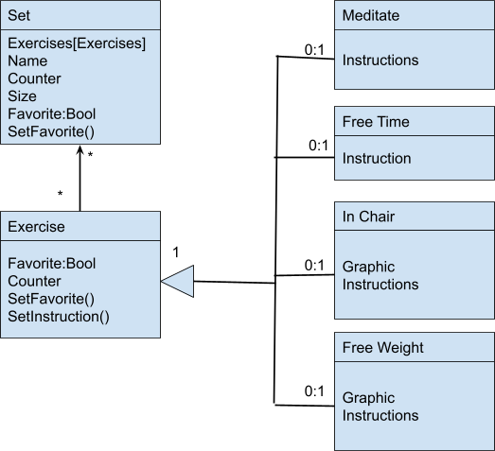

The Set class is directly connected to the user class. It has The ability to track and maintain a list of exercises. It also keeps track of how many times it's used by the user and how large each set of exercises are. The exercise class has four different types; Meditate, Free Time, In Chair and Free Weight. These types have different attributes, of graphics and instructions and how they are performed. They are kept separate for the user to more easily select from what they want to do. The Exercise class also keeps track of how many times each exercise has been completed, if it has been favorited, and can changed the instructions to be more clear to the user.