1. **Network Reconfiguration**: Update the network using the Network Layout Table in the Project Three Network Reconfiguration Specifications spreadsheet. Include screenshots of the following:
   1. **Network diagram**
   2. **Port assignment and VLAN** **assignment**for each switch

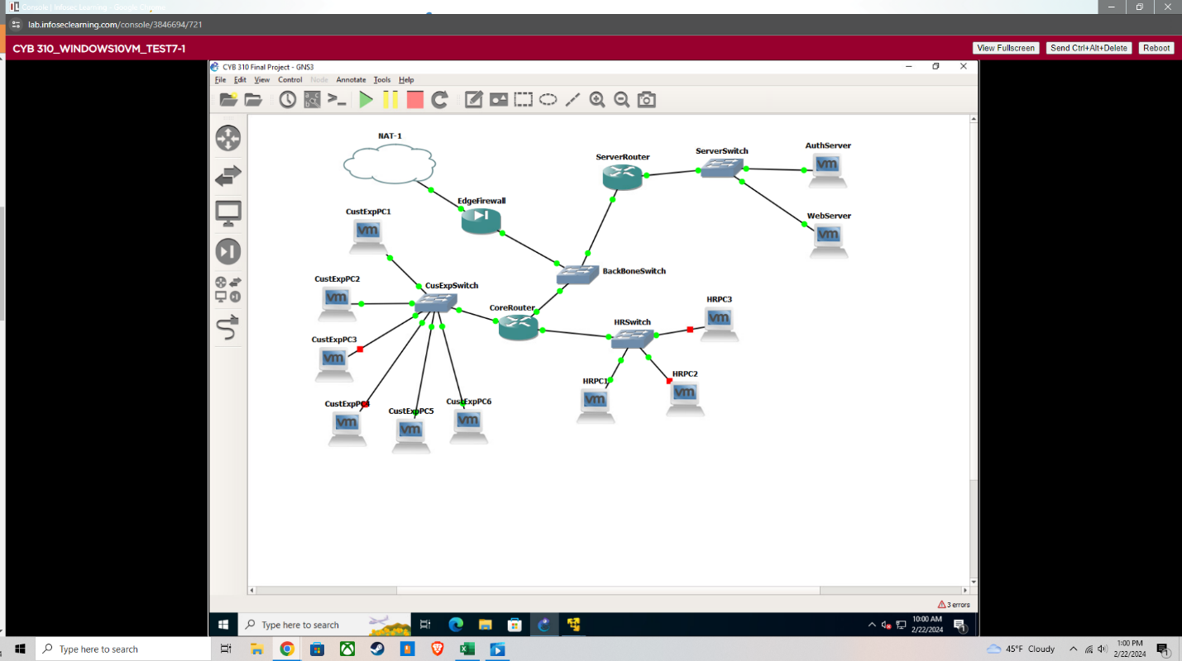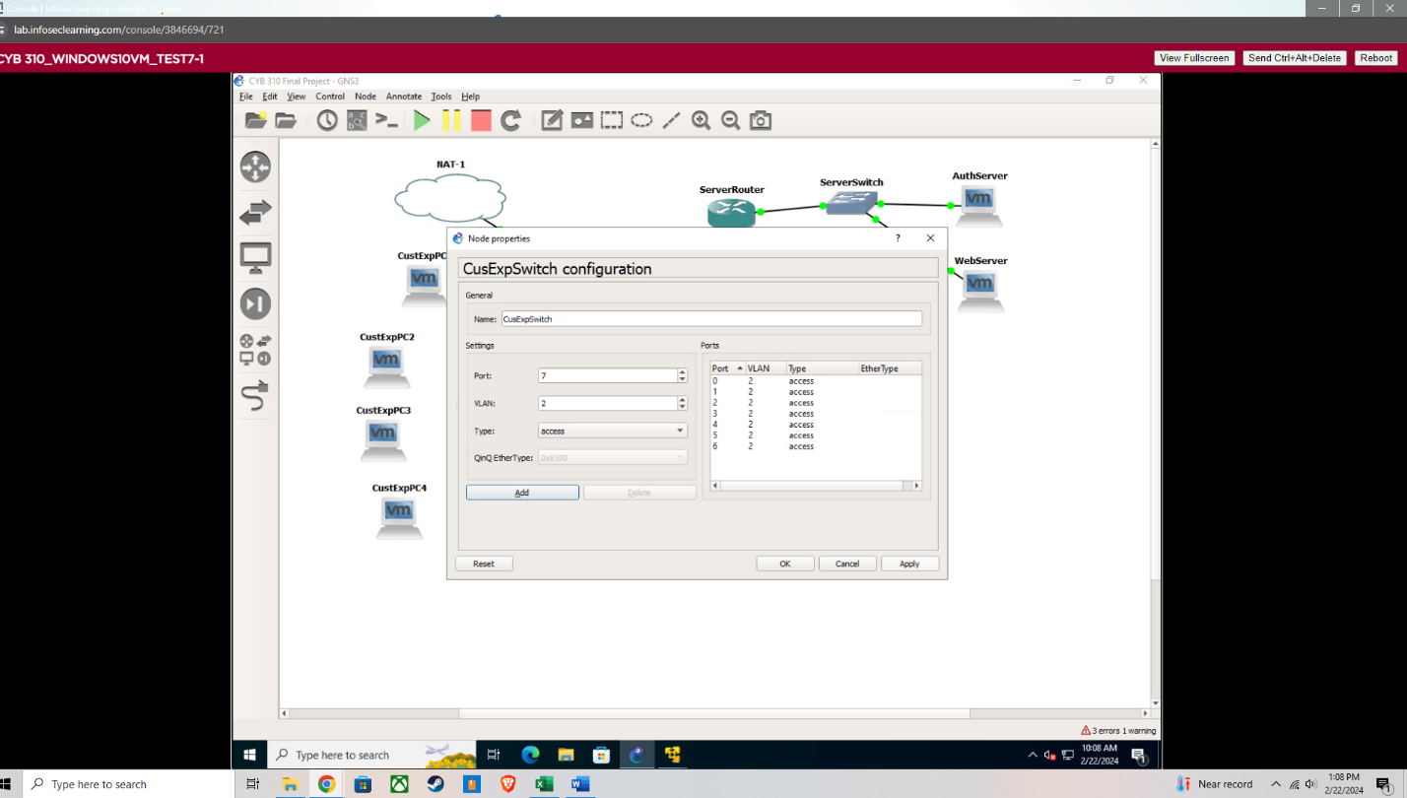

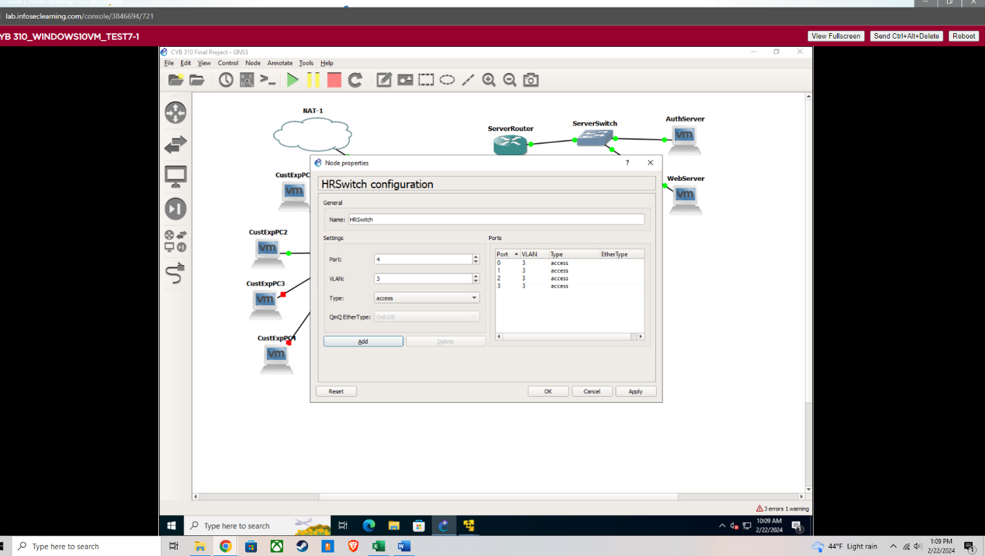

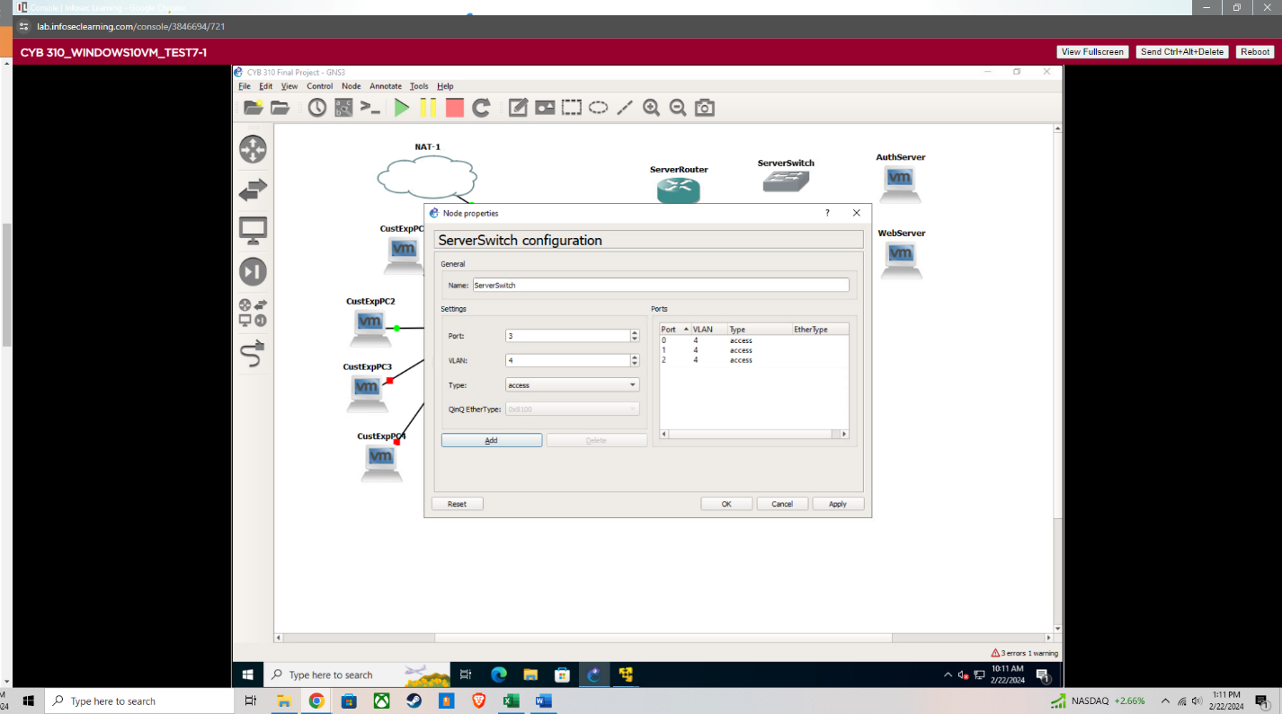

1. **Traffic Flow Configuration**: Shape the traffic flow using the Firewall Traffic Shaping Goals in the Project Three Network Reconfiguration Specifications spreadsheet. Include screenshot(s) of the following:
   1. Configure a firewall rule to **allow port 80** HTTP from the WAN to the web server.
   2. Configure a firewall rule to **allow port 443** HTTPS from the WAN to the web server.
   3. Configure a firewall rule to **block port 80** HTTP from the WAN to any other system.
   4. Configure a firewall rule to **block port 443** HTTPS from the WAN to any other system.

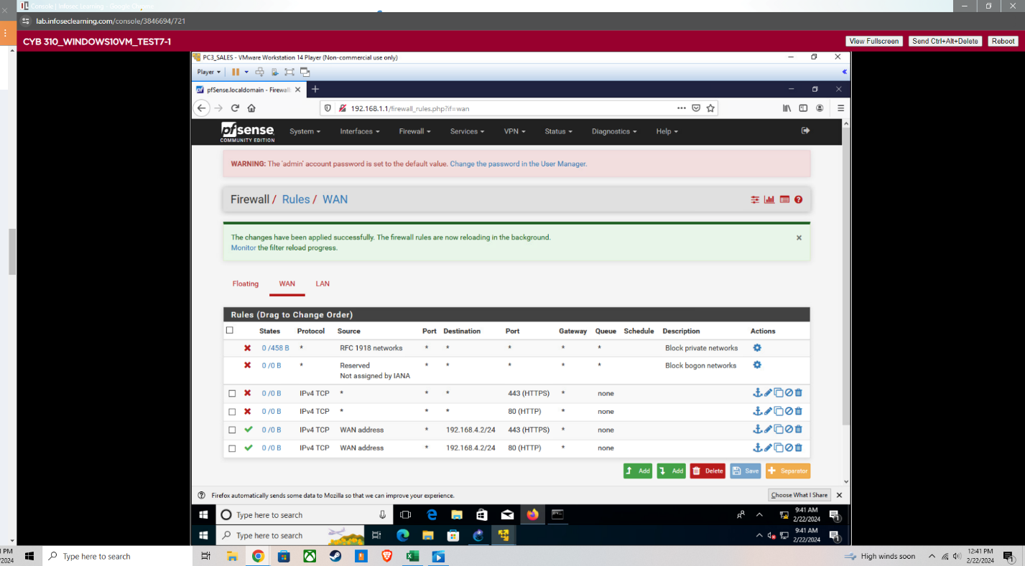

1. **Organizational Security Strategy**
   1. Explain how the **security posture** of the organization has been improved by the restructuring.
   2. Describe how the tenets of the **CIA triad** (confidentiality, integrity, and availability) are affected by the restructuring.

By restructuring, an organization can implement more sophisticated access control mechanisms, ensuring that sensitive information is only accessible to authorized personnel. This can involve the adoption of role-based access controls (RBAC), where access rights are granted according to the roles within the organization, thus reducing the risk of unauthorized access. Restructuring can lead to better data segmentation practices, where critical data is segregated from less sensitive information. This limits potential exposure and reduces the risk of sensitive data breaches. With restructuring, an organization might adopt stronger encryption standards for data at rest and in transit, enhancing the confidentiality of its data.

Restructuring can lead to the implementation of more rigorous change management processes, ensuring that any alterations to data or systems are properly monitored, logged, and validated. This helps in maintaining data integrity by preventing unauthorized changes. Organizations may adopt more sophisticated data validation techniques to ensure accuracy and consistency of data, thereby enhancing its integrity. This could involve the use of checksums, digital signatures, and other data integrity mechanisms.

By redesigning network and system architectures to include redundancy, organizations can improve the availability of their services. This might involve implementing failover systems, redundant network paths, and distributed data storage solutions. Restructuring often includes upgrading infrastructure and adopting cloud services, which can enhance the performance and scalability of systems. This ensures that resources are available when needed and can adapt to varying loads, thereby supporting the availability of services which is exactly what was being implemented within this project.