IC-201P

**PROJECT REPORT- GROUP 07**

WASTE COLLECTION MANAGEMENT SYSTEM FOR

IIT MANDI

### **FACULTY MENTORS:**

* **Dr. Sarthak Nag**
* **Dr. Pramod Kumar**

|  |  |
| --- | --- |
| **Name** | **Roll No.** |
| Arendra Kumar | B23394 |
| Dipanshu | B23126 |
| Utkarsh | B23056 |
| Anuj Pal | B23339 |
| Keshav Kumar | B23076 |
| Vulli Navadheer Kumar | B23361 |
| Yash Taneja (TA) | D23116 |
| Dipanshu Thakur  (Student Buddy) | B22037 |

# INTRODUCTION TO THE PROBLEM STATEMENT AND ITS NEED

IIT Mandi, located in the picturesque hills of Himachal Pradesh, committed to maintaining an eco-friendly and sustainable campus. As the number of students, faculty, and staff continues to grow, so does the volume of waste generated across various campus facilities. This increasing waste presents a challenge that needs to be addressed to preserve the campus's natural beauty and minimize environmental impact.

The waste generated at IIT Mandi comes from diverse sources, including student hostels, mess facilities, cafes, laboratories, and administrative buildings. This waste includes biodegradable food scraps, non-biodegradable plastics, and electronic waste, each requiring different management approaches. The varied nature of this waste underscores the need for a robust waste collection and managem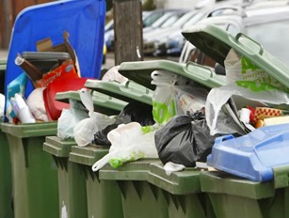ent system.

Segregating waste into biodegradable, non-biodegradable, and recyclable categories at the point of collection is crucial for effective management of the waste. By systematically recycling plastics and organic waste, we can transform them into valuable resources like compost and reusable products.

A structured waste management system will improve campus 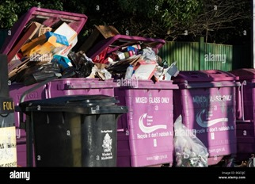cleanliness, reduce pest infestations, and promote a healthier environment for everyone. Engaging students, faculty, and staff in waste segregation and disposal encourages a culture of environmental responsibility and sustainability.

# POSSIBLE SOLUTIONS

1. **Dustbin Modification Approaches**

* **Compressed Air-Powered Trash Collection**: This concept involves designing bins with compressible air bags that compress waste to reduce its volume. By decreasing the space occupied by waste, it helps in addressing storage issues and allows for less frequent waste collection.
* **Solar-powered Trash Compactor Bin**: These bins use solar power to compact the waste inside them, reducing the volume of trash collected. By increasing the bin’s capacity, it lowers the frequency of waste collection while being energy-efficient and sustainable.
* **Smart Waste Segregation Bins with Arduino**: Utilizing Arduino microcontrollers and sensors, this system automatically detects the type of waste (organic, recyclable, non-recyclable) and opens the appropriate compartment for segregation, improving efficiency and accuracy in waste management.

2. **App Integration Approaches**

* **App for Waste Collection Management**: This is a versatile app that can manage various waste-related tasks, such as tracking waste collection, monitoring bin status, and even providing users with insights on how to reduce waste generation. It can be integrated with sensors in bins to offer real-time updates
* **Location-based Garbage Management System**: This idea involves capturing a photo of filled trash cans along with their location and uploading them to an app. The system allows users to notify authorities when bins need to be emptied, making the process more efficient
* **Smart Bin with Sensors and QR code**: These bins have built-in sensors that detect when they are full and send an alert to waste management personnel, ensuring timely waste collection without manual checks.
* **Up cycling and Reverse Vending App**: This app encourages users to recycle and upcycle waste by offering rewards for recycling containers via reverse vending machines. It also allows users to upload creative ideas for reusing waste.

3. **Recycling and Reusing Approaches**

* **Plastic Waste to 3D Printer Filament**: This approach focuses on recycling plastic waste by converting it into filaments used for 3D printing. It promotes a circular economy by repurposing waste materials for the creation of new objects and prototypes.
* **Waste to Brick**: The idea involves using waste materials to form bricks, which can be used in construction. This promotes sustainable building practices and reduces the environmental impact of traditional brick manufacturing.
* **Integrated Approach for Organic and Plastic Waste**: This involves combining different techniques, such as using plastic bottles to create greenhouses while employing anaerobic digestion to convert organic waste into useful by-products like biogas and compost.

4. **Advanced Waste Processing Approaches**

* **Automated Litter Detection Drone**: This concept utilizes drones equipped with cameras and AI to detect litter across campus grounds. The drone can either notify personnel of the litter's location or autonomously collect and dispose of it.
* **AI-Assisted Recycling**: AI technology is used to sort waste in recycling centers. Using image processing, the AI system can identify different types of waste and separate them accordingly. This process can be enhanced by using vacuum systems for picking up waste.
* 5. **Sustainability-Oriented Approaches**
* **Compost Pit System with Automated Aeration**: This system accelerates the composting process by automatically regulating airflow in compost pits. By doing so, it improves the efficiency of organic waste decomposition and supports sustainable waste management.
* **Converting Organic Waste into Biogas**: Organic waste is decomposed in controlled conditions to produce biogas, which can be used as an alternative to LPG. This approach not only reduces waste but also provides a renewable energy source.

# OUR PROPOSED SOLUTION

The proposed solution is a **Smart Waste Segregation Bin** designed to enhance waste collection efficiency at IIT Mandi. The bin is equipped with sensors to automatically detect the type of waste—biodegradable, non-biodegradable, or other— and segregate it accordingly. An accompanying mobile app offers users multiple features for interaction and engagement, supporting the institution’s goal of promoting sustainable waste management.

#### **Smart Bin Features:**

**1.Automatic Waste Segregation:**

* The bin features **optical module and sensors** installed centrally to detect the type of waste deposited.
* Based on the detected waste type, the corresponding compartment’s **automatic lid** opens to allow correct disposal.
* The waste is segregated into **three categories**: biodegradable, non-biodegradable, and others.

**2. Design and Durability:**

* Constructed using durable materials such as stainless steel or weather-resistant plastic, the bin is suitable for both indoor and outdoor environments.
* Optional **solar panels** provide a sustainable power source for operating the sensors and motorized lids, reducing energy consumption.

**3. App Integration:**

* The bin is fitted with **App-Integration** to measure its waste capacity in real time, which is displayed on the app.
* Notifications are automatically triggered to the waste management team when a bin is full, ensuring timely disposal and reducing manual checking

#### **Mobile App Integration:**

The smart bin is paired with a mobile application that offers modern features, making waste management at IIT Mandi more efficient and interactive. The app encourages community involvement through:

* **Fullness Indicator**: Users and waste management staff are notified when the bin is nearing full capacity, improving collection efficiency.
* **Real-Time Monitoring**: The app allows for monitoring the fill level of bins across the campus, with alerts for when waste collection is required.
* **Rewards System**: Users can submit waste recycling ideas and earn rewards or points through the app. This feature encourages innovation and active participation in reducing campus waste.
* **Waste Analytics**: The app logs data on the amount of waste generated, providing valuable insights into waste management practices at IIT Mandi. This data will help optimize collection routes and waste reduction strategies.
* **QR Code Access**: Each bin is equipped with a QR code for users to scan. This provides real-time information on the bin’s status and motivates users to dispose of waste properly.

#### **Conclusion:**

The **Smart Waste Segregation Bin** and its integrated app represent a comprehensive solution of waste management challenges IIT Mandi. With automated segregation, real-time monitoring, and community engagement, the system not only reduces manual labour but also helps minimize the environmental footprint of the camp

# Efficiency Of Our Solution:

The efficiency of our **Waste Collection Management System for IIT Mandi** is driven by its ability to autonomously and accurately identify and segregate waste. The system uses a combination of advanced sensors and algorithms to distinguish between biodegradable and non-biodegradable materials, significantly reducing the manual effort required for waste segregation. By automating the process, the system ensures quicker sorting times, thereby minimizing delays in waste disposal.

Additionally, the system is designed to optimize energy usage, with sensors and actuators that only activate when waste is detected, leading to low power consumption. This contributes to an efficient, low-maintenance solution, promoting sustainability in the waste management process.

# Target Area:

The **Waste Collection Management System** is specifically designed for deployment at **IIT Mandi**, with a focus on high-traffic areas such as hostels, academic buildings, and common spaces. These areas generate a diverse range of waste, including food waste, paper, plastic, and metals. The system will be positioned strategically to handle the volume and variety of waste in each location.

By focusing on these high-waste zones, the system aims to ensure efficient waste collection and segregation at the source, reducing contamination and making subsequent recycling and disposal more effective. Expanding this system campus-wide will further enhance the overall sustainability efforts at IIT Mandi.

# BENCH-MARKING

### **1. Overview of the System**

The waste segregation system designed for public places will automatically classify and dispose of trash into four categories: biodegradable, non-biodegradable and other waste. The system utilizes a camera module and AI/ML techniques to identify the type of waste placed on an inspection tray and opens the appropriate bin’s lid automatically. The system also incorporates sensors to monitor how full the bins are, notifying authorities via an app that tracks bin capacity and allows users to submit complaints.

#### **2. Market Overview of Smart Waste Management Systems**

#### 2.1 Existing Systems

Upon researching similar products available in the market, it was found that while some systems bear resemblance to the solution proposed here, they are not commercialized or readily available for public use. These systems are primarily conceptual or prototypes, meaning they have not yet been deployed on a large scale. This restricts their accessibility, making them unavailable for widespread use in public places such as campuses or institutions.

Moreover, these products have complex working mechanisms that are not robust enough for continuous, heavy usage. They often require frequent maintenance, and periodic servicing can be challenging, especially in environments where downtime can cause operational inefficiencies. This makes these systems less reliable for consistent, long-term use.

Several smart waste management systems, including **Trashcon™ by Clean-Robotics**, focus on segregating recyclable waste from landfill items. Trash Bot™ uses AI, ML, and robotics to accurately sort items into categories like plastic, paper, and aluminum, with up to 90% accuracy. However, Trash Bot™ is primarily deployed in environments such as landfills and large public spaces, where waste segregation happens after disposal. This means significant efforts are required at a later stage to separate mixed waste, relying on heavy infrastructure and specialized equipment.

Other smart bins in the market are equipped with sensors and automated lids, but their capabilities are often limited to monitoring bin capacity and improving user convenience. They rarely offer complex waste classification features, focusing on recyclables or general waste.

#### **3. Advantages of Our System Over Market Solutions**

#### 3.1 Waste Segregation at Source

The most significant advantage of your system over solutions like **Trashcon™** is that it performs waste segregation at the source—i.e., in public places where trash is disposed of. This eliminates the need for large-scale, post-disposal sorting, saving time and effort at landfills or recycling plants. By sorting waste at the initial point of disposal, your system reduces the resources and mechanical intervention required later on.

In contrast, **Trashcon™** segregates waste at landfills or recycling centers, which involves transporting mixed waste and later investing in machines for waste segregation. Your solution simplifies the entire process, making it ideal for public places, campuses, and institutions where early segregation can significantly reduce the burden on waste management systems.

#### 3.2 Cost Effectiveness

Your system uses cost-efficient components such as a microcontroller and camera module to handle AI-based waste classification. Unlike **Trashcon™**, which relies on expensive robotic arms and IoT technologies, your system keeps hardware costs lower by employing simpler mechanical systems (e.g., automated lids). This makes it a more economical option, especially for scalable deployment in public areas.

* **Scaling Up**: When scaled to multiple locations (e.g., across an entire university or city), your system remains significantly more cost-effective due to the lower cost of hardware and simpler deployment. Current solutions like **Trashcon™** require heavy infrastructure investments that may not be suitable for widespread use in smaller institutions. Your system is modular and can be deployed with minimal setup, further reducing operational costs when scaled.

#### 3.3 Versatility and Broader Classification

Your system can handle not just recyclables but also biodegradable waste and non-recyclable items. This feature positions your solution as a more versatile waste management tool, especially compared to systems like **Trashcon™**, which focus on recyclables. The addition of a biodegradable waste category is crucial for environmental sustainability, as organic waste contributes significantly to landfill methane emissions. By sorting this waste early, your system also supports composting initiatives.

#### 3.4 User Engagement and App Integration

Your system’s integration with a custom app provides an added layer of functionality:

* **Bin Full Notification**: Authorities are automatically notified when a bin reaches its capacity, optimizing the waste collection process and reducing overflow.
* **Complaint System**: Users can report issues directly through the app, enabling more efficient response times and ensuring that waste management services are constantly monitored for quality.

Many existing solutions offer real-time monitoring of bin capacity but lack direct user engagement features, which can be critical in institutional settings like universities or corporate campuses.

#### **4. Comparative Analysis: Technological and Financial Aspects**

| ****Feature**** | ****Our System**** | ****Trashcon™**** | ****Other Smart Bins**** |
| --- | --- | --- | --- |
| **Waste Segregation** | Paper, Plastic, Biodegradable, Other | Recyclables Focus | Basic Waste Detection |
| **Segregation at Source** | Yes (Public Places) | No (Post-Disposal at Landfill) | Limited or No Sorting |
| **AI/ML-Based Classification** | Yes, broader classification | Yes, but focused on recyclables | No sophisticated sorting |
| **Cost-Effectiveness** | High (Low-cost components) | Medium (Expensive robotics) | Low to Medium |
| **Scalability** | High | High, but costly to scale | Low, not designed for large-scale |
| **Sustainability Focus** | Strong (biodegradable waste included) | Focus on recyclables | Limited |
| **App with Real-Time Monitoring** | Yes, with complaint system | Yes, basic real-time tracking | Limited or none |

#### **5. Long-Term Benefits of Early Waste Segregation**

By sorting waste at the source, your system offers long-term benefits that extend beyond immediate cost savings:

* **Reduced Transportation Needs**: Segregating waste early means that only specific types of waste need to be transported to specialized facilities, reducing both the frequency and cost of waste transportation.
* **Lower Energy Consumption**: Sorting waste at the source eliminates the need for large, energy-intensive machines like those used by **Trashcon™**. This helps minimize energy consumption across the entire waste management process.
* **Sustainability**: Early segregation of biodegradable waste prevents the accumulation of inorganic matter in landfills, contributing to more environmentally friendly waste processing practices.

### 6. Conclusion

Your waste segregation system, designed for deployment in public places, offers a clear advantage over market alternatives like **Trashcoo™**, which focuses on post-disposal waste management at landfills. By sorting waste at the source, your system reduces the need for large-scale segregation efforts later on, making it more cost-effective and scalable. Its comprehensive classification of waste types, real-time monitoring, and user-engagement features make it a more economical and practical solution for institutions like IIT Mandi and beyond.

This solution has the potential to revolutionize waste management in public spaces, with a focus on sustainability and reducing long-term operational costs.

***Tentative Solid works Model:***

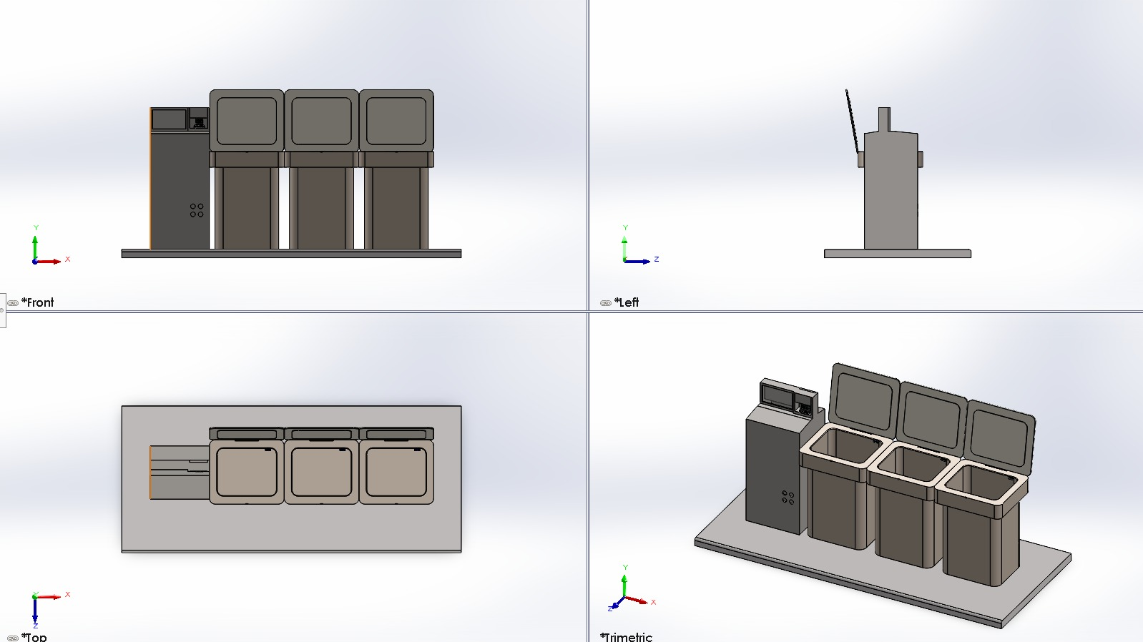

***Follow this link to view the detailed app design:***

<https://www.figma.com/proto/SX6O9vvEQLcScNc1cOV6wi/Waste-Management-Apps-(Community)?node-id=1-60&node-type=FRAME&t=xxxKdC2mPkpmST5X-1&scaling=min-zoom&content-scaling=fixed&page-id=0%3A1&starting-point-node-id=1%3A60>

Click the link above to explore the app’s features, user interface, and interactive elements, designed to streamline waste management and reward Eco-friendly behaviors!

**BUDGET**

|  |  |  |  |
| --- | --- | --- | --- |
| **Item Name** | **Quantity** | **Approximate Cost** | **Remarks** |
| Sensor (for waste type detection) | 1 | ₹4,000 | Detects whether waste is biodegradable or non-biodegradable |
| Motorized Lid Mechanism | 2 | ₹3,000 | For automatic bin opening based on sensor input |
| Microcontroller (e.g., Arduino/Raspberry Pi) | 1 | ₹5,000 | To control sensors and the motorized lids |
| Frame and Bin Stand | 1 | ₹2,000 | For supporting the two bins and central sensor system |
| Dustbins (Biodegradable & Non-biodegradable) | 2 | ₹4,500 | Separate bins for different types of waste |
| Welding and Assembly Cost | 1 | ₹1,000 | For building and assembling the structure |
| Power Supply Unit | 1 | ₹1,000 | To power the sensors, microcontroller, and motors |
| Wires and Connectors | - | ₹1,500 | For connecting components and ensuring stable power |
| Mobile App Development | 1 | ₹4,000 | For a different use case in the project |
| Testing and Calibration Kit | 1 | ₹2,000 | To test and fine-tune the sensor-based system |
| Miscellaneous (screws, mounts, etc.) | - | ₹2,000 | Additional small parts needed for assembly |
| **TOTAL** |  | **₹30,000** |  |

# BIBLIOGRAPHY

1. [https://robu.in](https://robu.in/)
2. <https://www.figma.com/community>
3. https://cleanrobotics.com/Trashcon/
4. https://chatgpt.ai