

ZENUX\_Update\_MAN\_EXT\_EN\_V003.docx

Update procedure for ZENUX devices

including  
Option activation

ZERA_Logo_30mm_cmyk MANUAL



­­­

Revision: 28.03.2025



ZERA_Logo_30mm_cmyk

© Copyright 2024 ZERA GmbH.  
  
ZERA GmbH ∙ Humboldtstrasse 2a∙ D-53639 Königswinter

Tel.: +49 (0) 2244 9277-0

E-Mail: [info@zera.de](mailto:info@zera.de)

www.zera.de

**Important Notes**

First check the current software version of your device.  
Touch the Info-button **ⓘ** and read the „Operating system version“

**Important:**  
An update via USB stick can only be executed if on the device (MT3x0S2 or COM500x):

* .. a series software is already installed e.g. ‘release-4.5.0’  
  (if snapshot-... is displayed here, an update is not possible!)
* ..at least the version ‘release-4.0.0’ is already installed

If your device runs with version 4.7.2 or lower, follow the steps from point **1**.  
If your device runs with version 4.7.3 or higher, perform the steps from point **14**.

Depending on which component is being updated, the update may take several minutes.  
Please do not disconnect the device from the power supply during the update.

**Information on installing an option:**To install an option (e.g. THP 100), it is necessary to purchase a license file.  
The license files are specific to each device and cannot be exchanged between devices.  
The option only needs to be installed **once** on the device. ZENUX updates have no effect on the option that has already been installed.

Please follow the sequence below. To avoid issues it is important to follow the exact sequence:

1. Copy the update files (\*.zup) to a memory stick [[1]](#footnote-2)
2. Insert memory stick in the device to update
3. 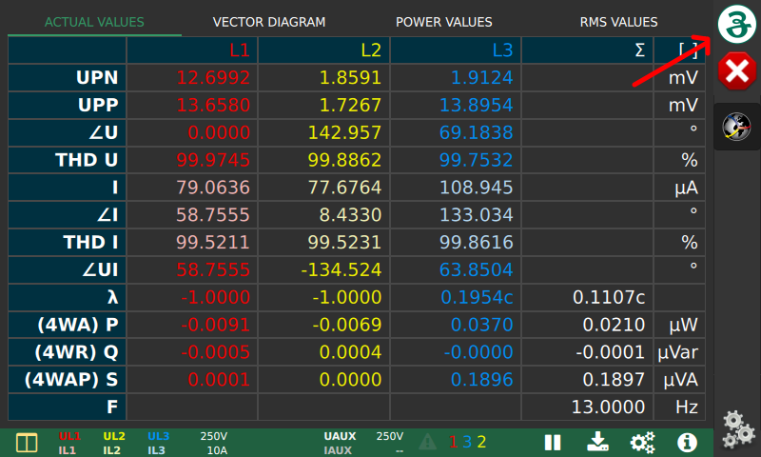Open start menu
4. 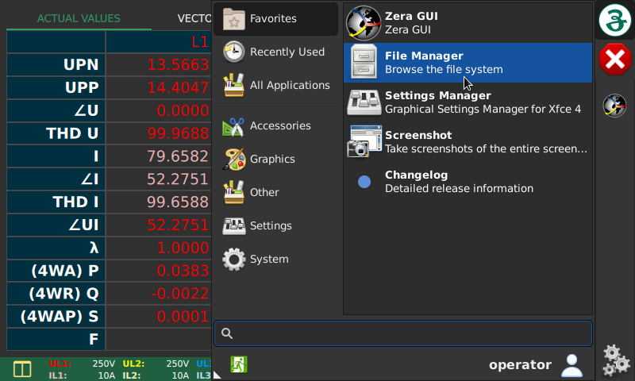Open “File Manager“
5. Navigate to Update files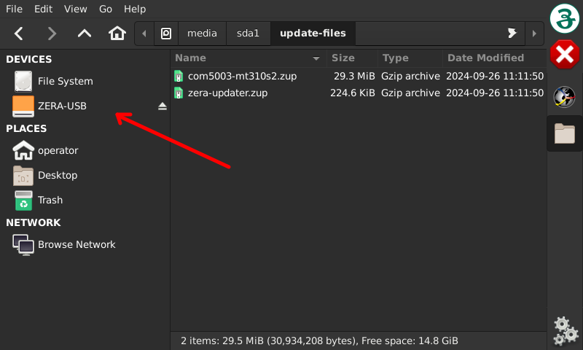
6. 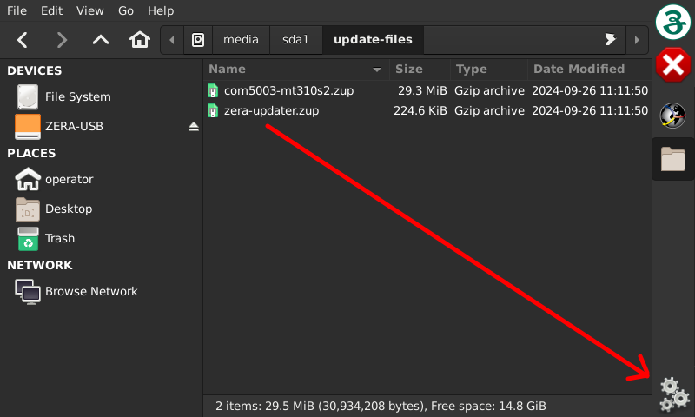Drag the file ‘zera-updater.zup’ to the ZERA update manager icon in status bar:
7. After few seconds a window is created displaying the packages to install. Start update procedure by pressing ‘Install’: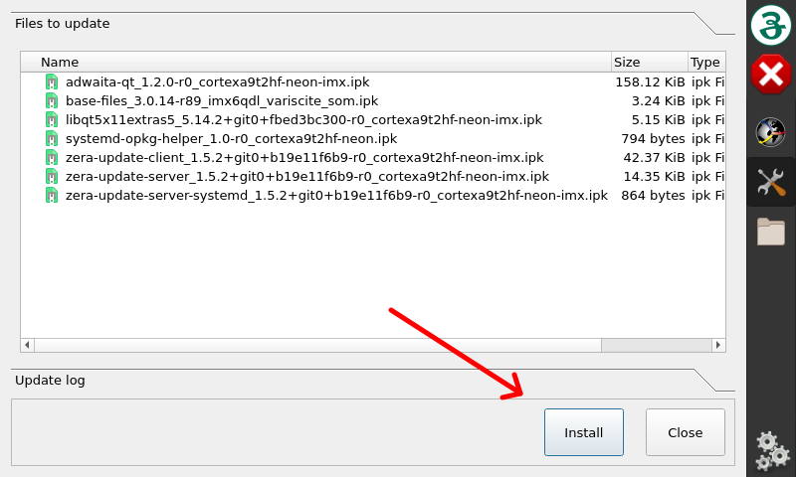
8. The update manager installs the packages and displays the log. After installation close the

Update manager: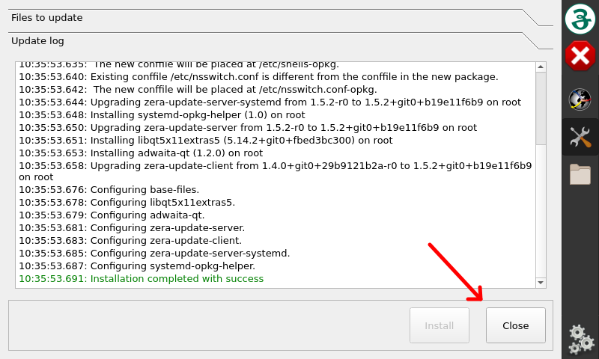

1. If you do not wish to install a license, please go to point **15**.  
   If you want to install a license navigate to the license file (<serialnumber>-licenses.zup) on the USB stick.  
   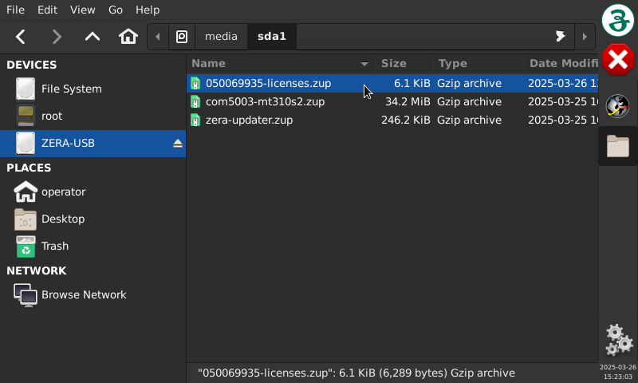
2. Drag the file ‘<serialnumber>-licenses.zup’ to the ZERA update manager icon in status bar:
3. After a few seconds, an ‘Install’ window appears. Start the update process by pressing the ‘Install’ button. (Analogue to point **7**).
4. The ‘Update manager’ installs the necessary packages and displays this in the log output. After the installation (log output: Finished update with success!), please close the ‘Update manager’. (Analogue to point **8**)
5. Install the operting system. Repeat steps **6** - **8** with the files fitting to your device e.g. ‘com5003-mt310s2.zup’. After installation is completed, update manager asks to restart the machine and it is strongly recommended to perform a restart by pressing ‘Yes’:

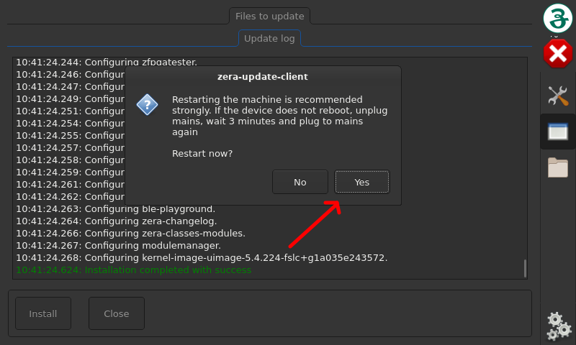

**Notes:**

* Update with ‘zera-updater.zup’ must be performed before any other updates
* During installation error-messages or warnings are displayed in the update log. The final message ‘Installation completed with success’ in update log is important: If an error occurs, repeat steps **3** - **8**. If the error remains, copy the installation log-files to the memory stick and send them with device’s serial number to service@zera.de. The installation log files are found 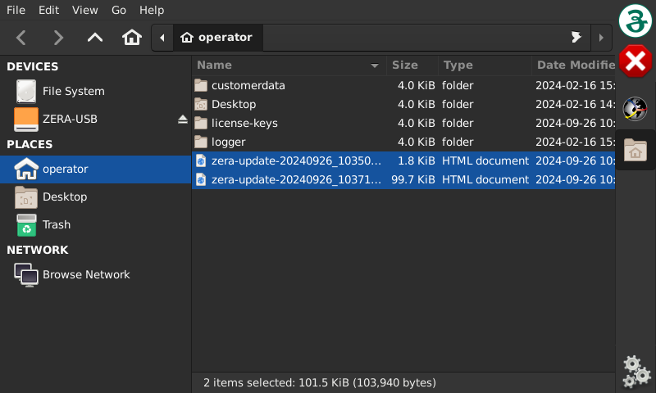in operator’s home directory:
* If the device does not restart automatically, power off the device, wait 2 minutes and power on again.

1. Update process for devices running on software version 4.7.3 or higher.  
     
   **Note:**  
   This update process updates the software version of the device and installs the license file on the device if the <serialnumber>-licenses.zup file is available on the USB stick.
2. Copy the update files (\*.zup) to a memory stick in the root directory (in the first or top-most directory) [[2]](#footnote-3)  
   - com5003-mt310s2.zup (**mandatory**)  
   - zera-updater.zup (**mandatory**)  
   - <serialnumber>-licenses.zup (**optional**)  
     
   Notes: An option only needs to be installed once on the device.
3. Insert memory stick in the device to update
4. Touch the butten **ⓘ** (Info) and choose the tab „SERVICE SUPPORT“
5. Click on START UPDATE  
     
     
     
     
     
     
     
     
     
   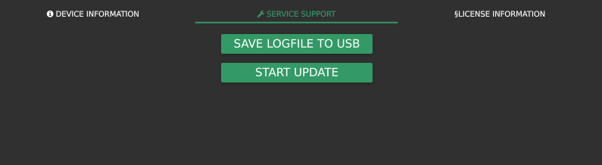  
     
   This process requires no input from the user and can take a few minutes.  
   After completing the update, the device reboots automatically.  
   Remove the USB-Stick.
6. 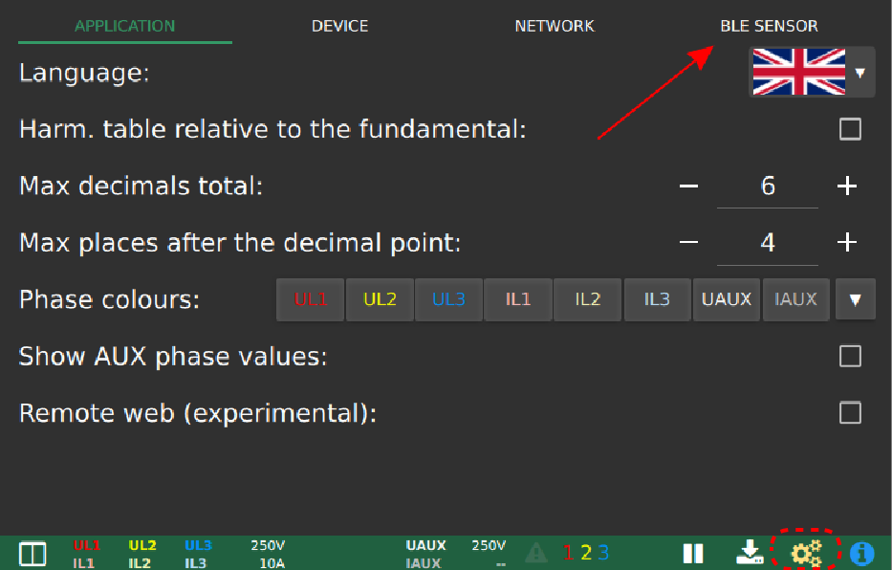Configuration of the THP100 option (only possible if license file is installed)  
   Restart device. Navigate to the Settings menu by pressing the symbol settings.  
   The tab „BLE SENSOR“ should be displayed when license file has been installed successfully.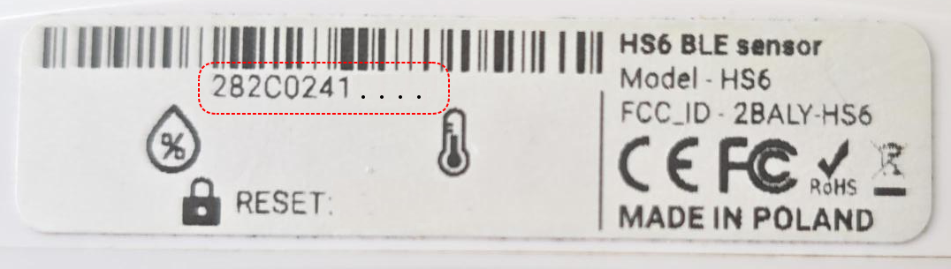
7. Navigate to the tab BLE SENSOR  
   - Enable Bluetooth checkbox  
   - Enter the MAC address (12 digits) of  
    THP100 (see sticker on THP100)  
     
     
     
     
     
     
     
     
     
     
     
     
   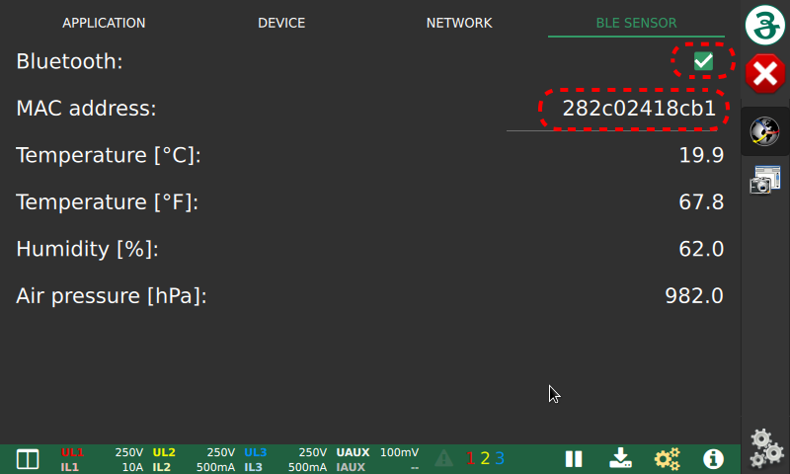  
     
     
     
     
     
     
     
     
     
     
     
   → It is not necessary to enter colons, upper/lower case letters are possible  
   → Sensor should be within max. 2m of the MT310S2  
   → Multiple MT310S2 can be set to one THP100
8. 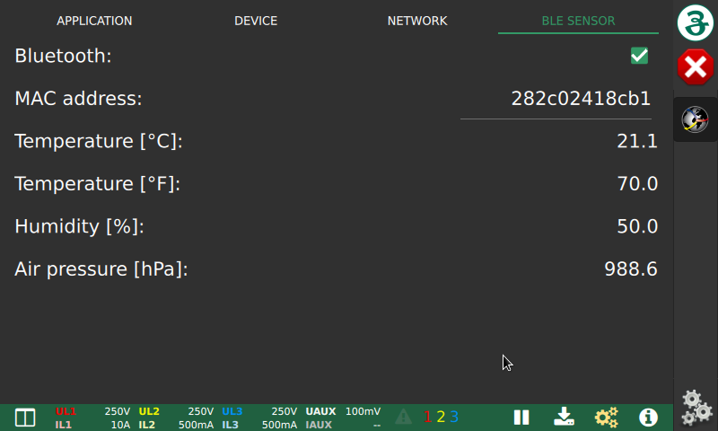Check if settings are correct  
   Temperature/humidity/air pressure are displayed a few seconds after the settings are made.  
   The display location varies depending on the active session.  
   If the license is not assigned (or is not accepted by the device), the tab „BLE SENSOR“ does not appear in the settings menu.

1. Note: The file format of the USB stick should be FAT32. (NTFS formatted sticks do not work) [↑](#footnote-ref-2)
2. Note: The file format of the USB stick should be FAT32. (NTFS formatted sticks do not work) [↑](#footnote-ref-3)