

TEST PLAN

SHOPPING ONLINE – 2N1D

Class: SE1605 Mentor
Group 6 Lâm Lê Huấn
- Nguyễn Hồng Yến CE150745 Leader
- Đặng Minh Luân CE161164
- Bùi Hoang Linh CE160280
- Trần Phúc Lợi CE161098
- Đỗ Nhật Nam CE170031
- Trần Thanh Huyền CS160841

TABLE OF CONTENTS

I. INTRODUCTION 4
II. TEST OBJECTIVE 5
III. SCOPE OF TESTING 5
a. Features Not To Be Tested (Out of scope) 5
b. Features To Be Tested (In scope) 5
IV. TEST STRATEGY 7
a. Test Types 7
b. Test Levels 8
c. Supporting Tools 9
V. RISKS 9
VI. TEST CRITERIA 9
a. Entry criteria 9
b. Suspension Criteria. 10
c. Exits criteria 10
VII. RESOURCE PLANNING 10
a. System Resource 10
b. Human Resource 11
VIII. TEST ENVIRONMENT 11
IX. SCHEDULE & ESTIMATION 12
X.TEST DELIVERABLES 12
a. Before testing 13
b. During testing 13
c. After the test 13

VERSION HISTORY
Version # | Revision Date | Write by | Approved By | Approval Date | Outline
1.0 | 31/01/2023 | Tran Thanh Huyen  Do Nhat Nam | Tran Phuc Loi | 01/02/2023 | Test Plan create
1.1 | 02/02/2023 | Nguyen Hong Yen  Bui Hoang Linh | Tran Phuc Loi | 03/02/2023 | Test Plan create
2.0 | 12/02/2023 | Dang Minh Luan  Tran Thanh Huyen | Tran Phuc Loi | 13/02/2023 | Test Plan create
2.1 | 14/02/2023 | Bui Hoang Linh  Do Nhat Nam | Tran Phuc Loi | 15/02/2023 | Test Plan create

- INTRODUCTION
The Test Plan is designed to prescribe the scope, approach, resources, and schedule of all testing activities of the project 2N1D. The plan identify the items to be tested, the features to be tested, the types of testing to be performed, the personnel responsible for testing, the resources and schedule required to complete testing, and the risks associated with the plan.

2N1D Store is an online website for local brand that sells a plenty of fashionable clothes for both men and women. We will accept online clothing orders and delivers them to your home. The initial idea was put forth in response to the realization that local clothing retailers mostly focus develop through conventional ways of purchasing and selling in nearby communities. The goal of the team's online shopping initiative is to deliver the finest possible purchasing experience. Along with assisting homegrown fashion firms to improve their brand image.

Team Members
Name | Role
Nguyen Hong Yen | Test Manager  Manage the whole project, Define project directions, Acquire appropriate resources
Bui Hoang Linh | Tester  Identifying and describing appropriate test  techniques/tools/automation architecture, Verify and assess the Test Approach, Execute the tests, Log results, Report the defects, Outsourced members
Dang Minh Luan | Developer in Test  Implement the test cases, test program, test suite.
Tran Phuc Loi | Test Administrator  Builds up and ensures test environment and assets are managed and maintained  Support Tester to use the test environment for test execution
Do Nhat Nam | SQA Member  Take in charge of quality assurance  Check to confirm whether the testing process is meeting specified requirements
Tran Thanh Huyen | SQA Member  Take in charge of quality assurance  Check to confirm whether the testing process is meeting specified requirements

II. TEST OBJECTIVE
The following is the test document's objectives:
- Determine the fundamentals of the project, the functional components that are tested and those that are not tested.
- Check to see if the website's functionality performs flawlessly in a genuine business setting without any glitches or issues.
- Verify the website's external interface, such as the user interface (UI), to ensure it functions as planned and satisfies the needs of the user.
- Make sure the website is user-friendly and convenient.
- Estimate the resources needed and testing costs by testing your website on several browsers to guarantee performance and device compatibility.

III. SCOPE OF TESTING
- Features Not To Be Tested (Out of scope)
- Software Interfaces
- Hardware Interfaces
- Database logical
- Website Security and Performance
- Features To Be Tested (In scope)
- User Interfaces
- Functional Item: All the feature of 2N1D which were defined in software requirement specs are need to tested

# | Feature | Applicable Roles | Description
1 | Product Management | Manager | Manager are allowed to manage information, quantity, have the right to add, update and delete product, etc.
2 | Customer Management | Manager | Manager are allowed to manage information, accounts, have the right to add, update and delete customers, etc.
3 | Search Product | Manager  Customer  Guest | Allows users to search for names, prices, types,...
4 | View Product information | Manager  Customer  Guest | This is a table of information of the product that displays below when clicking on the product details.
5 | Cart | Manager  Customer  Guest | Allow users to select the product they want to buy into the shopping cart
6 | Buy Now | Manager  Customer  Guest | Allows users to buy product instantly without going through the shopping cart
7 | View and Edit profile | Manager  Customer | This is the customer's function, where they can view and edit their personal information and order information
8 | View history of buying | Manager  Customer | This is a customer function, allowing them to review a list of products they have purchased, repurchased and reviewed.
9 | View about store | Customer  Guest | When clicked, it will take you to a page containing the founder's information, an overview of the website

- Non-Functional Item:
- System must be HIPAA and TRUSTe compliance.
- In the normal condition (could be 100 concurrent users or less), each page should load in 3 seconds or less.
- In the stress condition (could be more than 100 concurrent users), each page should load in 6 seconds or less.

IV. TEST STRATEGY
  - Test Types
    - User Interface Testing
Test Objective: | Navigation through the target-of-test properly reflects business functions and requirements, including screen to screen, field-to-field, and use of access methods. Objects and characteristics, such as menus, size, position, state, and focus conform to standards.
Technique: | - Testers will create specific test scenarios against UI prototypes approved by customer.  - Testers execute test based on test scenarios and create report. Common defects will be collected for improved checklists.  - Execute each case, using valid, invalid and boundary data, to verify the expected results display when valid, invalid and boundary data is used.
Completion Criteria: | - All GUI test cases have been executed and passed  - Any defects related to GUI are fixed, except those accepted by customer  - All defects found by tester are addressed in DMS
Special Considerations: | N/A

    - Function Testing
Test Objective: | Verify the application and its internal processes by interacting with the application via the Graphical User Interface (GUI) and analyzing the outputs or results
Technique: | - Testers will create test scenarios against the requirements provided by customer. Test scenarios will be created based on black box test technique.  - Testers execute test based on test scenarios and create report. Common defects will be collected for improved checklist.  - Execute each case, using valid and invalid data, to verify the following:  Get the expected results when valid and invalid data is used  Valid input data is updated correctly into database  The appropriate errors or warning messages are displayed when invalid data is used  - Execute each case, using boundary data, to verify the following:  Get the expected results when boundary data is used  Data is updated correctly to database  The appropriate errors or warning messages are displayed when invalid data is used  - Each valid data input is updated correctly into database.  - Each business rule is properly applied.
Completion Criteria: | All functional test cases have been executed to verify proper data acceptance, processing, and retrieval, and the appropriate implementation of the business rules, and passed  The appropriate activities will be performed when valid data is used  The corresponding error/warning message mechanism is applied for each specific case  All bugs found must be fixed
Special Considerations: | Functional testing will NOT be started in case of developers have not executed unit test before passing application to testers

    - Load Testing
Test Objective: | Verify the application and its internal processes should be met:  In the normal condition could be 100 concurrent users or less, each page should load in 3 seconds or less  In the stress condition could be more than 100 concurrent users, each page should load in 6 seconds or less
Technique: | - Testers will create test scenarios, test scripts against the requirements provided by customer. Test scenarios will be created based on black box test technique, and be supported by one of the following tools: IBM Rational Robot & Manager.  - Testers execute test based on test scenarios and create report. Common defects will be collected for improved checklists.  - Execute each case, using valid and invalid data, to verify the following on a random device:  In the normal condition could be 100 concurrent users or less, each page should load in 3 seconds or less  In the stress condition could be more than 100 concurrent users, each page should load in 6 seconds or less
Completion Criteria: | In the normal condition could be 100 concurrent users or less, each page should load in 3 seconds or less.  In the stress condition could be more than 100 concurrent users, each page should load in 6 seconds or less  All performance requirements must be met
Special Considerations: | Numbers of 100 virtual users should be available for Microsoft Visual Studio

  - Test Levels
Types of Test | Stages of Test
 | Unit | Integration | System | Acceptance
Function Test | X |  | X | X
User Interface test |  |  | X
Load test |  |  |  | X
  - Supporting Tools
Purpose | Tool | Vendor/In-house | Version
Defect log | DMS | FPT tool
Collect test effort | Timesheet | FPT tool
Documenting | MS Word, Excel | Microsoft | 2010
Unit Testing | Pax | Microsoft
Function Testing | Manual | Manual
Load Testing | IBM Rational Robot & Manager | Microsoft | 2010
Security Testing | WireShark | <open source> | 1.6.1
Database | SQL Server | Microsoft | 2008

V. RISKS
Risks | Mitigation risks
Team member lack the required skills for website testing | Recommend training courses to improve skills for team members
Time is urgent, difficult to complete on time | Plan a suitable time for each test phase
Difficulty accessing tools test | Find information and how to use the tool
Lack of consensus among members to make joint decisions in the group | There are regular meetings to give votes and unify a common opinion
Wrong budget estimate and cost overruns | Establish the scope before beginning work, pay a lot of attention to project planning and constantly track and measure the progress

VI. TEST CRITERIA
  - Entry criteria
- Unit testing
- The planning phase has been completed.
- Functional requirements and specifications are available.
- Programmer must be above 80% tester
- System testing
- The system test environment has been set up.
- Test cases/scripts are ready.
- Internet Connection
- Acceptance testing
- The system test environment has been set up.
- Invite end-users to participate in testing
- Test cases/scripts are ready.
- Internet Connection
  - Suspension Criteria.
If the team members report that there are 40% of test cases failed, suspend testing until the development team fixes all the failed cases.
  - Exits criteria
Specifies the criteria that denote a successful completion of a test phase
- Run rate is mandatory to be 100% unless a clear reason is given.
- Pass rate is 95%, achieving the pass rate is mandatory

VII. RESOURCE PLANNING

System Resource
No | Resources | Descriptions
1 | Server | Need a Database server which install MySQL server Web server which install Apache Server
2 | Test tool | Develop a Test tool which can auto generate the test result to the predefined form and automated test execution
3 | Network | Setup internet line with the speed at least 5 Mb/s
4 | Computer | Run Windows 10/11, Ram 8GB, CPU 3.4GHZ
5 | Phone | Run Android, IOS operating system

Human Resource
No | Member | Task
1 | Test Manager | - Manage the whole project.  - Define project directions.
2 | Programmer in Test | - Implement the test cases.  - Test program, test suite etc.
3 | Test | - Identifying and describing appropriate test techniques/tools/automation architecture.  - Verify and assess the Test Approach.  - Execute the tests, Log results, Report the defects.Outsourced members.

VIII. TEST ENVIRONMENT
- Device: Laptop, Desktop, Mobile
- Operating System: Windows 10/11
- Browser:
+ Google Chrome
+ Microsoft Edge
- Network: Wi-Fi
- Database: Microsoft SQL Server 2022 (CTP2.0) - 16.0.600.9 (X64)
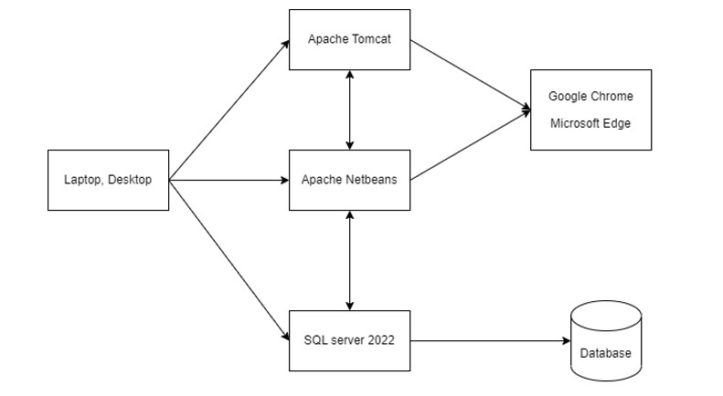

IX. SCHEDULE & ESTIMATION
No | Task | Member | Estimate effort
1 | Sign-In/Sign-Up | Yến | 3 man-hour
2 | Product Management | Lợi | 10 man-hour
3 | Customer Management | Luân | 12 man-hour
4 | Search Product | Linh | 5 man-hour
5 | View Product information | Nam | 7 man-hour
6 | Cart | Huyền | 10 man-hour
7 | Buy Now | Linh | 8 man-hour
8 | View and Edit profile | Lợi, Luân | 6 man-hour
9 | View history of buying | Nam | 9 man-hour
10 | View about store | Yến, Huyền | 5 man-hour
 | Total |  | 75 man-hour

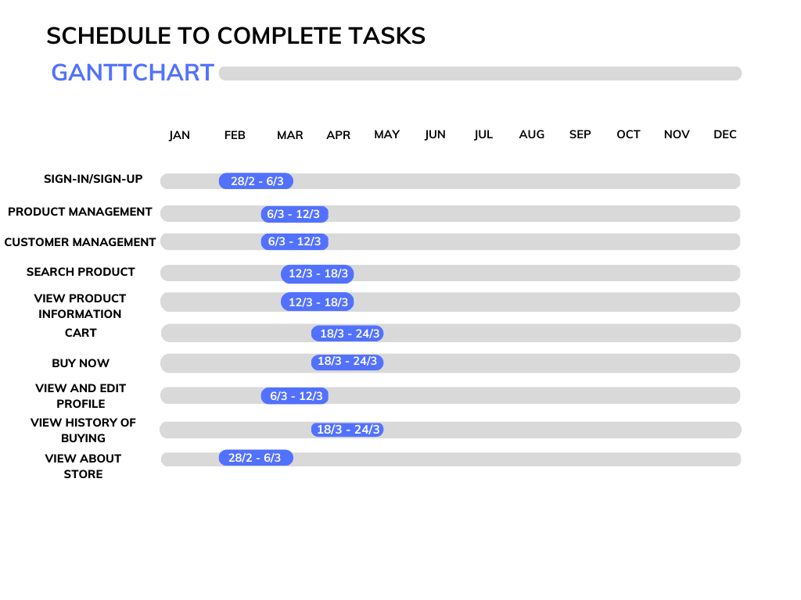

X.TEST DELIVERABLES
  - Before testing
- Test plan document
- Test case documentation
- Specific requirements for test design
  - During testing
- Test tool
- Simulation
- Test data
- Log errors and execute log
  - After the test
- Test results/reports
- Error report
- Install/guide the test procedure
- Release notes

