Democratizing AI: The ShashChess Reinforcement Learning Architecture

1. Executive Summary
While the chess world was revolutionized by AlphaZero and Leela Chess Zero (Lc0), these systems rely on massive, expensive hardware (GPUs/TPUs) to perform Reinforcement Learning (RL). ShashChess introduces a democratized approach: a lightweight, CPU-based RL algorithm that runs on standard hardware (laptops, phones) yet still achieves superhuman performance gains through self-play.
Based on the Forward Sparse Sampling Search (FSSS) framework by Weinstein, Littman, and Goschin, ShashChess implements a persistent Q-Learning mechanism. This allows the engine to "remember" the consequences of its decisions across games, effectively building a long-term memory ("Experience") that refines its evaluation function without requiring neural network training passes.

2. Theoretical Foundation: FSSS and Q-Learning
The core of the ShashChess learning engine (internally referred to as "BrainLearn") is an adaptation of the FSSS algorithm within the Minimax framework.

The Problem with Traditional FSSS
The original FSSS implementation requires heavy computation to sample states during the search tree expansion. This is too slow for competitive chess engines.

The ShashChess Solution: Online Sampling
ShashChess modifies this by collecting samples across games rather than during a single search. As the engine plays, it treats every game as a data collection trajectory.
- State Abstraction: The board state is represented by a 64-bit Zobrist hash key (Signature).
- Sample Data: For each significant position, the engine stores the Move made, the Minimax Score, and the Search Depth.
- Persistent Memory: These samples are stored on the hard disk (.exp files) and loaded into RAM for reuse in future games.

3. Algorithmic Implementation

A. The Q-Learning Update Rule
The most sophisticated part of the implementation is found in learn.cpp. When LearningMode::Self is active, the engine applies a Q-Learning update to the trajectory of the game once it concludes or a decisive advantage is reached.
The engine back-propagates the result of the game to update the scores of the moves that led there. The implementation uses a variation of the Bellman equation:
$$Q(s, a) \leftarrow Q(s, a) \cdot (1 - \alpha) + \alpha \cdot (\gamma \cdot Q(s', a'))$$
Where:
- $\alpha$ (Learning Rate) is set to 0.5.
- $\gamma$ (Discount Factor) is set to 0.99.
Code Evidence:
C++
// from learn.cpp
void putQLearningTrajectoryIntoLearningTable() {
const double learning_rate = 0.5;
const double gamma = 0.99;

// ... iterate backwards through the game trajectory ...
prevLearningMove.score = prevLearningMove.score * (1 - learning_rate)
+ learning_rate * (gamma * currentLearningMove.score);
}
This allows the engine to mathematically "realize" that a specific move played 20 turns ago was the true cause of a victory or defeat, updating its score accordingly for the next game.

B. The Experience Data Structure
The learning data is stored efficiently to allow fast retrieval during the time-critical search phase.
- Hash Table: Uses a std::unordered_multimap to map Position Keys to LearningMove pointers.
- Struct LearningMove:
  - depth: The depth at which the move was analyzed.
  - score: The evaluation (centipawns) or Q-value.
  - move: The best move found.
  - performance: A Win-Probability metric derived from the score.

C. Search Integration (Pruning and Ordering)
The "Experience" directly interacts with the Alpha-Beta search in search.cpp. It acts as a Persistent Transposition Table (Step 4Bis in the search loop).
- Pruning (Instant Reply): If the current search depth is lower than or equal to the depth stored in the Experience file (learningMove->depth), the engine immediately returns the stored score. This saves immense amounts of time by not recalculating known positions.
  - Code Evidence: In search.cpp, inside Step 4Bis, the code checks if (!PvNode ... && learningMove->depth > depth ...) and returns expTTValue immediately.
- Move Ordering: If the stored depth is not sufficient to prune, the engine retrieves the learningMove->move and injects it into the search data (ttData.move). This ensures the "learned best move" is tried first by the MovePicker, drastically improving Beta-cutoffs.

4. Modes of Operation
ShashChess offers distinct learning modes configurable via UCI options:
- Standard Learning: The engine memorizes the results of its calculations. If it analyzes a position to depth 20 and finds a score of +0.50, it saves it. Next time, it knows the score is +0.50 without thinking.
- Self (Q-Learning): The engine plays against itself (or opponents) and updates the scores based on the outcome. Even if the static evaluation said +0.50, if the game was lost, the Q-Learning algorithm will downgrade that score, "teaching" the engine that the position is dangerous.

5. Performance and Empirical Results
The efficacy of this R-Learning approach was validated through rigorous testing detailed in the research paper.

The "Learning Curve"
In a match of 1,000 bullet games against Stockfish (without learning):
- Baseline: ShashChess started evenly matched.
- Evolution: As games progressed, the win rate drastically increased as the "Experience" file grew.
- Result: +14 Elo gain in just 1,000 games.
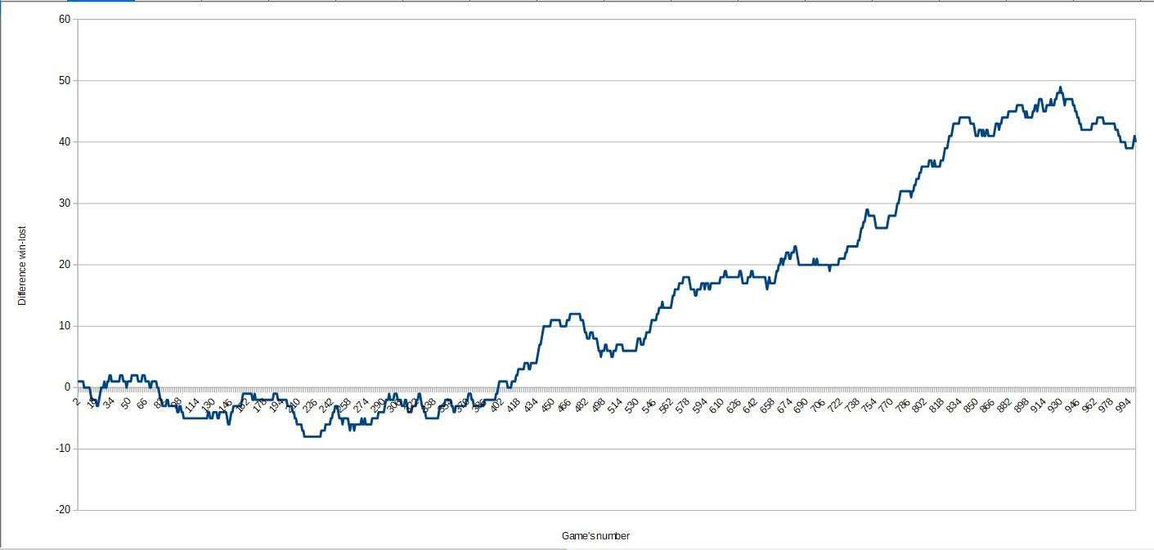
(The graph shows a clear upward trend in the difference between wins and losses as the game number increases).

Algorithm Refinement
A second iteration of the algorithm ("Improved Algorithm"), which captures priors for both players to improve search efficiency, was tested against the first version. The new R-Learning algorithm won the match 503 to 497, proving that capturing opponent moves as priors further enhances strength.

6. Conclusion
ShashChess demonstrates that Reinforcement Learning is not the exclusive domain of supercomputers. By implementing FSSS with Q-Learning and integrating it directly into the search tree as a persistent memory, ShashChess creates an agent that:
- Learns from mistakes (Q-Learning updates).
- Analyzes faster over time (Experience Pruning).
- Runs on commodity hardware (No GPU required).
This validates the project's goal: creating the ultimate engine for detailed analysis and long time controls, capable of "remembering" chess truth where others must recalculate it from scratch every time.

