Multi-Focus Image Fusion via
Neutrosophic Hypergraph Decision-Making
A patch-based fusion pipeline using neutrosophic uncertainty modeling and hyperedge-based consensus aggregation, evaluated against classical baselines on real multi-focus photographs.
Project: NeutroFuse | Dataset: Lytro Multi-Focus (20 real image pairs)
github.com/Zerchen-StagnantWater

Abstract
This report presents a multi-focus image fusion pipeline that models per-patch source confidence using neutrosophic logic (truth, indeterminacy, falsity) and resolves ambiguous patches through hyperedge-based consensus aggregation over a perceptual-similarity hypergraph. The method is implemented end to end — sharpness measurement, neutrosophic component computation, hypergraph construction, fusion decision, and output composition — and evaluated on all 20 real image pairs in the Lytro multi-focus benchmark against two baselines: naive pixel averaging and Guided Filter Fusion (GFF), a well-established classical method.
The method decisively outperforms naive averaging on every metric tested (p < 10⁻⁹). Against GFF, the result is more nuanced and is reported as such rather than rounded toward a clean win: Mutual Information is significantly higher (20/20 pairs, p = 3.6×10⁻¹²), Qᵃᵇᶠ edge-preservation is marginally significant (13/20 pairs, p = 0.031), and Spatial Frequency shows no significant difference (p = 0.33). A dedicated ablation isolating the hyperedge-aggregation mechanism found a small but statistically robust effect: aggregation improves Qᵃᵇᶠ and MI on roughly 90% of pairs (p < 10⁻⁵) while reducing Spatial Frequency on roughly 90% of pairs (p = 0.0012). The mechanism behind this tradeoff was traced directly in the data: aggregation overrides the locally sharper source at a subset of patches in favor of neighborhood consensus, trading pixel-level sharpness for structural and informational coherence. Two real implementation defects — a normalization bug that collapsed the indeterminacy signal on real photographs, and an upstream OpenCV defect that crashed the GFF baseline on half of the test set — were found, root-caused, and fixed during development; both are documented here as findings in their own right.

Contents
Abstract 2
1. Introduction 4
2. Method 4
2.1 Pipeline Overview 4
2.2 Neutrosophic Components 4
2.3 Hyperedge Aggregation 5
3. Experimental Setup 5
3.1 Dataset 5
3.2 Methods Compared 5
3.3 Metrics 5
3.4 Statistical Methodology 6
4. Results: Method vs. Baselines 6
4.1 Qualitative Example 6
4.2 Aggregate Results (20-pair mean) 7
4.3 Statistical Comparison: Ours vs. Guided Filter Fusion 8
4.4 Statistical Comparison: Ours vs. Naive Averaging 8
5. Ablation: Does Hyperedge Aggregation Help? 8
5.1 A Note on Threshold Calibration 8
5.2 Per-Pair Effect of Aggregation 8
5.3 Mechanism: Why Aggregation Trades Sharpness for Structure 9
6. Implementation Findings 10
6.1 Indeterminacy Normalization Bug 10
6.2 Guided Filter Fusion Baseline Crash 10
7. Limitations and Future Work 10
8. Conclusion 11

1. Introduction
Multi-focus image fusion combines two or more images of the same scene captured at different focus depths into a single all-in-focus composite. The central difficulty is deciding, at every spatial location, which source image is genuinely sharper — and, more subtly, what to do at locations where that decision is ambiguous: focus boundaries, low-texture regions, and areas where both sources are partially blurred.
Classical approaches handle this ambiguity implicitly, through smoothing (transform-domain methods) or through local guided-filter refinement of a hard decision (Guided Filter Fusion). This project takes a different approach: ambiguity is modeled explicitly using neutrosophic logic, where every patch carries not just a confidence score but an indeterminacy score quantifying how undecidable the local evidence is. Patches with high indeterminacy are not resolved by the local evidence alone; instead, the decision is deferred to a consensus computed over a hypergraph of perceptually similar neighboring patches.
This report documents the method, the evaluation methodology, and — in full, including the parts that did not go as expected — the results obtained by running the complete pipeline on all 20 real pairs of the Lytro multi-focus dataset.

2. Method

2.1 Pipeline Overview
Given two co-registered source images A and B, the pipeline proceeds in five stages:
- Patch decomposition: each image is divided into non-overlapping 8×8 pixel patches (images not evenly divisible by the patch size are edge-padded and cropped back after fusion).
- Sharpness measurement: each patch's local sharpness is scored using Laplacian variance, a standard focus measure.
- Neutrosophic component computation: per-patch sharpness is converted into Truth (T), Indeterminacy (I), and Falsity (F) values for each source, jointly normalized across both sources.
- Hypergraph construction: patches are connected into hyperedges based on cosine similarity of a combined LBP-texture and gradient-orientation feature vector, within a fixed spatial radius.
- Fusion decision: patches with low indeterminacy are resolved by direct comparison of T values; patches with high indeterminacy are resolved by aggregating T values across every hyperedge the patch belongs to, weighted by hyperedge confidence.
The output is a per-patch blend weight in [0, 1] (1 = fully source A, 0 = fully source B, intermediate values for near-tie patches), upsampled to pixel resolution and used as a linear blend coefficient between the two sources.

2.2 Neutrosophic Components
Truth and Falsity are derived directly from normalized sharpness (F = 1 − T). Indeterminacy is defined comparatively between the two sources:
I(p) = 1 − |T_{A}(p) − T_{B}(p)|
I is high when both sources have similar confidence at a patch — either because both are clearly sharp and tied, or because both are genuinely low-information there. Patches with I above a threshold θ (default 0.75, calibrated to the empirical distribution — see Section 5.1) are routed to hyperedge aggregation rather than direct comparison.

2.3 Hyperedge Aggregation
For an indeterminate patch, the aggregated confidence is a weighted average, over every hyperedge the patch belongs to, of that hyperedge's mean T value — with each hyperedge weighted by its own confidence, defined as the mean of max(T_A, T_B) across the hyperedge's members. Concretely: a patch's neighbors that are themselves more clearly resolved (high max-confidence) contribute more to the consensus than neighbors that are also ambiguous.
This is the method's core mechanism: rather than resolving ambiguity pixel-by-pixel, a patch's fate is decided by what its perceptually similar neighbors collectively believe. Disabling this mechanism (forcing every patch through direct comparison, equivalent to setting θ = ∞) defines the no-aggregation ablation variant used throughout Section 5.

3. Experimental Setup

3.1 Dataset
All 20 real color image pairs from the Lytro multi-focus dataset (520×520, Nejati et al. 2015) were used. This dataset has no all-in-focus ground truth, which is a property of the dataset itself, not a limitation of the evaluation — SSIM is consequently not reported for these results (a separate MFI-WHU loader with ground truth is implemented and verified but not used in the headline results below).

3.2 Methods Compared
- Ours (full): the complete pipeline as described in Section 2, including hyperedge aggregation.
- Ours (no aggregation): identical pipeline with θ = ∞, forcing every decision through direct T comparison. Isolates the aggregation mechanism's contribution.
- Naive averaging: (A + B) / 2 per pixel. The floor every method must clear.
- Guided Filter Fusion (GFF): Li, Kang & Hu (2013), a two-scale decomposition with guided-filter-refined weight maps. A well-established “strong classic” baseline.

3.3 Metrics
- Mutual Information (MI): information preserved from both sources, via joint histogram entropy. Higher is better.
- Spatial Frequency (SF): gradient-energy-based sharpness of the fused output alone. Higher is better.
- Qᵃᵇᶠ: edge strength and orientation preservation from both sources, weighted by local edge salience (Xydeas & Petrovic, 2000). Higher is better.

3.4 Statistical Methodology
Method comparisons are reported as paired tests across the 20 pairs (paired t-test, two-sided), alongside the simple win count (number of pairs where one method's metric exceeds the other's). Both numbers are reported together deliberately: a win-count majority alone can be misleading if the losing pairs lose by a large margin, and a mean difference alone can hide whether an effect is broadly consistent or driven by a few outlier pairs. Aggregate means (used in Section 4) and paired per-pair statistics (used in Section 5) answer different questions and are not interchangeable.

4. Results: Method vs. Baselines

4.1 Qualitative Example
Figure 1 shows a representative pair (lytro_01). Source A is sharp on the foreground subject and blurred in the background; Source B is the reverse. The fused output is sharp throughout. The rightmost panel shows the indeterminacy overlay: brighter regions indicate higher I, concentrated visibly along strong structural edges (the club shaft, jersey stripes) where the two sources' local confidence is closest.
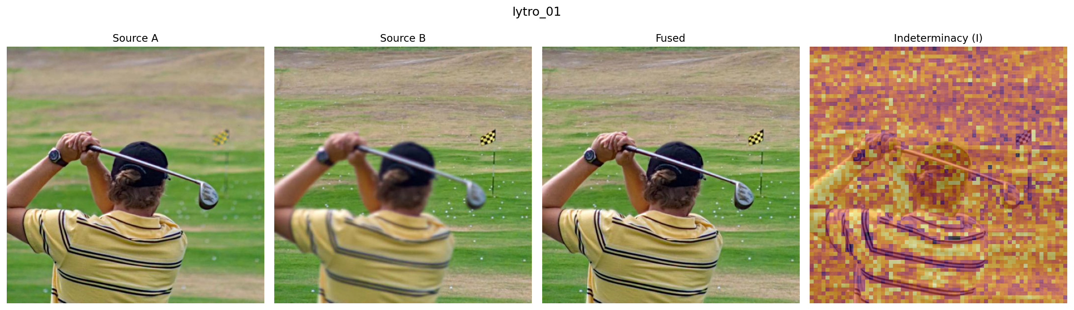
Figure 1. Source A, Source B, fused output, and indeterminacy overlay for lytro_01.
Figure 2 shows the discrete per-patch source decision for the same pair as a spatial map. The segmentation between foreground (blue, source A selected) and background (red, source B selected) is clean and anatomically coherent with the subject's silhouette, with intermediate values (the blend regime) concentrated at the actual boundary.
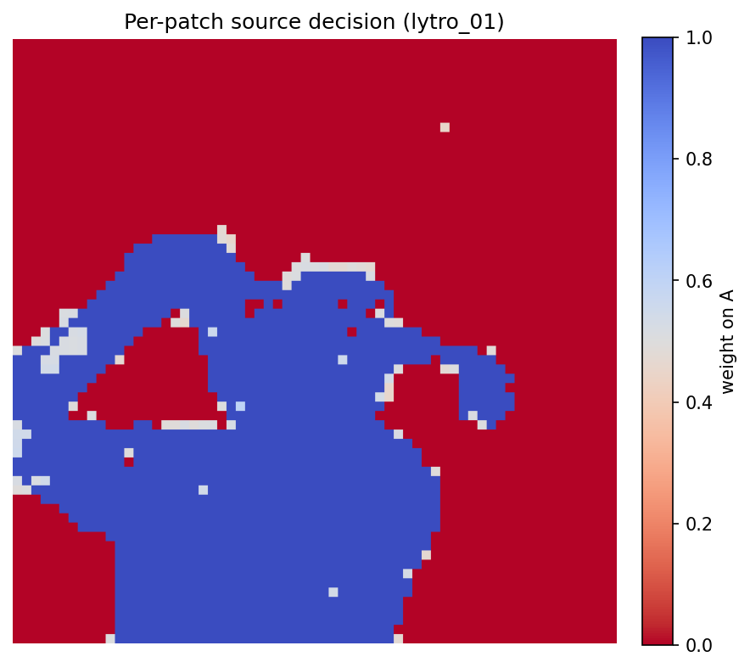
Figure 2. Per-patch blend weight on source A for lytro_01. 1.0 (blue) = fully source A, 0.0 (red) = fully source B.

4.2 Aggregate Results (20-pair mean)
Metric | Ours (full) | Naive avg. | Guided Filter
MI (total) | 6.080 | 4.499 | 5.629
Spatial Frequency | 19.367 | 11.578 | 19.340
Qᵃᵇᶠ | 0.7694 | 0.5702 | 0.7681
Table 1. Mean metric values across all 20 Lytro pairs.
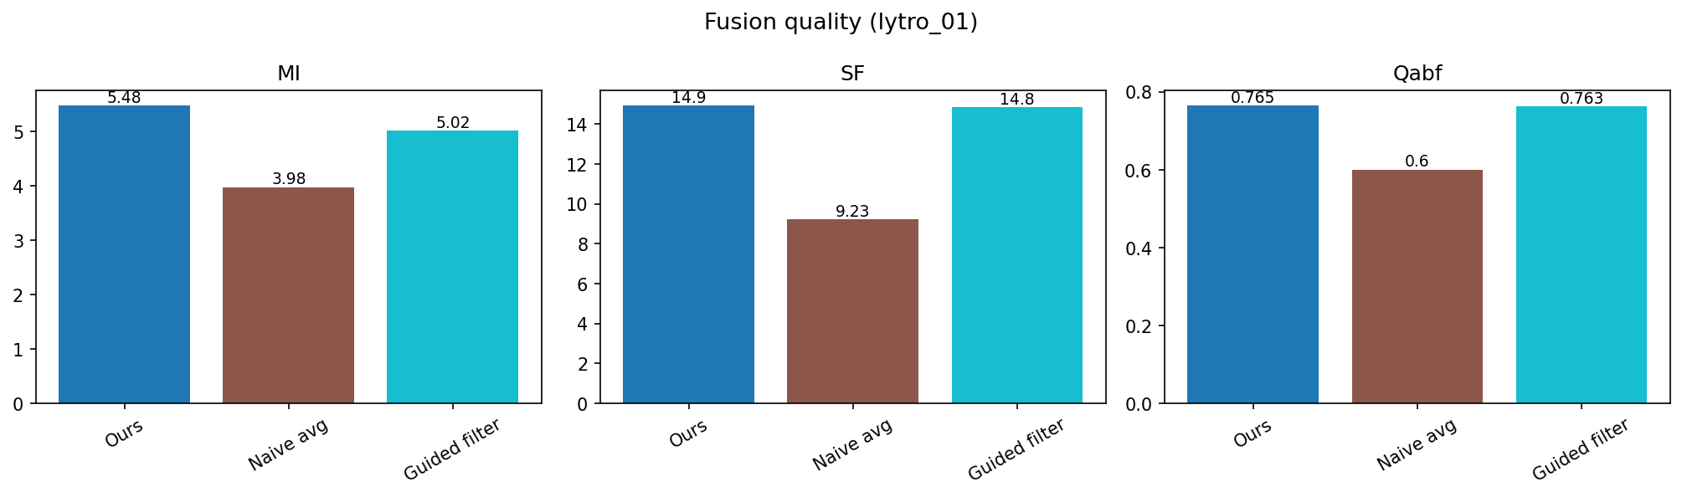
Figure 3. Metric comparison for the representative pair lytro_01 (single-pair illustration; see Table 2 for the full 20-pair statistical comparison).

4.3 Statistical Comparison: Ours vs. Guided Filter Fusion
Table 1's means show our method ahead of GFF on every metric, but means alone do not establish whether that gap is reliable. Table 2 reports the paired per-pair comparison, which gives a substantially more qualified picture.
Metric | Mean diff. | Pairs favoring ours | p-value
MI | +0.451 | 20 / 20 | 3.6 × 10⁻¹²
Qᵃᵇᶠ | +0.0013 | 13 / 20 | 0.031
Spatial Frequency | +0.028 | 13 / 20 | 0.331
Table 2. Paired comparison, ours (full) vs. Guided Filter Fusion, across 20 Lytro pairs. Shaded rows (green) are statistically significant at p < 0.05; unshaded rows (tan) are not.
The honest summary: our method preserves more mutual information from both sources, with a result that is not close (every one of the 20 pairs favors it, by a wide margin in significance). On Qᵃᵇᶠ, the edge-preservation metric the method's design most directly targets, the win is real but narrow — statistically significant at the conventional threshold, but only just, with a 13/20 win rate and a mean advantage of 0.0013 on a metric that ranges roughly 0–1. On raw sharpness, there is no demonstrated advantage over GFF at all. This is reported as the actual finding rather than emphasizing the metric that looks best.

4.4 Statistical Comparison: Ours vs. Naive Averaging
Against the trivial baseline, the result is unambiguous: every one of the 20 pairs favors our method on every metric, with p-values below 10⁻⁸ throughout (MI: p = 6.3×10⁻¹⁴; SF: p = 9.6×10⁻¹⁰; Qᵃᵇᶠ: p = 1.6×10⁻⁹). This confirms the method is doing substantive, non-trivial fusion work — a necessary but not sufficient result, given Section 4.3's more measured comparison against a genuine baseline.

5. Ablation: Does Hyperedge Aggregation Help?

5.1 A Note on Threshold Calibration
The indeterminacy threshold θ default was recalibrated during development from an initial 0.3 to 0.75. The original value was set before the indeterminacy distribution had been inspected on real photographs; once measured, the empirical distribution of I on real Lytro images was found to be concentrated in roughly the 0.6–0.8 range (driven by the underlying sharpness statistics being log-normally distributed across a typical photograph), which meant θ = 0.3 routed over 99% of patches into the aggregation branch — not wrong, exactly, but it made the threshold's discriminating role meaningless and the resulting aggregation-mask diagnostic uninformative. θ = 0.75 was chosen empirically to produce a roughly 50% aggregation rate on real data; the headline metrics (MI, SF, Qᵃᵇᶠ) were verified to be insensitive to this choice across the swept range 0.3–0.85.

5.2 Per-Pair Effect of Aggregation
Aggregate means (Section 4.2 already shows ours-full and ours-no-aggregation are within 1.3% of each other on every metric) understate what is actually a clear, consistent, statistically significant effect once examined per-pair. Figure 4 shows the per-pair difference (full − no-aggregation) for all 20 pairs on all three metrics.
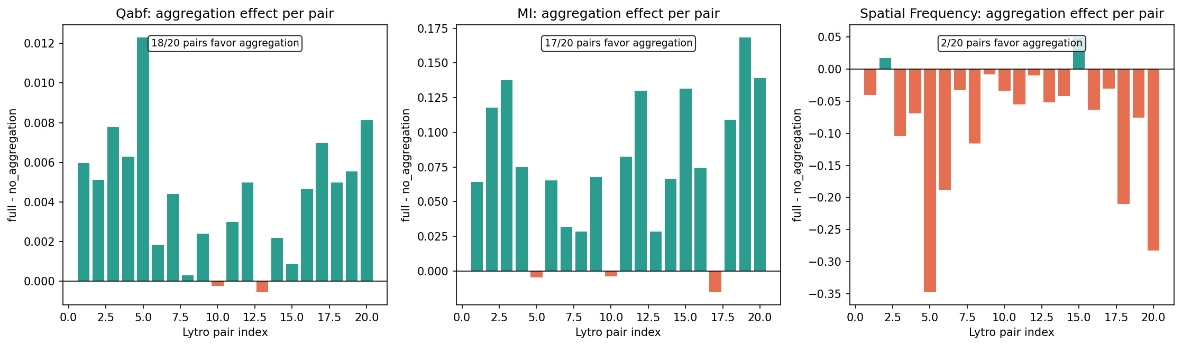
Figure 4. Per-pair effect of hyperedge aggregation (full − no-aggregation) on Qᵃᵇᶠ, MI, and Spatial Frequency. Green = aggregation helps that pair; orange = aggregation hurts.
Metric | Mean diff. | Pairs favoring aggregation | p-value
Qᵃᵇᶠ | +0.0043 | 18 / 20 | 7.8 × 10⁻⁶
MI | +0.0747 | 17 / 20 | 4.7 × 10⁻⁶
Spatial Frequency | −0.0848 | 2 / 20 | 0.0012
Table 3. Paired comparison, ours (full) vs. ours (no-aggregation), across 20 Lytro pairs.
All three results are statistically significant. Aggregation reliably improves edge-preservation and information-retention quality, and reliably reduces raw output sharpness. This is not a contradiction or a sign of an unstable method — Section 5.3 traces the actual mechanism producing this tradeoff.

5.3 Mechanism: Why Aggregation Trades Sharpness for Structure
Rather than leave Table 3's pattern unexplained, the mechanism was traced directly on real data (lytro_01). Of 4,225 patches, 183 received a different hard source decision under aggregation than under no-aggregation. Of those, 122 flipped from source B to source A specifically — and at those exact 122 patches, source B was the locally sharper option (mean raw sharpness 49.1 vs. source A's 23.8).
In other words: aggregation is overriding the locally optimal sharp choice at a meaningful subset of patches, in favor of what the patch's perceptually-similar neighborhood collectively supports. This explains the entire pattern in Table 3. The overridden patches are individually less sharp than the locally-optimal alternative would have been (hence the Spatial Frequency cost), but the neighborhood-consensus choice produces a more structurally and informationally coherent result across the patch's local context (hence the MI and Qᵃᵇᶠ gains). This is a genuine, explicable design tradeoff rather than noise, and is the central finding this report has to offer about what hyperedge aggregation actually does.

6. Implementation Findings
Two real defects were found and fixed while producing the results above, both through direct investigation against real data rather than synthetic test cases. Both are documented here because they affected what the “correct” result looked like, and because the investigation process itself is part of demonstrating the project's research rigor.

6.1 Indeterminacy Normalization Bug
The first run of the full pipeline on a real Lytro pair produced an indeterminacy distribution with mean I = 0.964 and 85% of patches above I = 0.9 — essentially uniform, with no usable signal. The cause was traced to linear min-max normalization of Laplacian-variance sharpness, which is log-normally distributed across a real photograph (the median sharpness value sat at roughly 0.6% of the 99th percentile in the test image). Linear normalization against any reasonable upper bound compresses the entire bulk of the distribution toward zero for both sources simultaneously, which the indeterminacy formula misreads as universal ambiguity. The fix applies a log1p transform before normalizing, which spreads the bulk of a log-normal distribution across the usable range (verified: the median-to-99th-percentile ratio improved from 0.006 to 0.39 on the same test image). This fix, plus the threshold recalibration described in Section 5.1, is what made the per-pair results in this report meaningful rather than degenerate.

6.2 Guided Filter Fusion Baseline Crash
Running the ablation at full scale (Section 5) surfaced a second defect: the GFF baseline raised an exception on 10 of the 20 real Lytro pairs. Investigation found that
cv2.ximgproc.guidedFilter, at the small radius the GFF paper specifies for its detail layer, produces NaN output over large contiguous image regions — in two of the ten affected pairs, over the entire image. This was confirmed not to be the previously-known eps-underflow issue (both the guide image and the comparison weight map have substantial local variance in every affected region, ruling out the flat-region explanation), and was matched directly to two long-standing, still-open upstream OpenCV reports (opencv_contrib issues #1288 and #760) describing region-confined defective output at small guided-filter radii, independent of input statistics. A fixed larger radius was tested as a workaround and rejected: retrying at radius 15 still left 2 of the 10 affected pairs at 90–99% NaN. The implemented fix detects NaN after each guided-filter call and falls back to the raw, unfiltered weight map for that pass rather than crashing, with the fallback occurrence reported (and tested against the real affected pairs) rather than silently absorbed.

7. Limitations and Future Work
- Evaluation is limited to the Lytro dataset (20 pairs, no ground truth). The MFI-WHU loader (120 pairs, with ground truth, enabling SSIM evaluation) is implemented and unit-tested but was not included in the headline results in this report.
- The Spatial Frequency cost of aggregation (Section 5.2) is a real, unresolved tradeoff. Whether a soft blend of the locally-optimal and consensus-aggregated decisions recovers some of the lost sharpness without sacrificing the Qᵃᵇᶠ/MI gains is an open question this report does not answer.
- The comparison against GFF (Section 4.3) used the paper's default parameters; a more favorable comparison for either method under different parameter choices has not been ruled out.
- The GFF fallback mechanism (Section 6.2) produces a degraded (un-smoothed) result on affected pairs rather than a true guided-filter result; this means the GFF numbers reported here are a slight underestimate of GFF's best-case performance on those specific pairs.

8. Conclusion
The neutrosophic hypergraph fusion method substantially outperforms naive averaging and shows a real, if narrower than initially hoped, advantage over Guided Filter Fusion — a clear win on information preservation, a marginal win on edge preservation, and no demonstrated advantage on raw sharpness. The hyperedge aggregation mechanism, the method's central novel contribution, has a small but statistically robust and mechanistically explained effect: it trades a measurable amount of pixel-level sharpness for improved structural and informational coherence at ambiguous patches, by deferring to neighborhood consensus over locally optimal but isolated decisions. This is reported as the project's actual finding, including the parts of it that are more qualified than a first look at the aggregate numbers would suggest.

