**Calculating the Sound Absorption Coefficient of Sound Absorbing Materials Using Flow Resistance**

**ZHU Congyun（朱从云）[1]*, SHAO Zhenya（邵镇亚）， DING Guofang（丁国芳）**

*School of Mechanical Science & Engineering, Zhongyuan University of Technology, Zhengzhou 450007, China*

**Abstract: Flow resistance is one of the important factors that affect the accuracy of calculating sound absorption coefficient. The flow resistance of porous sound absorbing materials is usually measured by experiment, but due to the interference of sample preparation effect and environmental factors, the actual measurement results often have errors. In order to reduce the calculation error of sound absorption coefficient caused by inaccurate measurement of flow resistance, this study measured the sound absorption coefficient of any two frequencies in the sound absorption material by impedance tube method, and then calculated the flow resistance of the sound absorption material by using MATLAB cycle program according to the empirical formula of wave number and acoustic impedance in the fiber material. Finally, the sound absorption coefficient, the real part of impedance and the imaginary part of impedance of the material at different frequencies are calculated theoretically, and the correctness of the theoretical calculation is verified by experiments. The experimental results show that the calculated values are basically consistent with the measured values, and the feasibility and reliability of this method are also verified. A simple method for calculating the absorption coefficient of sound absorbing materials is presented.**

***Keywords:*** *flow resistance; Acoustic impedance; Sound absorption coefficient*

**CLC numbers:** TB527

**Introduction**

Porous materials have a large number of interconnected pores inside, which play a role in sound absorption. When sound waves propagate inside the material, the viscosity of the air and the thermal conductivity of the material will lead to a gradual loss of sound energy. According to practice, there is a close correlation between porosity and sound absorption performance [1-3]. If the porosity is too small, the material will become dense, making it difficult for sound waves to enter the interior of the material, resulting in poor sound absorption performance. On the contrary, if the porosity is too large, the material will become too loose, allowing sound waves to pass through the pores of the material without sufficient friction, resulting in a significant loss of sound energy and affecting sound absorption performance. In addition, the size of porosity also reflects the resistance encountered by air as it flows through the material, i.e. the magnitude of the flow resistance [4-5]. Therefore, we can evaluate the acoustic performance of porous sound absorbing materials through flow resistance, and conduct acoustic calculations and analysis.

Wang [6] proposed a method for measuring the flow resistance of materials in an impedance tube that can measure the sound absorption coefficient of materials using the existing transfer function method, and analyzed the accuracy of measuring the flow resistance using this method and verified its feasibility through experiments; Li [7] used the direct current method to experimentally measure the flow resistance of porous materials and the transfer function method to measure the sound absorption coefficient of porous materials, and found that there is an optimal flow resistance that allows the porous sound absorption material to reach its maximum sound absorption coefficient; Wang [8] designed a device for measuring flow resistance, and used this device to measure the flow resistance of different porous materials. At the same time, impedance tubes were used to measure the sound absorption coefficient of different porous materials; Ma [9] first measured the sound absorption coefficient and flow resistance of four samples of sound absorbing materials, and then performed inverse operations on other parameters of the materials through differential evolution algorithm. The reliability of the inverse operation results was also verified by experiments. Xiong [10] added rings, applied Vaseline, or polished the surface of sound absorbing materials samples during flow resistance measurement, achieving the effect of reducing significant errors in flow resistance measurement.

Through the above research, it can be seen that the flow resistance of porous sound absorbing materials is generally measured by experiments, but due to the interference of sample preparation effect and environmental factors, the actual measurement results are often inaccurate [11].In order to avoid the calculation error of sound absorption coefficient caused by inaccurate experimental measurement of flow resistivity, the process of experimental measurement of flow resistivity was omitted in this study, and the sound absorption coefficient of any two frequencies was measured in the sound absorption material by impedance tube method. Then, according to the empirical formula of wave number and acoustic impedance in fiber materials. The flow resistance of the sound absorbing material is calculated by using MATLAB cycle program. By changing the thickness of the absorbing material, the absorbing coefficient, the real part of impedance and the imaginary part of impedance of the absorbing material at different frequencies are calculated theoretically, and the calculated values are verified by experiments. The results of several experiments show that the calculated values are basically consistent with the measured values, which also shows that the method is feasible.

1. **Calculation method of sound absorption coefficient**

Fig. 1 shows the acoustic impedance layout of the sound absorbing material:

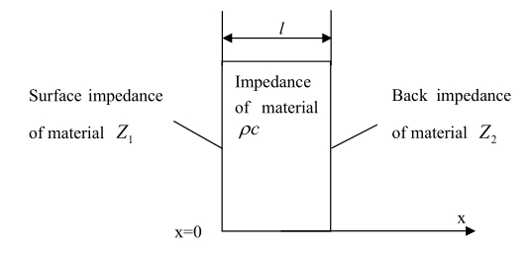

1. Acoustic impedance layout of the acoustic absorbing material

It can be seen from Fig. 1, the acoustic impedance Z1 at *x*=0 is [12]：

 (1)

When the sound absorbing material is backed by a rigid wall, i.e., *Z2*=0, then the acoustic impedance *Z1* at *x*=0 is:

 (2)

In this paper, glass fiber is used as the sound absorbing material for this study, whose density *ρ(ω)* and bulk elastic modulus *K(ω)* are [13]:

 (3)

 (4)

Among them:

 (5)

*ρ0*——Air density *Kg/m3*

*ƒ*——Acoustic frequency *Hz*

*σ*——Flow resistance *Ns/m4*

The wave numbers *γ(ω)* and acoustic impedance *ρc(ω)* of sound waves propagating in sound absorbing materials are:

 (6)

 (7)

Among them: *ϕ*——Porosity

1. **Calculating the flow resistance of sound absorbing materials using MATLAB cycles**

Measure the sound absorption coefficient at two different frequencies: if the sound absorption coefficient at frequency *ƒ1* is *α1*; The sound absorption coefficient at frequency *ƒ2* is *α2*. Therefore, according to Eq. (3), Eq. (4), and Eq. (5), the density *ρ(ω)* and bulk elastic modulus *K(ω)* of the sound absorbing material at two different frequencies are:

 (8)

 (9)

Substitute Eq. (8) and Eq. (9) into Eq. (6) and Eq. (7), respectively, to obtain the wave numbers *γ(ω)* and acoustic impedance *ρc(ω)* of sound waves propagating in the sound absorbing material at two frequencies:

 (10)

 (11)

If the back of the sound absorbing material is a rigid wall, the surface acoustic impedance of the sound absorbing material is:

 (12)  (13)

The sound absorption coefficient at two frequencies is [14]:

 (14)

From Eq. (12) to Eq. (14), it can be seen that the flow resistance coefficient *σ* and porosity coefficient *ϕ* are unknown. However, solving these two unknowns using general methods is relatively difficult, so it is necessary to use a MATLAB cyclic program to solve the equation.

1. **Theoretical calculation and experimental verification**
2. **Experimental measurement of sound absorption coefficient**

Standing wave ratio method, also known as impedance tube method, is a method to measure the absorption coefficient of sound absorbing materials using impedance tubes [15-16]. The sound absorbing material is arranged at one end of the impedance tube. Figure 2 shows the standing wave ratio method. The speaker generates sinusoidal plane wave incidence, the incident wave meets the sound absorbing material to form reflected wave, and the incident wave and reflected wave are superimposed in the impedance tube to form standing wave. It is assumed that the acoustic wave in the impedance tube is positive along the negative direction x, the incident sound pressure is *Pi*, the reflected sound pressure is *Pr*, and the reflection coefficient is *r* [17].

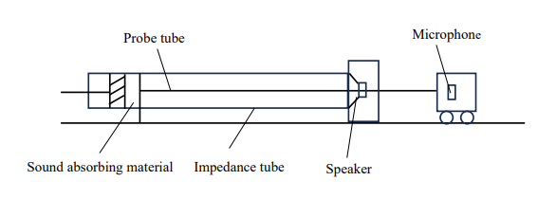

1. Schematic diagram of standing wave ratio method

When *Pi* and *Pr* are in phase, the maximum measured is:

 (15)

When *Pi* and *Pr* are in reverse phase, the minimum measured is:

 (16)

Standing wave ratio:

 (17)

Absorption coefficient:

 (18)

In this experiment, impedance tube method was used to measure the absorption coefficient of sound absorbing material. The signal is amplified by the power amplifier and then converted into sound waves by the loudspeaker into the impedance tube. The sound pressure signal collected by the microphone at the corresponding position in the impedance tube is collected by the signal acquisition front end, and then the sound pressure signal is imported into the computer, and then the acquired data is processed by MATLAB software program. To obtain the sound absorption coefficient of the material [14]. Fig. 3 is the physical diagram of the device for measuring the sound absorption coefficient, and Fig. 4 is the flow chart for measuring the sound absorption coefficient.

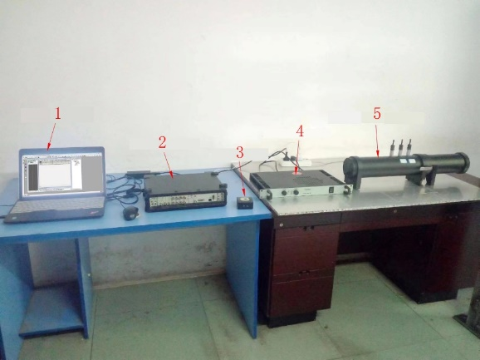

1-laptop; 2-signal acquisition front-end; 3-sound level calibrator;

4-power amplifier; 5-dual microphone impedance test tube.

1. Physical diagram of the device for measuring the sound absorption coefficient

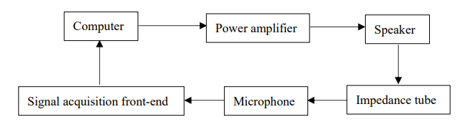

1. Flow chart of measuring sound absorption coefficient
2. **The theoretical calculation is verified by experiment**

According to experiment 3.1, the sound absorption coefficients of sound absorbing materials with different thicknesses at 500Hz and 1000Hz were measured respectively, and then the flow resistivity and porosity at different thicknesses were derived using MATLAB according to the measured values, and recorded in Table 1. Table 1 shows the experimental measured values and theoretical calculated values of different thicknesses of acoustic absorbing materials. Fig. 5 shows the program of MATLAB to reverse the flow resistance and porosity of the sound absorbing material.

1. Experimental measurement values and theoretical calculation values of different thicknesses of acoustic absorbing materials

|  |  |  |  |  |
| --- | --- | --- | --- | --- |
| Thickness*/mm* | Porosity | Absorption coefficient | | Flow resistivity/(*Ns/m4)* |
| 500Hz | 1000Hz |
| 50 | 2% | 0.91 | 0.87 | 15905 |
| 100 | 2% | 0.90 | 0.85 | 20688 |
| 150 | 2% | 0.93 | 0.87 | 24048 |
| 200 | 2% | 0.94 | 0.89 | 26829 |
| 250 | 2% | 0.95 | 0.91 | 28912 |
| 300 | 2% | 0.96 | 0.93 | 30830 |

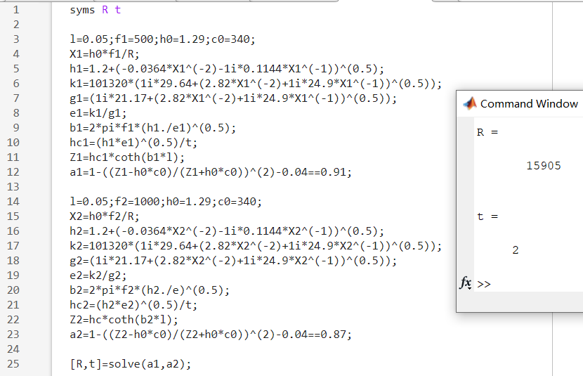

1. MATLAB inverse flow resistance and porosity of sound absorbing material program

From Fig. 6 to Fig. 8 respectively show the relationship between theoretical calculation and experimental measurement of sound absorption coefficient, real part of impedance, imaginary part of impedance, and frequency when the material is of different thickness, the porosity is 2%, and the rigid wall is behind it.

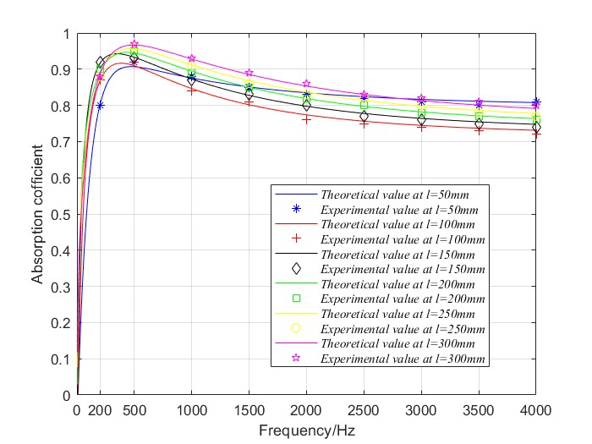

1. Relation between sound absorption coefficient and frequency under different thicknesses calculated theoretically and measured experimentally

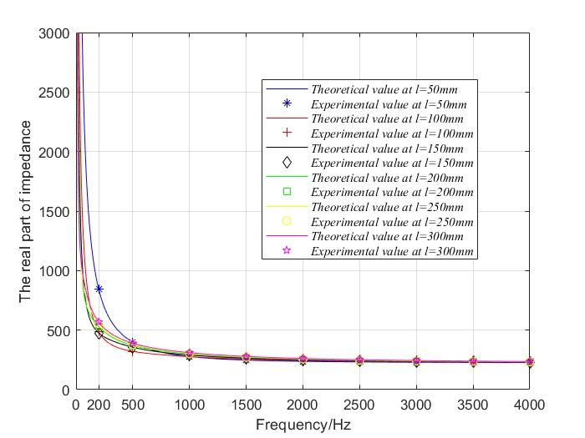

1. Relation between impedance real part and frequency under different thicknesses calculated theoretically and measured experimentally

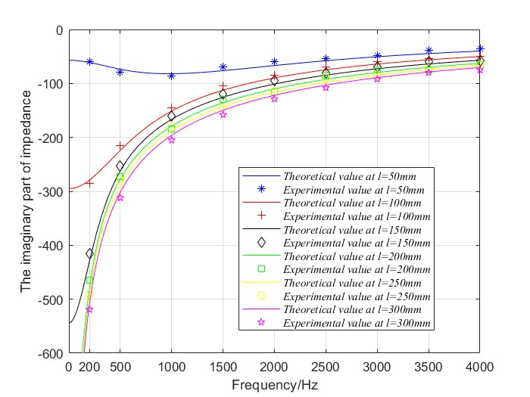

1. Relation between imaginary part of impedance and frequency under different thicknesses calculated theoretically and measured experimentally

After inverse flow resistance is calculated using MATLAB cycle program, the relationship between theoretical calculation of sound absorption coefficient, real part of impedance and imaginary part of impedance and frequency is drawn respectively. Then, the acoustic absorption coefficient, the experimental values of the real part and the imaginary part of the impedance of nine places were measured respectively when the frequency was 200Hz, 500Hz, 1000Hz, 1500Hz, 2000Hz, 2500Hz, 3000Hz, 3500Hz and 4000Hz, and the measured experimental values were compared with the theoretical calculated values. From Fig. 6 to Fig. 8, it can be seen that the theoretical calculated values are basically consistent with the experimental measured values.

1. **Conclusions**

In this study, the process of experimental measurement of flow resistance is omitted, and the sound absorption coefficient of any two frequencies is measured in the sound absorption material by impedance tube method. Then, according to the empirical formula of wave number and acoustic impedance in the fiber material, the flow resistance of the sound absorption material is calculated by MATLAB cycle program in reverse order to avoid the calculation error of sound absorption coefficient caused by inaccurate experimental measurement of flow resistance. Then, by changing the thickness of the absorbing material and using the flow resistance obtained by the reverse operation, the absorption coefficient, the real part of impedance and the imaginary part of impedance of the absorbing material at different frequencies are calculated, and the relationship between them and the frequency is drawn. Finally, the calculated acoustic absorption coefficient, real and imaginary parts of impedance are compared with the measured values. The results show that the theoretical calculated value is basically consistent with the experimental measured value, which further verifies the feasibility and reliability of calculating the sound absorption coefficient by using the flow resistance obtained by the reverse operation, and provides a simple method for calculating the sound absorption coefficient of the sound absorption material theoretically.

**References**

1. ZHU R X, LI J, BI W L, *et al*. Study on inorganic porous sound absorption materials [J]. *Journal of Liaoning University of Science and Technology*, 2017, 40(03): 194-199. (in Chinese)
2. XING T, LI X H, GE X L. Research progress and prospect of porous absorption materials [J]. *Noise and Vibration Control*, 2014, 34(S1): 45-48. (in Chinese)
3. LENG P B, BIAN G L, WANG Q L, *et al*. The sound absorption performance and influencing factors of porous sound absorbing materials in health engineering [J]. *China Health Engineering*, 2011, 10 (04): 338-339+341. (in Chinese)
4. XIANG J H, LIAO R D, PU D Y. Performance of sound-absorbing material based on flow resistivity [J]. *Journal of Beijing University of Technology*, 2009, 29(11): 10181021+1034. (in Chinese)
5. BI Y Z. Development and experimental study of steady state airflow resistance measurement system for ultra-thin porous materials[D]. Hefei: Hefei University of Technology, 2022. (in Chinese)
6. WANG P. A study on the acoustic measurement methods of static flow resistivity [D]. Nanjing: Nanjing University, 2013. (in Chinese)
7. LI Y C. Study on sound absorption properties of porous Materials [D]. Qinhuangdao: Yanshan University, 2021. (in Chinese)
8. WANG L H. Analysis and optimization of sound absorption performance of porous material used in automobile [D]. Jilin: Jilin University, 2017. (in Chinese).
9. MA W T. Analysis and optimization of sound absorption and insulation properties of acoustic materials for vehicle high frequency noise [D]. Jilin: Jilin University, 2021. (in Chinese)
10. XIONG X Z. Research on measurement for acoustic performance of automotive porous sound absorbing materials [D]. Shanghai: Shanghai University of Engineering and Technology, 2021. (in Chinese)
11. GB/T 25077-2010, Acoustics—Materials for acoustical applications—Determination of airflow resistance[S]. Beijing: Standards Press of China, 2010. (in Chinese)
12. YU C S, LUO Z, LUO H T, *et al*. Research progress on acoustic model of porous sound absorbing materials and measurement method of its characteristic parameters[J]. *Materials Reports*, 2002, 36(04):226-236. (in Chinese)
13. ZHU C Y. Research on theories and methods of active sound absorption [D]. Wuhan: Huazhong University of Science and Technology, 2005. (in Chinese)
14. ZHANG R Q, ZHU C Y, DING G F, *et al*. Active absorption of perforated plate based on airflow [J]. *Journal of Donghua University*, 2022, 39(6): 590-596.
15. GB/T 18696,1-2004. Acoustics—Determination of sound absorption coefficient and impedance in impedance tubes—Part 1: Method using standing wave ratio[S]. Beijing: Standards Press of China, 2004. (in Chinese)
16. WANG X L, LIU B L, YANG J, *et al*. Utilizing vector hydrophones to achieve an active anechoic terminal in an acoustic tube [J]. *Chinese Journal of Acoustics*, 2019, 38(02): 201-214.
17. FAN D D. The design and realization of a measurement system by impedance tube for sound absorption coefficient and sound tramission loss[D]. Jilin: Jilin University, 2017. (in Chinese)

1. Received date: 2023-10-06

   Foundation item: National Natural Science Foundation of China (Nos. 51705545 and 15A460041)

   * Correspondence should be addressed to ZHU Congyun, E-mail: zcy711126@ 163.com