**Calculating Sound Absorption Coefficients of** **Sound-Absorbing Materials Using Flow Resistivity**

School of Intelligent Mechatronics Engineering (School of Industrial Design), Zhongyuan University of Technology, Zhengzhou 450007, China

**Abstract:** **MXene is an emerging class of two-dimensional (2D) layered transition metal carbides or nitrides. Due to the highly tunable components and surface functional groups, they hold great potential in electrocatalytic hydrogen evolution reaction (HER). However, MXene nanosheets suffer from a strong tendency to restack and a lack of active edge sites. In this work, the porous Ti3C2T*x* was synthesized by an oxidation and etching two-step strategy and then characterized by a series of spectroscopic techniques. The obtained porous Ti3C2T*x* possesses a large number of in-plane pores and shows a high specific surface area (111.4 m2/g). This not onl[1]y creates abundant active edge sites but also** **enhances the mass transfer and increases the accessibility of the active sites. Compared with Ti3C2T*x*, in a 0.5 mol/L H2SO4 electrolyte, the porous Ti3C2T*x*shows a 1.7 times higher** **electrochemical surface area (440 mF/cm2), a 95.2% lower charge transfer resistance (12.8 Ω), and a 69.8% lower Tafel slope (144 mV/dec), and thus exhibits a lower overpotential (535.5 mV) with good stability at a current density of 10 mA/cm2. At the same time, the HER performance of porous Ti3C2T*x* can be further enhanced by** **near-infrared laser irradiation based on the localized surface plasmon resonance effect.**

**Keywords:***porous Ti3C2Tx, hydrogen evolution reaction (HER); active edge site; localized surface plasmon resonance*

**CLC number:** O611 **Document code:** A

**0 Introduction**

Hydrogen is a renewable and green energy source, serving as a potential alternative to traditional fossil fuels, meeting the demands of sustainable social development[1]. Electrochemical water splitting via the hydrogen evolution reaction (HER) is considered as the most economical and efficient method for hydrogen production[2]. Pt-based noble metal materials have attracted great attention due to their efficient HER performance[3-5], but high cost and scarcity hinder their large-scale applications[6]. Therefore, the rational design of economically efficient HER electrocatalysts is an important research topic at present[7-9]. MXene is an emerging class of two-dimensional (2D) transition metal carbides or nitrides[10-12] with exhibit excellent conductivity[13], highly tunable composition[14], and surface functional groups[15], holding great potential in HER[16]. However, MXene nanosheet has a large aspect ratio structure, which mainly exposes in-plane sites with poor activity, leading to poor intrinsic a(1)ctivity[17-18]. Moreover, due to the strong

Hydrogen is a renewable and green energy source, serving as a potential alternative to traditional fossil fuels, meeting the demands of sustaina。

$m{\ddot{x}}_{1}+c\left(ω\right)\left({\dot{x}}_{1}-{\dot{x}}_{0}\right)+k\left(ω\right)\left(x_{1}-x_{0}\right)=0$ (2)

$Z_{s}=Z_{0}\coth{(}γl)$ (2)

**Table 1** Material parameters

|  |  |  |  |  |  |
| --- | --- | --- | --- | --- | --- |
| Material parameter | Material | | Poisson's ratio | | Density  /(kg·m/s^2) |
| Rubber O-rings | Nitrile Butadiene Rubber (NBR) | 0.49 | | 1200 | |
| Other | Structure steel | 0.3 | | 7850 | |

**1 Materials and methods**

**1.1 Materials**

Saskjldjaslj asjdkas asjdkj aksjdjas jkjdasjk jasjdkajskd jasj kjdasj kajsjd asjk jkasj djasj kdjaskj djakskj dasj jdasjkjakj jaksdjasj jdajs dajs jkjasjd jask djas jdajk.

**1.1.1 Materialss**

topic at present[7-9]. MXene is an emerging class of two-dimensional (2D) transition metal carbides or nitrides[10-12] with exhibit excellent conductivity[13], highly tunable composition[14], and surface functional groups[15], holding great potential in HER[16]. However, MXene nanosheet has a large aspect ratio structure, which mainly exposes in-

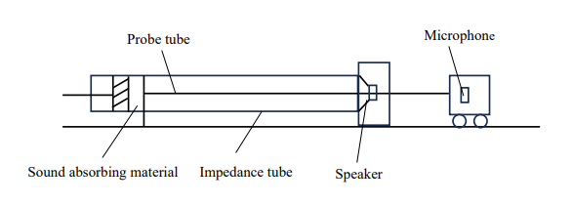

Fig. 5 Comparison of theoretical and experimental real part of acoustic impedance

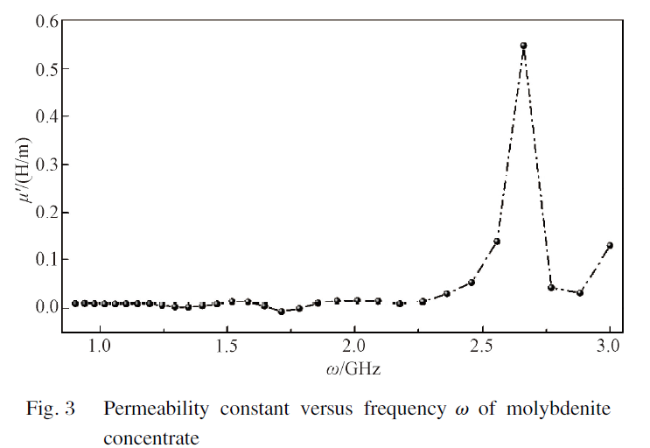

1. Received date: 2023-10-06

   Foundation item: National Natural Science Foundation of China (No. 51705545)

   * Correspondence should be addressed to ZHU Congyun, email: zcy711126@ 163.com

   Citation: ZHU C Y, SHAO Z Y, DING G F. Calculating sound absorption coefficients of sound-absorbing materials using flow resistivity [J]. *Journal of Donghua University* (*English Edition*), 2025, 42(2):