 | Vellore Institute of Technology, Chennai  School of Computer Science and Engineering  Course Code: BCSE355L Course Name: Cloud Architecture Design  Direct Assessment III Max Marks: 10
Team Members
Reg. ID | Name
24BCE1520 | Nitish Kumar
24BCE1594 | Balan N
Faculty: S Vigneshwari
CollabDoc: A Real-Time Collaborative Document Editor with Operational Transformation and Stylometric Authorship Attribution, Deployed on AWS
Abstract
CollabDoc lets several people edit one document at the same time and then tells them who wrote which part. Edits are merged by a server-side operational transformation (OT) engine so that every client converges on identical text. A keystroke ledger records who typed each character, and a dependency-free softmax classifier over 44 stylometric features forms an independent opinion about the writing style of each block; the two are blended into a per-block confidence score. Because a document's editing state lives in the memory of one process, scaling it is a cloud-architecture problem, and this project treats it as one. The system was deployed on AWS as a k3s Kubernetes cluster on a single EC2 instance in ap-south-1 with three application pods, Kafka for cross-pod events, a Caddy router that hashes the document id so each document always reaches the same pod, RDS PostgreSQL in private subnets, S3 for uploads, ECR for images, and CloudWatch alarms and a budget for operations. The whole stack is described in Terraform and cost about US$2.5 per day while running; it has since been torn down because the AWS credits were used up. On a development machine an edit was acknowledged in 2.3 ms median (3.9 ms p95) against a 200 ms requirement, and the OT engine converged on 2000 of 2000 random concurrent-edit pairs.
Problem Statement
Group documents are written by several people, but ordinary shared editors answer neither of two questions that follow: how to keep every collaborator's copy identical under concurrent edits at low latency, and who actually wrote each part. The second matters in coursework and team reports, where a reviewer must tell a real contribution from a pasted one. A third, architectural question follows once the service has more than one user: how to run it on several backends in the cloud when a document's live state (its version counter) is held in the memory of a single process, and the operation log has no database constraint that would catch two processes numbering operations independently.
Highlights of the Project / Novelty
- Ledger-supervised stylometry. Text that the keystroke ledger proves a user typed becomes that user's labelled training corpus, so the model learns from the mechanical record and then forms an opinion independent of it.
- Length-aware blending. Stylometric weight grows with block length and is capped at 0.65, so a four-word heading is decided by keystrokes and a paragraph mostly by style; the model can never fully overrule the recorded keystrokes.
- Leave-one-out integrity report. Each block is judged by a model retrained without it, so a passage copied from one author does not vouch for itself. In a two-author demonstration this moved a copied passage from 59% to 98% "reads like Alice".
- Honest abstention. With fewer than two authors with three samples each, the model declines and attribution falls back to the ledger.
- Document-aware routing on Kubernetes. A Caddy router extracts the document id from the URL and uses rendezvous hashing over stable StatefulSet pod names, so each document is live on exactly one pod. Kafka carries presence and notifications between pods.
- One code path for scale-out. Every event leaves through a broadcaster interface even in one process, so the multi-pod path is the same code path as the single-process one.
- Cost-aware cloud design. k3s on one EC2 node gives real Kubernetes without the roughly US$73 per month EKS control-plane fee; a stop script pauses EC2 and RDS and brings the cost to about US$0.25 per day.
- Dual OT implementations, cross-checked. The Python server engine and its JavaScript browser port are checked against each other on random edits, because a divergence would silently desynchronise editors.
Dataset Link
The project uses no external dataset. The attribution model is trained at run time on each document's own ledger-labelled text, and the evaluation uses three synthetic writing styles built to differ on the measured features (server/tests/corpora.py in the repository). No original dataset was collected, so no Zenodo DOI exists.
Citation (no dataset DOI; reserved if a corpus is later archived): Nitish Kumar, Balan N, S Vigneshwari, "CollabDoc collaborative-writing corpus," Zenodo, [DOI to be assigned].
Project Demo Link
Not available. The project was deployed on AWS (k3s on EC2, RDS, S3, ECR) and demonstrated live, but the AWS free-plan credits have been used up and the stack has been torn down, so there is no live demo URL. The full deployment can be recreated from the repository with Terraform and deploy/deploy.ps1, and the screenshots, results and deployment configuration are included in this document and in the repository.
GitHub Repository Link
https://github.com/Zerko-sd/CollabDoc
Citation: Nitish Kumar, Balan N, S Vigneshwari, "CollabDoc: A Real-Time Collaborative Document Editor with Operational Transformation and Stylometric Authorship Attribution," GitHub repository, https://github.com/Zerko-sd/CollabDoc.
Architecture Diagram
Application architecture. A browser reaches the server through REST routers (accounts, documents, sharing, history) and a WebSocket (editing, presence, attribution). Both read through a per-document session that holds the OT state, the keystroke ledger and the attribution engine. Every event leaves through a broadcaster.
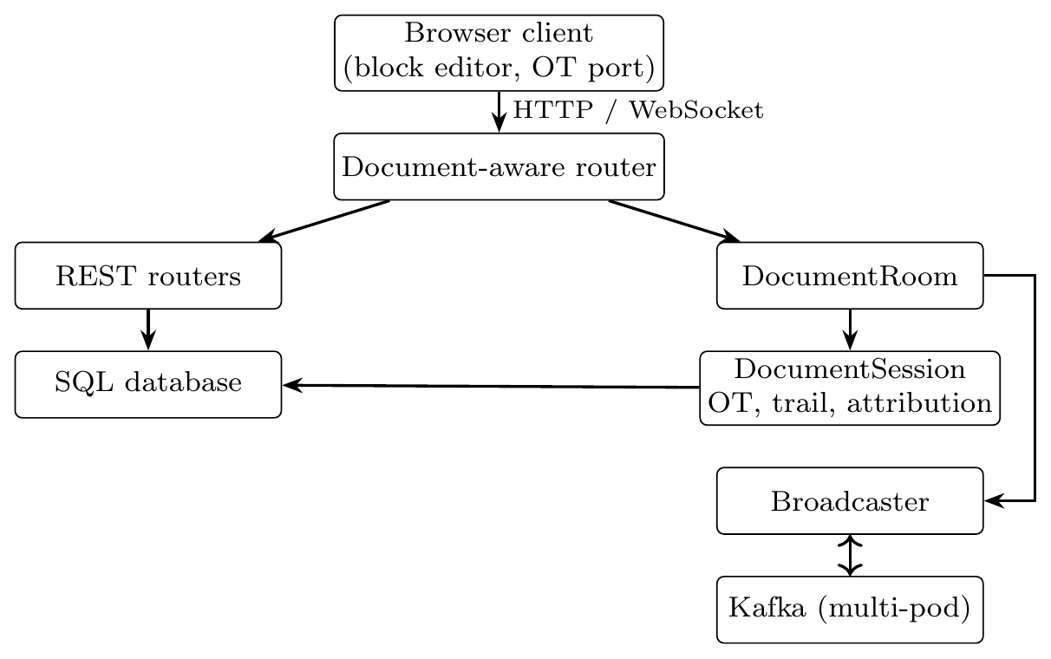
Fig. 1. Application request paths.
AWS deployment architecture. The browser reaches an Elastic IP in front of a Caddy router, which sends each document to one of three application pods. The cluster talks to RDS PostgreSQL (shared durable state, private subnets), an S3 bucket (uploads visible to every pod) and ECR (container image). The Kubernetes API is open to the owner's IP only, and the kubeconfig is handed over through SSM Parameter Store, so no SSH keys are used. CloudWatch records node and database metrics with four alarms (node status check, node CPU, database CPU, database storage), and a monthly AWS Budget tracks spend.
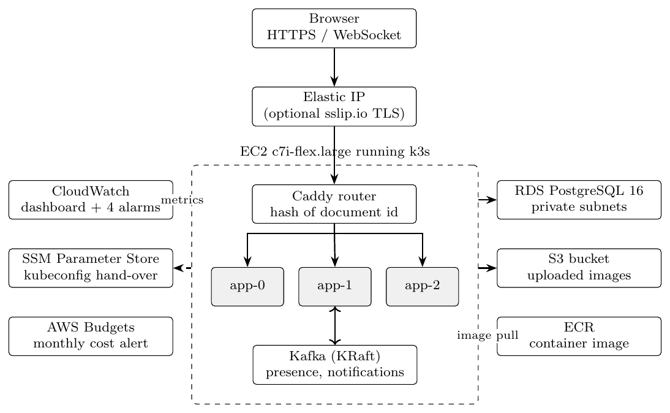
Fig. 2. AWS deployment architecture (ap-south-1).
Component | AWS / Kubernetes resource | Why
Application | StatefulSet "app", 3 pods | Stable pod names for the router to hash onto; ordered start so one pod at a time runs schema migrations
Router | Caddy Deployment + LoadBalancer Service | Sends every request for a document to the same pod; optional automatic HTTPS
Fan-out | Kafka (KRaft, one pod) | Presence and notifications reach users connected to other pods
Database | RDS PostgreSQL 16, private subnets | Shared, durable state for all pods
Uploads | S3 bucket, private | Every pod sees every image
Image | ECR repository | Pulled by the node with a pull secret refreshed every 6 hours from the instance role
Cluster | k3s on one EC2 c7i-flex.large | Real Kubernetes without the EKS control-plane fee
Operations | CloudWatch dashboard and alarms, AWS Budgets, stop/start scripts | Visibility and a hard handle on cost
Table I. Cloud components and the reason for each.
Why one document lives on one pod. A document's version counter is held in the memory of the pod that opened it. If two pods opened the same document, each would number operations independently and the copies would drift apart, and the operation log has no unique (document id, version) constraint to catch it. The router therefore hashes the id found in /ws/documents/{id}, /api/documents/{id}/... and /p/{id}. This favours consistency: a document is unavailable only while its pod fails over, never inconsistent. Every response carries an X-Served-By header so the routing is visible. Known limitation: after a pod failure the documents move to other pods and a connected editor should reload; a per-document lease would remove this.
Screenshots

Fig. 3. Block editor with live collaborators and authorship attribution.
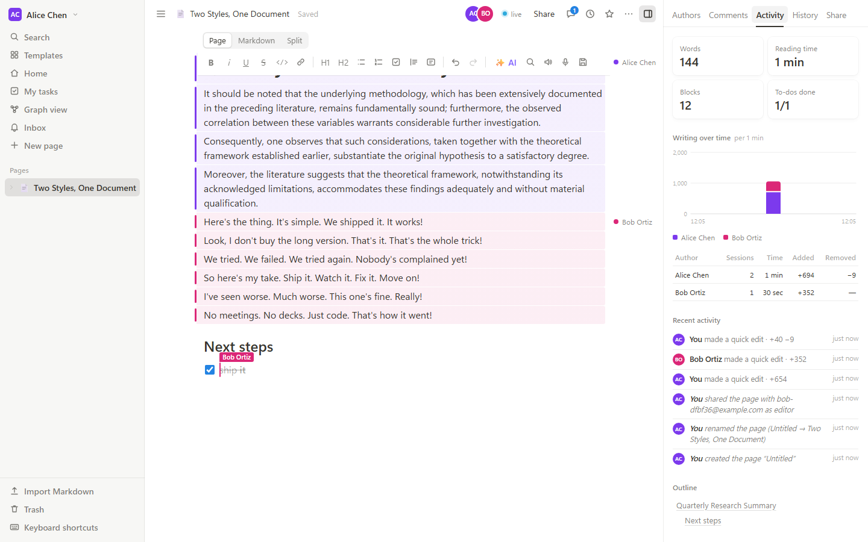
Fig. 4. Anchored comments and the per-author activity timeline.
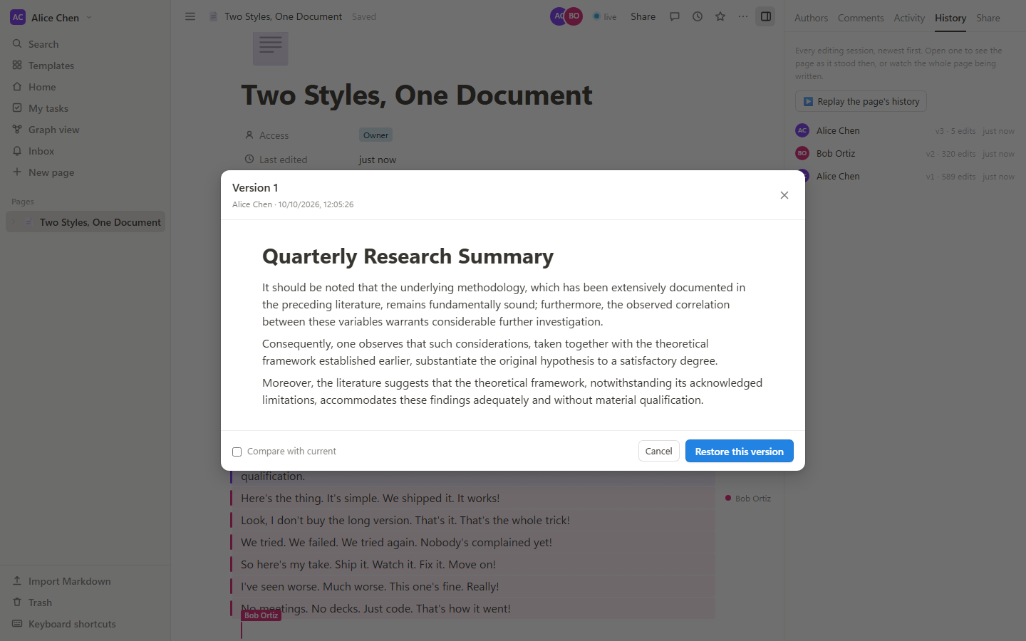
Fig. 5. Version history drawn from the operation log.
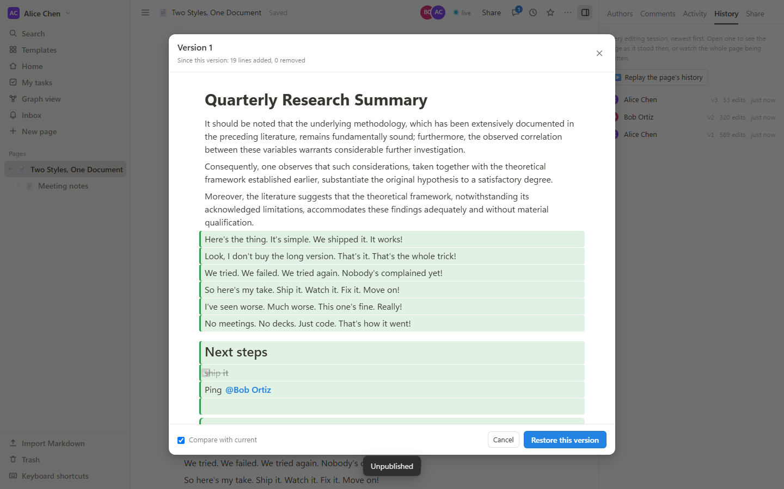
Fig. 6. Comparing a past version with the current page.
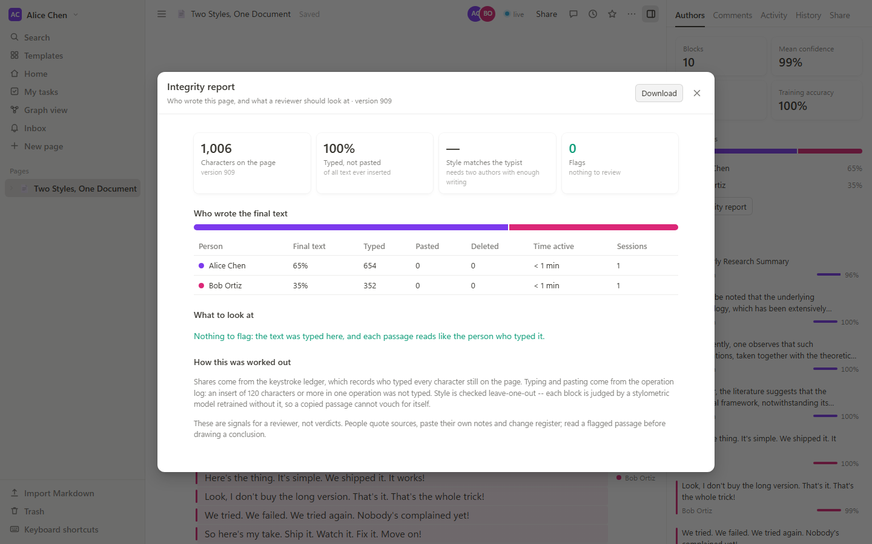
Fig. 7. Integrity report: share and effort per person, pastes and style-mismatch flags.
Results
Measured on the authors' development machine with the in-memory broadcaster and SQLite. They are not cloud benchmarks.
Measure | Result
Edit round trip (8 operations, demo script) | 2.3 ms median, 3.9 ms p95 (budget 200 ms)
Random concurrent edit pairs, convergence | 2000 / 2000
Random compose and invert cases | 1000 / 1000
Python vs. browser OT engine parity | Equal on all random cases
Held-out accuracy on synthetic corpora, 2 and 3 authors | 100% (floor 85%)
Stylometry vs. keystroke ledger agreement in demo | 100% over 6 blocks
Automated tests collected (pytest) | 205
Real-browser end-to-end checks | 55
Deployment cost while running / while stopped | about US$2.5 / US$0.25 per day
Table II. Measured results.
The latency sample is small (eight operations) and excludes network distance, so it shows that the server adds little delay rather than characterising wide-area behaviour. The 100% accuracy is on deliberately separable synthetic text and should not be read as real-world accuracy; the honest runtime measure is the agreement rate between stylometry and the ledger. A multi-client load script exists, but its results are not reported here. Browser testing found defects the unit tests could not, including a hidden attribute overridden by CSS, a silent parse error, and a race in which two simultaneous openers could reset a room to version 0.
Conclusion
CollabDoc shows that one source of truth, the OT operation log, can serve editing, version history and authorship evidence together, and that the cloud design follows from one constraint: a document's live state belongs to exactly one process. Routing by document id, a broadcaster used on every path, managed PostgreSQL and S3 for state, and scripted start/stop for cost give a deployment that is small enough to run on free-plan credits and still exercises real multi-pod behaviour. Limits remain: rich text is markup over plain text, fail-over needs a per-document lease, the operation log has no compaction, and attribution has been measured only on synthetic text. Future work is a study with real collaborators, a lease-based fail-over, and log compaction.
References
[1] C. A. Ellis and S. J. Gibbs, “Concurrency control in groupware systems,” in Proc. ACM SIGMOD, 1989, pp. 399–407. doi:10.1145/67544.66963. https://doi.org/10.1145/67544.66963
[2] C. Sun, X. Jia, Y. Zhang, Y. Yang, and D. Chen, “Achieving convergence, causality preservation, and intention preservation in real-time cooperative editing systems,” ACM Trans. Comput.-Hum. Interact., vol. 5, no. 1, pp. 63–108, 1998. https://doi.org/10.1145/274444.274447
[3] C. Sun and C. Ellis, “Operational transformation in real-time group editors: issues, algorithms, and achievements,” in Proc. ACM CSCW, 1998, pp. 59–68. https://doi.org/10.1145/289444.289469
[4] D. A. Nichols, P. Curtis, M. Dixon, and J. Lamping, “High-latency, low-bandwidth windowing in the Jupiter collaboration system,” in Proc. ACM UIST, 1995, pp. 111–120. https://doi.org/10.1145/215585.215706
[5] M. Ressel, D. Nitsche-Ruhland, and R. Gunzenhäuser, “An integrating, transformation-oriented approach to concurrency control and undo in group editors,” in Proc. ACM CSCW, 1996, pp. 288–297. https://doi.org/10.1145/240080.240305
[6] G. Oster, P. Urso, P. Molli, and A. Imine, “Data consistency for P2P collaborative editing,” in Proc. ACM CSCW, 2006, pp. 259–268. https://doi.org/10.1145/1180875.1180916
[7] M. Shapiro, N. Preguiça, C. Baquero, and M. Zawirski, “Conflict-free replicated data types,” in Proc. SSS, LNCS vol. 6976, 2011, pp. 386–400. https://doi.org/10.1007/978-3-642-24550-3_29
[8] M. Kleppmann and A. R. Beresford, “A conflict-free replicated JSON datatype,” IEEE Trans. Parallel Distrib. Syst., vol. 28, no. 10, pp. 2733–2746, 2017. https://doi.org/10.1109/TPDS.2017.2697382
[9] S. Weiss, P. Urso, and P. Molli, “Logoot: a scalable optimistic replication algorithm for collaborative editing on P2P networks,” in Proc. IEEE ICDCS, 2009, pp. 404–412. https://doi.org/10.1109/ICDCS.2009.75
[10] H.-G. Roh, M. Jeon, J.-S. Kim, and J. Lee, “Replicated abstract data types: building blocks for collaborative applications,” J. Parallel Distrib. Comput., vol. 71, no. 3, pp. 354–368, 2011. https://doi.org/10.1016/j.jpdc.2010.12.006
[11] P. Nicolaescu, K. Jahns, M. Derntl, and R. Klamma, “Near real-time peer-to-peer shared editing on extensible data types,” in Proc. ACM GROUP, 2016, pp. 39–49. https://doi.org/10.1145/2957276.2957310
[12] M. Kleppmann, A. Wiggins, P. van Hardenberg, and M. McGranaghan, “Local-first software: you own your data, in spite of the cloud,” in Proc. ACM Onward!, 2019, pp. 154–178. https://doi.org/10.1145/3359591.3359737
[13] H. Attiya, S. Burckhardt, A. Gotsman, A. Morrison, H. Yang, and M. Zawirski, “Specification and complexity of collaborative text editing,” in Proc. ACM PODC, 2016, pp. 259–268. https://doi.org/10.1145/2933057.2933090
[14] N. Fraser, “Differential synchronization,” in Proc. ACM DocEng, 2009. https://neil.fraser.name/writing/sync/
[15] F. Mosteller and D. L. Wallace, “Inference in an authorship problem,” J. Amer. Statist. Assoc., vol. 58, no. 302, pp. 275–309, 1963. https://doi.org/10.1080/01621459.1963.10500849
[16] E. Stamatatos, “A survey of modern authorship attribution methods,” J. Amer. Soc. Inf. Sci. Technol., vol. 60, no. 3, pp. 538–556, 2009. https://doi.org/10.1002/asi.21001
[17] M. Koppel, J. Schler, and S. Argamon, “Computational methods in authorship attribution,” J. Amer. Soc. Inf. Sci. Technol., vol. 60, no. 1, pp. 9–26, 2009. https://doi.org/10.1002/asi.20961
[18] P. Juola, “Authorship attribution,” Found. Trends Inf. Retr., vol. 1, no. 3, pp. 233–334, 2006. https://doi.org/10.1561/1500000005
[19] J. Burrows, “‘Delta’: a measure of stylistic difference and a guide to likely authorship,” Lit. Linguist. Comput., vol. 17, no. 3, pp. 267–287, 2002. https://doi.org/10.1093/llc/17.3.267
[20] S. Evert et al., “Understanding and explaining Delta measures for authorship attribution,” Digit. Scholarsh. Humanit., vol. 32, suppl. 2, pp. ii4–ii16, 2017. https://doi.org/10.1093/llc/fqx023
[21] A. Narayanan et al., “On the feasibility of internet-scale author identification,” in Proc. IEEE Symp. Security and Privacy, 2012, pp. 300–314. https://doi.org/10.1109/SP.2012.46
[22] F. Monrose and A. D. Rubin, “Keystroke dynamics as a biometric for authentication,” Future Gener. Comput. Syst., vol. 16, no. 4, pp. 351–359, 2000. https://doi.org/10.1016/S0167-739X(99)00059-X
[23] K. S. Killourhy and R. A. Maxion, “Comparing anomaly-detection algorithms for keystroke dynamics,” in Proc. IEEE/IFIP DSN, 2009, pp. 125–134. https://doi.org/10.1109/DSN.2009.5270346
[24] S. P. Banerjee and D. L. Woodard, “Biometric authentication and identification using keystroke dynamics: a survey,” J. Pattern Recognit. Res., vol. 7, no. 1, pp. 116–139, 2012. https://doi.org/10.13176/11.427
[25] L. Lamport, “Time, clocks, and the ordering of events in a distributed system,” Commun. ACM, vol. 21, no. 7, pp. 558–565, 1978. https://doi.org/10.1145/359545.359563
[26] S. Gilbert and N. Lynch, “Brewer’s conjecture and the feasibility of consistent, available, partition-tolerant web services,” ACM SIGACT News, vol. 33, no. 2, pp. 51–59, 2002. https://doi.org/10.1145/564585.564601
[27] E. A. Brewer, “Towards robust distributed systems,” keynote, ACM PODC, 2000. https://people.eecs.berkeley.edu/~brewer/cs262b-2004/PODC-keynote.pdf
[28] D. Karger et al., “Consistent hashing and random trees,” in Proc. ACM STOC, 1997, pp. 654–663. https://doi.org/10.1145/258533.258660
[29] D. G. Thaler and C. V. Ravishankar, “Using name-based mappings to increase hit rates,” IEEE/ACM Trans. Netw., vol. 6, no. 1, pp. 1–14, 1998. https://doi.org/10.1109/90.663936
[30] I. Fette and A. Melnikov, “The WebSocket protocol,” RFC 6455, IETF, 2011. https://doi.org/10.17487/RFC6455
[31] J. Kreps, N. Narkhede, and J. Rao, “Kafka: a distributed messaging system for log processing,” in Proc. NetDB, 2011. https://www.microsoft.com/en-us/research/wp-content/uploads/2017/09/Kafka.pdf
[32] B. Burns, B. Grant, D. Oppenheimer, E. Brewer, and J. Wilkes, “Borg, Omega, and Kubernetes,” Commun. ACM, vol. 59, no. 5, pp. 50–57, 2016. https://doi.org/10.1145/2890784
[33] K. Moriarty, B. Kaliski, and A. Rusch, “PKCS #5: password-based cryptography specification version 2.1,” RFC 8018, IETF, 2017. https://doi.org/10.17487/RFC8018
[34] M. Jones, J. Bradley, and N. Sakimura, “JSON Web Token (JWT),” RFC 7519, IETF, 2015. https://doi.org/10.17487/RFC7519
[35] F. Pedregosa et al., “Scikit-learn: machine learning in Python,” J. Mach. Learn. Res., vol. 12, pp. 2825–2830, 2011. https://jmlr.org/papers/v12/pedregosa11a.html
[36] S. Ramírez, “FastAPI documentation.” https://fastapi.tiangolo.com
[37] M. Kleppmann, Designing Data-Intensive Applications. O’Reilly Media, 2017. https://dataintensive.net
[38] D. Ongaro and J. Ousterhout, “In search of an understandable consensus algorithm,” in Proc. USENIX ATC, 2014, pp. 305–319. https://www.usenix.org/conference/atc14/technical-sessions/presentation/ongaro
Appendix
Research paper (Word format): https://github.com/Zerko-sd/CollabDoc/blob/main/paper/collabdoc.docx
Research paper (PDF): https://github.com/Zerko-sd/CollabDoc/blob/main/paper/collabdoc.pdf

