Практикум: Проектирование и разработка игры «Тетрис»
Ход работы
Интерфейс:
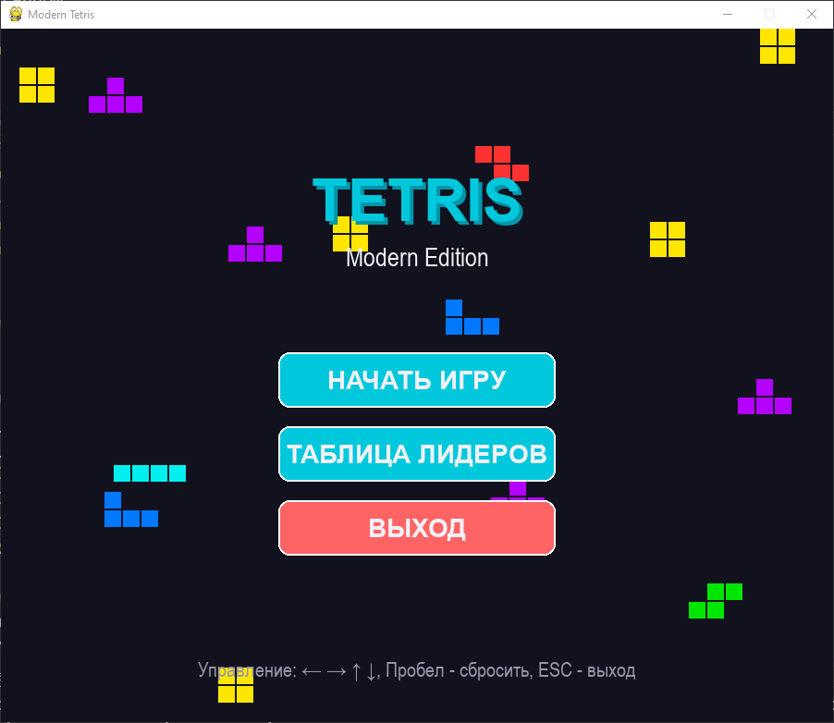

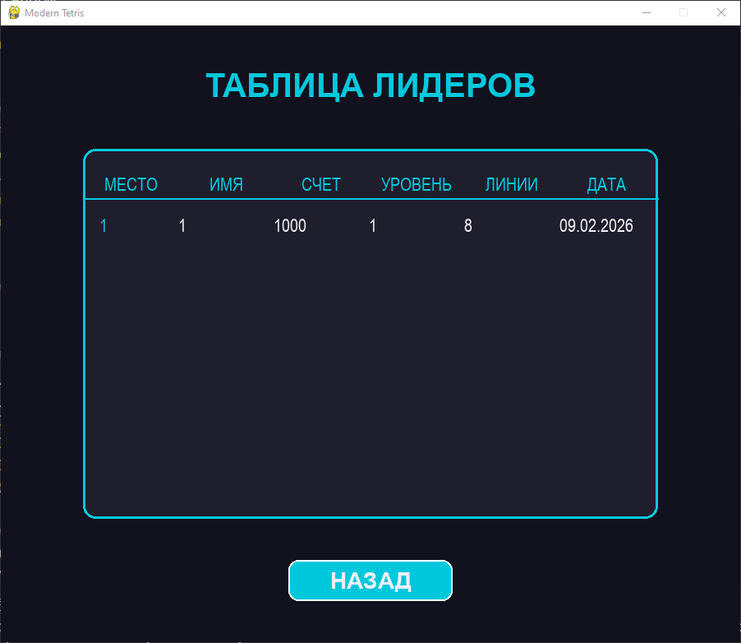

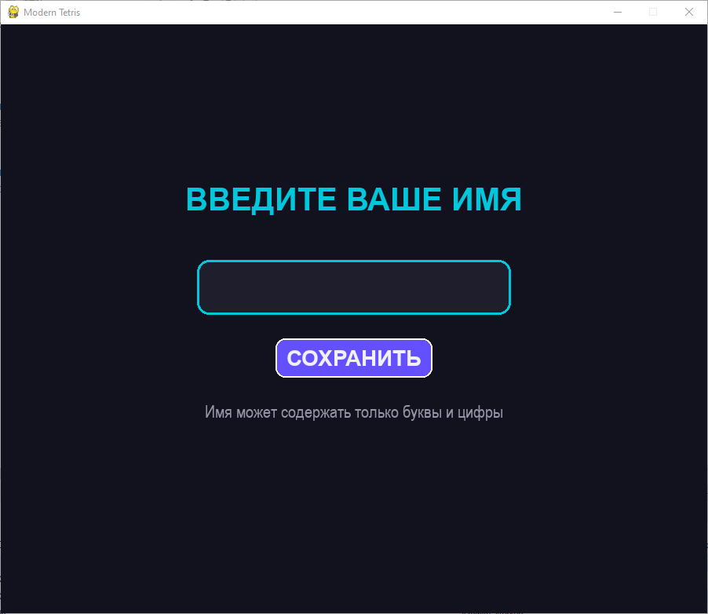

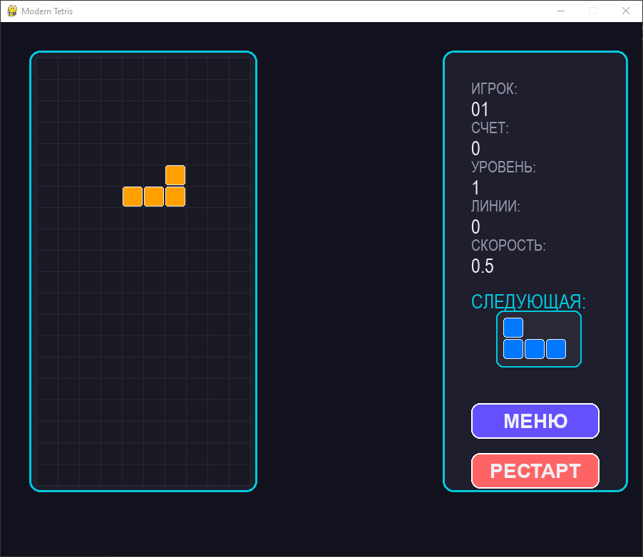

Листинг кода:

import pygame
import random
import mysql.connector
from datetime import datetime
import sys

# Конфигурация MySQL
DB_CONFIG = {
'host': 'localhost',
'user': 'root',
'password': 'root',
'database': 'tetris_db'
}

# Инициализация PyGame
pygame.init()

# Константы
SCREEN_WIDTH = 900
SCREEN_HEIGHT = 750
GRID_SIZE = 30
GRID_WIDTH = 10
GRID_HEIGHT = 20
SIDEBAR_WIDTH = 300

# Цвета
BACKGROUND = (18, 18, 30)
PRIMARY = (0, 200, 220)
SECONDARY = (100, 80, 255)
ACCENT = (255, 100, 100)
TEXT_COLOR = (240, 240, 245)
DARK_CARD = (30, 30, 45)
LIGHT_CARD = (40, 40, 55)
GRID_BG = (25, 25, 35)

# Цвета фигур
COLORS = [
(0, 240, 240), # I
(0, 120, 255), # J
(255, 160, 0), # L
(255, 230, 0), # O
(0, 230, 0), # S
(180, 0, 255), # T
(255, 50, 50) # Z
]

# Фигуры Тетриса
SHAPES = [
[[1, 1, 1, 1]],
[[1, 0, 0], [1, 1, 1]],
[[0, 0, 1], [1, 1, 1]],
[[1, 1], [1, 1]],
[[0, 1, 1], [1, 1, 0]],
[[0, 1, 0], [1, 1, 1]],
[[1, 1, 0], [0, 1, 1]]
]

class Button:
def __init__(self, x, y, width, height, text, color=PRIMARY, hover_color=(0, 180, 200)):
self.rect = pygame.Rect(x, y, width, height)
self.text = text
self.color = color
self.hover_color = hover_color
self.current_color = color
self.font = pygame.font.SysFont('Arial', 28, bold=True)
self.hovered = False

def draw(self, surface):
# Рисуем кнопку с скругленными углами
pygame.draw.rect(surface, self.current_color, self.rect, border_radius=12)
pygame.draw.rect(surface, (255, 255, 255), self.rect, 2, border_radius=12)

# Текст
text_surf = self.font.render(self.text, True, TEXT_COLOR)
text_rect = text_surf.get_rect(center=self.rect.center)
surface.blit(text_surf, text_rect)

def check_hover(self, pos):
self.hovered = self.rect.collidepoint(pos)
self.current_color = self.hover_color if self.hovered else self.color
return self.hovered

def is_clicked(self, pos, event):
if event.type == pygame.MOUSEBUTTONDOWN and event.button == 1:
return self.rect.collidepoint(pos)
return False

class Tetromino:
def __init__(self):
self.shape_idx = random.randint(0, len(SHAPES) - 1)
self.shape = SHAPES[self.shape_idx]
self.color = COLORS[self.shape_idx]
self.x = GRID_WIDTH // 2 - len(self.shape[0]) // 2
self.y = 0

def rotate(self):
rotated = list(zip(*self.shape[::-1]))
return [list(row) for row in rotated]

class TetrisGame:
def __init__(self):
self.screen = pygame.display.set_mode((SCREEN_WIDTH, SCREEN_HEIGHT))
pygame.display.set_caption("Modern Tetris")
self.clock = pygame.time.Clock()

# Шрифты
self.title_font = pygame.font.SysFont('Arial', 64, bold=True)
self.big_font = pygame.font.SysFont('Arial', 40, bold=True)
self.normal_font = pygame.font.SysFont('Arial', 28)
self.small_font = pygame.font.SysFont('Arial', 22)

# Состояния игры
self.state = "menu" # menu, enter_name, game, leaders
self.reset_game()

def reset_game(self):
self.board = [[0 for _ in range(GRID_WIDTH)] for _ in range(GRID_HEIGHT)]
self.current_piece = Tetromino()
self.next_piece = Tetromino()
self.game_over = False
self.score = 0
self.level = 1
self.lines_cleared = 0
self.fall_speed = 0.5
self.fall_time = 0
self.player_name = ""

def create_buttons(self):
center_x = SCREEN_WIDTH // 2

if self.state == "menu":
self.buttons = [
Button(center_x - 150, 350, 300, 60, "НАЧАТЬ ИГРУ"),
Button(center_x - 150, 430, 300, 60, "ТАБЛИЦА ЛИДЕРОВ"),
Button(center_x - 150, 510, 300, 60, "ВЫХОД", color=ACCENT)
]
elif self.state == "enter_name":
self.buttons = [
Button(center_x - 100, 400, 200, 50, "СОХРАНИТЬ", color=SECONDARY)
]
elif self.state == "game":
self.buttons = [
Button(SCREEN_WIDTH - SIDEBAR_WIDTH + 60, 550, 180, 50, "МЕНЮ", color=SECONDARY),
Button(SCREEN_WIDTH - SIDEBAR_WIDTH + 60, 610, 180, 50, "РЕСТАРТ", color=ACCENT)
]
elif self.state == "leaders":
self.buttons = [
Button(center_x - 100, 650, 200, 50, "НАЗАД")
]

def draw_menu(self):
# Фон
self.screen.fill(BACKGROUND)

# Анимированные фигуры на фоне
self.draw_background_shapes()

# Заголовок
title = self.title_font.render("TETRIS", True, PRIMARY)
title_shadow = self.title_font.render("TETRIS", True, (0, 150, 170))
self.screen.blit(title_shadow, (SCREEN_WIDTH//2 - title.get_width()//2 + 4, 154))
self.screen.blit(title, (SCREEN_WIDTH//2 - title.get_width()//2, 150))

subtitle = self.normal_font.render("Modern Edition", True, TEXT_COLOR)
self.screen.blit(subtitle, (SCREEN_WIDTH//2 - subtitle.get_width()//2, 230))

# Кнопки
for button in self.buttons:
button.draw(self.screen)

# Информация внизу
info_text = self.small_font.render("Управление: ← → ↑ ↓, Пробел - сбросить, ESC - выход", True, (150, 150, 170))
self.screen.blit(info_text, (SCREEN_WIDTH//2 - info_text.get_width()//2, 680))

def draw_background_shapes(self):
# Рисуем случайные фигуры на фоне
for i in range(15):
shape_idx = random.randint(0, len(SHAPES) - 1)
shape = SHAPES[shape_idx]
color = (*COLORS[shape_idx], 30) # Прозрачный цвет
x = random.randint(0, SCREEN_WIDTH)
y = random.randint(0, SCREEN_HEIGHT)

for sy, row in enumerate(shape):
for sx, cell in enumerate(row):
if cell:
rect = pygame.Rect(x + sx * 20, y + sy * 20, 18, 18)
pygame.draw.rect(self.screen, color[:3], rect)

def draw_enter_name(self):
self.screen.fill(BACKGROUND)

# Заголовок
title = self.big_font.render("ВВЕДИТЕ ВАШЕ ИМЯ", True, PRIMARY)
self.screen.blit(title, (SCREEN_WIDTH//2 - title.get_width()//2, 200))

# Поле ввода
input_rect = pygame.Rect(SCREEN_WIDTH//2 - 200, 300, 400, 70)
pygame.draw.rect(self.screen, DARK_CARD, input_rect, border_radius=15)
pygame.draw.rect(self.screen, PRIMARY, input_rect, 3, border_radius=15)

# Текст имени
name_text = self.normal_font.render(self.player_name + ("|" if pygame.time.get_ticks() % 1000 < 500 else ""),
True, TEXT_COLOR)
self.screen.blit(name_text, (SCREEN_WIDTH//2 - name_text.get_width()//2, 325))

# Кнопки
for button in self.buttons:
button.draw(self.screen)

# Инструкция
inst_text = self.small_font.render("Имя может содержать только буквы и цифры", True, (150, 150, 170))
self.screen.blit(inst_text, (SCREEN_WIDTH//2 - inst_text.get_width()//2, 480))

def draw_game(self):
self.screen.fill(BACKGROUND)

# Основной контейнер игры
game_rect = pygame.Rect(40, 40, GRID_WIDTH * GRID_SIZE + 20, GRID_HEIGHT * GRID_SIZE + 20)
pygame.draw.rect(self.screen, DARK_CARD, game_rect, border_radius=15)
pygame.draw.rect(self.screen, PRIMARY, game_rect, 3, border_radius=15)

# Игровое поле
self.draw_grid()

# Боковая панель
sidebar_rect = pygame.Rect(SCREEN_WIDTH - SIDEBAR_WIDTH + 20, 40,
SIDEBAR_WIDTH - 40, GRID_HEIGHT * GRID_SIZE + 20)
pygame.draw.rect(self.screen, DARK_CARD, sidebar_rect, border_radius=15)
pygame.draw.rect(self.screen, PRIMARY, sidebar_rect, 3, border_radius=15)

# Статистика
stats_y = 80
stats = [
("ИГРОК:", self.player_name),
("СЧЕТ:", str(self.score)),
("УРОВЕНЬ:", str(self.level)),
("ЛИНИИ:", str(self.lines_cleared)),
("СКОРОСТЬ:", f"{self.fall_speed:.1f}")
]

for i, (label, value) in enumerate(stats):
label_text = self.small_font.render(label, True, (150, 150, 170))
value_text = self.normal_font.render(value, True, TEXT_COLOR)
self.screen.blit(label_text, (SCREEN_WIDTH - SIDEBAR_WIDTH + 60, stats_y + i * 55))
self.screen.blit(value_text, (SCREEN_WIDTH - SIDEBAR_WIDTH + 60, stats_y + i * 55 + 25))

# Следующая фигура - ПЕРЕМЕЩЕНА НИЖЕ
next_text_y = stats_y + len(stats) * 55 + 20 # Добавляем отступ после статистики
next_text = self.normal_font.render("СЛЕДУЮЩАЯ:", True, PRIMARY)
self.screen.blit(next_text, (SCREEN_WIDTH - SIDEBAR_WIDTH + 60, next_text_y))

# Рисуем следующую фигуру - ПЕРЕМЕЩЕНА ЕЩЕ НИЖЕ
next_piece_y = next_text_y + 40 # Отступ после текста
# Центрируем следующую фигуру
shape_width = len(self.next_piece.shape[0]) * GRID_SIZE
next_piece_x = SCREEN_WIDTH - SIDEBAR_WIDTH + 60 + (SIDEBAR_WIDTH - 120 - shape_width) // 2

# Рисуем фон для следующей фигуры
preview_bg_width = max(shape_width, 100) + 20
preview_bg_height = len(self.next_piece.shape) * GRID_SIZE + 20
preview_bg_rect = pygame.Rect(
next_piece_x - 10,
next_piece_y - 10,
preview_bg_width,
preview_bg_height
)
pygame.draw.rect(self.screen, LIGHT_CARD, preview_bg_rect, border_radius=10)
pygame.draw.rect(self.screen, PRIMARY, preview_bg_rect, 2, border_radius=10)

# Рисуем саму фигуру
for y, row in enumerate(self.next_piece.shape):
for x, cell in enumerate(row):
if cell:
rect = pygame.Rect(
next_piece_x + x * GRID_SIZE,
next_piece_y + y * GRID_SIZE,
GRID_SIZE - 2,
GRID_SIZE - 2
)
pygame.draw.rect(self.screen, self.next_piece.color, rect, border_radius=4)
pygame.draw.rect(self.screen, TEXT_COLOR, rect, 1, border_radius=4)

# Кнопки - ПЕРЕМЕЩЕНЫ ЕЩЕ НИЖЕ
button_start_y = next_piece_y + preview_bg_height + 40
self.buttons[0].rect.y = button_start_y
self.buttons[1].rect.y = button_start_y + 70

for button in self.buttons:
button.draw(self.screen)

# Игра окончена
if self.game_over:
overlay = pygame.Surface((SCREEN_WIDTH, SCREEN_HEIGHT))
overlay.set_alpha(180)
overlay.fill(BACKGROUND)
self.screen.blit(overlay, (0, 0))

game_over_text = self.big_font.render("ИГРА ОКОНЧЕНА!", True, ACCENT)
score_text = self.normal_font.render(f"Ваш счет: {self.score}", True, TEXT_COLOR)

self.screen.blit(game_over_text, (SCREEN_WIDTH//2 - game_over_text.get_width()//2, 300))
self.screen.blit(score_text, (SCREEN_WIDTH//2 - score_text.get_width()//2, 370))

def draw_grid(self):
# Фон сетки
grid_bg = pygame.Rect(50, 50, GRID_WIDTH * GRID_SIZE, GRID_HEIGHT * GRID_SIZE)
pygame.draw.rect(self.screen, GRID_BG, grid_bg)

# Заполненные клетки
for y in range(GRID_HEIGHT):
for x in range(GRID_WIDTH):
if self.board[y][x]:
color_idx = self.board[y][x] - 1
color = COLORS[color_idx]
rect = pygame.Rect(51 + x * GRID_SIZE, 51 + y * GRID_SIZE,
GRID_SIZE - 2, GRID_SIZE - 2)
pygame.draw.rect(self.screen, color, rect, border_radius=3)
pygame.draw.rect(self.screen, TEXT_COLOR, rect, 1, border_radius=3)

# Текущая фигура
for y, row in enumerate(self.current_piece.shape):
for x, cell in enumerate(row):
if cell:
rect = pygame.Rect(51 + (self.current_piece.x + x) * GRID_SIZE,
51 + (self.current_piece.y + y) * GRID_SIZE,
GRID_SIZE - 2, GRID_SIZE - 2)
pygame.draw.rect(self.screen, self.current_piece.color, rect, border_radius=3)
pygame.draw.rect(self.screen, TEXT_COLOR, rect, 1, border_radius=3)

# Сетка
for x in range(GRID_WIDTH + 1):
pygame.draw.line(self.screen, (40, 40, 55),
(50 + x * GRID_SIZE, 50),
(50 + x * GRID_SIZE, 50 + GRID_HEIGHT * GRID_SIZE), 1)
for y in range(GRID_HEIGHT + 1):
pygame.draw.line(self.screen, (40, 40, 55),
(50, 50 + y * GRID_SIZE),
(50 + GRID_WIDTH * GRID_SIZE, 50 + y * GRID_SIZE), 1)

def draw_leaders(self):
self.screen.fill(BACKGROUND)

# Заголовок
title = self.big_font.render("ТАБЛИЦА ЛИДЕРОВ", True, PRIMARY)
self.screen.blit(title, (SCREEN_WIDTH//2 - title.get_width()//2, 50))

# Получаем данные
scores = self.get_high_scores()

# Контейнер таблицы
table_rect = pygame.Rect(100, 150, SCREEN_WIDTH - 200, 450)
pygame.draw.rect(self.screen, DARK_CARD, table_rect, border_radius=15)
pygame.draw.rect(self.screen, PRIMARY, table_rect, 3, border_radius=15)

# Заголовки колонок
headers = ["МЕСТО", "ИМЯ", "СЧЕТ", "УРОВЕНЬ", "ЛИНИИ", "ДАТА"]
header_y = 180
col_width = (SCREEN_WIDTH - 200) // len(headers)

for i, header in enumerate(headers):
header_text = self.small_font.render(header, True, PRIMARY)
x = 100 + i * col_width + col_width // 2 - header_text.get_width() // 2
self.screen.blit(header_text, (x, header_y))

# Разделитель
pygame.draw.line(self.screen, PRIMARY, (100, 210), (SCREEN_WIDTH - 100, 210), 2)

# Данные игроков
if scores:
for idx, score in enumerate(scores[:10]):
row_y = 230 + idx * 40

# Цвет строки
row_color = TEXT_COLOR if idx % 2 == 0 else (200, 200, 220)

# Место
place_text = self.small_font.render(str(idx + 1), True,
PRIMARY if idx < 3 else row_color)
self.screen.blit(place_text, (120, row_y))

# Имя
name_text = self.small_font.render(score[1][:15], True, row_color)
self.screen.blit(name_text, (100 + col_width, row_y))

# Счет
score_text = self.small_font.render(str(score[2]), True, row_color)
self.screen.blit(score_text, (100 + col_width * 2, row_y))

# Уровень
level_text = self.small_font.render(str(score[3]), True, row_color)
self.screen.blit(level_text, (100 + col_width * 3, row_y))

# Линии
lines_text = self.small_font.render(str(score[4]), True, row_color)
self.screen.blit(lines_text, (100 + col_width * 4, row_y))

# Дата
date = score[5].strftime("%d.%m.%Y") if isinstance(score[5], datetime) else str(score[5])
date_text = self.small_font.render(date, True, row_color)
self.screen.blit(date_text, (100 + col_width * 5, row_y))
else:
no_data = self.normal_font.render("Нет данных о рекордах", True, (150, 150, 170))
self.screen.blit(no_data, (SCREEN_WIDTH//2 - no_data.get_width()//2, 300))

# Кнопки
for button in self.buttons:
button.draw(self.screen)

def check_collision(self, shape, x, y):
for shape_y, row in enumerate(shape):
for shape_x, cell in enumerate(row):
if cell:
if (x + shape_x < 0 or x + shape_x >= GRID_WIDTH or
y + shape_y >= GRID_HEIGHT or
(y + shape_y >= 0 and self.board[y + shape_y][x + shape_x])):
return True
return False

def merge_piece(self):
for y, row in enumerate(self.current_piece.shape):
for x, cell in enumerate(row):
if cell:
if self.current_piece.y + y >= 0:
self.board[self.current_piece.y + y][self.current_piece.x + x] = self.current_piece.shape_idx + 1

def clear_lines(self):
lines_to_clear = []
for y in range(GRID_HEIGHT):
if all(self.board[y]):
lines_to_clear.append(y)

for line in lines_to_clear:
del self.board[line]
self.board.insert(0, [0 for _ in range(GRID_WIDTH)])

if lines_to_clear:
self.lines_cleared += len(lines_to_clear)
self.score += (1, 2, 5, 10)[min(len(lines_to_clear) - 1, 3)] * 100 * self.level
self.level = self.lines_cleared // 10 + 1
self.fall_speed = max(0.1, 0.5 - (self.level - 1) * 0.05)

def save_score(self):
try:
conn = mysql.connector.connect(**DB_CONFIG)
cursor = conn.cursor()
query = "INSERT INTO scores (player_name, score, level, lines_cleared) VALUES (%s, %s, %s, %s)"
cursor.execute(query, (self.player_name, self.score, self.level, self.lines_cleared))
conn.commit()
conn.close()
return True
except Exception as e:
print(f"Ошибка сохранения: {e}")
return False

def get_high_scores(self):
try:
conn = mysql.connector.connect(**DB_CONFIG)
cursor = conn.cursor()
cursor.execute("SELECT * FROM scores ORDER BY score DESC LIMIT 10")
scores = cursor.fetchall()
conn.close()
return scores
except Exception as e:
print(f"Ошибка загрузки рекордов: {e}")
return []

def run(self):
running = True
last_time = pygame.time.get_ticks()
self.create_buttons()

while running:
current_time = pygame.time.get_ticks()
delta_time = (current_time - last_time) / 1000.0
last_time = current_time

# Получаем позицию мыши
mouse_pos = pygame.mouse.get_pos()

# Обработка событий
for event in pygame.event.get():
if event.type == pygame.QUIT:
running = False

# Проверка нажатия кнопок
for button in self.buttons:
if button.check_hover(mouse_pos):
if button.is_clicked(mouse_pos, event):
# Обработка кнопок меню
if self.state == "menu":
if button.text == "НАЧАТЬ ИГРУ":
self.state = "enter_name"
self.create_buttons()
elif button.text == "ТАБЛИЦА ЛИДЕРОВ":
self.state = "leaders"
self.create_buttons()
elif button.text == "ВЫХОД":
running = False

# Обработка кнопок ввода имени
elif self.state == "enter_name":
if button.text == "СОХРАНИТЬ" and self.player_name:
self.state = "game"
self.create_buttons()

# Обработка кнопок игры
elif self.state == "game":
if button.text == "МЕНЮ":
if self.game_over:
self.save_score()
self.state = "menu"
self.reset_game()
self.create_buttons()
elif button.text == "РЕСТАРТ":
if self.game_over:
self.save_score()
self.reset_game()

# Обработка кнопок таблицы лидеров
elif self.state == "leaders":
if button.text == "НАЗАД":
self.state = "menu"
self.create_buttons()

# Обработка клавиатуры
if event.type == pygame.KEYDOWN:
if event.key == pygame.K_ESCAPE:
if self.state == "game":
if self.game_over:
self.save_score()
self.state = "menu"
self.reset_game()
self.create_buttons()
elif self.state in ["enter_name", "leaders"]:
self.state = "menu"
self.create_buttons()

# Ввод имени
if self.state == "enter_name":
if event.key == pygame.K_RETURN and self.player_name:
self.state = "game"
self.create_buttons()
elif event.key == pygame.K_BACKSPACE:
self.player_name = self.player_name[:-1]
elif len(self.player_name) < 15 and event.unicode.isalnum():
self.player_name += event.unicode

# Управление игрой
elif self.state == "game" and not self.game_over:
if event.key == pygame.K_LEFT:
if not self.check_collision(self.current_piece.shape,
self.current_piece.x - 1,
self.current_piece.y):
self.current_piece.x -= 1

elif event.key == pygame.K_RIGHT:
if not self.check_collision(self.current_piece.shape,
self.current_piece.x + 1,
self.current_piece.y):
self.current_piece.x += 1

elif event.key == pygame.K_DOWN:
if not self.check_collision(self.current_piece.shape,
self.current_piece.x,
self.current_piece.y + 1):
self.current_piece.y += 1

elif event.key == pygame.K_UP:
rotated = self.current_piece.rotate()
if not self.check_collision(rotated,
self.current_piece.x,
self.current_piece.y):
self.current_piece.shape = rotated

elif event.key == pygame.K_SPACE:
while not self.check_collision(self.current_piece.shape,
self.current_piece.x,
self.current_piece.y + 1):
self.current_piece.y += 1

# Логика игры
if self.state == "game" and not self.game_over:
self.fall_time += delta_time

if self.fall_time >= self.fall_speed:
self.fall_time = 0

if not self.check_collision(self.current_piece.shape,
self.current_piece.x,
self.current_piece.y + 1):
self.current_piece.y += 1
else:
self.merge_piece()
self.clear_lines()

self.current_piece = self.next_piece
self.next_piece = Tetromino()

if self.check_collision(self.current_piece.shape,
self.current_piece.x,
self.current_piece.y):
self.game_over = True

# Отрисовка
if self.state == "menu":
self.draw_menu()
elif self.state == "enter_name":
self.draw_enter_name()
elif self.state == "game":
self.draw_game()
elif self.state == "leaders":
self.draw_leaders()

# Обновление hover состояния кнопок
for button in self.buttons:
button.check_hover(mouse_pos)

pygame.display.flip()
self.clock.tick(60)

pygame.quit()
sys.exit()

if __name__ == "__main__":
game = TetrisGame()
game.run()

