UMians EduGig: A Student Freelance Services Mobile Application



In Partial Fulfillment of the Requirements
In CCE106/L – Applications Development and Emerging Technologies

Submitted by:
April Bords M. Nerosa

Submitted to:
Michael Aguido Velez

September 27, 2026
Table of Contents
Chapter 1 3
I. Introduction 3
II. Purpose and Value Proposition 3
III. Target Audience 4
IV. Core Functionalities 5
V. Technical Feasibility & Flutter Elements 9
Chapter 2 10
VI. Prototype 10
VII. Task Analysis/User Interface Manual 30
VIII. Use Case Diagram 33
IX. Conceptual Framework 34
X. Gantt Chart 35
XI. Test Cases 36
A. White-Box Test Cases — Client 36
B. White-Box Test Cases — Freelancer 37
C. White-Box Test Cases — Authorized Staff 38
D. Black-Box Test Cases — Client 39
E. Black-Box Test Cases — Freelancer 40
F. Black-Box Test Cases — Authorized Staff 42

Chapter 1

I. Introduction
Students at the University of Mindanao already hire each other for small paid jobs: a poster for an org event, a tutor before an exam, someone to proofread a thesis chapter. Today those deals happen in Facebook groups and group chats, where posts disappear within hours, nobody knows who is reliable, and nothing records what was agreed. UMians EduGig is a Flutter mobile application that gives UM students one place to offer and hire skill-based services. A student signs in with their UM Google account, publishes a service listing or browses the ones already there, places an order, chats with the other party, receives the work, and leaves a review. Every account can both buy and sell, so there is no separate freelancer registration. The app runs on Firebase (Authentication, Cloud Firestore, Cloud Storage, and Cloud Functions) and targets Android, with the same code running on the web and Windows for testing.

II. Purpose and Value Proposition
The purpose of UMians EduGig is to turn informal peer hiring into orders that both sides can trust without knowing each other first. The current process fails in four ways. Discovery is poor because posts scroll away and cannot be searched. Trust is weak because testimonials are screenshots, which are easy to fake. Structure is missing because the price, the deadline, and the number of revisions are never written down. Payment is awkward because either the buyer pays first and hopes, or the freelancer works first and hopes. Global platforms such as Upwork and Fiverr solve these for professionals, but their dollar pricing, worldwide competition, and payout requirements make no sense for a student charging 300 pesos for an hour of tutoring.
The app answers each of these gaps. Listings are searchable by category, keyword, and price. Reviews can only be written by the buyer of a completed order, one per order, so they cannot be faked or duplicated. Every order freezes its price, delivery days, revisions, and requirements at creation, and neither side can edit them afterwards. Payment goes through a Xendit checkout, and the platform holds the money until the client accepts the delivery, refunds it if the order is cancelled, or lets staff decide on a dispute. The platform keeps a 10 percent commission on completed orders and offers an optional Pro subscription for featured listings and a verified badge. What makes the app different is campus scale. The person you hire may sit beside you next semester, and the app adds a written record and a review trail on top of trust that already exists.

III. Target Audience
The users of UMians EduGig are students of the University of Mindanao, mostly college students aged 18 to 24. Only a verified umindanao.edu.ph Google account can sign in, so every user on the platform is a UM student, and the student number is read from the email address itself. Buying is open to everyone; selling and payouts require a birth date showing 18 or over. Each account can act in two roles. Buyers need short, deadline-bound tasks such as thesis proofreading, tutoring, posters for a student organization, video editing for a defense, or help with a programming assignment. They are price sensitive and already used to hiring peers informally, but they lack a quick way to find the right person and some assurance that the work will arrive. Sellers have a skill someone will pay for, such as design, programming, writing, video, photography, or music, and want income that fits between classes. They cannot commit to fixed hours and are not competitive on global platforms, but they are well matched to campus-scale work.
The app fits them by pricing in pesos, measuring delivery in days, and organizing listings into the eight categories students actually trade in: Tutoring, Graphic Design, Writing and Editing, Programming, Video Editing, Photography, Music and Audio, and Other. Profiles show each student's college and program from a closed list, so a buyer can see that a calculus tutor really is from the College of Engineering. A seller can pause a listing during exam week instead of deleting it, and released earnings are paid out to GCash, Maya, or a bank account.

IV. Core Functionalities
1. Marketplace with Search, Offers, and Ordering
The marketplace shows every published service as a card with its title, category, price, delivery time, seller, and rating. Buyers filter by category with a strip of ChoiceChip widgets, search with a TextField, and sort by newest or price. Results load through a ListView.builder on phones and a GridView on wider screens, paging with a Firestore cursor as the user scrolls. When a seller saves a listing, the app derives keyword tokens from the title and skills, so "poster" finds "Event poster for your student org". A listing is either fixed price, which can be ordered directly, or a starting price, where the buyer messages the seller and the seller sends an offer card in the chat with the agreed price, delivery days, and scope; accepting the card creates the order from those figures. This matters because a listing that cannot be found two weeks after posting means nothing else in the app gets used. Tapping a card pushes the service page through go_router, where the order or message button stays pinned at the bottom of the screen.
2. Order Lifecycle with Held Payment
An order records what was agreed and moves through pending, accepted, in progress, submitted, and completed, with a revision loop from submitted and with rejected, cancelled, and disputed as exits. On creation the price and terms are copied from the service inside a Firestore transaction, so a tampered request cannot change them. A transition table lists which state may move to which and which party may make each move: the seller accepts, starts, and submits; the buyer completes or asks for a revision. This is enforced three times. The screen only shows legal buttons, the repository re-checks inside a transaction, and Firestore security rules reject anything else. Once the seller accepts, the buyer pays through a Xendit checkout page and the platform holds the money until the order ends, then releases it to the seller's wallet minus commission, or refunds it. A client who ignores a delivery for three days does not keep the freelancer unpaid; a scheduled Cloud Function completes the order. The order screen listens to the document with a StreamBuilder, so when the other party acts, the status tracker and buttons update without a refresh. Cancelling or disputing opens an AlertDialog that asks for a reason first.
3. Chat, Reviews, and Notifications
A buyer and seller message each other from a service page or an order, with text, image, and file attachments stored in Cloud Storage. The conversation id is the two user ids sorted and joined, so a pair always lands in the same thread. A reversed ListView.builder keeps the newest message at the bottom, and the unread badge on the NavigationBar updates from the same stream. After completion the buyer leaves a star rating and comment through a dialog. The review's document id is the order id, so a second review on the same order is impossible, and the same atomic batch updates the service's rating counters. Every order and chat event writes an inbox document for the recipient, which a Cloud Function fans out as a push notification through Firebase Cloud Messaging. Tapping a notification goes through one NotificationRouter that validates the id and opens the exact order or chat. These pieces matter because negotiation, delivery, and the evidence for a dispute all live in the chat, and reviews are the trust signal a screenshot cannot provide.
4. Admin Console with Role-Based Access
Staff run the platform from a console inside the same app. Access is the existence of an admins document for the signed-in student, written only with a service account key, and it carries a role and a list of permissions: manage students, moderate listings, manage categories, resolve disputes, settle payouts, handle refunds, decide identity verification, view reports, and edit platform settings. The screen builds one section per permission the staff member actually holds, as a NavigationRail on wide screens and a ChipStrip on phones, and each queue is a StreamBuilder over a ListView.builder with a Badge showing how many items are waiting. Disputes close as a full release or a full refund from an AlertDialog that records the reason, and orders of 2,000 pesos or more need one staff member to propose and a different one to confirm. Payouts are sent through Xendit or recorded by hand, stuck refunds are retried, chargebacks are passed on to the seller, and a student ID is approved only after the reviewer confirms it matches the declared name and birth date. Staff can also suspend an account, take down a listing, post an announcement, and pause new orders platform-wide. The same permission names are checked in the security rules and in the backend, the main admin grants staff but never themselves, and every staff action lands in an audit log that only the backend can write. This matters because money and identity decisions need a named person behind them and a record that cannot be edited afterwards.

V. Technical Feasibility & Flutter Elements
UMians EduGig is feasible with Flutter and Firebase because both are free to start, well documented, and already used in the course. The app is written in Dart 3 with Material 3 and uses firebase_core, firebase_auth, cloud_firestore, firebase_storage, and firebase_messaging for the backend, go_router for navigation, provider for state, intl for peso and date formatting, and file_picker and url_launcher for attachments and the checkout page. Code under lib is split by feature into data, domain, and presentation folders. Only repositories touch the Firebase SDKs; no widget imports Firestore. Repositories are created once at startup as plain Providers, and a single AuthController ChangeNotifier drives go_router's redirect, so a signed-out or non-UM account cannot reach a protected route. A ShellRoute wraps the four tabs (Home, Orders, Messages, Me) in a NavigationBar on phones and a NavigationRail from 1000 pixels wide. Live data uses StreamBuilder with streams created once in initState and held, because a fresh stream on every rebuild tears down the Firestore listener. Forms use Form and TextFormField with validators kept in one file, and every Firebase error is mapped in the repository to a small failure class whose message is the only thing a screen shows.
Anything involving money or entitlements is decided on the server, never in the app, because an APK decompiles and a web build ships readable JavaScript. Cloud Functions in the asia-southeast1 region hold the Xendit secret key, re-derive every amount from the order, and are the only writer of payment verification, wallet balances, payouts, and Pro subscriptions; Firestore rules make those fields unreachable from clients. A gateway callback is checked against a shared token in constant time and applied inside an idempotent transaction, and a scheduled job asks Xendit every thirty minutes about any checkout still pending, so a lost callback is a delay rather than a stuck order. A card chargeback after release is recorded by staff and taken from the seller's balance, with any remainder repaid from their next releases. Disputes of 2,000 pesos or more need one staff member to propose the outcome and a different one to confirm it, and every staff action lands in an audit log only the backend can write.

Chapter 2
VI. Prototypes
Login and Account Selection
Login and Account Selection
Explanation / Description | Mobile Perspective Screenshot
Purpose: The entry screen provides UM Google sign-in and a development-only demo-account selector. Authentication prevents protected features from opening before an eligible profile is loaded.  User interaction: The student chooses an account and signs in; the app loads the profile then routes the student to Home. | 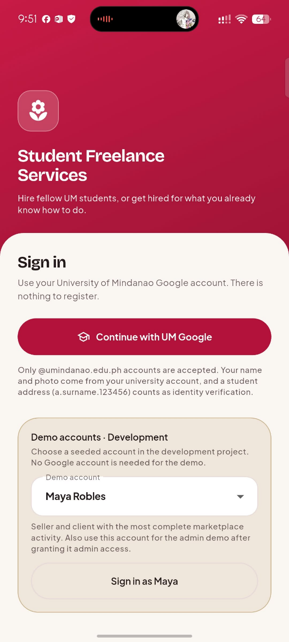
Figure 1. Login and Account Selection

Marketplace Home and Service Cards
Marketplace Home and Service Cards
Explanation / Description | Mobile Perspective Screenshot
Purpose: Home combines search, categories, sorting, price, rating, seller identity, and delivery duration so clients can compare listings. At phone width, users can switch to a vertically scanned list.  User interaction: The student searches or filters services, changes view mode if needed, and taps a listing to open it. | 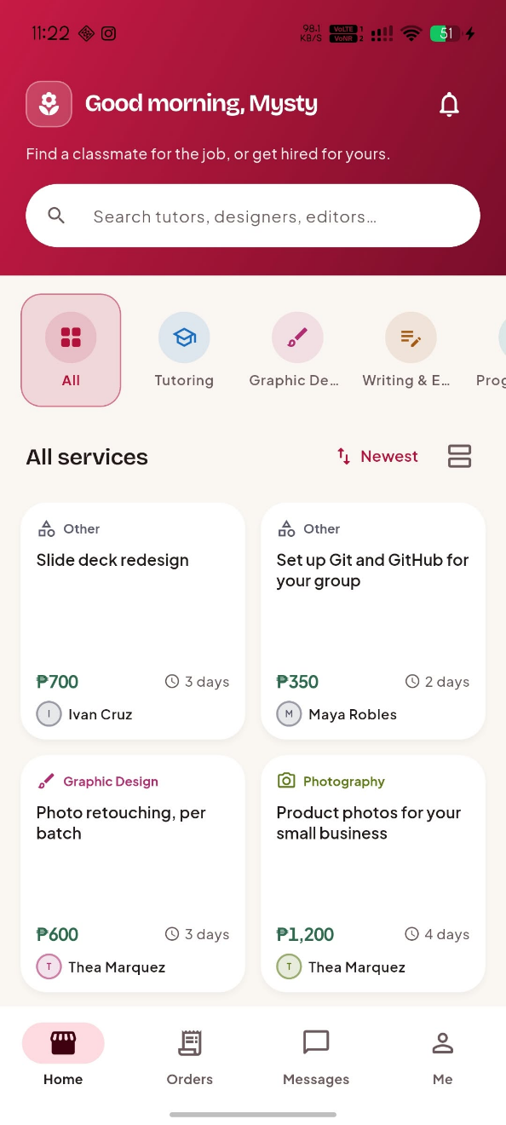
Figure 2. Marketplace Home and Service Cards

Service Detail
Service Detail
Explanation / Description | Mobile Perspective Screenshot
Purpose: The listing detail explains seller, price, delivery time, revisions, description, and reviews before the client commits.  User interaction: A client orders fixed-price work or messages the seller to negotiate. | 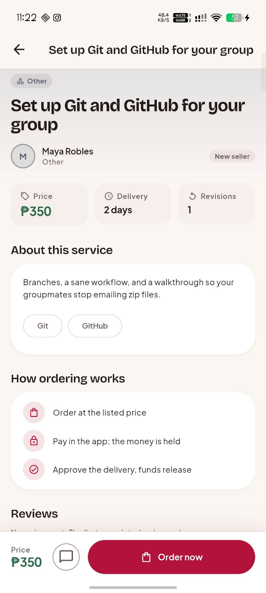
Figure 3. Service Detail

Create Order
Create Order
Explanation / Description | Mobile Perspective Screenshot
Purpose: The order form captures requirements while displaying terms that will be copied and frozen on the order record.  User interaction: The client enters a brief, passes validation, confirms the order, and begins payment. | 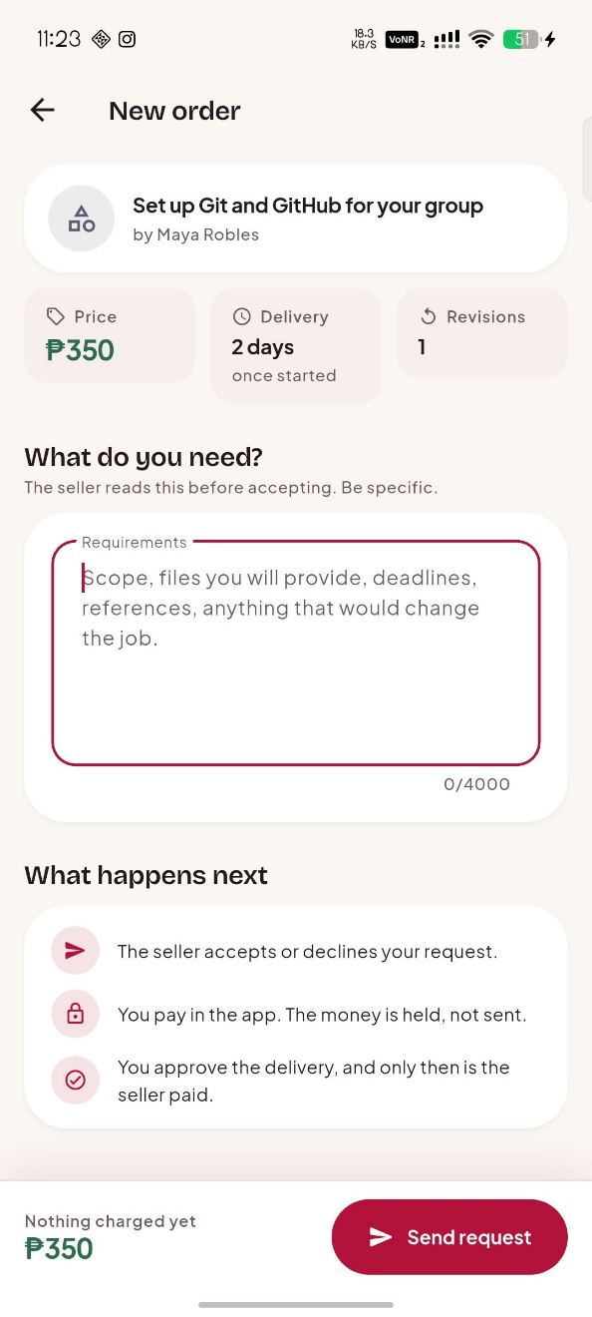
Figure 4. Create Order

Chat and Offer Negotiation
Chat and Offer Negotiation
Explanation / Description | Mobile Perspective Screenshot
Purpose: The conversation keeps negotiation, messages, files, and offer cards together as written evidence of an agreement.  User interaction: The freelancer sends an offer; the client reviews, accepts, or declines it. | 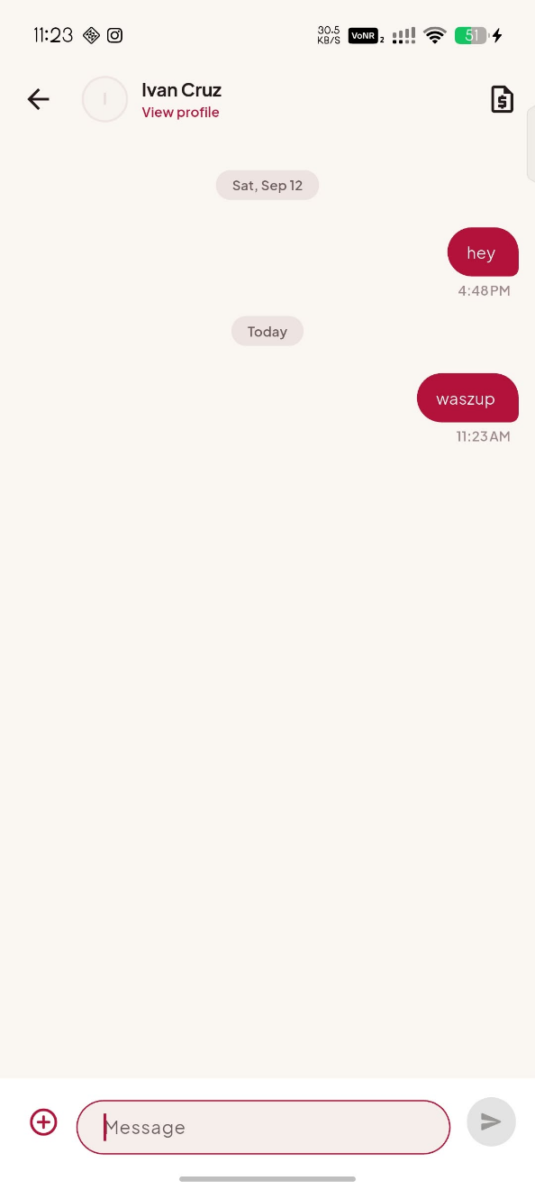
Figure 5. Chat and Offer Negotiation

Orders List
Orders List
Explanation / Description | Mobile Perspective Screenshot
Purpose: The Orders tab presents live jobs with their current state and relevant due information for the signed-in participant.  User interaction: The client or freelancer opens an order to see terms, payment state, and legal next actions. | 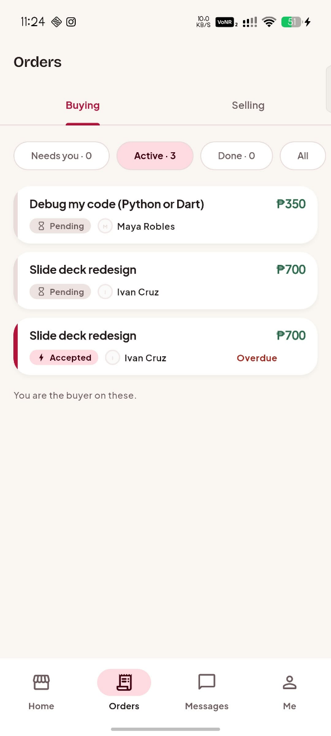
Figure 6. Orders List

Order Detail and Lifecycle
Order Detail and Lifecycle
Explanation / Description | Mobile Perspective Screenshot
Purpose: The detail page combines the status tracker, agreed terms, delivery evidence, and a persistent action area that changes by role and state.  User interaction: The freelancer accepts, starts, or submits work; the client pays, revises, accepts, cancels, or disputes. | 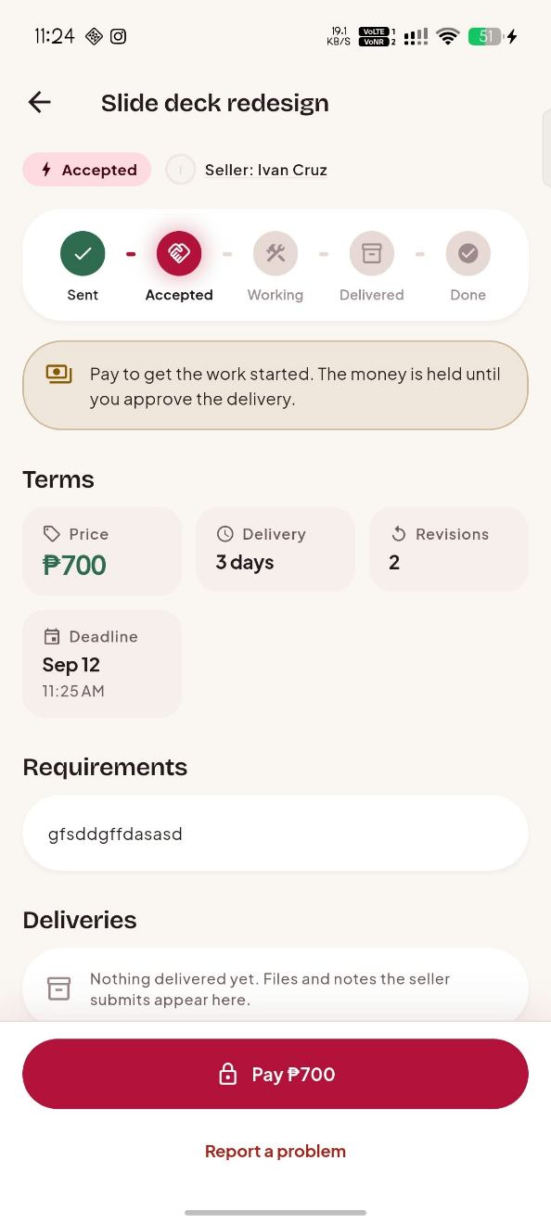
Figure 7. Order Detail and Lifecycle

Payment Confirmation
Payment Confirmation
Explanation / Description | Mobile Perspective Screenshot
Purpose: The payment interface explains that funds are held until completion or an authorized refund/dispute outcome.  User interaction: The client chooses a method or submits a manual reference; verification updates the order. | 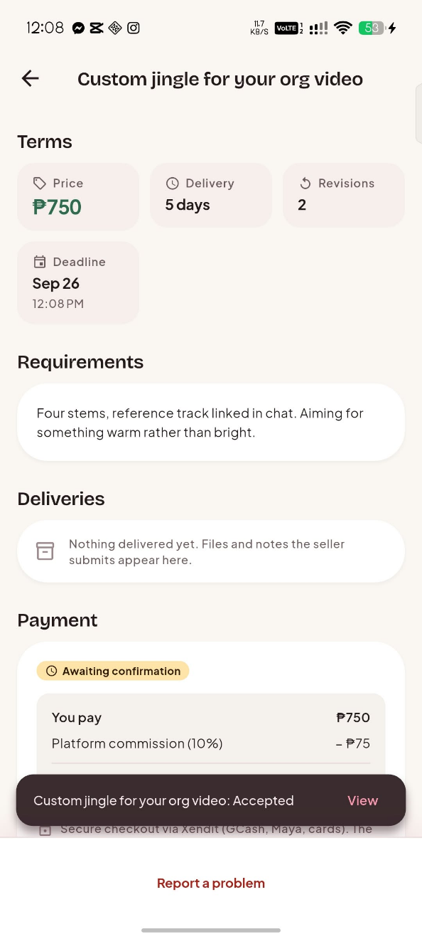
Figure 8. Payment Confirmation

Student Profile Hub
Student Profile Hub
Explanation / Description | Mobile Perspective Screenshot
Purpose: The profile hub links public information, services, wallet, Pro option, verification, and notifications.  User interaction: The student selects a profile-management destination and changes information they own. | 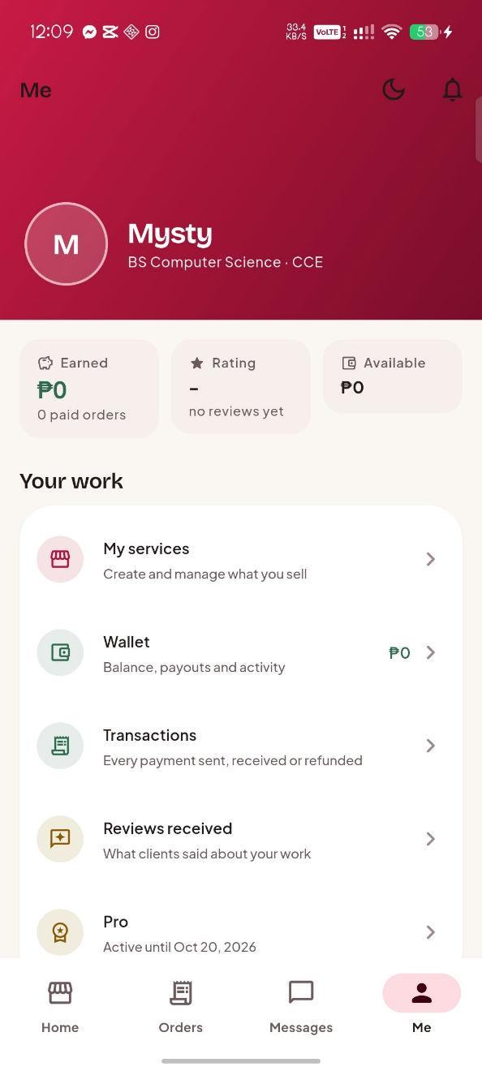
Figure 9. Student Profile Hub

Public Student Profile
Public Student Profile
Explanation / Description | Mobile Perspective Screenshot
Purpose: A public profile provides college, programme, listings, and completed-order reviews to support informed hiring.  User interaction: A client views listings or reviews and starts a contextual conversation with the freelancer. | 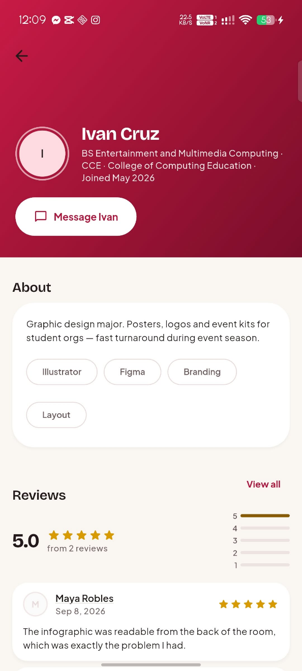
Figure 10. Public Student Profile

My Services
My Services
Explanation / Description | Mobile Perspective Screenshot
Purpose: Freelancers see draft, published, paused, and archived listings without exposing unpublished work to clients.  User interaction: The owner creates, edits, publishes, pauses, or archives their services. | 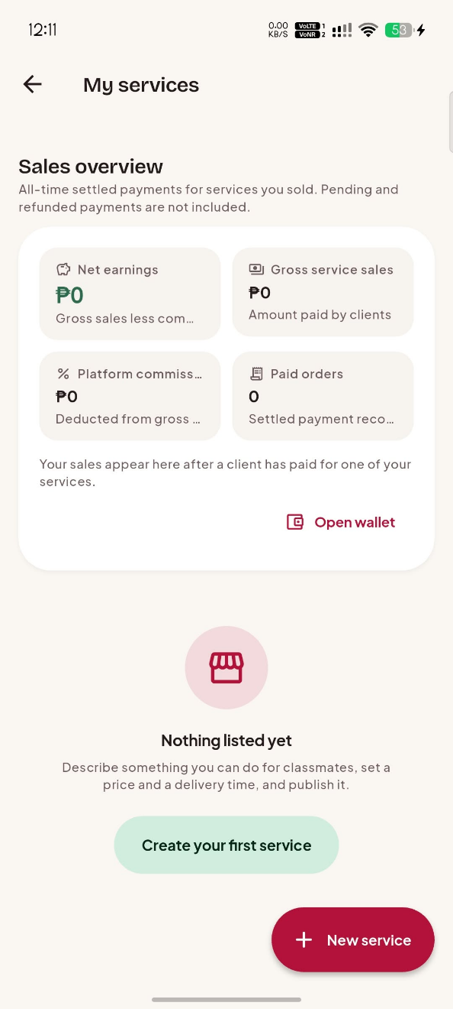
Figure 11. My Services

Create Service Listing
Create Service Listing
Explanation / Description | Mobile Perspective Screenshot
Purpose: The form validates title, category, skills, price, duration, revisions, and order method before publishing.  User interaction: The freelancer enters terms, corrects messages, saves a draft, or publishes. | 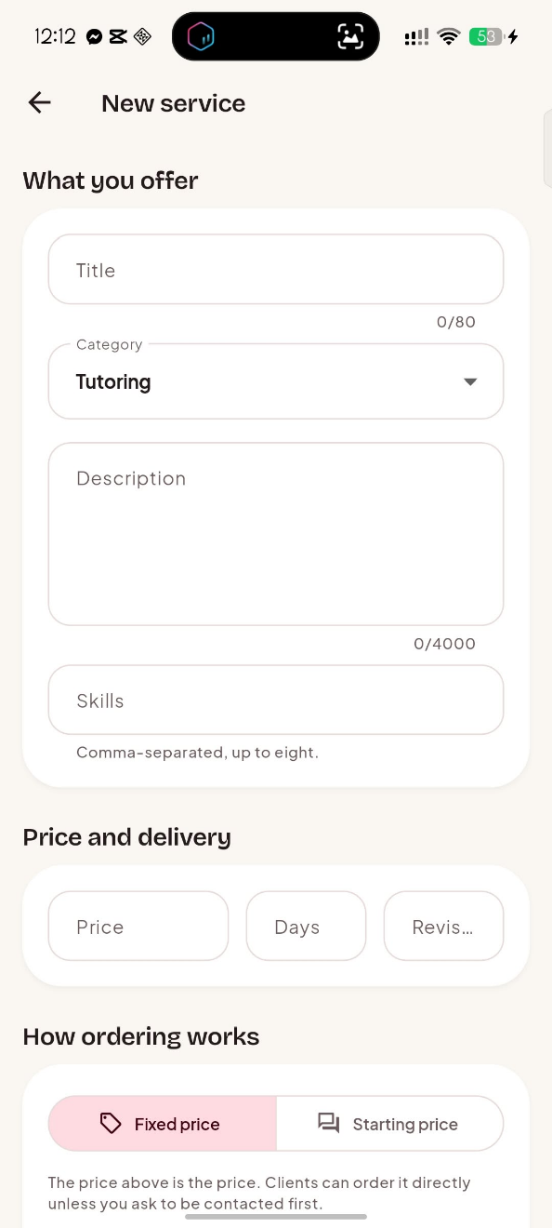
Figure 12. Create Service Listing

Wallet
Wallet
Explanation / Description | Mobile Perspective Screenshot
Purpose: The wallet separates held, clearing, available, and payout-requested funds so sellers understand balance movement.  User interaction: A qualified freelancer opens payout setup or requests a payout from available funds. | 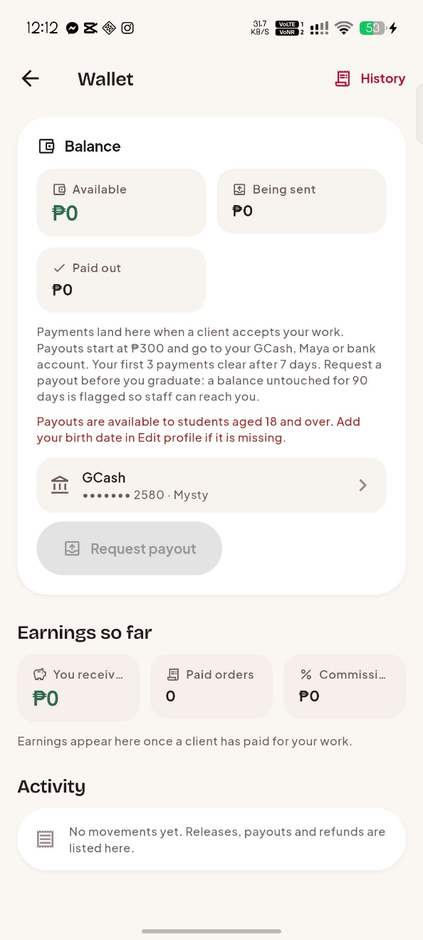
Figure 13. Wallet

Payout Account Setup
Payout Account Setup
Explanation / Description | Mobile Perspective Screenshot
Purpose: The payout form validates supported GCash, Maya, or bank details before an account becomes a payment destination.  User interaction: The seller chooses a provider, enters details, and saves it for future requests. | 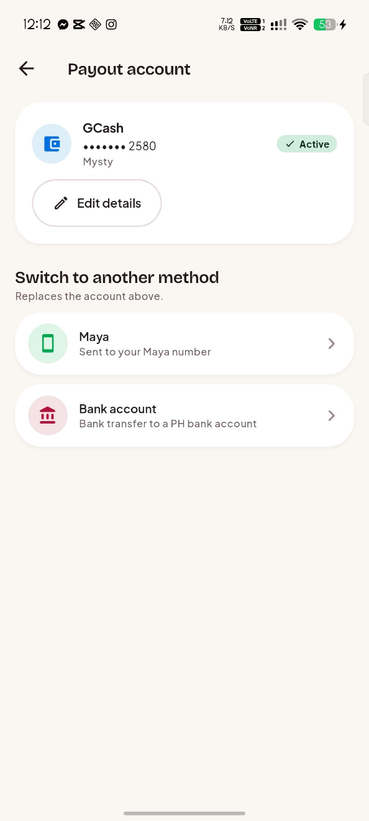
Figure 14. Payout Account Setup

Wallet Transactions
Wallet Transactions
Explanation / Description | Mobile Perspective Screenshot
Purpose: The ledger records releases, clearance, payout requests, refunds, and chargeback adjustments.  User interaction: The seller reviews entries to reconcile the available wallet balance. | 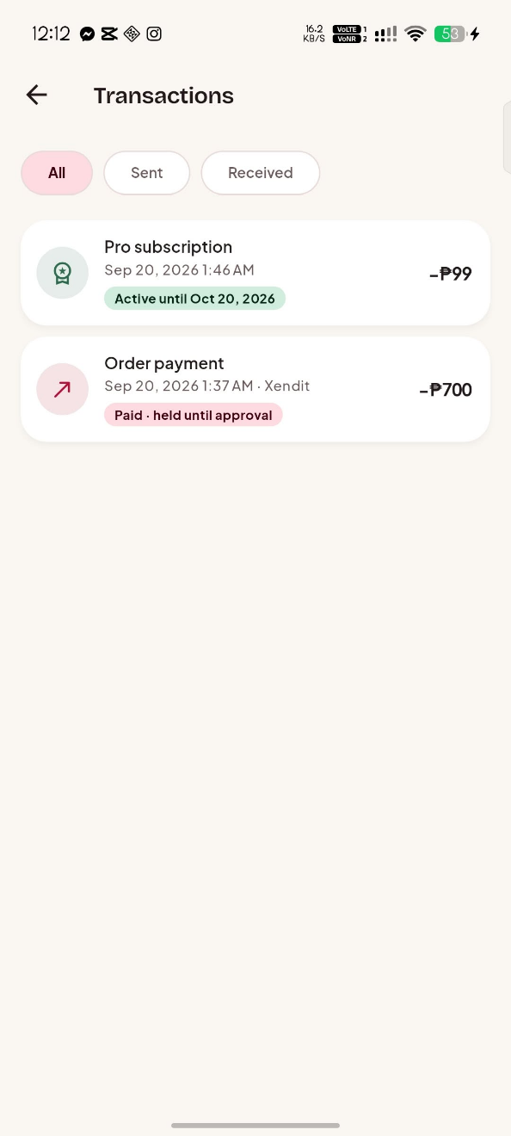
Figure 15. Wallet Transactions

Pro Subscription and Verification
Pro Subscription and Verification
Explanation / Description | Mobile Perspective Screenshot
Purpose: The Pro screen explains the optional subscription, featured-listing allowance, and verified-badge requirement.  User interaction: The student begins a subscription payment or submits identity evidence for staff review. | 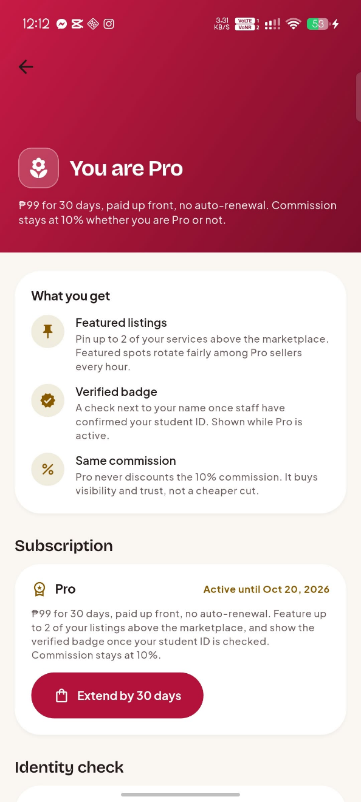
Figure 16. Pro Subscription and Verification

Notifications
Notifications
Explanation / Description | Mobile Perspective Screenshot
Purpose: The inbox gathers order, chat, review, payout, and platform events in one place.  User interaction: Tapping a notice validates its destination and opens the relevant task. | 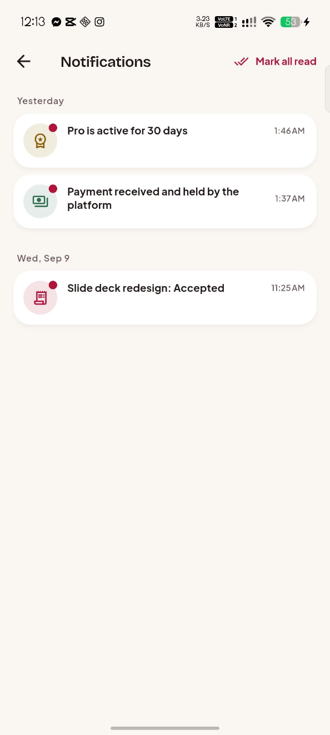
Figure 17. Notifications

Conversations List
Conversations List
Explanation / Description | Mobile Perspective Screenshot
Purpose: The Messages tab shows conversations, recent activity, and unread state so students return to active work quickly.  User interaction: The student opens a conversation to continue negotiation, send evidence, or answer a client. | 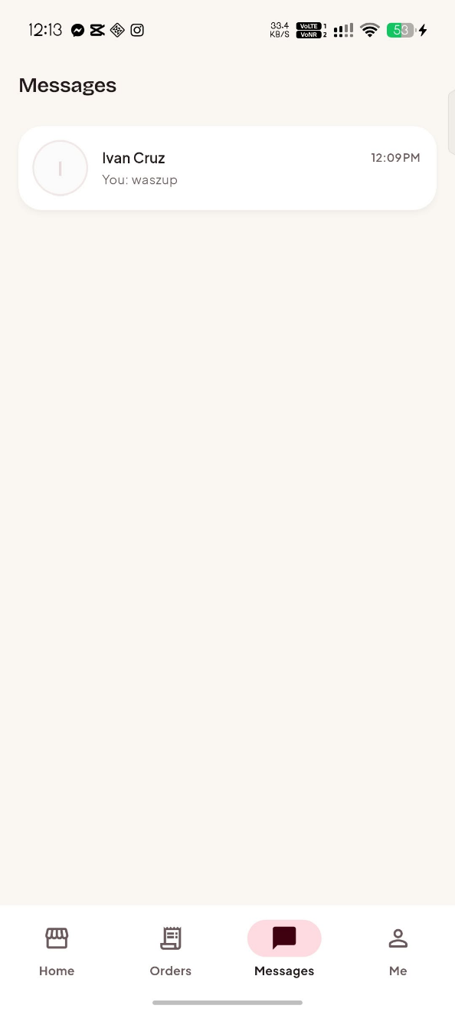
Figure 18. Conversations List

Reviews
Reviews
Explanation / Description | Mobile Perspective Screenshot
Purpose: Review data is tied to completed orders, preventing arbitrary or duplicate testimonials.  User interaction: The client submits one rating after completion; users read feedback while evaluating a service. | 
Figure 19. Reviews

Role-Based Admin Console
Role-Based Admin Console
Explanation / Description | Mobile Perspective Screenshot
Purpose: The console centralizes queues and reports while limiting staff to permissions they were granted.  User interaction: Authorized staff open profiles, moderation queues, orders, disputes, payouts, refunds, verification, sales, and audit details. | 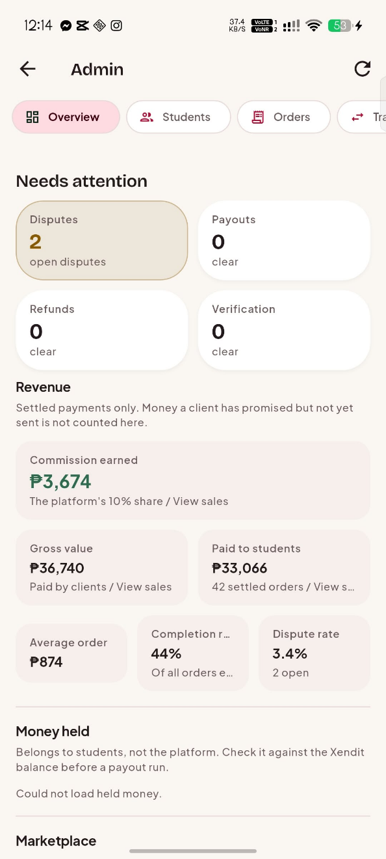
Figure 20. Role-Based Admin Console

VII. Task Analysis/User Interface Manual
The manual explains the main transactions in the order real users perform them. Each visible action is reinforced by repository validation, security rules, and trusted backend checks where money or staff authority is involved.
A. Client: Find and Order a Fixed-Price Service
Step 1. Open Home. The marketplace loads published listings with category chips, search, sorting, and the list/card-view control.
Step 2. Enter a term or choose a category. The query narrows cards to listings matching the entered keyword and category.
Step 3. Open the selected listing. The detail page presents seller, price, duration, revisions, reviews, and the available ordering method.
Step 4. Select Order, write requirements, and submit the validated form. The system copies listing terms to a pending order so later listing changes cannot alter the agreement.
Step 5. Choose payment and complete checkout. The backend verifies payment information before fulfillment becomes eligible.
Step 6. Open Orders to monitor the lifecycle, accept delivery, request revision, cancel where legal, or open a dispute.
B. Client and Freelancer: Negotiate an Offer
Step 1. The client opens a negotiated listing and selects Message to get an offer, opening the conversation shared by the two students.
Step 2. Both parties discuss scope, cost, revisions, and timing in chat. Messages and attached files remain available evidence for a later dispute.
Step 3. The freelancer selects Send offer and enters the final scope, price, delivery days, and revisions. The chat receives an expiring offer card.
Step 4. The client reviews and accepts the offer. The application creates exactly one order using the offer values instead of the original starting price.
Step 5. The client pays and both participants continue through the normal fulfillment lifecycle.
C. Freelancer: Publish, Deliver, and Request Payout
Step 1. Open Me and select My Services to view personal draft, published, paused, and archived listings.
Step 2. Select Add service or edit an existing service. The form requires valid marketplace terms before publication.
Step 3. After a client pays, open Orders and accept the job. Start work, use chat for clarification, and submit delivery evidence when finished.
Step 4. When the client accepts, the backend applies commission and moves the net amount to the wallet.
Step 5. Open Wallet, configure a valid payout destination if needed, and request payout from available funds. The request enters the guarded settlement flow and ledger.
D. Authorized Staff: Moderate and Resolve
Step 1. Open Admin. Navigation is built from the staff member's permission list, so unauthorized queues are not usable work surfaces.
Step 2. Choose an authorized queue such as Students, Orders, Disputes, Payouts, Refunds, Verification, Sales, or Audit Log and inspect the relevant evidence.
Step 3. For student moderation, open the student profile and take down a listing directly. For financial and identity queues, select the permitted decision and supply required notes.
Step 4. Confirm the action. Protected money and permission operations go to the backend rather than direct client writes.
Step 5. Review the changed queue state and audit record, whose references resolve into readable student, service, order, offer, payment, or payout names.

VIII. Use Case
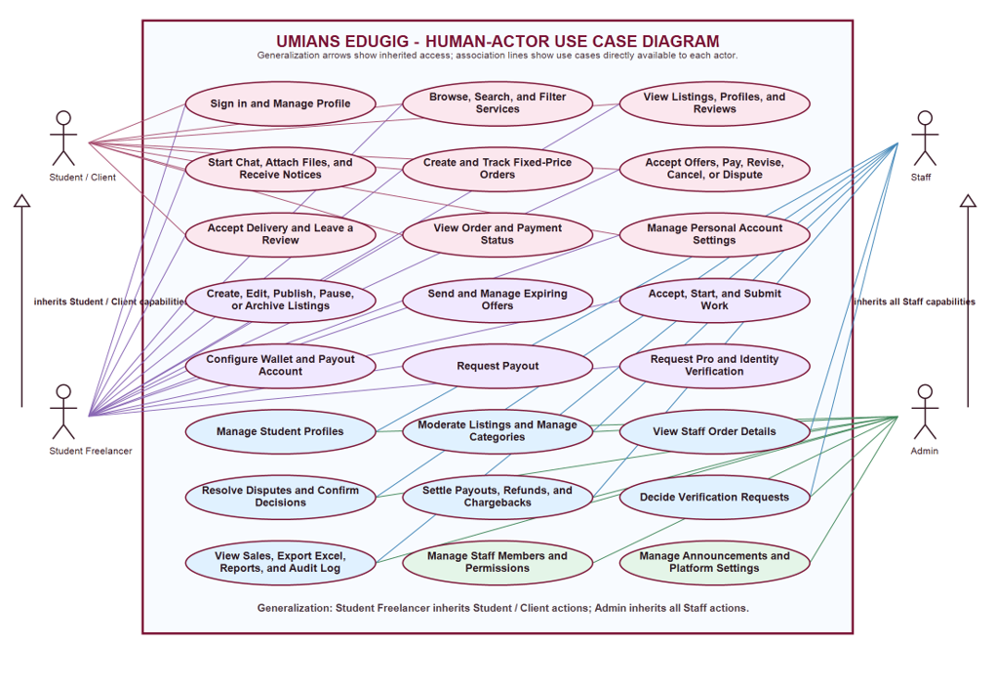
Figure 21. Complete human-actor use-case diagram for UMians EduGig
Student/Client covers account access, marketplace discovery, profiles, chat, fixed and negotiated orders, payment completion, tracking, revisions, cancellation, disputes, delivery acceptance, and reviews. The Student Freelancer has all of those actions and adds listings, offers, work submission, wallet, payout, Pro, and verification. Staff actions remain permission-scoped. Admin inherits the entire Staff set such as student moderation, queues, financial decisions, verification, sales, Excel export, reports, and audit access, then adds staff-permission, announcement, and platform-setting management.
IX. Conceptual Framework
Figure 22 presents the Input-Process-Output framework. Student and staff/admin inputs pass through role-specific processes to produce marketplace, transaction, and management outputs.
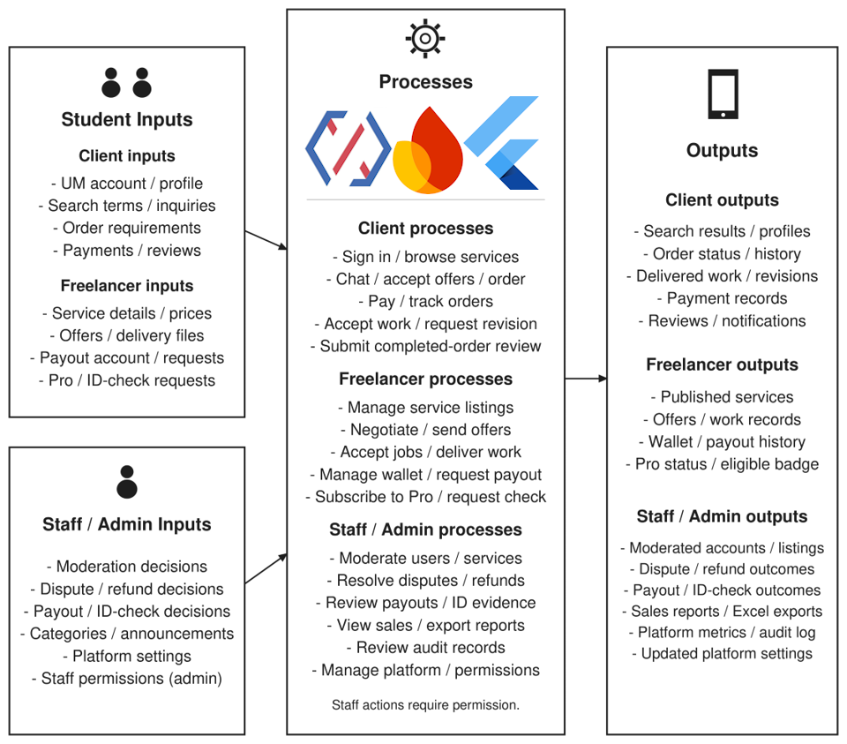
Figure 22. Input-Process-Output conceptual framework and tools used
Flutter and Dart provide the interface; Firebase supports authentication, data, files, notifications, and backend processing; Xendit handles gateway payments. Reviews and audit records inform later decisions.
X. Gantt Chart
Activity | Description | Responsibility | Dependency | W4 | W5 | W6 | W7 | W8
Requirements refinement and UI prototype | Define system requirements and design screen layouts for the student marketplace. | April Bords Nerosa - Systems Analyst / UI Designer | —
Authentication and profile foundation | Implement UM account sign-in, profile setup, and access to protected screens. | April Bords Nerosa - App Developer | Requirements
Marketplace and service management | Build service search, filtering, listing creation, editing, and publishing. | April Bords Nerosa - App Developer | Authentication
Chat, offers, and order lifecycle | Implement messaging, negotiated offers, order tracking, deliveries, and revisions. | April Bords Nerosa - App Developer | Marketplace
Payments, wallet, and notifications | Integrate payment processing, wallet records, payout requests, and notifications. | April Bords Nerosa - Backend Developer | Orders
Admin console, reports, and audit | Develop permission-based administration, moderation queues, sales reports, and audit records. | April Bords Nerosa - Full-stack Developer | Authentication; payments
Integration, regression, and mobile UI testing | Test connected workflows, access controls, regressions, and mobile screen behavior. | April Bords Nerosa - Software Tester | All modules
Chapter documentation and final presentation | Prepare chapter documentation, compile test evidence, and present the completed system. | April Bords Nerosa - Technical Writer / Presenter | Test evidence

XI. Test Case
A. White-Box Test Cases — Client
Test ID | Scenario | Preconditions and steps | Expected result | Actual result | Status
WB-C-01 | Search keyword derivation | Save a published listing, then search by title and skill token. | Only matching published listings are returned. | Search returned only published listings matching the title or skill token. | Passed
WB-C-02 | Order-state guard | Attempt legal and illegal state transitions. | Only the authorized actor and legal next state succeed. | Authorized legal transitions succeeded; unauthorized and illegal transitions were rejected. | Passed
WB-C-03 | Review uniqueness | Submit then duplicate a completed-order review. | Deterministic review id prevents a duplicate. | The first review was saved; the duplicate review was rejected. | Passed
WB-C-04 | Marketplace pagination | Load a first query page, retain its cursor, and request the next page. | The next page adds only later matching listings with no duplicate record. | The next page returned later matching listings without duplicate records. | Passed
WB-C-05 | Profile access guard | Attempt to open a protected client route while signed out and while signed in. | Signed-out navigation redirects to login; authenticated navigation opens the route. | Signed-out access redirected to login; signed-in access opened the protected route. | Passed
WB-C-06 | Category filter combination | Combine a category selection, text query, and sort order. | The query returns only records satisfying every selected constraint. | Results matched the selected category and search term in the requested sort order. | Passed
WB-C-07 | Notification target validation | Open notifications with valid, missing, and malformed target identifiers. | Only valid targets navigate; invalid targets show a safe failure message. | Valid targets opened; missing or malformed targets displayed a safe failure message. | Passed
WB-C-08 | Suspended-user guard | Attempt protected client actions after a profile is suspended. | The account cannot continue protected marketplace activity. | The suspended account was prevented from continuing protected marketplace actions. | Passed

B. White-Box Test Cases — Freelancer
Test ID | Scenario | Preconditions and steps | Expected result | Actual result | Status
WB-F-01 | Listing ownership | Edit a listing as owner then as another user. | Only owner can change listing fields. | The owner could edit the listing; another user could not change its fields. | Passed
WB-F-02 | Payout validation | Submit valid and invalid provider account formats. | Only valid payout details are accepted. | Valid payout details were accepted; invalid account formats were rejected. | Passed
WB-F-03 | Delivery transition | Submit delivery before and after in-progress state. | Delivery is accepted only in permitted state. | Delivery was rejected before the permitted work state and accepted after work started. | Passed
WB-F-04 | Listing field validation | Save listings with delivery, price, revision, and title values at valid and invalid boundaries. | Only values inside the defined validation range persist. | Valid listing values were saved; values outside the allowed limits were rejected. | Passed
WB-F-05 | Offer expiry guard | Attempt to accept an offer before and after its expiry timestamp. | Only a still-valid pending offer can create an order. | A valid pending offer created an order; an expired offer was rejected. | Passed
WB-F-06 | Draft visibility | Save a listing as draft and query marketplace results. | Draft data remains visible only to its owner. | The owner could view the draft; it did not appear in public marketplace results. | Passed
WB-F-07 | Minimum payout guard | Request a payout below and at the configured minimum balance. | Below-minimum request is refused; qualifying request is accepted. | The below-minimum payout request was rejected; the qualifying request was accepted. | Passed
WB-F-08 | Conversation participant guard | Attempt message or offer creation as a conversation participant and outsider. | Only participants can write to the conversation. | Conversation participants could send messages and offers; outsiders were denied. | Passed

C. White-Box Test Cases — Authorized Staff
Test ID | Scenario | Preconditions and steps | Expected result | Actual result | Status
WB-S-01 | Permission boundary | Use an account lacking a queue permission. | Rules and backend reject access. | The account without the required permission was denied queue access. | Passed
WB-S-02 | Moderation audit | Take down a listing as authorized staff. | Listing update and readable audit entry are recorded. | The listing was taken down and a readable audit entry recorded the action. | Passed
WB-S-03 | Dispute confirmation | Confirm a qualifying decision as same then separate staff. | Same-person confirmation fails; independent confirmation succeeds. | Confirmation by the same staff member was rejected; independent confirmation succeeded. | Passed
WB-S-04 | Sales-report scope | Query payment reports using all-time and date-range filters. | Only settled payments inside the selected range are returned. | Reports returned only settled payments within the selected date range. | Passed
WB-S-05 | Audit reference resolution | Open entries targeting a user, service, order, payment, offer, and payout. | The display resolves readable subjects without exposing raw target ids. | Audit references displayed readable subjects for each tested record type. | Passed
WB-S-06 | Verification permission | Attempt verification decisions with and without verification permission. | Only the authorized staff member can decide the request. | Authorized staff could decide verification requests; staff without permission were denied. | Passed
WB-S-07 | Refund permission | Attempt refund retry and manual refund with different permission sets. | Only staff with refund authority can invoke either action. | Refund retry and manual refund actions were allowed only for staff with refund authority. | Passed
WB-S-08 | Payout settlement permission | Attempt payout settlement with and without settlement permission. | Only authorized staff can settle or reject a payout. | Authorized staff could settle or reject payouts; staff without permission were denied. | Passed

D. Black-Box Test Cases — Client
Test ID | Scenario | Preconditions and steps | Expected result | Actual result | Status
BB-C-01 | Order fixed-price service | Browse → listing → requirements → create → pay. | Frozen terms display and next action becomes available. | The order displayed the agreed terms, and the next eligible action became available after payment. | Passed
BB-C-02 | Accept negotiated offer | Chat → receive offer → accept → pay. | One order uses the offer values. | Accepting the offer created one order using the negotiated terms. | Passed
BB-C-03 | Complete and review | Accept submitted order → enter rating. | Net release and one genuine review appear. | Completion released the net amount and allowed one completed-order review. | Passed
BB-C-04 | Open a dispute | Open a paid active order, select Dispute, provide a reason, and confirm. | The dispute enters the staff queue and both participants see the appropriate state. | The dispute appeared in the staff queue, and both participants saw the disputed state. | Passed
BB-C-05 | Empty marketplace search | Search for a term with no matching published listing. | A clear empty state appears without a runtime error. | The unmatched search displayed a clear empty state without a runtime error. | Passed
BB-C-06 | Cancel before fulfillment | Open an eligible unpaid or pending order and choose Cancel with a reason. | The order follows the legal cancellation/refund path. | The eligible order followed the permitted cancellation and applicable refund path. | Passed
BB-C-07 | Notification deep link | Tap a client order or chat notification. | The relevant target opens and invalid links fail safely. | Valid notifications opened the relevant order or chat; invalid destinations failed safely. | Passed
BB-C-08 | Open an active buyer order | Orders â†’ Buying â†’ select a pending active order. | The complete order-detail screen opens with status, terms, requirements, delivery, and payment information. | The pending buyer order 'Debug my code (Python or Dart)' opened successfully with its lifecycle tracker, frozen terms, requirements, delivery section, and unpaid payment summary; no error screen appeared. | Passed

E. Black-Box Test Cases — Freelancer
Test ID | Scenario | Preconditions and steps | Expected result | Actual result | Status
BB-F-01 | Publish service | My Services → Add → valid fields → Publish. | Listing appears in marketplace search. | The published service appeared in marketplace search results. | Passed
BB-F-02 | Fulfill order | Accept → start → submit delivery evidence. | Client sees submitted state and choices. | Submitted delivery evidence appeared for the client with the submitted status and available actions. | Passed
BB-F-03 | Request payout | Wallet → configure account → request payout. | Request appears with expected queue state. | The payout request was created and appeared with the expected queue status. | Passed
BB-F-04 | Pause and resume a listing | Open My Services, pause a published service, then publish it again. | The service disappears from search while paused and returns only when published. | The paused listing disappeared from search and returned after it was published again. | Passed
BB-F-05 | Send an offer | Open a client conversation, create a valid offer, and submit it. | The client receives a readable offer card with scope, amount, revisions, and duration. | The client received an offer card showing scope, price, revisions, and delivery duration. | Passed
BB-F-06 | Receive a client message | Client starts a conversation from a listing; freelancer opens Messages. | The conversation appears with the latest message and unread state. | The conversation appeared with the latest client message and unread state. | Passed
BB-F-07 | Revision loop | Client requests revision on submitted work; freelancer opens the order. | The order returns to the permitted work state and can be resubmitted. | The revision request returned the order to the permitted work state and allowed resubmission. | Passed
BB-F-08 | Clearing balance explanation | Complete a new seller's early order and open Wallet. | The amount appears as clearing rather than incorrectly available. | The early-order earnings appeared as clearing funds rather than available funds. | Passed
BB-F-09 | No selling orders state | Orders â†’ Selling for a freelancer account that has no received orders. | A clear empty state and My services action appear without an error or indefinite loader. | The Selling tab loaded the intentional 'No orders for your services yet' state and displayed the My services action without an error or endless loading indicator. | Passed

F. Black-Box Test Cases — Authorized Staff
Test ID | Scenario | Preconditions and steps | Expected result | Actual result | Status
BB-S-01 | Moderate from profile | Students → profile → listing → take down. | Listing leaves public marketplace; action recorded. | The listing was removed from the public marketplace and the moderation action was recorded. | Passed
BB-S-02 | Decide verification | Verification → inspect → approve/reject with note. | Status, notice, and audit update. | The verification decision updated the request status, notification, and audit record. | Passed
BB-S-03 | Sales and Excel export | Overview → Sales → range → export. | Settled sales filter and XLSX has readable names. | The selected range filtered settled sales, and the Excel export displayed readable names. | Passed
BB-S-04 | Open audit-entry details | Admin → Audit Log → select an entry with a linked subject and actor. | A readable detail screen opens without endless loading or raw document ids. | Audit details opened with readable subject and actor information without an endless loader. | Passed
BB-S-05 | Filter and export sales | Select All time, Last 7 days, and Last 30 days; export the current view. | Each range changes the settled-sales result and export produces the matching XLSX report. | Each date filter updated the sales results, and the Excel export matched the selected view. | Passed
BB-S-06 | Settle payout | Open an eligible payout and record a valid staff settlement. | The payout, wallet ledger, notification, and audit record update together. | Settlement updated the payout, wallet ledger, notification, and audit record together. | Passed
BB-S-07 | Retry a stuck refund | Open a failed refund queue item and invoke retry. | The retry result is shown without leaving the queue indefinitely loading. | The refund retry displayed its result without leaving the queue loading indefinitely. | Passed
BB-S-08 | Student-profile listing moderation | Open a student profile that owns multiple listings and moderate one item. | Only the selected listing changes; the profile remains readable. | Only the selected listing changed; the student profile remained readable. | Passed

