Chapter 2:
Conceptualizing the Mobile Application

VI. Prototypes

Take a screenshot for prototypes:
Every Page: should represent a core action or interaction
(e.g., form submission, booking, etc.).

​Annotate your prototypes with explanations of page elements, user interactions,
and the purpose of each component.

Include every screens here.
Sample Format:
Login Page:  Explanation/Description here | Screenshot here

VII. Task Analysis/User Interface Manual

Include a task analysis explaining the user journey for the main transaction process. Highlight the steps the user will take from accessing the home page to every possible the transaction.

VIII. Use Case

Insert your Use Case here.
(Include: actors, main flow)

IX. Conceptual Framework

Insert your Conceptual Framework here.
(You may include diagrams showing relationships between system components, user interactions, and data flow.)
Sample format for cf
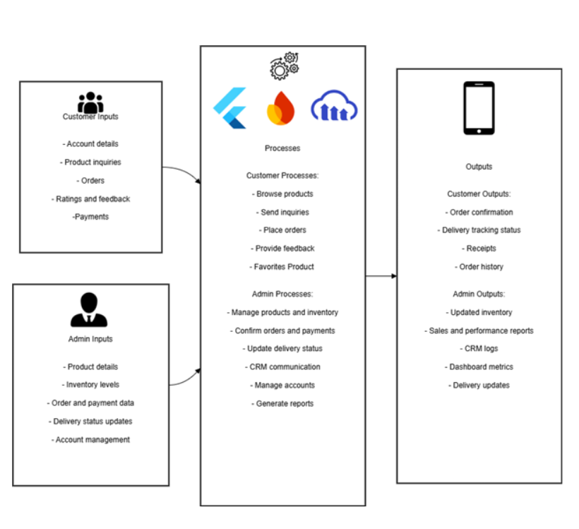

X. Gantt Chart

Insert your Gantt Chart here.
(Ensure it covers project phases, tasks, durations, and dependencies.)

XI. Test Case

Insert your Test Cases here. For each role it should have White-box test cases and black-box test cases

Test ID | Test Cases | Objective | Preconditions | Steps | Expected Result | Actual Result | Status

