Final Project

By Abdulrahman Abdulbari

absaabdu@iupui.edu

**Introduction**

The primary objective of this final project is to create an automated plant watering IoT application. To do this, we will be using Raspberry Pi 2. We will be getting/sending updates using the coAP library. Given that the raspberry pi reads digital signals, MCP3008 ADC was used to produce digital readings from the analog soil moisture sensors.

**Sensors**

N-channel power MOSFET - 30V / 60A

Peristaltic Liquid Pump with Silicone Tubing

8 x AA battery holder -12V

MCP3008 - 8-Channel 10-Bit ADC With SPI Interface

FC-28 Soil Moisture Sensor

**Protocols**

For this project CoAP will be used as the primary protocol. Specifically, CoAPThon will be used along side of Python.

**Circuit Diagram**

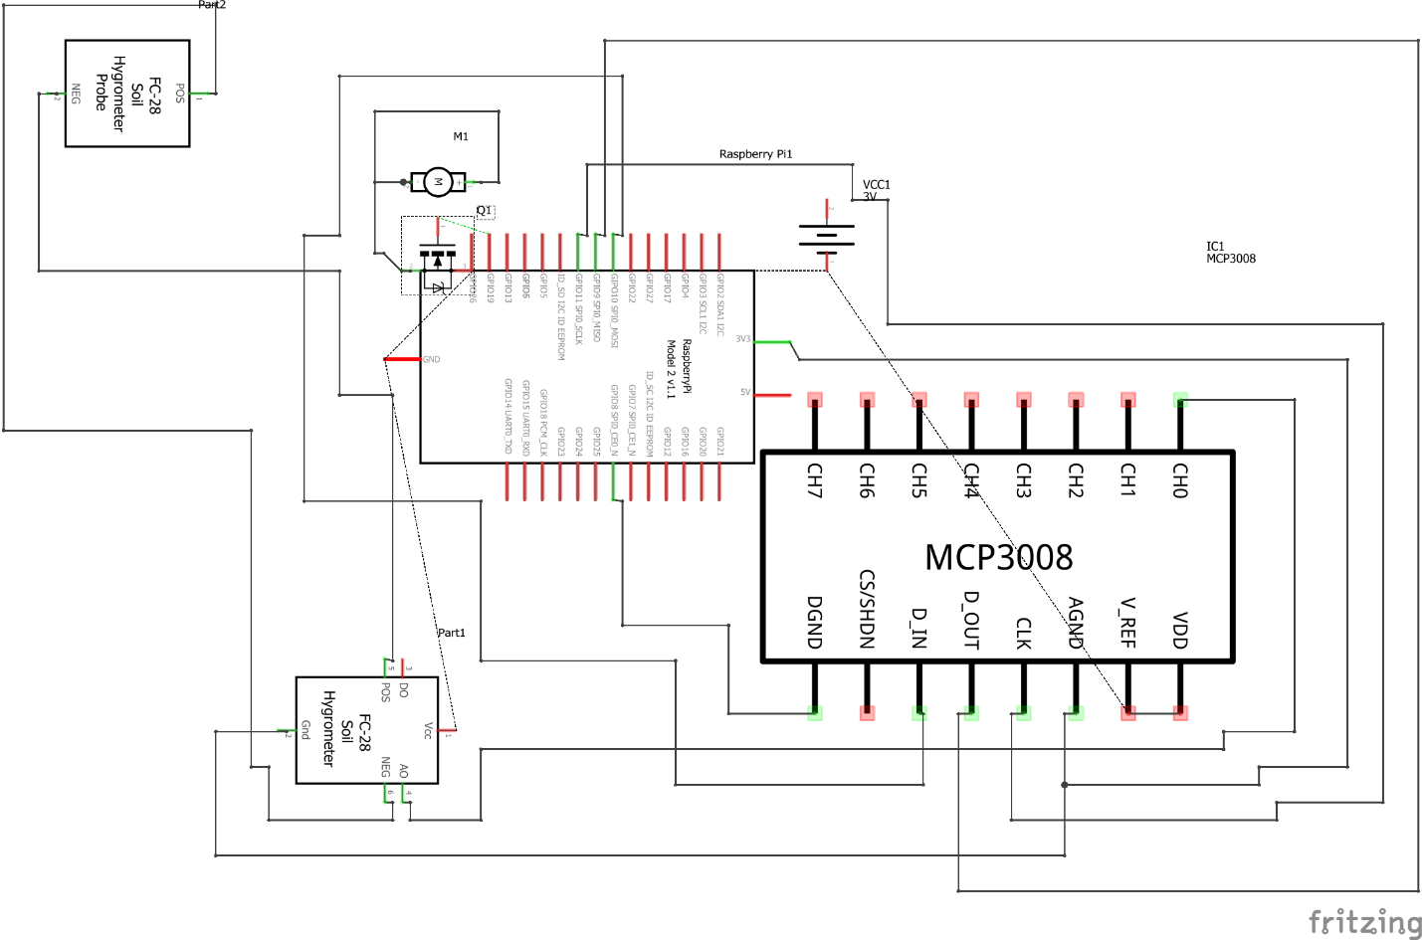

I ran into several issues figuring out how to wire together the water pump with the battery and the N Channel Power. There was a lack of proper documentation for some of the sensors which made things slightly difficult. I eventually managed to figure it out after some trial and error.

**Code Logic**

* Read ADC value
* Save ADC Value
* Set PWM and start
* Change duty cycle if not wet
* Notify any changes.

The code below creates a timer and threads.

timer = threading.Timer(self.period, self.update)

timer.setDaemon(True) timer.start()

if not first and self._coap_server is not None:

logger.debug("Periodic Update")

myValue = mcp.read_adc(0)

print(myValue)

p = GPIO.PWM(19, 50)

p.start(0)

while(myValue> 600):

p.ChangeDutyCycle(70)

time.sleep(0.2)

else:

print("The dirt is wet right now...")

p.stop()

self._coap_server.notify(self)

self.observe_count += 1

**Results**

As we can see from the images below, coapserver.py turns on the coAP server on 0.0.0.0:5683 and it gets the resource “Moisture”. The initial thread does not check/print the moisture sensor output. This part only starts on the 2nd thread. Currently, the moisture sensor check is being done every 5 seconds. Realistically, this should be checked every hour but it was shortened due to project purposes.

