**Instructions**

1. Put the **Four** .rb file into same folder

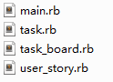

1. Open **CMD** and direct to the folder
2. Input “ruby main.rb” to run the program



**Notes**

1. options for column are “toDo”, “inProgress”, “toVerify”, and “done” (case-sensitive)
2. return a 0 for successful completion, 1 for an error
3. input “exit” to exit the program
4. when the story id or task id exists, it cannot be create
5. when the story id or task id does not exisit, it cannot be moved and deleted
6. when the task is in the “done” column, it cannot be moved

**Test cases**

1. create story 1 java



1. create story 2 c



1. list stories

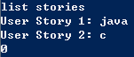

1. delete story 1, list stories

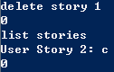

1. create task 2 1 headFile, list tasks 2

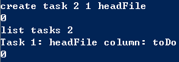

1. delete task 2 1, list tasks 2

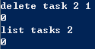

1. create task 2 1 headFile , move task 2 1 toVerify, list tasks 2

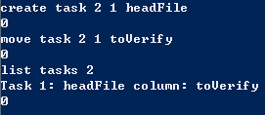

1. move task 2 1 done

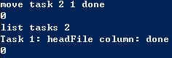

1. complete story 2



1. update task 2 1 builtInlib

