**ZERO DAY PESU ECC**

**CLUB AGREEMENT**

I, ……………………………………, hereby agree that I will follow the rules and regulations laid down by Zero Day PESU ECC as well as Indian Cyber Laws.

**INDIAN CYBER LAWS**

**Section 43** of the Act states that if any person without permission of the owner or any other person who is an in charge of a computer, computer system or computer network, if modifies, damages, disrupts computer network, downloads, copies or extract any data or information from such computer network or accesses to such computer system he may be penalized for damages.

**Section 43-A** of the Act states that if any person fails to protect the data, he is liable for compensation, so if an ethical hacker is a body corporate and he fails to protect the data he his handling he will be liable under section 43- A of IT Act.

**Section 65 – Tampering with computer Source Documents:** A person who intentionally conceals, destroys or alters any computer source code (such as programs, computer commands, design and layout), when it is required to be maintained by law commits an offence and can be punished with 3 years’ imprisonment or a fine of 2 Lakhs INR or both.

**Section 66** of the IT Act deals with the computer-related offences which state that any person who dishonestly and fraudulently does any act mentioned in section 43 of the Act he shall be penalized with up to three years or/and a fine of 5 Lakh INR.

The IT law of India does penalize a hacker who does not have proper authorization to get access to the computer hacker but it does not protect ethical hackers unless he is employed by the government under **section 84**.

**66A** Sending offensive messages through communication service, causing annoyance etc. through an electronic communication or sending an email to mislead or deceive the recipient about the origin of such messages (commonly known as IP or email spoofing) are all covered here. Punishment for these acts is imprisonment up to three years or fine.

**66B** Dishonestly receiving stolen computer resource or communication device with punishment up to three years or one lakh rupees as fine or both.

**66C** Electronic signature or other identity theft like using others’ password or electronic signature etc. Punishment is three years imprisonment or fine of one lakh rupees or both.

**66D** Cheating by personation using computer resource or a communication device shall be punished with imprisonment of either description for a term which extend to three years and shall also be liable to fine which may extend to one lakh rupee.

**66E** Privacy violation – Publishing or transmitting private area of any person without his or her consent etc. Punishment is three years imprisonment or two lakh rupees fine or both.

**66F** Cyber terrorism – Intent to threaten the unity, integrity, security or sovereignty of the nation and denying access to any person authorized to access the computer resource or attempting to penetrate or access a computer resource without authorization. Acts of causing a computer contaminant (like virus or Trojan Horse or other spyware or malware) likely to cause death or injuries to persons or damage to or destruction of property etc. come under this Section. Punishment is life imprisonment.

**Section 67** deals with publishing or transmitting obscene material in electronic form. The earlier Section in ITA was later widened as per ITAA 2008 in which child pornography and retention of records by intermediaries were all included.

**Section 67-A** deals with publishing or transmitting of material containing sexually explicit act in electronic form. Contents of Section 67 when combined with the material containing sexually explicit material attract penalty under this Section.

Due to the nature of this club and the content material, there is a risk that students may use their knowledge and experience they obtain for malicious purposes. Thus, new members are required to sign a clause stating they will not do so. All content shared, taught in this club is for educational purposes. You and only you are to take responsibility for your actions. The admins or mentors will not take responsibly for any damage or destruction caused by you.

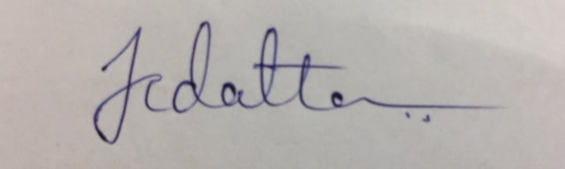

***STUDENT’S SIGNATURE CLUB HEAD'S SIGNATURE***