ZeroG’s GIS to GAME
Converter (GTG)
User manual · version 1.2.0 · November 2026
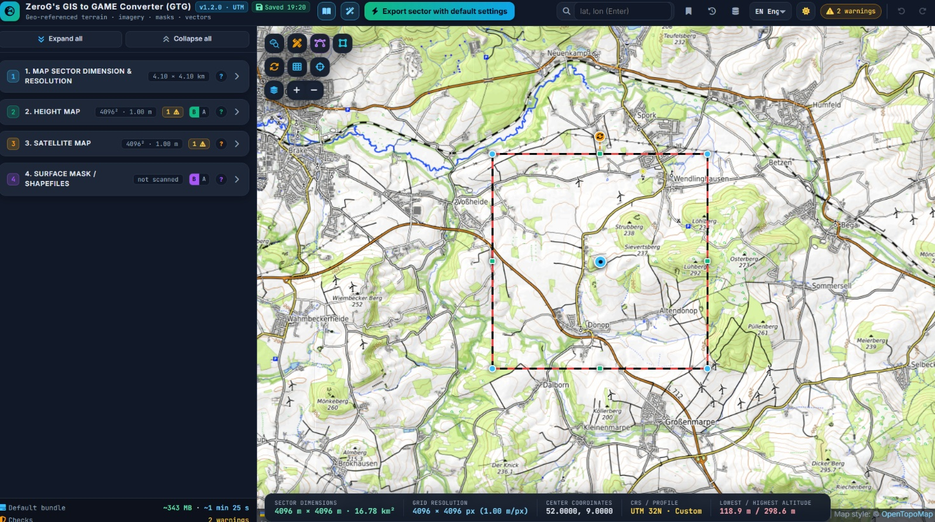
Real-world terrain for game engines – heightmaps, satellite maps, surface masks with colour legend, shapefiles and terrain shaping, georeferenced in UTM and ready for Arma Reforger, Arma 3, Unreal Engine and Unity.
New in 1.2.0: select, box-select, delete and batch-edit shapes directly on the map.
Contents
Preface 3
What is new in version 1.2.0 3
Core facts at a glance 3
How this manual is organised 4
Part 1 – Getting started 5
1.1 Starting the tool 5
1.2 The screen at a glance 5
1.3 Header bar 6
1.4 Fold and unfold 6
1.5 Map controls 6
1.6 Working with shapes – mouse and keyboard 7
1.7 Concepts used everywhere 8
Part 2 – Tutorial: Fulda Gap 1985 for Arma Reforger 12
Step 1 – Find the place 12
Step 2 – Choose the engine profile and size 13
Step 3 – Align the sector to the map grid 13
Step 4 – Look at the terrain 14
Step 5 – Check the satellite image 15
Step 6 – Scan the public shapefiles 16
Step 7 – Clean up the shapes with the mouse 17
Step 8 – Build the defence line – special zones 22
Step 9 – Morph the terrain 23
Step 10 – Surface masks and colour legend 24
Step 11 – Export 27
Part 3 – Feature reference 29
3.1 Section 1 – Map sector dimension & resolution 29
3.2 Section 2 – Height map 31
3.3 Section 3 – Satellite map 33
3.4 Map controls in detail 33
3.5 Section 4.1 – Public shapefiles (OpenStreetMap) 37
3.6 Section 4.2 – Custom shapefiles 38
3.7 Section 4.2b – Special zones 39
3.8 Section 4.3 – Heightmap morphing 40
3.9 Section 4.4 – Surface masks 42
3.10 Preview window 43
3.11 Project management 43
3.12 Language and theme 44
Part 4 – Reference 45
4.1 Keyboard and mouse 45
4.2 Engine import notes 45
4.3 Limits and formats 45
4.4 Troubleshooting 46
4.5 Credits and licences 46

Preface
ZeroG’s GIS to GAME Converter (GTG) turns any place on Earth into game-ready terrain data. You pick a sector on a map, and the tool produces a georeferenced heightmap, a satellite image, surface masks with a colour legend for material painting, shapefiles of roads, rivers, forests and buildings, and a reshaped (“morphed”) heightmap in which roads are graded, rivers are carved and buildings stand on smoothed ground. Special zones add craters, trenches, ditches, berms, dams, pits, dunes and other features on top.
The tool targets map makers for Arma Reforger (Enfusion), Arma 3 (Terrain Builder), Unreal Engine and Unity, and anyone who needs real-world terrain in a metric grid. Everything runs inside your web browser: there is nothing to install, no account and no server of its own. Data is loaded directly from public services (OpenStreetMap, AWS Terrain Tiles, Sentinel-2 cloudless, OpenTopoMap) or from your own files and WMS servers.

What is new in version 1.2.0
Area | Change
Shapes on the map | Shapes are now selected with the mouse: click = select, Shift+click = add or remove, Shift+drag = box select. Ctrl+click deletes a shape at once. Del deletes the selection, Esc clears it. Works for OpenStreetMap and custom shapes alike.
Selection bar | New bar at the top right of the map. It acts on every selected shape: rename, change class, include / exclude from export, mark for 4.3 morphing, convert OpenStreetMap shapes into custom shapes, edit vertices, join, simplify, zoom and delete.
Box select | New icon in the shapefile row of the map controls; replaces the former delete mode.
Shape lists | Click the colour dot of a row in 4.1 or 4.2 to select that shape on the map (Shift adds, Ctrl deletes). Selected rows are outlined in cyan.
Vertex editing | Ctrl+click a vertex deletes it. With one shape selected, key E opens it directly.
Simpler side panel | 4.1 categories start folded. In 4.2, Templates, Shapes from map colours, Join and Vertex limits fold behind their titles. The draw row is now Polygon · Line · Rectangle · Vertices. Fold states are remembered.
Speed | Only shapes whose look changes are redrawn. With thousands of shapes the shape list and map refresh several times faster, and the surface-mask overlay check is much quicker.
Changed behaviour | A plain click no longer switches a shape on or off – use the eye icon in the selection bar or the checkbox in the lists. Ctrl+click no longer marks shapes for 4.3 – use ⌖ in the selection bar.

Core facts at a glance
Topic | Fact
Delivery | One HTML file, opens in Chrome or Edge. Internet access is needed for map data.
Start state | English interface, map name “MyMap”, 4,096 × 4,096 m sector at latitude 52, longitude 9, 1 m cell size, all sections folded. Your last session is restored automatically; the shapefile scan always starts switched off.
Coordinate system | WGS84 / UTM (zone of the sector centre). The south-west corner of the sector is game origin 0,0.
Sector size | 128 m up to 65,536 m per side; square or rectangular; optional rotation against the UTM grid.
Heightmap | Cell size 0.25–8 m, max 8,192 px per side. Formats .asc, 16-bit .png, 16-bit .raw, 32-bit .r32, float GeoTIFF.
Elevation sources | AWS Terrain Tiles (global), custom elevation WMS, local DEM file (.tif / .asc).
Imagery sources | Sentinel-2 cloudless (2016 = commercial use allowed), OpenTopoMap, custom XYZ tiles, custom WMS.
Map backgrounds | OpenTopoMap, Sentinel-2 cloudless (newest year), Hybrid (Sentinel-2 + OpenTopoMap) and AWS Terrain Tiles as shaded relief – plus any custom WMS on top.
Shape editing | Click to select, Shift+click to add, Shift+drag for a box, Ctrl+click to delete; selection bar for rename, class, export on/off, morph marking, convert, join, simplify; vertex editor for every shape.
Vectors | OpenStreetMap scan in 8 categories / 33 subtypes, plus drawn, imported or colour-generated custom shapes with surface names and place-based names. Shapefile and GeoJSON.
Terrain shaping | Water carving, road and rail grading, building smoothing, flatten areas, 19 special-zone types.
Surface masks | Colour-coded mask with colour legend (picture and PDF), grayscale splat masks per subtype, RGBA splatmap, Enfusion block check.
Engine profiles | Unreal Engine 5, Unity, Arma 3, Arma Reforger – one click sets grid, formats and resolutions.
Languages | English (default), German, French, Spanish, Italian, Polish, Danish, Swedish, Norwegian, Czech, Ukrainian, Russian.
Storage | Session, bookmarks, history (20 versions) and tile cache are kept in the browser. Projects can be saved as .json.

How this manual is organised
- Part 1 – Getting started: the screen, the header, the map controls, working with shapes using the mouse, and the concepts that apply everywhere.
- Part 2 – Tutorial: a complete 4,096 × 4,096 m Fulda Gap scenario for Arma Reforger, from an empty map to the exported bundle.
- Part 3 – Feature reference: every section and every control, grouped like the side panel.
- Part 4 – Reference: keyboard and mouse, engine import notes, limits, troubleshooting, credits and licences.
Note The screenshots were made with a generated sample terrain and sample OpenStreetMap data at the tutorial coordinates. Live map tiles, heights and shapes look different; the controls and the workflow are identical. Village names in the pictures come from the sample data and do not match real positions.

Part 1 – Getting started

1.1 Starting the tool
- Open the HTML file in a current Chrome or Edge browser (double-click or drag it into a browser window).
- The tool starts in English with all sections folded and a 4,096 × 4,096 m sector named “MyMap” at latitude 52, longitude 9.
- Your last session is restored automatically (“Restored” in the header). The shapefile scan always starts switched off.
- A private window starts clean – useful for a fresh project or for testing.

1.2 The screen at a glance
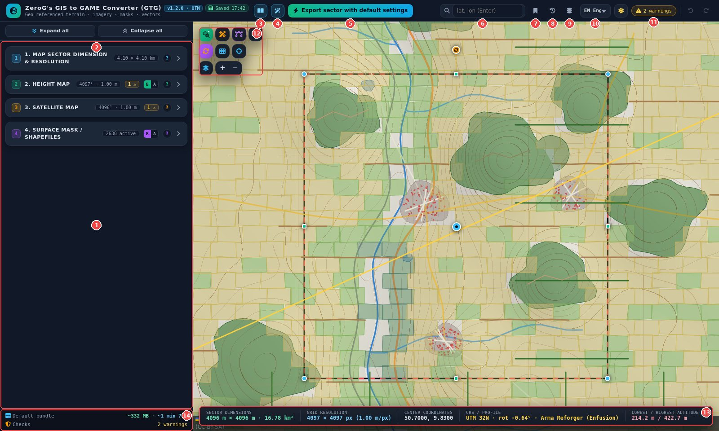
Figure 1 – Main screen with the numbered areas explained below
No. | Area | Purpose
1 | Side panel | Sections 1–4 with all settings, previews and exports. Click a header to fold or unfold it.
2 | Expand / collapse | Open or fold every section at once.
3 | Manual | Built-in manual; can be printed or saved as PDF.
4 | Wizard | Step-by-step tour that highlights every visible control.
5 | Default export | One ZIP with heightmap, satellite map, masks (with legend), shapefiles and morphed heightmap.
6 | Search | Enter coordinates “lat, lon” and press Enter – the sector jumps there.
7 | Locations | Bookmarks and recently used sectors.
8 | History | Saved project versions; one is stored with every export.
9 | Data cache | Tile and OpenStreetMap cache, size limit and clearing.
10 | Language | Interface language (12 languages).
11 | Messages | Number of errors and warnings; click to see all and jump to the setting.
12 | Map controls | Icon block at the top left of the map: shapefile row, sector row and map row (see 1.5).
13 | Status bar | Sector size, grid, centre, CRS / profile / rotation, lowest and highest altitude.
14 | Footer | Expected size and time of the default bundle and the overall check status.
Note The selection bar appears at the top right of the map as soon as one or more shapes are selected (see 1.6).

1.3 Header bar
Figure 2 – Header bar
- Version and save tag – shows “Saved hh:mm” after each automatic save.
- Undo / Redo – right end; reverses shape edits, deletions, class changes and on/off changes (Ctrl+Z / Ctrl+Y).
- Bright / dark – the sun icon switches the colour theme; the choice is saved.

1.4 Fold and unfold

Figure 3 – Expand all / Collapse all at the top of the side panel
- Sections – click a header to fold or unfold it; Expand all / Collapse all work on every section and subsection.
- Categories in 4.1 – start folded. Click the category row (or ▸ / ▾) to open it. The open state is remembered.
- Boxes in 4.2 – Templates, Shapes from map colours, Join adjacent shapes and Vertex limits fold behind their titles (▸ closed, ▾ open). They start closed and remember their state. Links from messages and the wizard open them automatically.

1.5 Map controls
All map controls sit in one compact block of icons in the top-left corner of the map, in three rows. Hover an icon to see its name, an explanation and its current state.
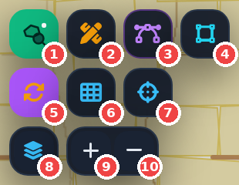
Figure 4 – The map-control block (scan switched on)
No. | Row · icon | What it does
1 | Shapefiles · Scan | Switch on to load the OpenStreetMap shapes and keep them shown; they follow the sector. Click again to switch off; Shift+click forces a fresh download.
2 | Shapefiles · Draw custom | Panel with class list and Polygon / Line / Rectangle tools.
3 | Shapefiles · Edit vertices | Move, add or delete vertices of any shape. Key E.
4 | Shapefiles · Box select | Drag a rectangle to select every visible shape inside it. Without the tool, Shift+drag does the same.
5 | Sector · Rotate sector | Angle input, slider, “Align to map grid” / “Align to UTM grid”.
6 | Sector · Map grid | UTM, lat / lon or sector grid overlay (display only).
7 | Sector · Centre in view | Moves the sector to the map centre; size and settings stay.
8 | Map · Background map | OpenTopoMap, Sentinel-2 (latest), Hybrid, AWS relief and a custom WMS on top.
9 / 10 | Map · Zoom + / − | Zoom in and out.

1.6 Working with shapes – mouse and keyboard
Every shape on the map – scanned from OpenStreetMap or drawn, imported and generated by you – is handled the same way. Select first, then act on the selection.
Action | Result
Click a shape | Selects it (cyan outline). Click it again to deselect.
Shift+click a shape | Adds it to the selection, or removes it.
Shift+drag on the map | Draws a box and adds every visible shape that has at least one vertex inside it.
Box-select icon, then drag | Same box without Shift. A plain drag replaces the selection, Shift adds. Esc ends the tool.
Ctrl+click a shape | Deletes it at once. Ctrl+Z restores it.
Del (or Backspace) | Deletes every selected shape in one step.
Esc / click on empty map | Clears the selection.
Colour dot in a 4.1 / 4.2 list row | Selects that shape on the map and zooms to it if needed; Shift adds, Ctrl deletes.
Hover a shape | Tooltip with name, surface, class, OSM / custom, “edited” and “EXCLUDED from export”.
Tip Only visible shapes can be selected. To work on one kind of shape, switch the other categories off in 4.1 first – box select then catches only what you see.

The selection bar
As soon as something is selected, the selection bar appears at the top right of the map. Buttons that do not fit the current selection are greyed out.
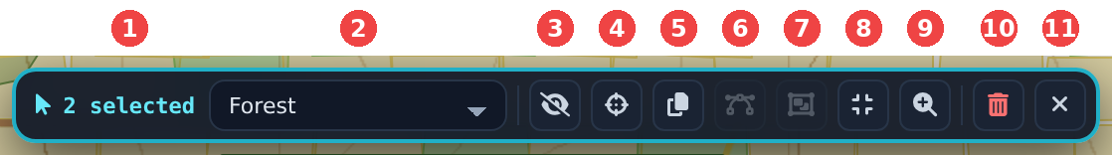
Figure 5 – Selection bar with two forest shapes selected (one OpenStreetMap, one custom)
No. | Control | What it does
1 | Counter | “1 OSM”, “1 custom” or “n selected”.
2 | Class | Changes the class of all selected shapes. Shown when all selected shapes are polygons or all are lines; with mixed types or special zones it is disabled.
3 | Eye | Include in or exclude from every export. Excluded shapes get red diagonal bars.
4 | Mark for morphing (⌖) | Marks the shapes for 4.3 “Selected only” (yellow outline). The mark stays when you clear the selection.
5 | Convert to custom | Turns OpenStreetMap shapes into custom shapes (4.2). They keep class, name, export state and marks, survive rescans and can be joined and simplified. Multipolygons become one shape per outer ring.
6 | Edit vertices | Opens the vertex editor for the selected shape (one shape only).
7 | Join | Joins adjacent selected custom shapes of the same type. Uses “Join shapes with the same” and “Max gap” from 4.2.
8 | Simplify | Simplifies the selected custom shapes with the vertex limits from 4.2.
9 | Zoom | Zooms the map to the selection.
10 | Delete | Deletes the selection (same as Del). Ctrl+Z restores it.
11 | Clear | Clears the selection (same as Esc).
Figure 6 – With one shape selected, a name field appears next to the counter – type a new name and press Enter
Important Changes to OpenStreetMap shapes – delete, class, name, export state, vertices – last until the next rescan, and the scan rescans automatically whenever the sector moves. Convert shapes you change into custom shapes to keep the changes. Every step can be undone with Ctrl+Z.

1.7 Concepts used everywhere

Basic and Advanced
- Sections 2 and 4 have a small B | A switch next to the “?” button.
- Basic shows the essential controls; hidden settings keep their values and are summarised in one line.
- Advanced shows every option. In section 4, subsections 4.2, 4.2b and 4.3 appear only in Advanced.
- Sections 1 and 3 always show all options.

Messages and checks
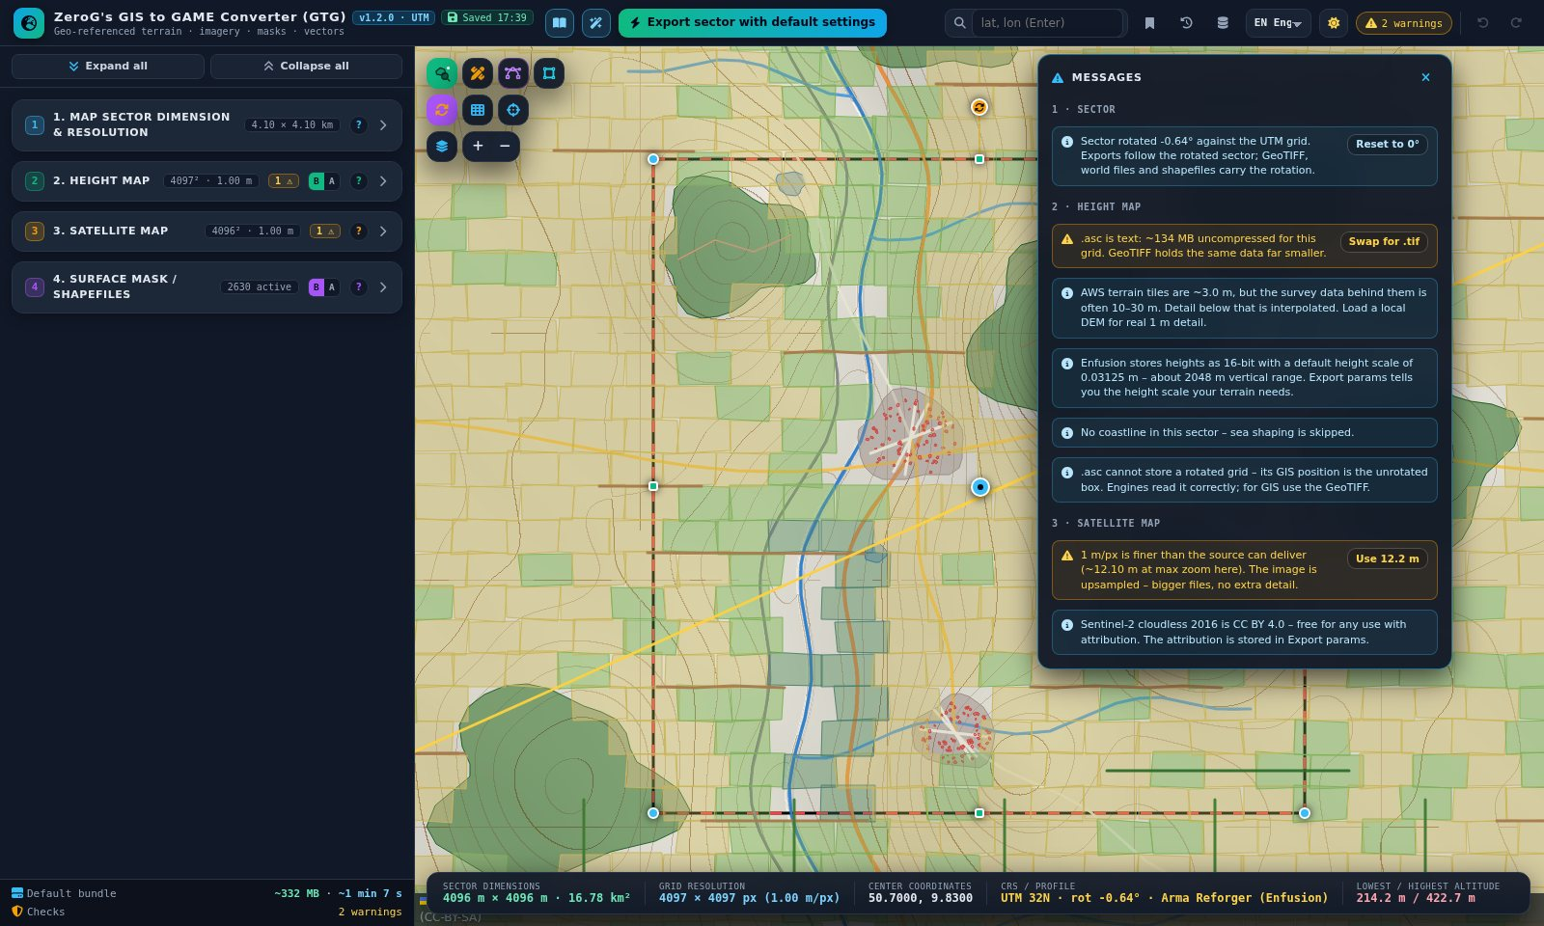
Figure 7 – Message list – click a message to jump to the setting, use the button for a one-click fix
- Every change is checked live. Red = error (blocks the export), amber = warning, blue = tip.
- The header button shows the count; the coloured badges on section headers open the same list.
- Clicking a message opens the section, scrolls to the setting and highlights it.
- Many messages offer a fix button (e.g. “Scan on”, “Use terrain metres”, “Use 2016”, “Reset to 0°”).

Help, wizard and built-in manual
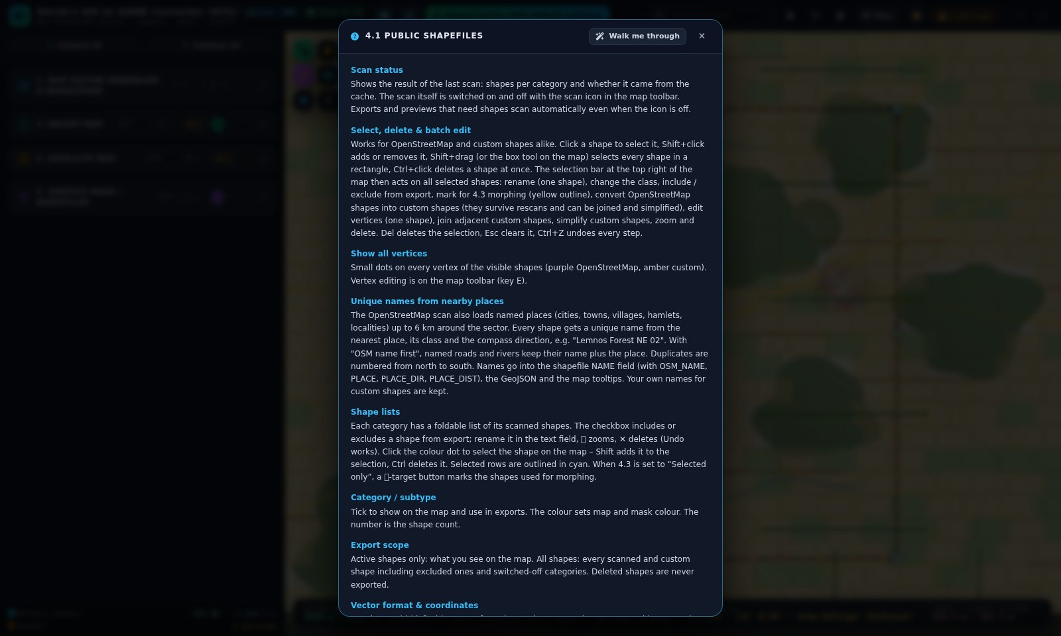
Figure 8 – Section help (“?”) of 4.1 with the new entry “Select, delete & batch edit”
- “?” on a section – explains every control of that section; “Walk me through” starts the wizard there.
- Wizard – black panel at the right, ← / → to move, drop-down to jump between chapters. It follows the Basic / Advanced state.
- Tooltips – hover any control for a one-line explanation; map icons show name, explanation and state.
- Built-in manual – every chapter with illustrations, keyboard table and troubleshooting; can be printed or saved as PDF.
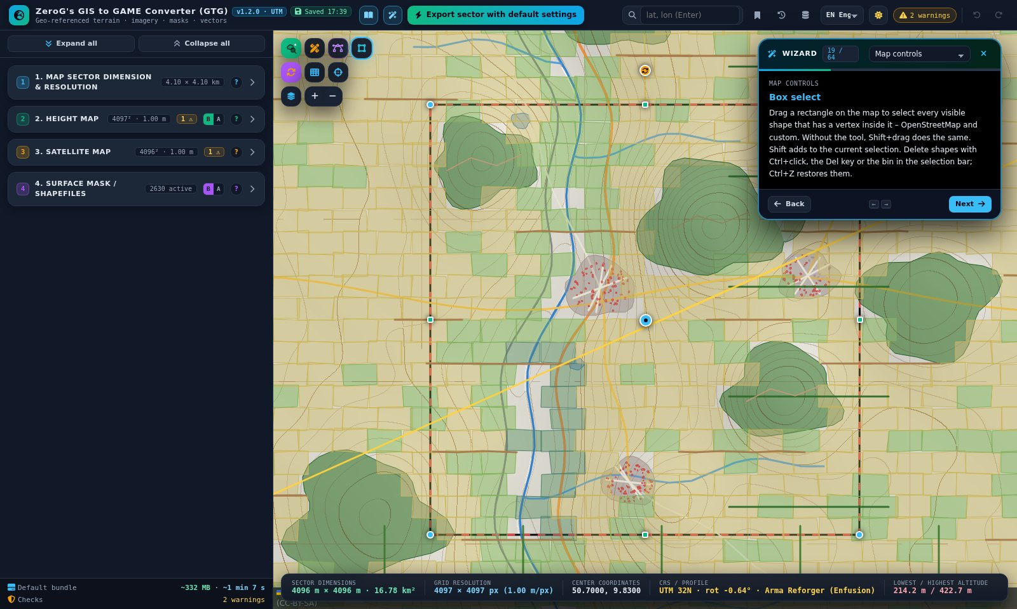
Figure 9 – Wizard explaining the box-select tool

Part 2 – Tutorial: Fulda Gap 1985 for Arma Reforger
Goal: a 4,096 × 4,096 m Arma Reforger terrain in the Fulda Gap, set in a fictional Cold War summer of 1985. The sector covers a river valley with a main road and a railway, three villages and wooded hills. You clean up the OpenStreetMap shapes with the mouse, build a defence line with an anti-tank ditch, a trench and dug-in positions, shell the fields in front of it, and export one ZIP with everything the Enfusion Workbench needs.
Item | Value
Place | Fulda Gap, Hesse – example centre 50.70° N, 9.83° E
Engine | Arma Reforger (Enfusion), grid 4097 × 4097 vertices
Size | 4,096 × 4,096 m = 16.78 km², cell size 1 m, 128 × 128 terrain blocks of 32 faces
Time | about 20 minutes
Result | Heightmap and morphed heightmap, satellite map, surface masks per surface with colour legend, shapefiles in terrain metres, import values in params.json
Note The coordinates are an example. Any place in the Fulda Gap works the same way; pick the exact spot on the live map.

Step 1 – Find the place
- Click into the search box in the header, type 50.70, 9.83 and press Enter. The red-black dashed frame (the sector) jumps there.
- Open section 1 and rename the map to FuldaGap_1985. This becomes the prefix of every file (the default is “MyMap”).
Alternatives: drag the blue centre marker, pan the map and click “Centre sector in view”, or switch to “4 coordinates”.
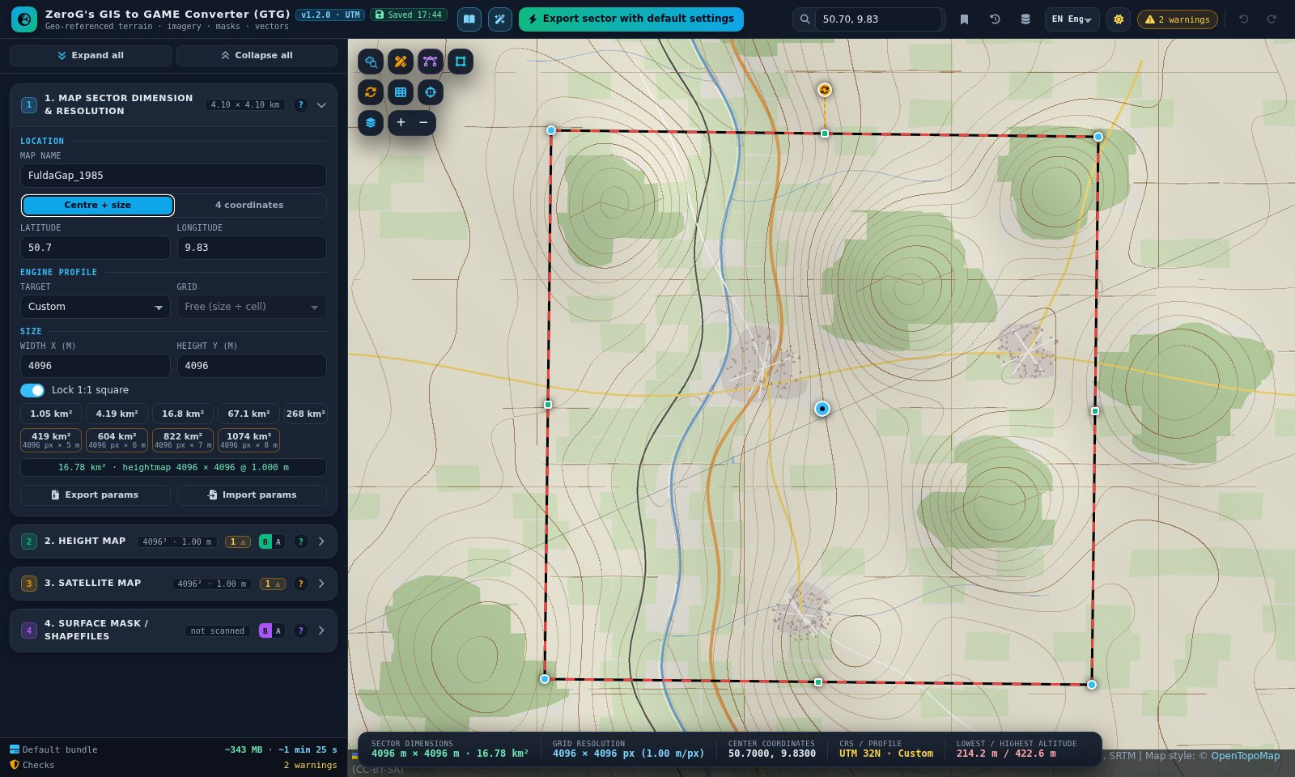
Figure 10 – Sector placed via coordinate search, map renamed

Step 2 – Choose the engine profile and size
- In section 1 set Target to “Arma Reforger (Enfusion)”.
- Set Grid to “4097 × 4097”. With the 1 m cell size the sector becomes 4,096 × 4,096 m.
The profile sets the heightmap formats (.asc + 16-bit .png), per-subtype splat masks, the Enfusion block check and terrain-metre coordinates. 4097 vertices = 4096 faces = 128 blocks of 32 faces per side.
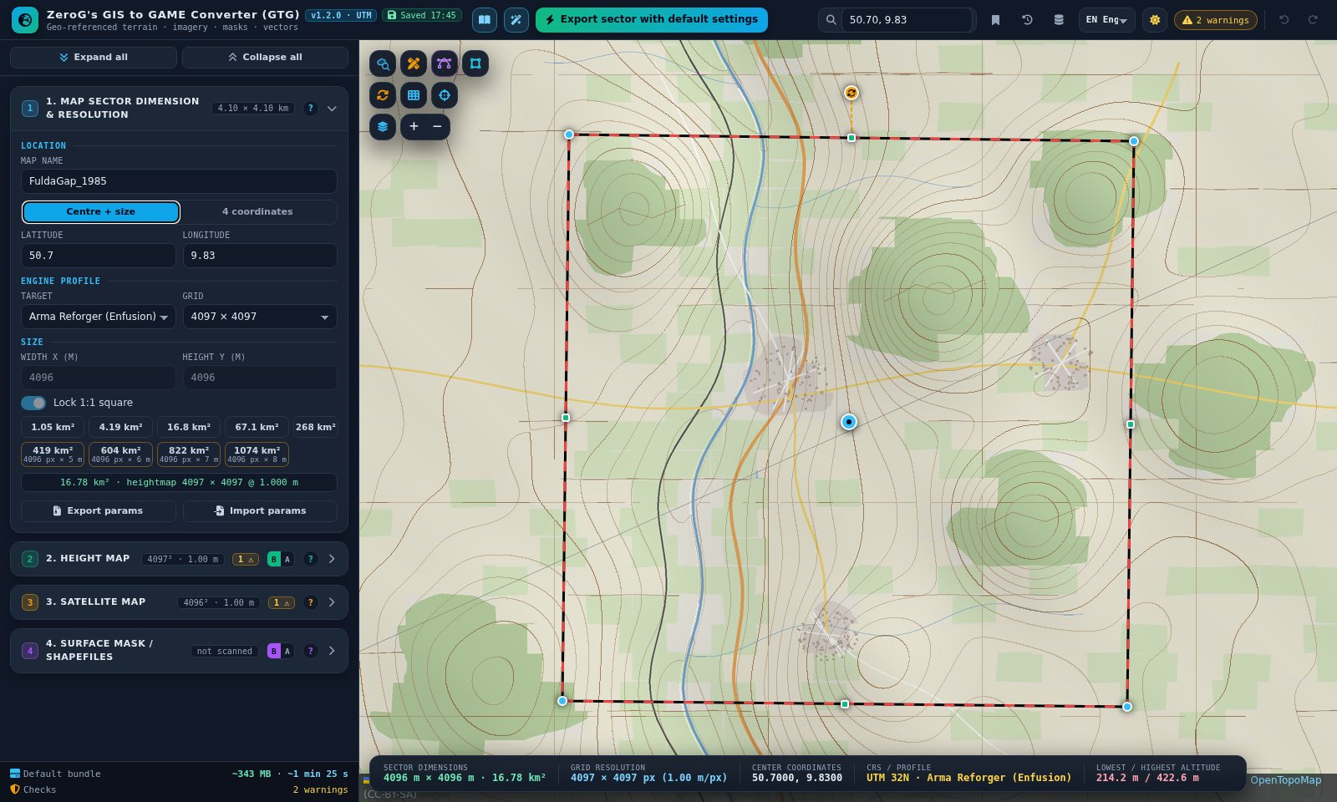
Figure 11 – Arma Reforger profile with the 4097 grid: 4096 × 4096 m

Step 3 – Align the sector to the map grid
- Click the rotate icon (sector row) and then “Align to map grid”.
- The sector turns by the grid convergence of UTM zone 32 at this place (about −0.6° here), so its edges run exactly north–south and east–west.
- Optional: map-grid icon → “Sector” shows the game grid from the south-west corner (0,0). It is display only.
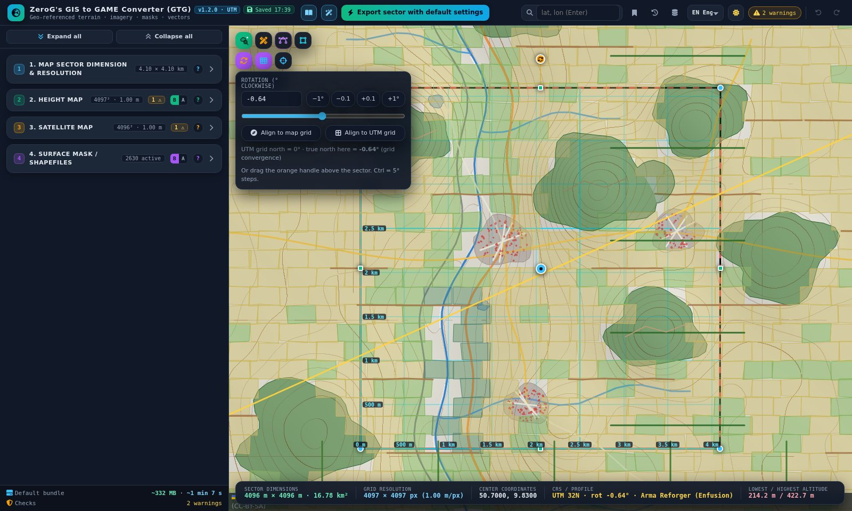
Figure 12 – Rotation panel and the sector grid (500 m spacing)

Step 4 – Look at the terrain
- Open section 2 and switch on “Show heightmap on map”. Choose the shader “Contours”.
- Switch on “Compare slider” and drag the orange handle: map on the left, heightmap on the right.
- The status line shows the elevation range – the valley lies at about 210 m, the hills reach about 420 m. Enfusion’s default height scale covers 2,048 m, so no change is needed.
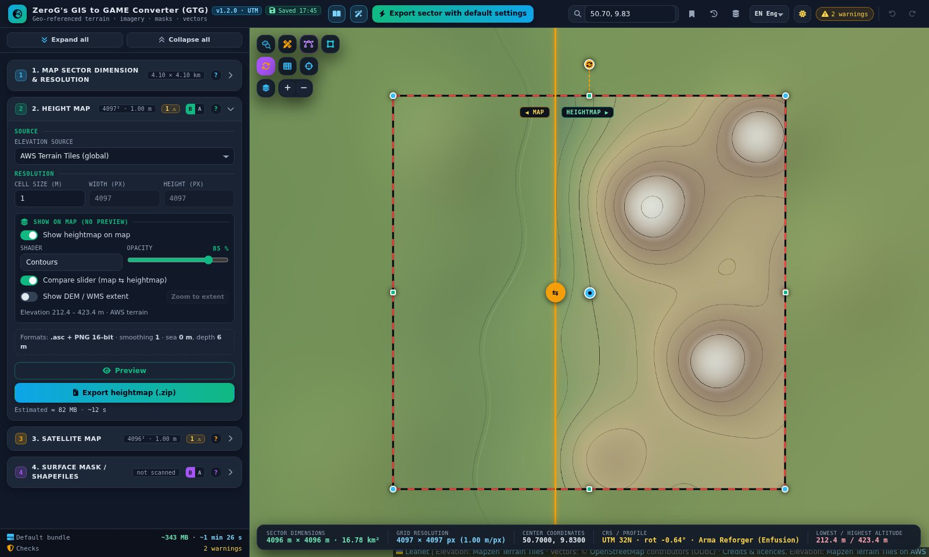
Figure 13 – Heightmap on the map with the compare slider
Preview opens the same terrain in a window, with a compare slider against the satellite image and a 3D tab.
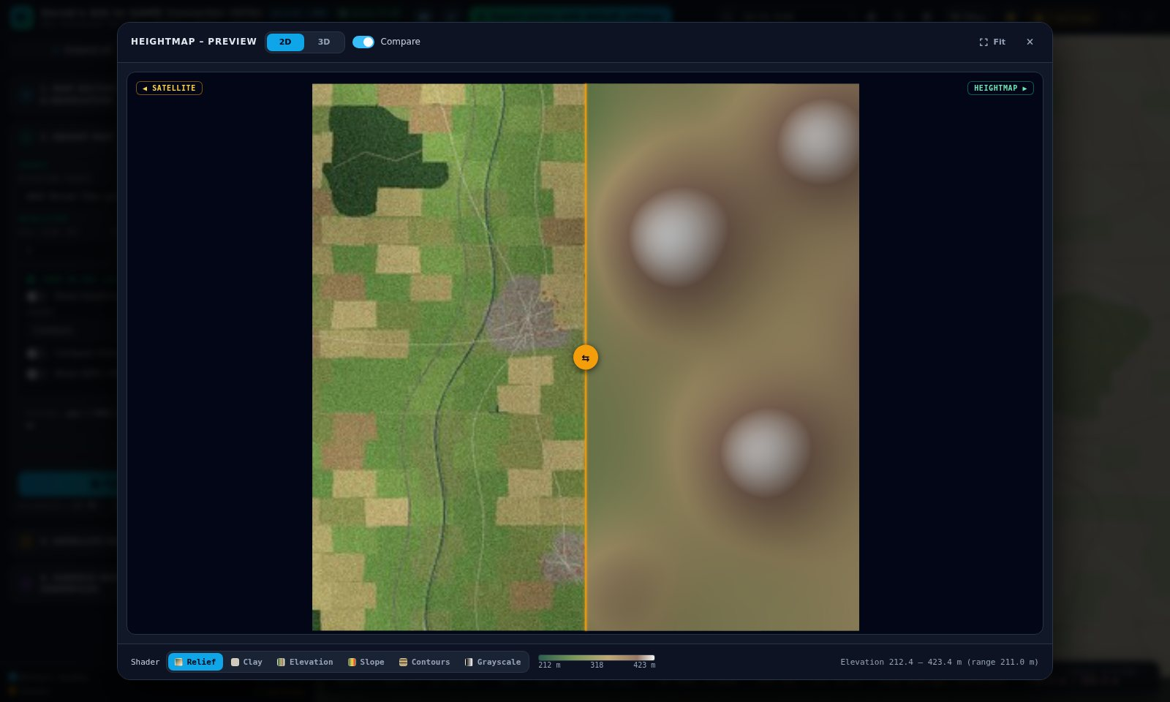
Figure 14 – Heightmap preview: satellite left, relief right

Step 5 – Check the satellite image
Section 3: keep “Sentinel-2 cloudless 2016” – it is the only year free for commercial use (with attribution). Preview shows the image against the terrain relief.
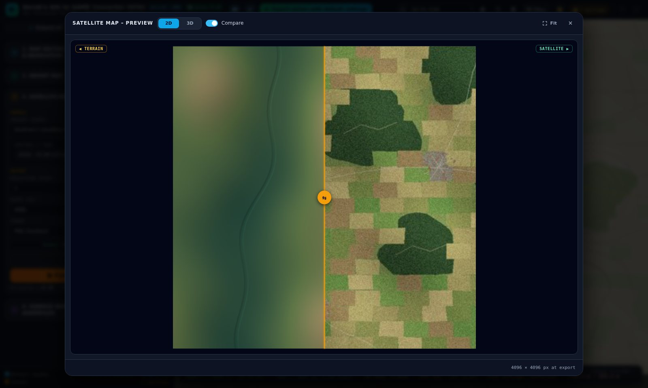
Figure 15 – Satellite preview with compare slider

Step 6 – Scan the public shapefiles
- Click the scan icon, the first icon of the shapefile row. It pulses while it works and then turns green.
- Roads, the railway, the river, land use, forests, buildings and the power line appear on the map. Section 4.1 lists the result per category.
While the icon is on, the shapes follow the sector: after every move, resize or rotation the sector is rescanned automatically.
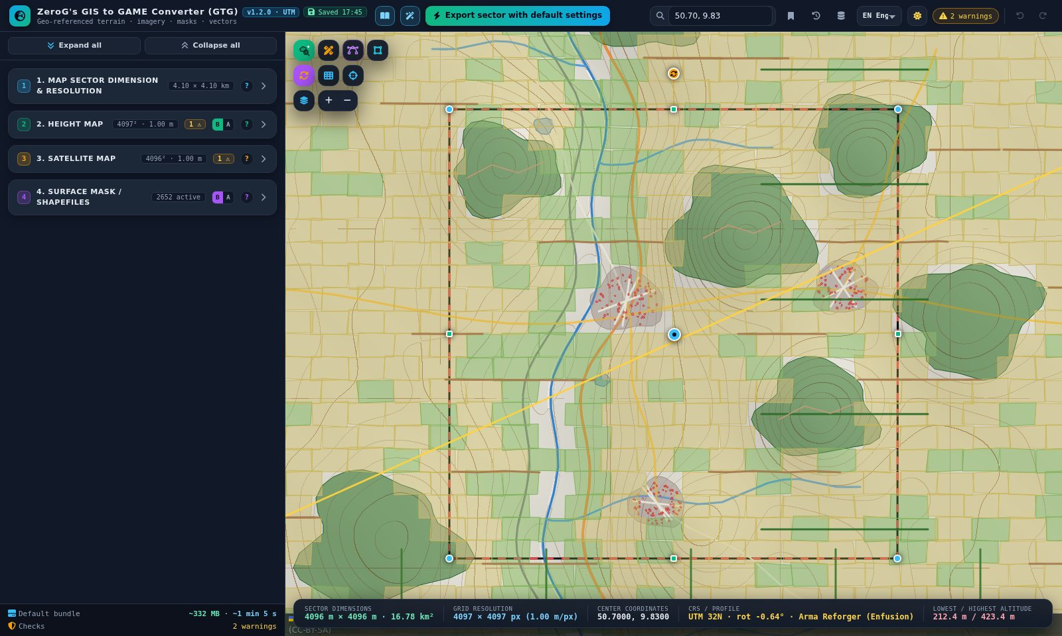
Figure 16 – Scan switched on – the OpenStreetMap shapes of the sector
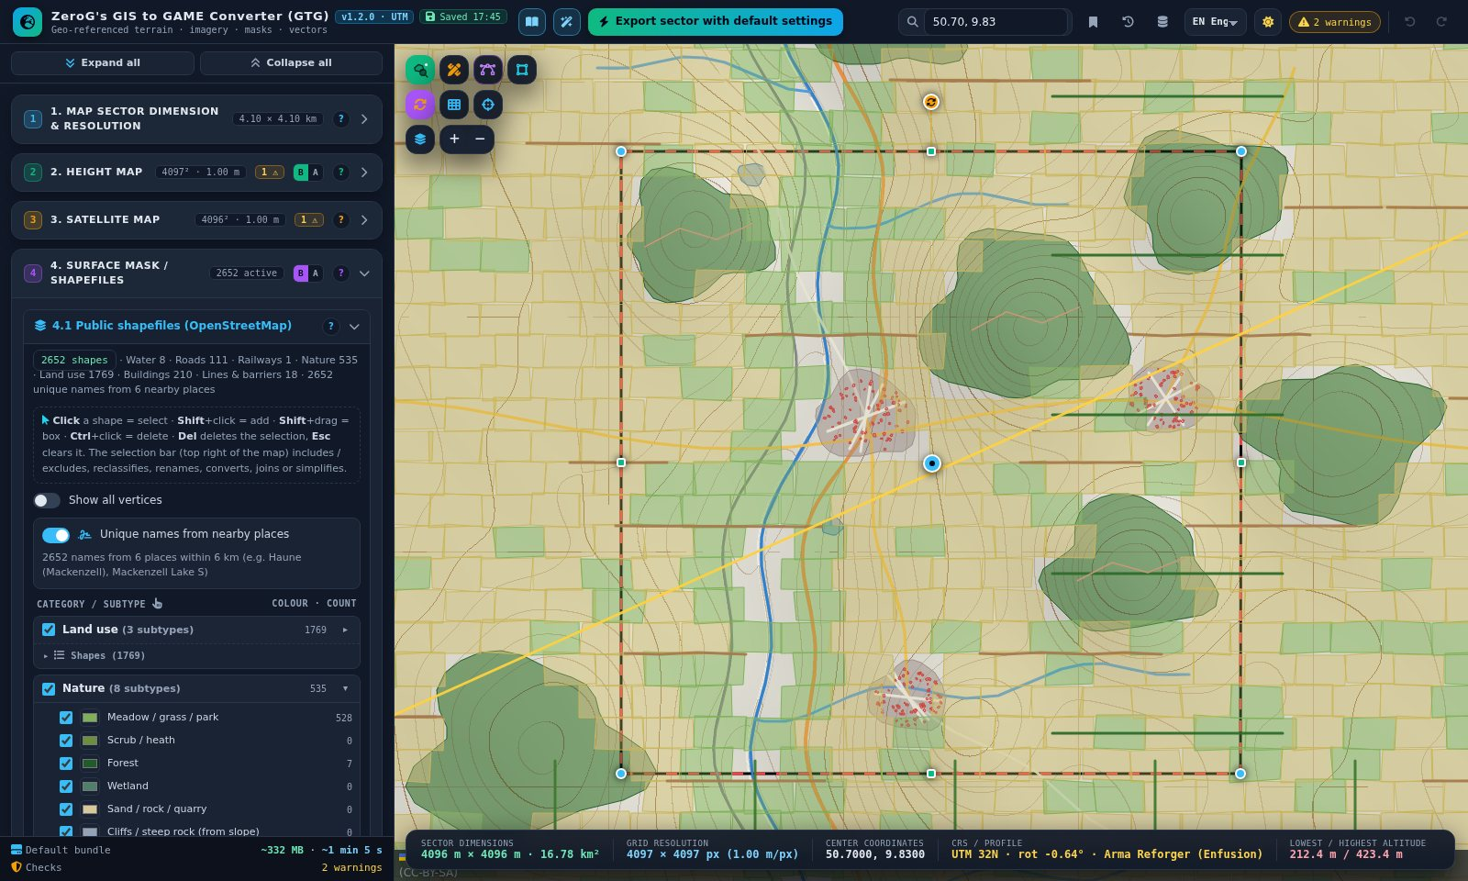
Figure 17 – Section 4.1: scan status, the new selection hint, folded categories and the shape list of “Nature”

Step 7 – Clean up the shapes with the mouse
This is where version 1.2.0 saves the most time. You prepare the shapes for 1985 directly on the map.

7a – Keep the hill forest: convert it to a custom shape
- Click the forest on the hill north-east of the centre. It turns cyan and the selection bar appears (“1 OSM” with its name and class).
- Click “Convert to custom” in the selection bar. The forest is now a custom shape in 4.2 and survives every rescan.
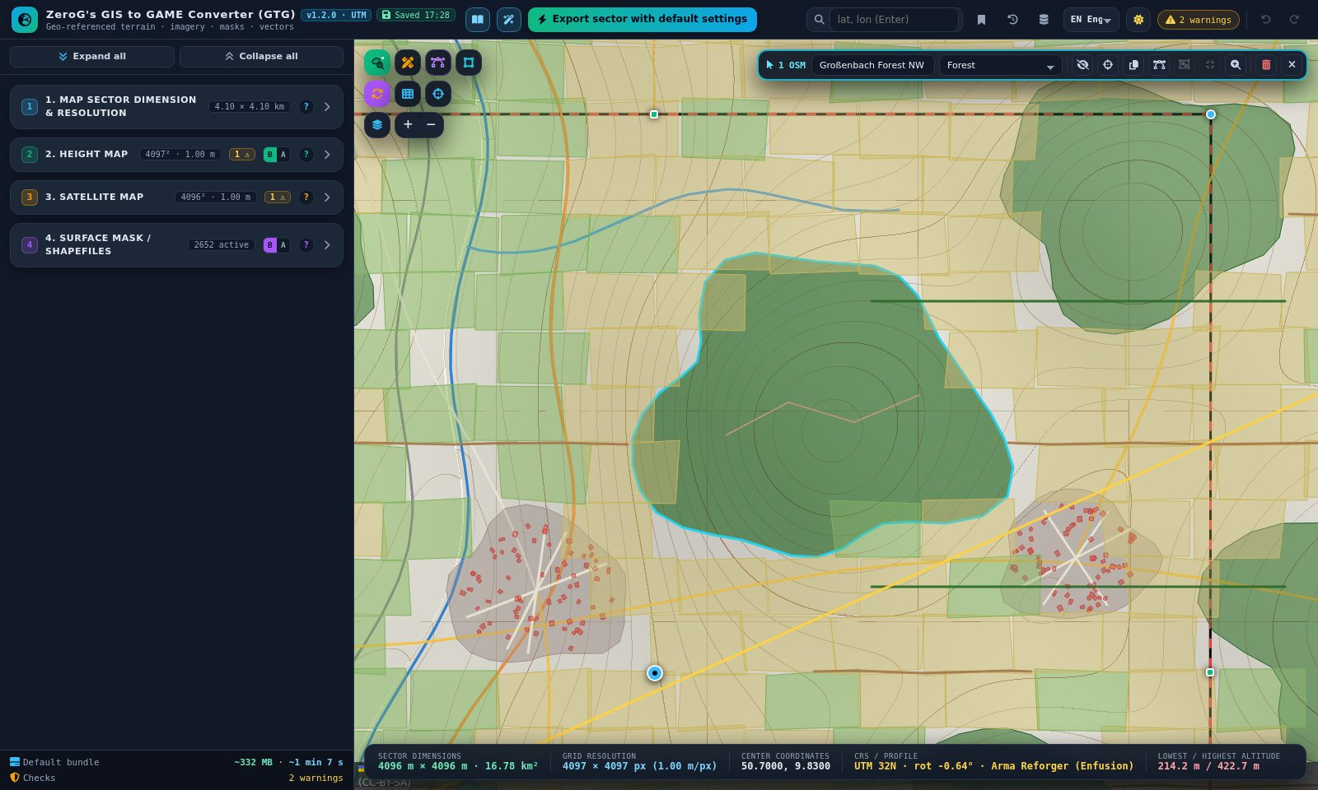
Figure 18 – One click selects the forest; the selection bar shows its name and class
- Draw or place a second forest polygon that overlaps the east edge of the wood (4.2 → Polygon, or Templates → Blob) – in 1985 the forest reached further east.
- Click the converted forest, then Shift+click the new piece. The bar now reads “2 selected”.
- Click “Join”. Both pieces become one forest outline. Ctrl+Z would undo it in one step.
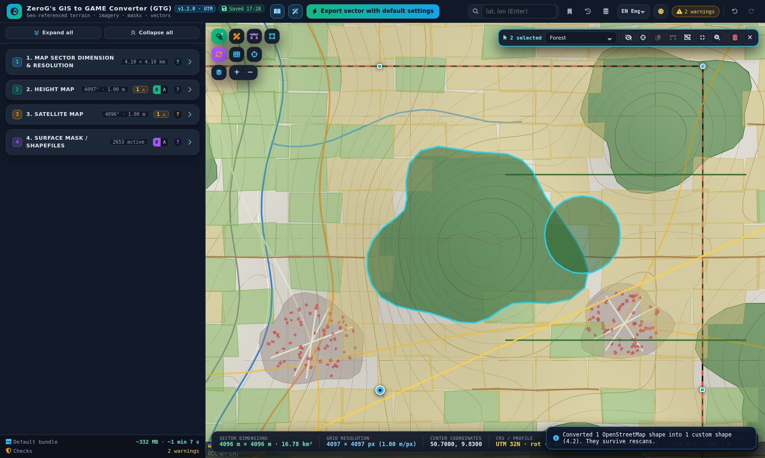
Figure 19 – Two forest pieces selected with click and Shift+click
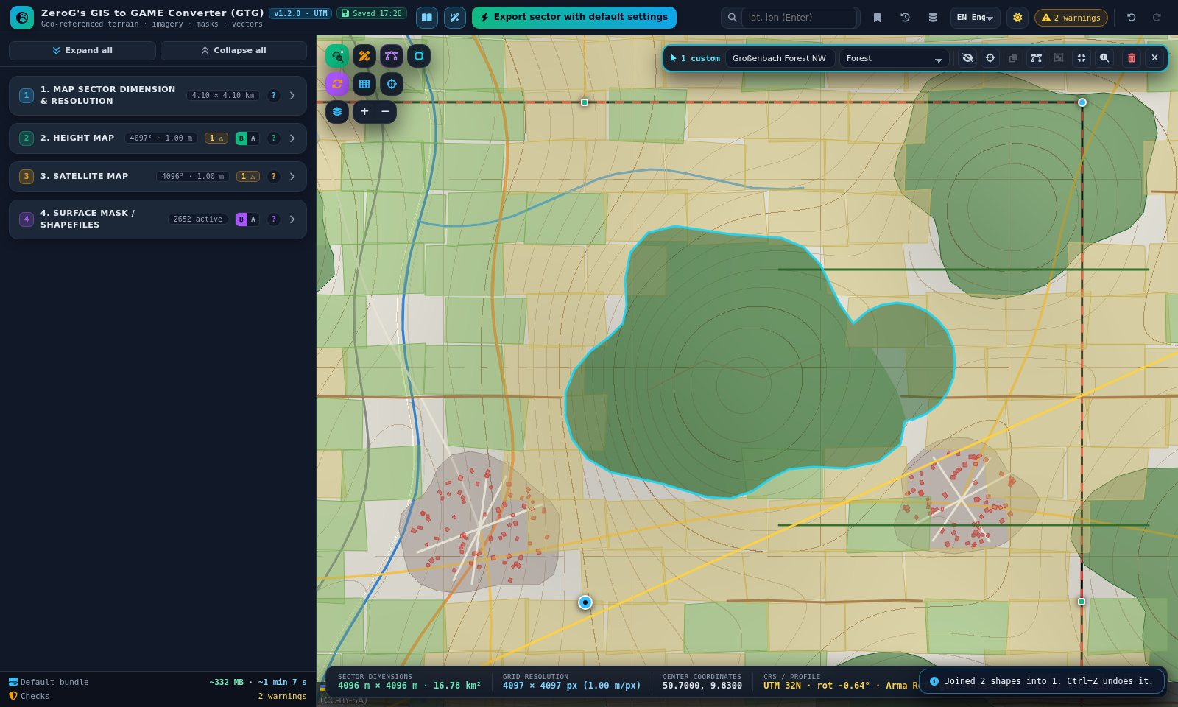
Figure 20 – After “Join”: one forest shape

7b – Remove newer buildings with box select
- In 4.1 switch off every category except “Buildings”, so the box catches only buildings. Zoom to the north-east part of Großenbach.
- Hold Shift and drag a box over the houses built after 1985. Release the mouse: the bar reads “21 selected”.
- Press Del. All 21 buildings are deleted in one step (Ctrl+Z restores them).
- A single building is even faster: Ctrl+click it.
- Switch the other categories on again.
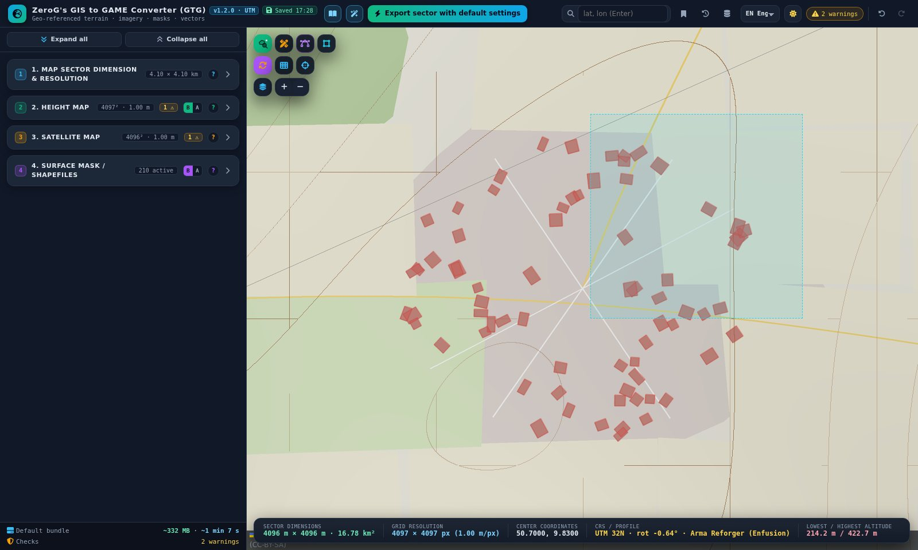
Figure 21 – Shift+drag draws the selection box
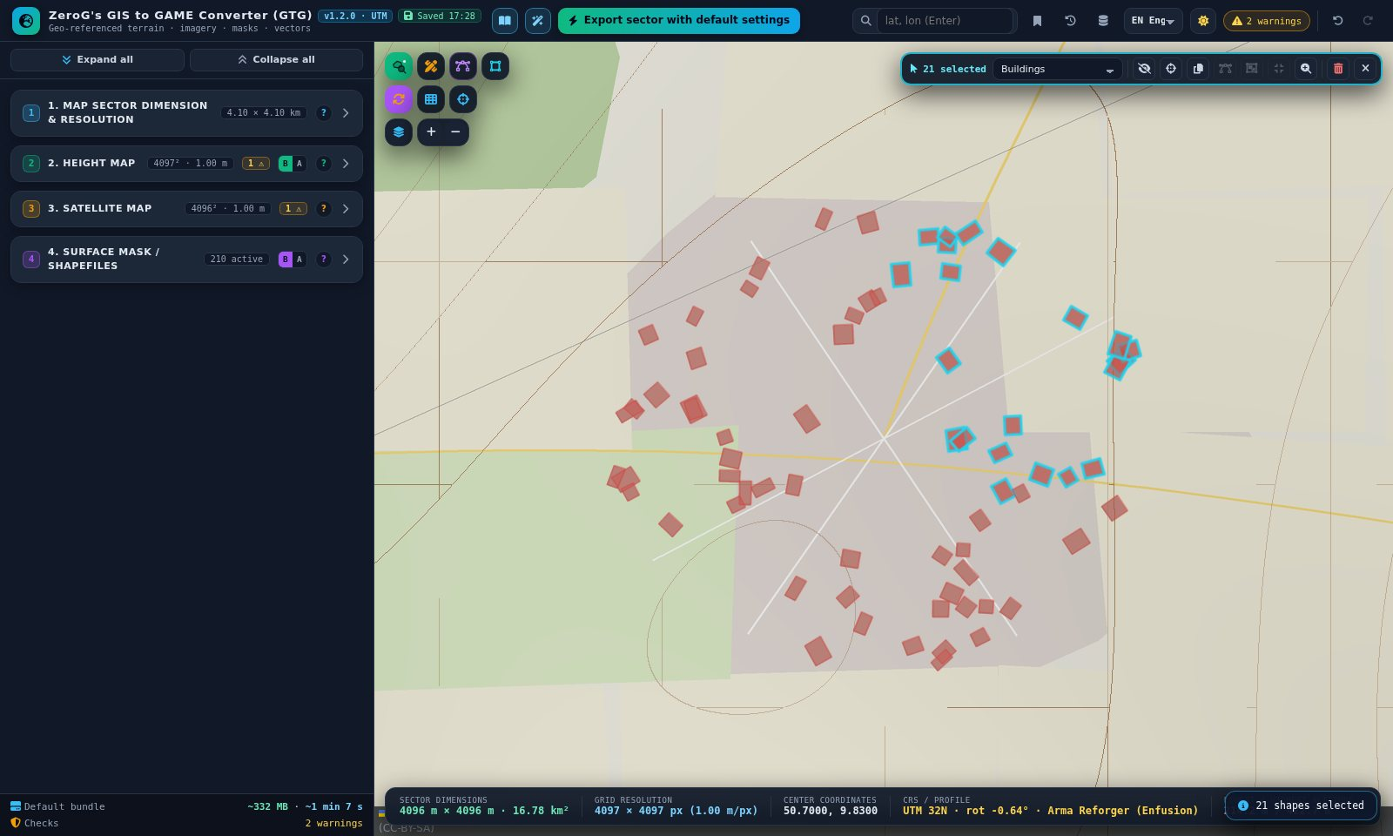
Figure 22 – The 21 buildings inside the box are selected
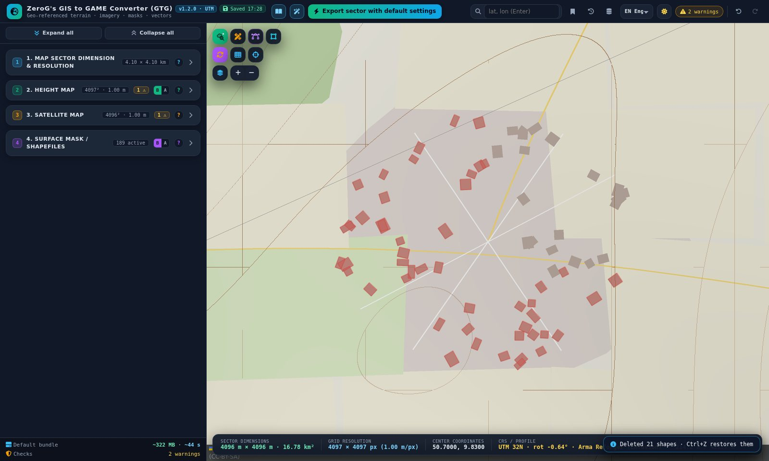
Figure 23 – After Del – the buildings are gone (the background map still shows them)

7c – Turn the river meadows into wetland
- Leave only “Meadow / grass / park” visible in 4.1 and zoom out to the whole sector.
- Shift+drag a box along the Haune meadows south of Mackenzell (11 shapes here).
- Open the class list in the selection bar and choose “Wetland”. All 11 meadows change class at once.
- Switch the categories on again and press Esc to clear the selection.
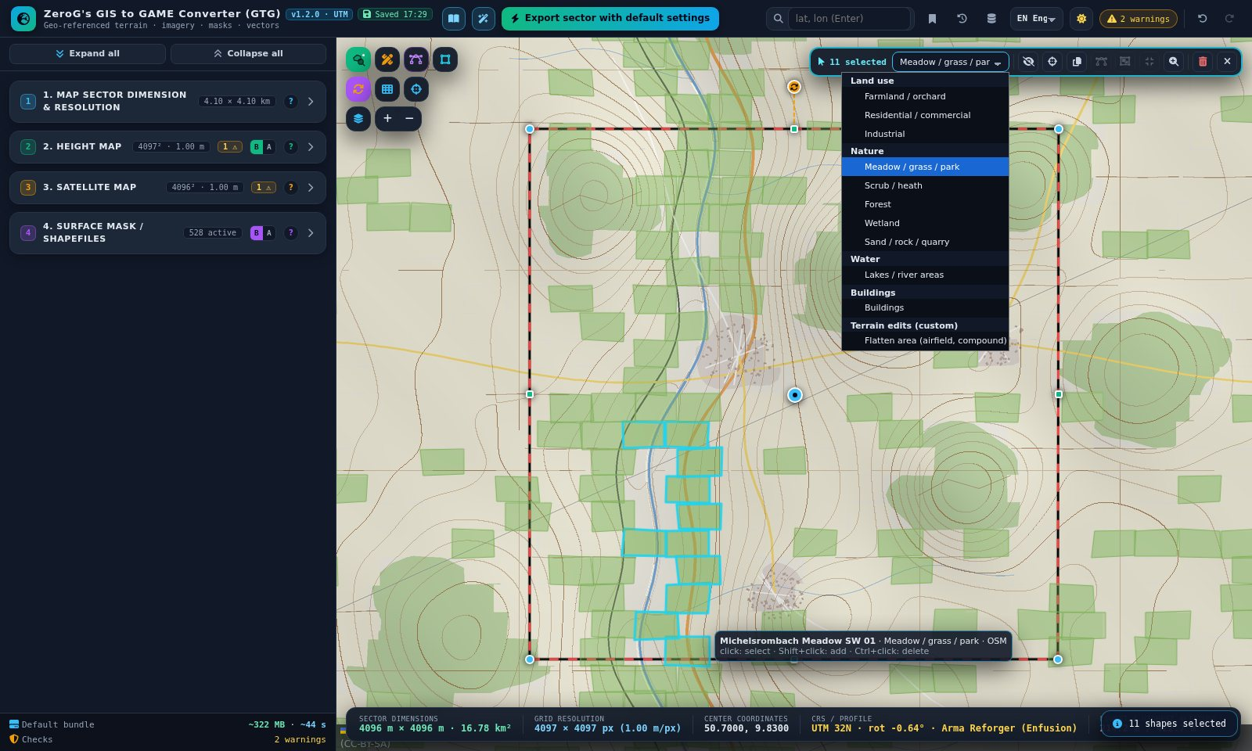
Figure 24 – Changing the class of 11 selected meadows
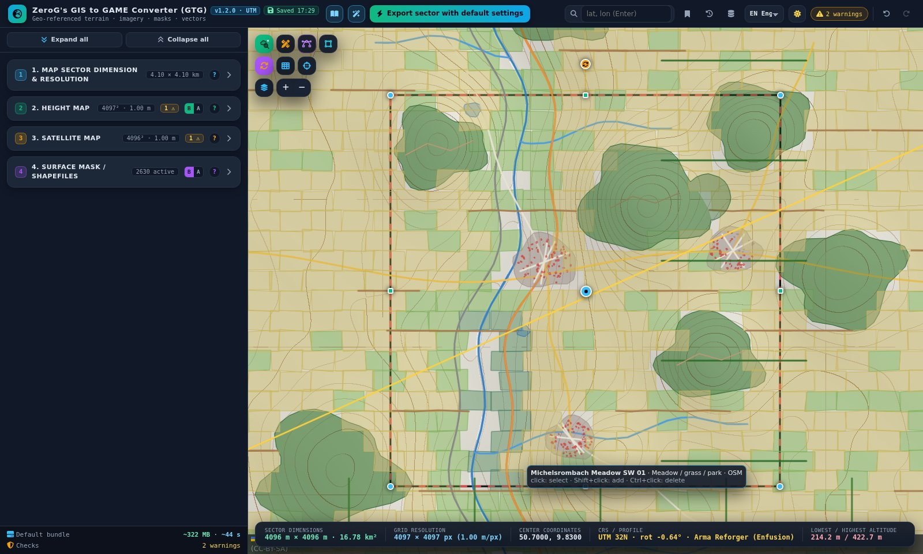
Figure 25 – The river meadows are now wetland
Important Steps 7b and 7c change OpenStreetMap shapes. They stay until the next rescan – keep the sector where it is from now on, or convert the shapes to custom shapes first.

Step 8 – Build the defence line – special zones
- Switch section 4 to Advanced (A) and open 4.2b.
- Draw the zones below with “Polygon zone”, “Rectangle zone” or “Line zone” and pick the type on each card.
Zone | Type | Where
Anti-tank ditch East | Anti-tank ditch (line) | North–south along the east edge of the sector. Drawn from south to north, so the spoil berm lies on the right (east) side.
Trench Hill 422 | Trench / earth crack (line) | Zigzag line on the east slope of the wooded hill.
MG nest 1, MG nest 2, Tank position | Firing position / revetment | Three small rectangles in front of the trench.
Shelled fields | Artillery field | Polygon over the fields in front of the ditch.
Bomb line | Bomb crater line (line) | Across the fields south-east of the centre.
Bridge crater | Explosion | Small polygon where the L 3176 crosses the Haune.
Every zone has its own card with intensity, radius, edge feather, “Keep roads & terrain edits inside the zone” and a dice for a new random layout.
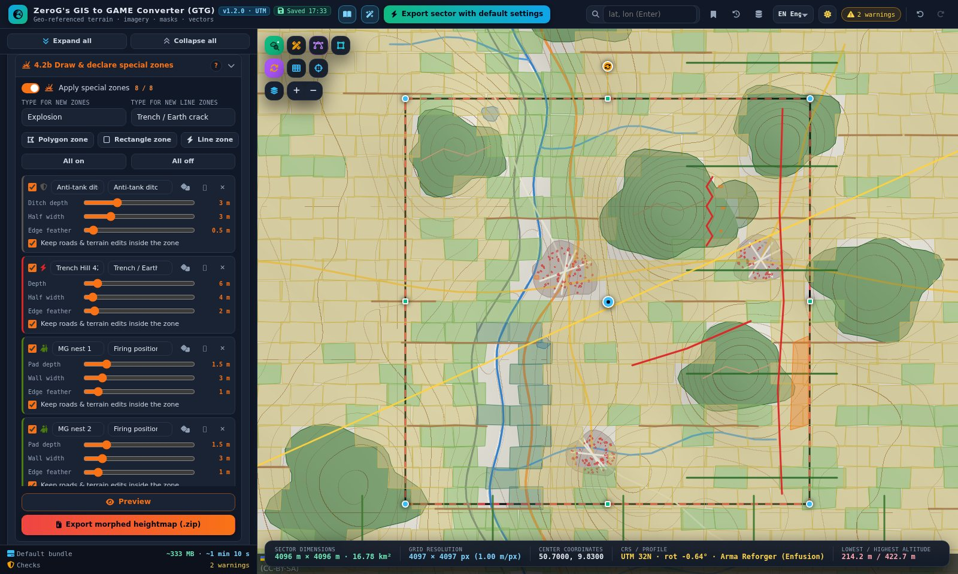
Figure 26 – The defence line on the map and the zone cards in 4.2b
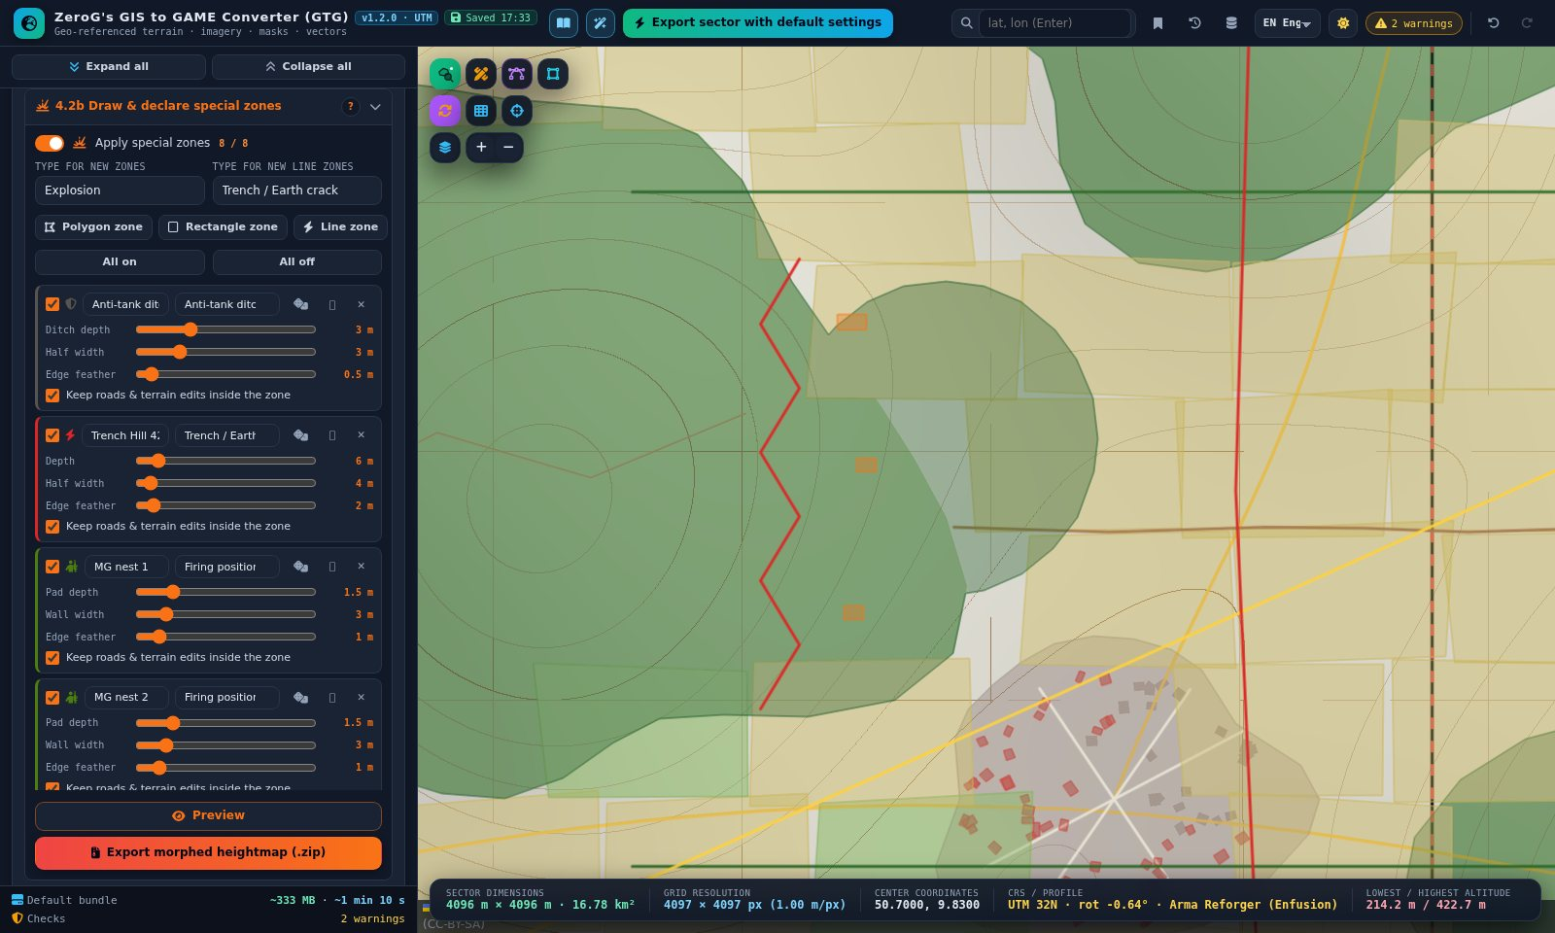
Figure 27 – Close-up: ditch, trench and the three dug-in positions

Step 9 – Morph the terrain
- Open 4.3 and click Preview. Left = original, right = morphed: the B 27 and the railway are graded, the river is carved, buildings stand on smoothed ground, and the ditch, trench, positions and craters are cut.
- Switch to the Slope shader and turn Compare off to see steep edges in red; Clay shows the pure shape.
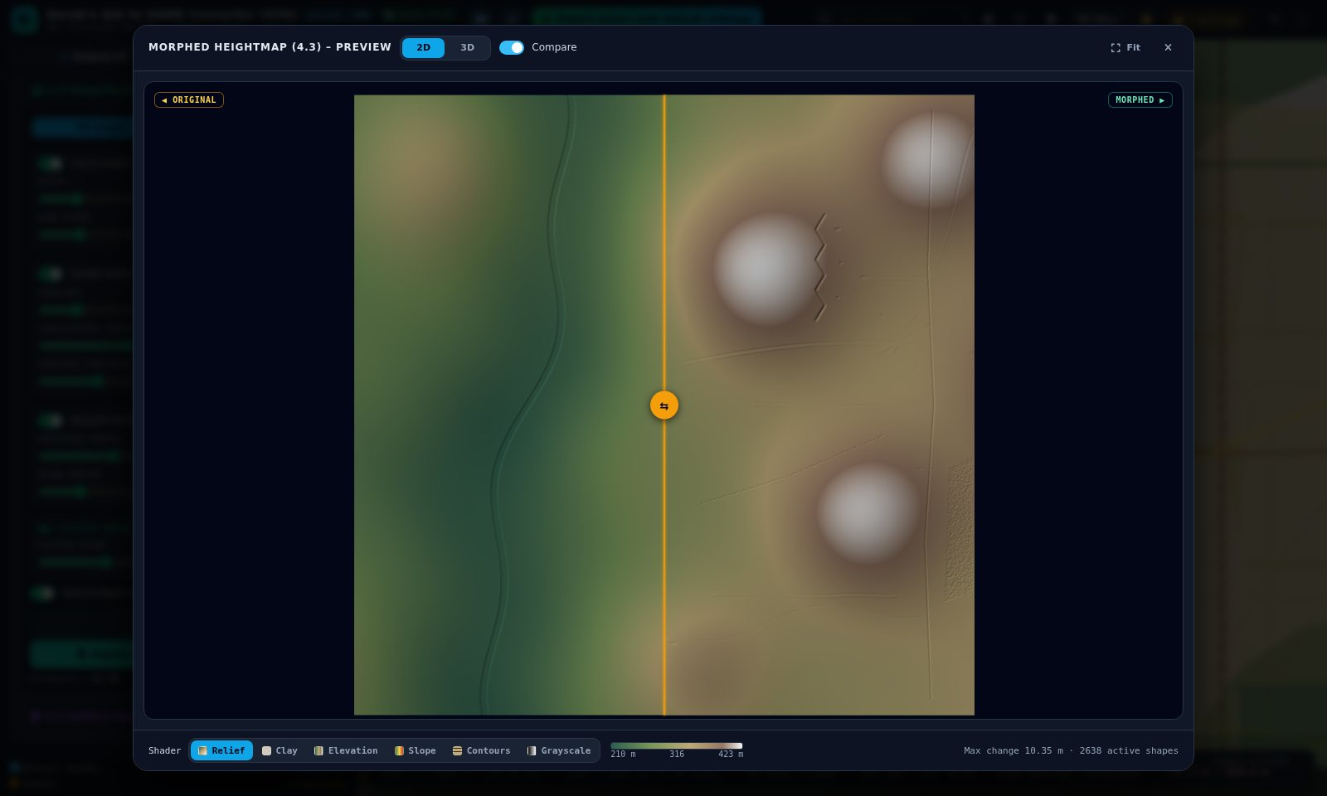
Figure 28 – Before / after preview of the morphed heightmap
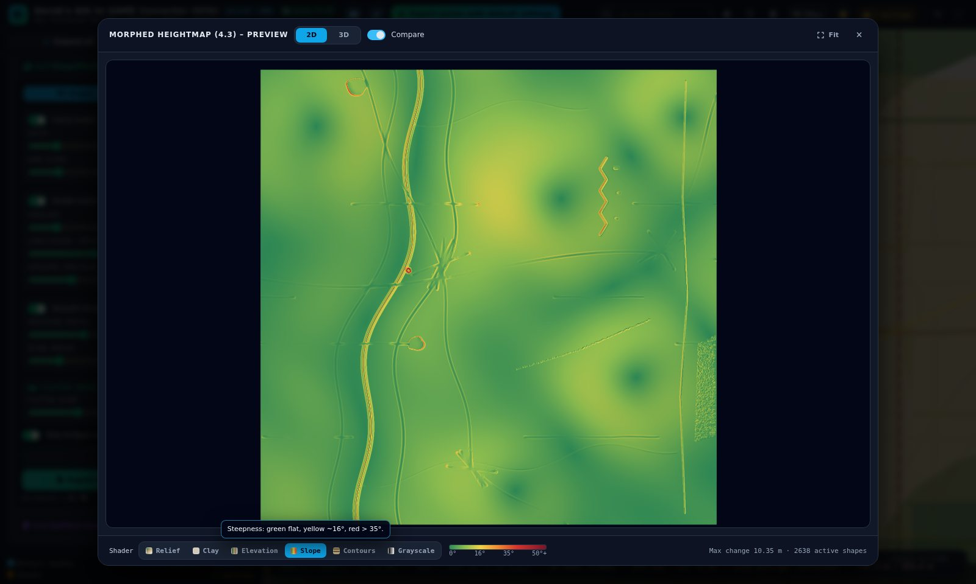
Figure 29 – Slope shader: road and rail embankments, the ditch and the trench

Step 10 – Surface masks and colour legend
- Open 4.4. With the Reforger profile the splat masks are written per subtype and the Enfusion block check is on.
- Switch on “Show surface mask on map” and the compare slider to check the mask against the map – the wetland meadows now have their own colour.
- Keep “Colour legend” on “Picture (PNG) + PDF”. The export then contains a legend of the colour-coded mask.
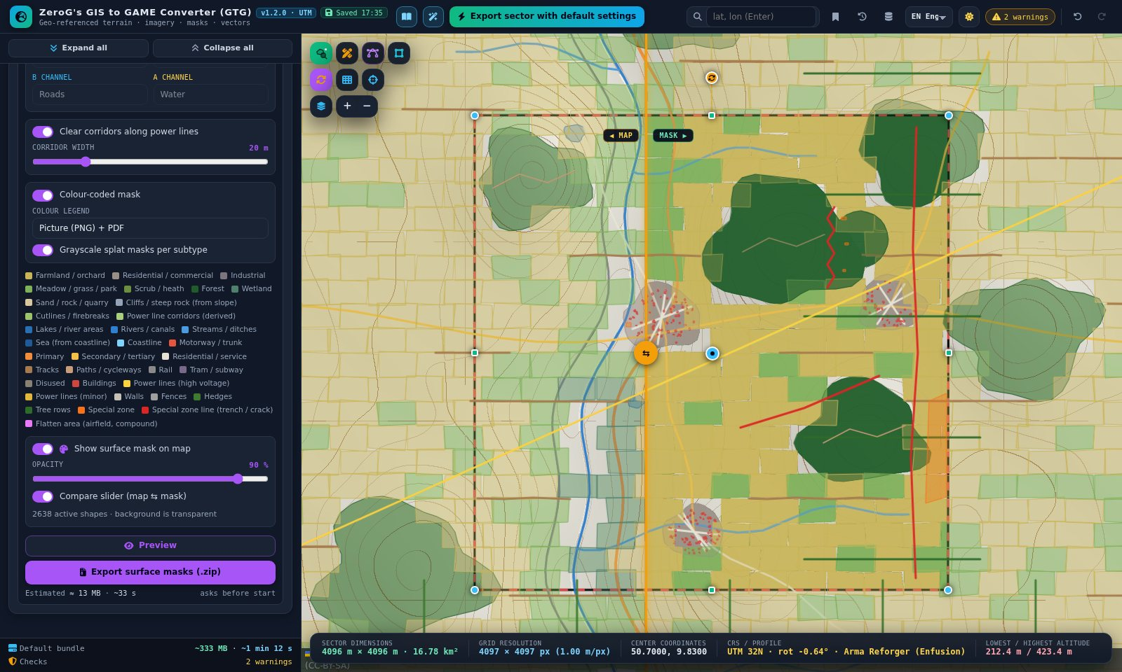
Figure 30 – Surface mask on the map, right of the compare handle
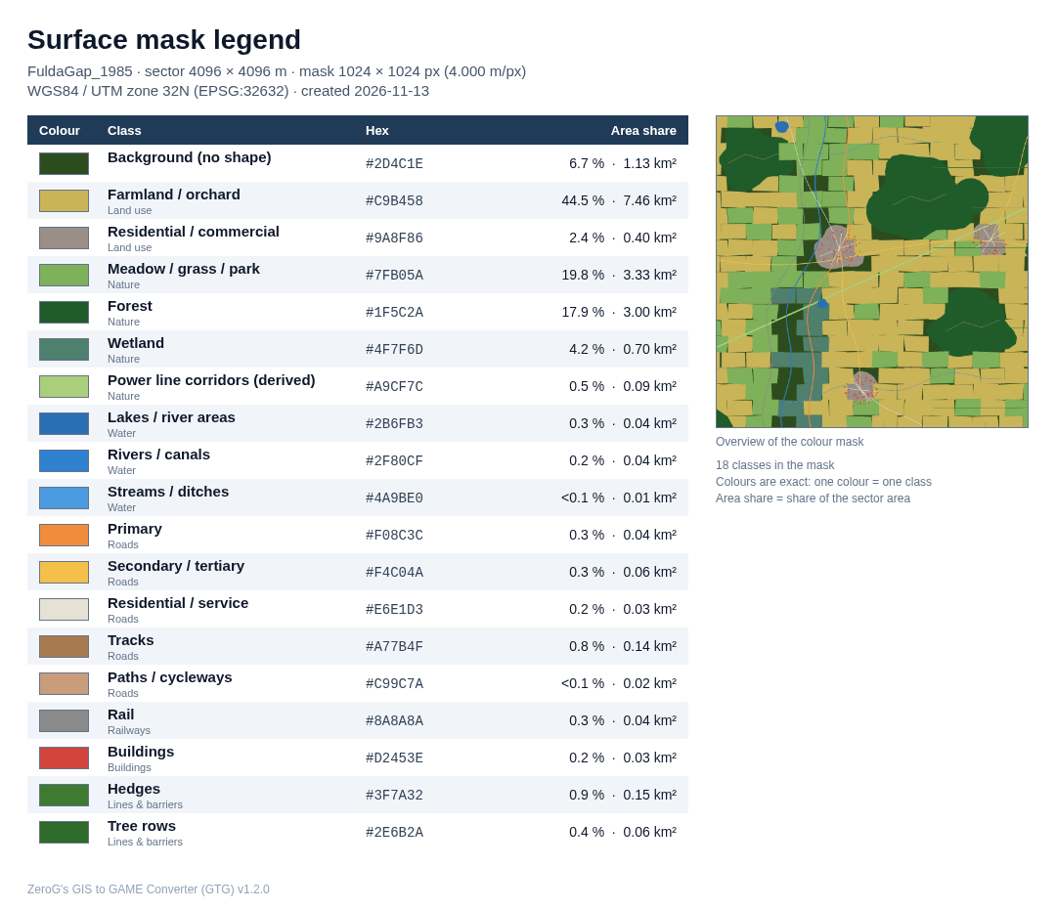
Figure 31 – Exported legend picture: only classes that appear in the mask, with hex colour and share of the area
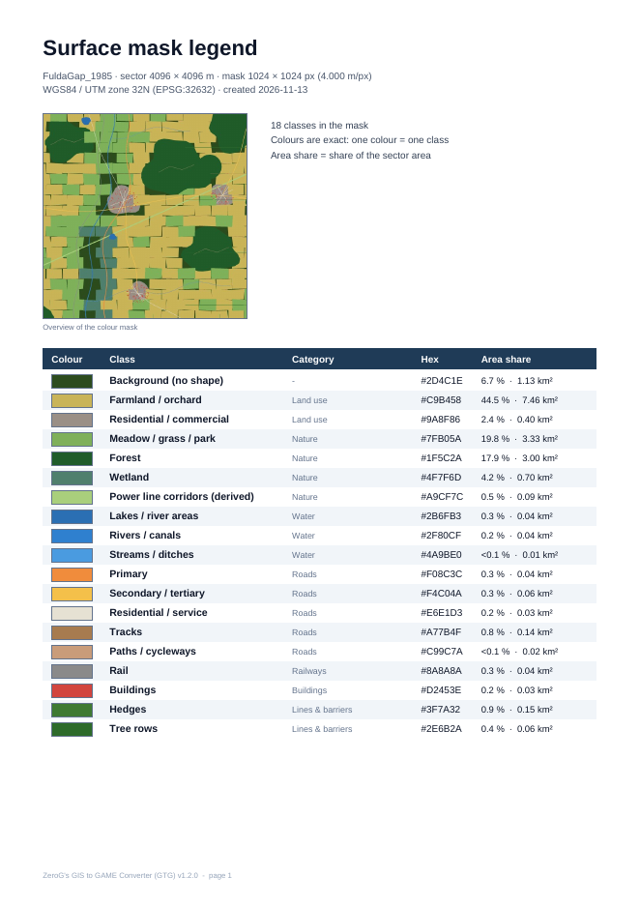
Figure 32 – The same legend as PDF (A4, text stays selectable)

Step 11 – Export
- Click “Export sector with default settings” in the header for one ZIP with everything, or use the export button of each section for single parts.
- Large exports show an estimate first, then a progress panel with Cancel.
- Use “Export params” in section 1 for the import values (height scale, grid, minimum and maximum height).
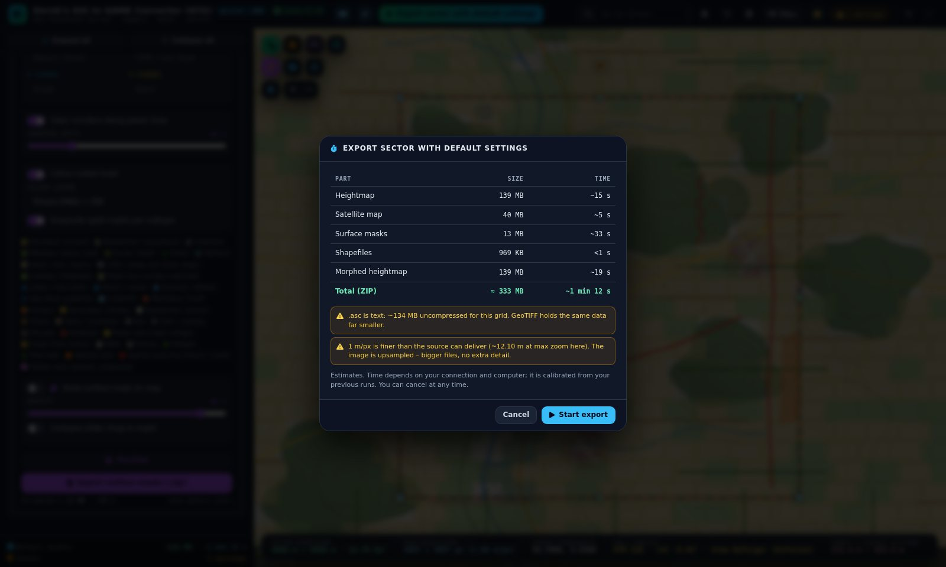
Figure 33 – Export estimate before the default bundle

What the default bundle contains
Folder | Content
1_Heightmap | GTG_FuldaGap_1985_4096x4096m_Heightmap as .asc, 16-bit .png and GeoTIFF, with world files and .prj
2_Satellite | …_Satellite.png with world file and .prj (Sentinel-2 2016, 1 m/px)
3_SurfaceMask | Colour-coded mask, legend (.csv, .png, .pdf), one grayscale PNG per surface, Surfaces_order.csv, block check
4_Shapefiles | One shapefile and GeoJSON per subtype in terrain metres, including the custom forest
5HeightmapMorphed | Morphed heightmap in the same formats as 1_Heightmap
(root) | …_params.json with all import values, ATTRIBUTION.txt

Importing the result into Arma Reforger
- Create a terrain entity at 0, 0, 0 with grid size 4096 × 4096 faces and cell size 1 m.
- Import the heightmap .asc (true metres) – or the 16-bit PNG with “Resample heights” and the minimum / maximum from params.json.
- Import the satellite map and the grayscale surface masks; Surfaces_order.csv lists the stack order (01 = bottom). The colour legend shows which colour of the colour-coded mask is which surface.
- Import the shapefiles from 4_Shapefiles/shp – they are in terrain metres and fit without offsets.

Part 3 – Feature reference

3.1 Section 1 – Map sector dimension & resolution

Location
- Map name – prefix of every exported file and ZIP (default “MyMap”).
- Centre + size – latitude / longitude of the sector centre (WGS84). Same as dragging the blue marker.
- 4 coordinates – enter north, south, west, east or paste them (also four “lat, lon” corner lines). The sector becomes the UTM rectangle that encloses them.

Engine profile, size and presets
- Target – Custom, Unreal Engine 5, Unity, Arma 3, Arma Reforger. Sets grid, heightmap formats, satellite / mask resolution, vector format and coordinates.
- Grid – samples per side. Unreal / Unity / Reforger use vertex counts (2ⁿ+1); Arma 3 uses cell counts (2ⁿ). The sector size is (grid − 1) × cell size.
- Width / height, Lock 1:1 – sector size in metres (fixed by the grid when a profile is active).
- Presets – 1.05 km² up to 1,074 km²; the large ones use a 4,096 px heightmap at 5–8 m cell size.
- Export / import params – saves or loads the whole project as .json, including all engine import values.

Direct manipulation on the map
- Blue centre marker: move the sector. Round corner handles: resize freely; hold Ctrl (or Alt) to keep it square.
- Green edge handles: change only width or height. Orange handle above the north edge: rotate (Ctrl = 5° steps).

Rotation and map grid
- Rotate sector – angle clockwise against UTM grid north; slider; ±0.1° / ±1° steps.
- Align to map grid – compensates the grid convergence so the edges run true north–south / east–west. Align to UTM grid sets 0°.
- Effect on exports – heightmap, imagery and masks are resampled into the rotated grid; shapefiles in terrain metres follow its axes; GeoTIFF and world files carry the rotation; .asc cannot store it (a message explains this).
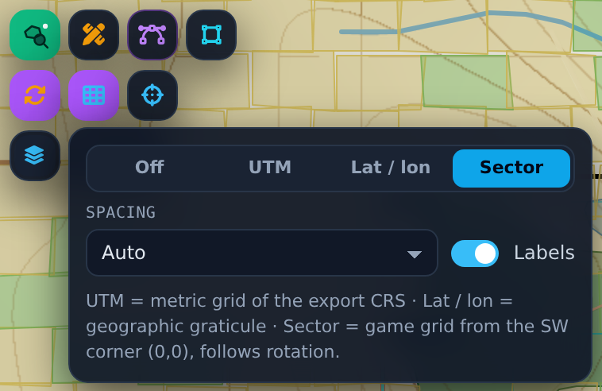
Figure 34 – Map grid panel: Off, UTM, Lat / lon, Sector; spacing and labels

3.2 Section 2 – Height map
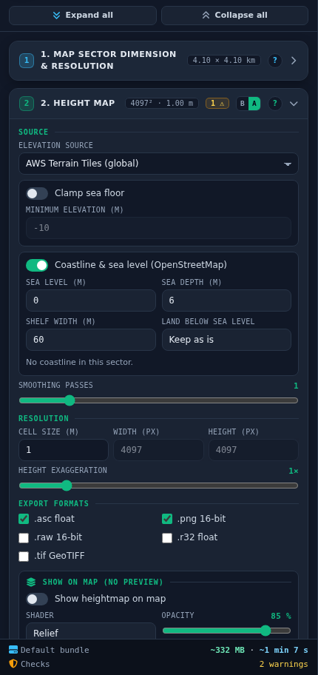
Figure 35 – Section 2 in Advanced mode
- Elevation source – AWS Terrain Tiles (free, global); custom elevation WMS (GeoTIFF float32, Terrarium, Mapbox Terrain-RGB or grayscale); local DEM (GeoTIFF or Esri ASCII). Gaps are filled from AWS.
- Sea and coast – clamp the sea floor; coastline & sea level from the shapefile scan, with depth, shelf width and an option to raise land below sea level.
- Resolution – cell size 0.25–8 m; pixel width / height follow from the sector; typing pixels changes the cell size.
- Smoothing, height exaggeration – light blur against terrace steps; 0.25–5× height scaling from the lowest point.
- Formats – .asc (true metres), .png 16-bit, .raw 16-bit, .r32 float, .tif GeoTIFF.
- Show on map – the heightmap of the sector drawn on the map (Relief, Elevation, Slope, Contours, Clay, Grayscale), opacity, compare slider, DEM / WMS extent.
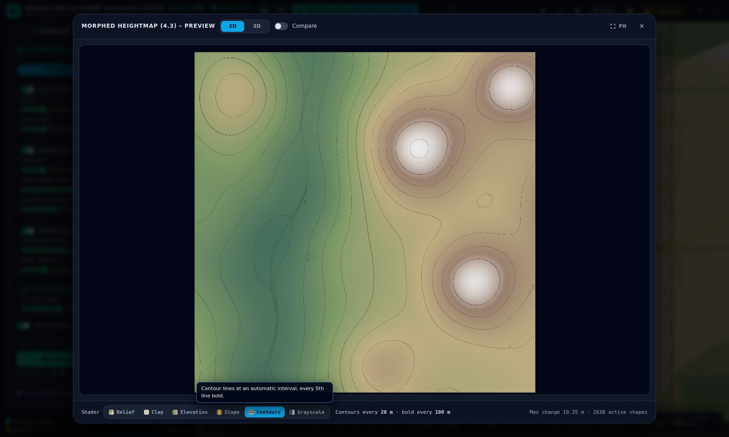
Figure 36 – Preview window, Contours shader on the morphed tutorial terrain

3.3 Section 3 – Satellite map
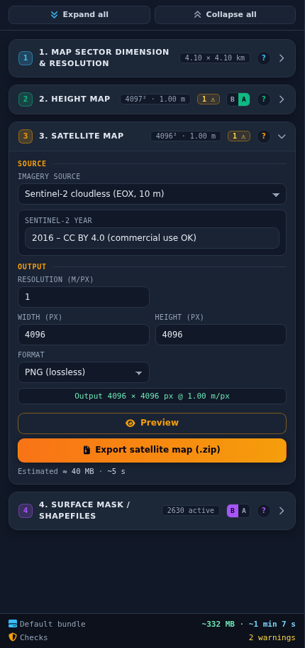
Figure 37 – Section 3
- Imagery source – Sentinel-2 cloudless (10 m colour; 2016 = CC BY 4.0, 2018 and later = non-commercial), OpenTopoMap, custom XYZ, custom WMS.
- Resolution, width / height – metres per pixel; a warning appears if you go finer than the source.
- Format – PNG (lossless) or JPG (about 5× smaller).

3.4 Map controls in detail

Shapefile row
- Scan – loads the public shapefiles of the sector and keeps them shown; rescans about a second after every move, resize or rotation (not above 64 km²). Shift+click forces a fresh download instead of the 7-day cache.
- Draw custom – panel with class list and Polygon, Line, Rectangle. Same tools as in 4.2.
- Edit vertices – see below.
- Box select – drag a rectangle to select every visible shape with a vertex inside it. A plain drag replaces the selection, Shift adds. Without the tool, Shift+drag does the same. Esc ends it.
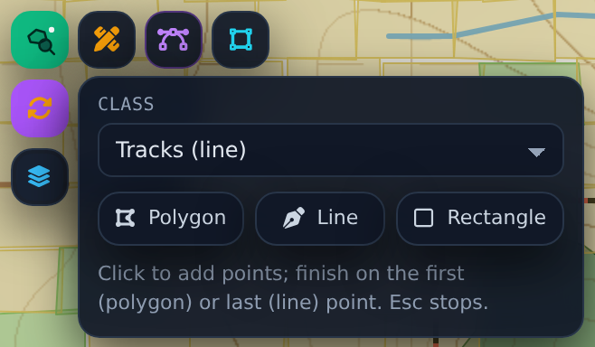
Figure 38 – Draw panel below the “Draw custom” icon

Edit vertices
- Switch it on with the icon, key E, “Vertices” in 4.2 or the selection bar. With one shape selected, that shape opens directly.
- Click any shape – OpenStreetMap or custom. Drag a vertex to move it, click a + between two vertices to add one.
- Ctrl+click a vertex deletes it. Or click the vertex (it turns red) and press Del; right-click also works.
- Ctrl+click on another shape deletes that shape. Click empty map to deselect, Esc or Done to finish.
- Edits go into every export; Undo works. Up to 4,000 vertices per shape can be edited – simplify larger shapes first.
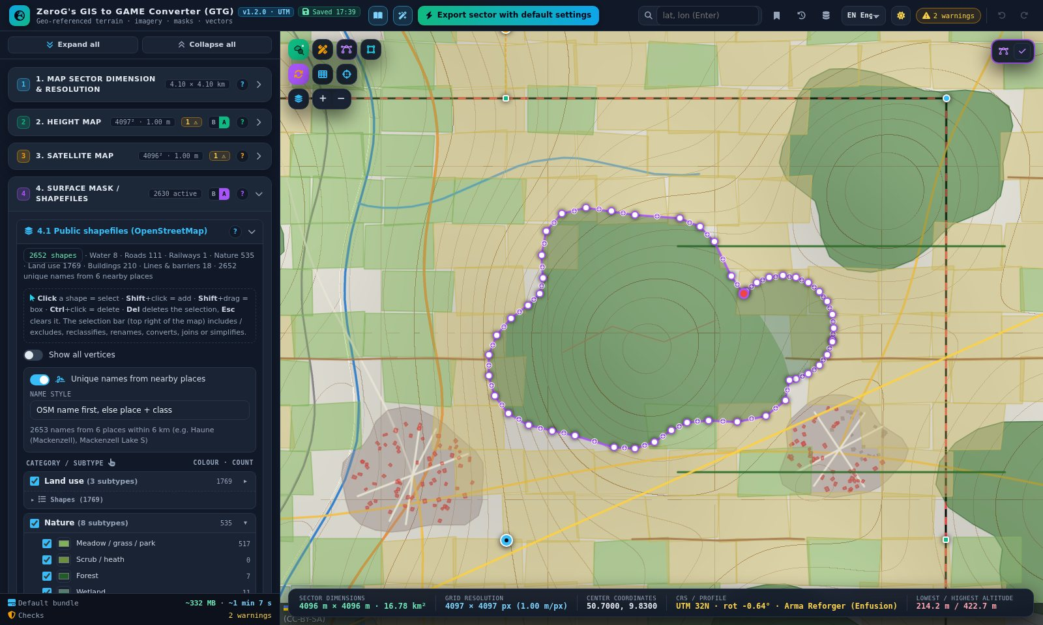
Figure 39 – Editing the joined tutorial forest – the red vertex is selected

Background map
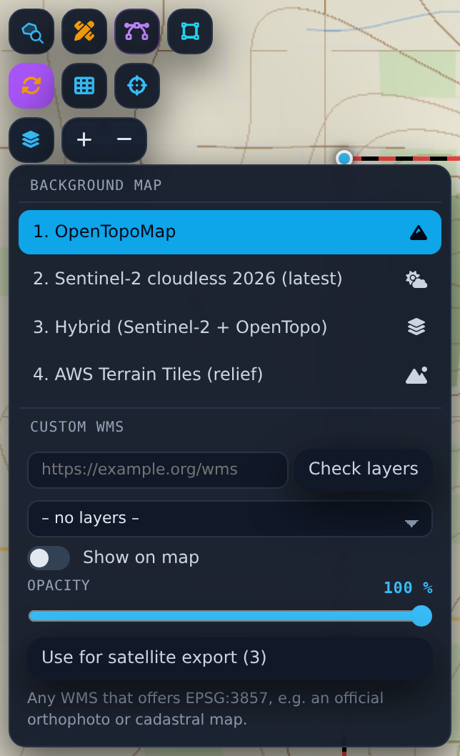
Figure 40 – Background menu with the custom WMS block
Background | What it shows
OpenTopoMap | Rendered topographic map with contours, roads and names.
Sentinel-2 cloudless (latest) | Cloud-free satellite colour; the newest year is detected automatically. 2018 and later are non-commercial.
Hybrid (Sentinel-2 + OpenTopo) | Newest Sentinel-2 imagery with OpenTopoMap on top; slider “Map layer strength”.
AWS Terrain Tiles (relief) | The elevation tiles behind the heightmap with a shader selector: Relief, Clay, Elevation, Slope, Contours. The sea stays blue.
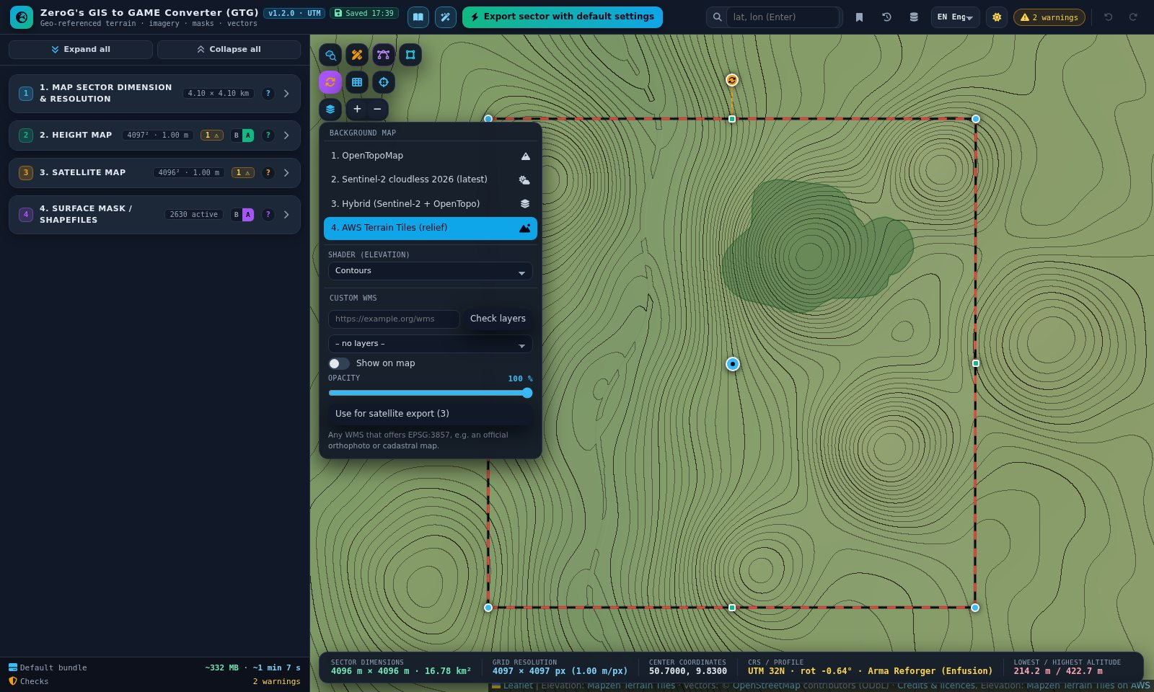
Figure 41 – AWS Terrain Tiles as background with the Contours shader
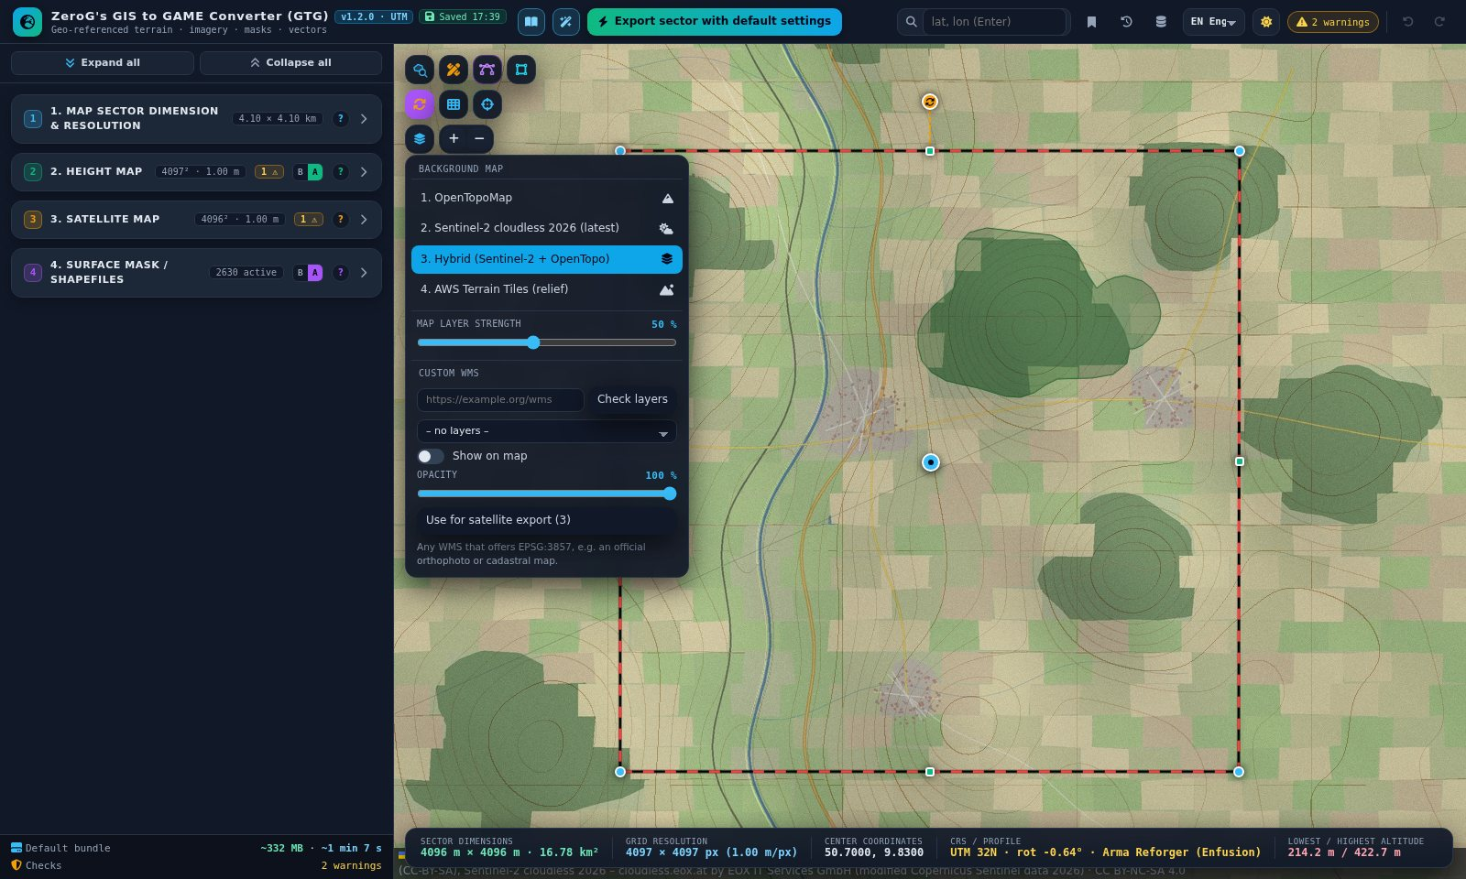
Figure 42 – Hybrid map with the “Map layer strength” slider
Custom WMS – below the list: enter a URL, “Check layers”, pick a layer. It is drawn on top of the background; opacity blends it. “Use for satellite export (3)” copies it to section 3. The server must offer EPSG:3857; some servers block browser access (CORS).

3.5 Section 4.1 – Public shapefiles (OpenStreetMap)
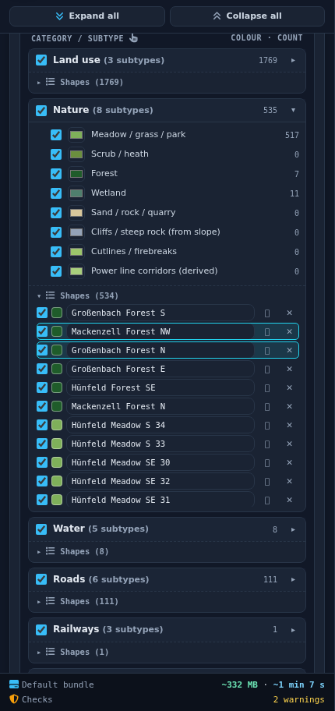
Figure 43 – Section 4.1: “Nature” open, two selected rows outlined in cyan
- Scan status – shapes per category and whether they came from the cache (with a link to download fresh data).
- Selection hint – short reminder of the mouse actions (see 1.6).
- Show all vertices – small dots on every vertex of the visible shapes (purple OpenStreetMap, amber custom).
- Unique names – every shape is named after the nearest place, its class and direction (e.g. “Großenbach Forest NW”). Written to NAME, OSMNAME, PLACE, PLACEDIR, PLACE_DIST.
- Category tree – tick categories / subtypes to show and export them; the colour sets map and mask colour. Categories start folded.
- Shape list – per category: export checkbox, colour dot (select on the map; Shift adds, Ctrl deletes), name field, ⌖ zoom, ✕ delete. With 4.3 “Selected only” a target button marks shapes for morphing.
- Export – scope (active / all), vector format (Shapefile + GeoJSON, Shapefile, GeoJSON), coordinates (Terrain / world for engines, UTM for GIS).

3.6 Section 4.2 – Custom shapefiles
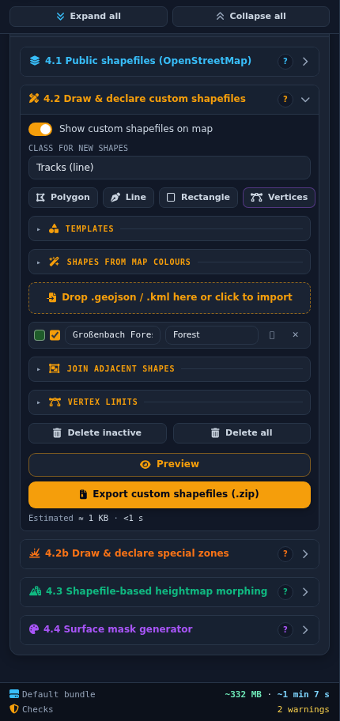
Figure 44 – Section 4.2 with the folded boxes
- Show custom shapefiles on map – hidden shapes are still exported.
- Class for new shapes – all OpenStreetMap classes plus “Flatten area”.
- Draw row – Polygon, Line, Rectangle, Vertices (vertex editor; reads “Done” while it is on).
- Templates – circle, ring, ellipse, rectangle, triangle, hexagon, scatter, teardrop, blob; size, rotation, count; Shift+click places copies.
- Import – drop GeoJSON (WGS84, UTM, terrain metres) or KML.
- Shape list – colour dot (select on the map), export checkbox, name, class, ⌖ zoom, ✕ delete.
- Join adjacent shapes – “Join now” joins all active custom shapes of the same type; “Join on export” leaves the map unchanged. To join only some shapes, select them and use Join in the selection bar.
- Vertex limits – max deviation and max vertices per shape; “Simplify custom shapes now” or Simplify in the selection bar for the selected shapes; “Limit vertices on export”.
- Delete inactive / Delete all – clean up the custom list.

Shapes from map colours
Turns the colours of a land-cover WMS or of the background map into custom shapes – useful where OpenStreetMap has little detail. Detect the colours, give each colour a class and a surface name, tune tolerance, minimum area and smoothing, check “Preview colour classes on map”, then “Generate shapes”. Generated shapes are normal custom shapes: select them, change their class, join or simplify them like any other shape.
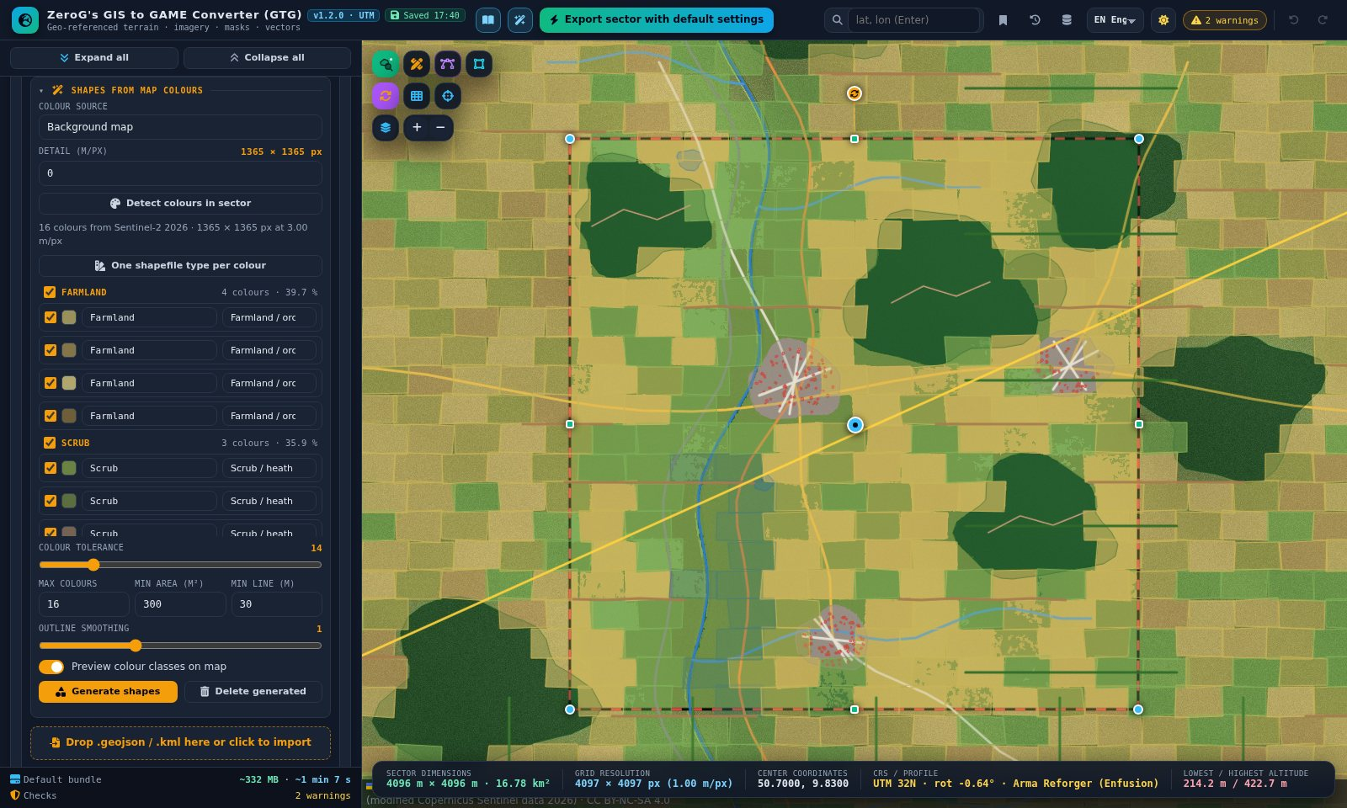
Figure 45 – Colours detected from the Sentinel-2 background, previewed as classes on the map

3.7 Section 4.2b – Special zones
- Apply special zones – master switch with active / total counter.
- Type for new zones / line zones – type for the next drawn polygon or line.
- Polygon zone, Rectangle zone, Line zone – start drawing directly.
- Zone card – on/off, name, type, dice, zoom, delete; Intensity, Radius, Edge feather; “Keep roads & terrain edits inside the zone”.
Zone type | Shape | Effect
Explosion | Polygon | Single irregular crater with rim and one-sided ejecta.
Artillery field | Polygon | Many overlapping irregular craters.
Meteor impact | Polygon | Large crater with central peak and raised rim.
Sinkhole | Polygon | Steep-walled collapse.
Volcano | Polygon | Cone with crater; wipes roads.
Erosion | Polygon | Gullies, stronger on steep slopes.
Firing position / revetment | Polygon | Dug-in pad with earth wall.
Dam / reservoir | Polygon | Raises a dam where the edge lies below the water level.
Open-pit mine / quarry | Polygon | Stepped benches down to a flat floor.
Mound / spoil heap | Polygon | Rounded dome with surface roughness.
Subsidence field | Polygon | Undulating sinking.
Dune field | Polygon | Asymmetric dunes; the dice changes the wind direction.
Rockfall / boulder field | Polygon | Scattered boulders.
Terraced fields | Polygon | Steps following the contours.
Trench / earth crack | Line / polygon | Narrow cut with noisy depth.
Bomb crater line | Line | Craters along the line.
Earthworks / berm | Line | Raised wall.
Anti-tank ditch | Line | Ditch with spoil berm on the right of the drawing direction.
Riverbed / dry wadi | Line | Meandering channel.

3.8 Section 4.3 – Heightmap morphing
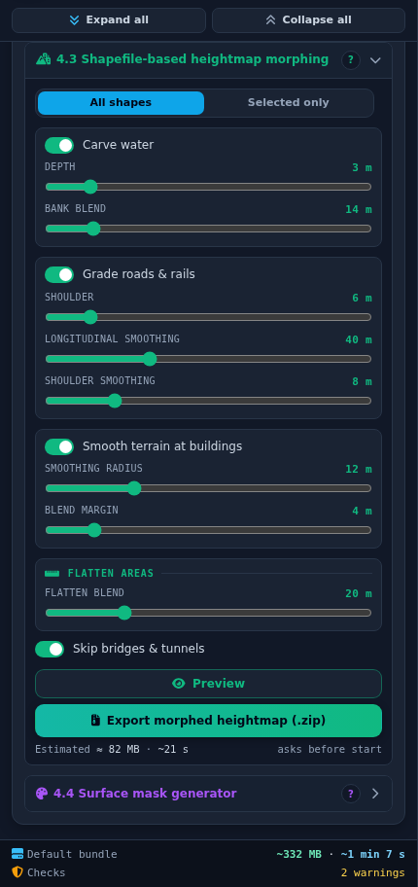
Figure 46 – Section 4.3
- All shapes / Selected only – “Selected only” uses only the shapes marked for morphing. Mark them with ⌖ in the selection bar or with the target buttons in the lists; marked shapes have a yellow outline. The counter shows the marked shapes, ✕ clears the marks.
- Carve water – flattens water to bank level, lowers it by Depth, blends over Bank blend.
- Grade roads & rails – flat cross-sections and smooth gradients; Shoulder, Longitudinal smoothing, Shoulder smoothing.
- Smooth terrain at buildings – smoothing radius and blend margin.
- Flatten areas – each “Flatten area” polygon is levelled to its mean height.
- Skip bridges & tunnels – no dammed rivers, no cut hills.
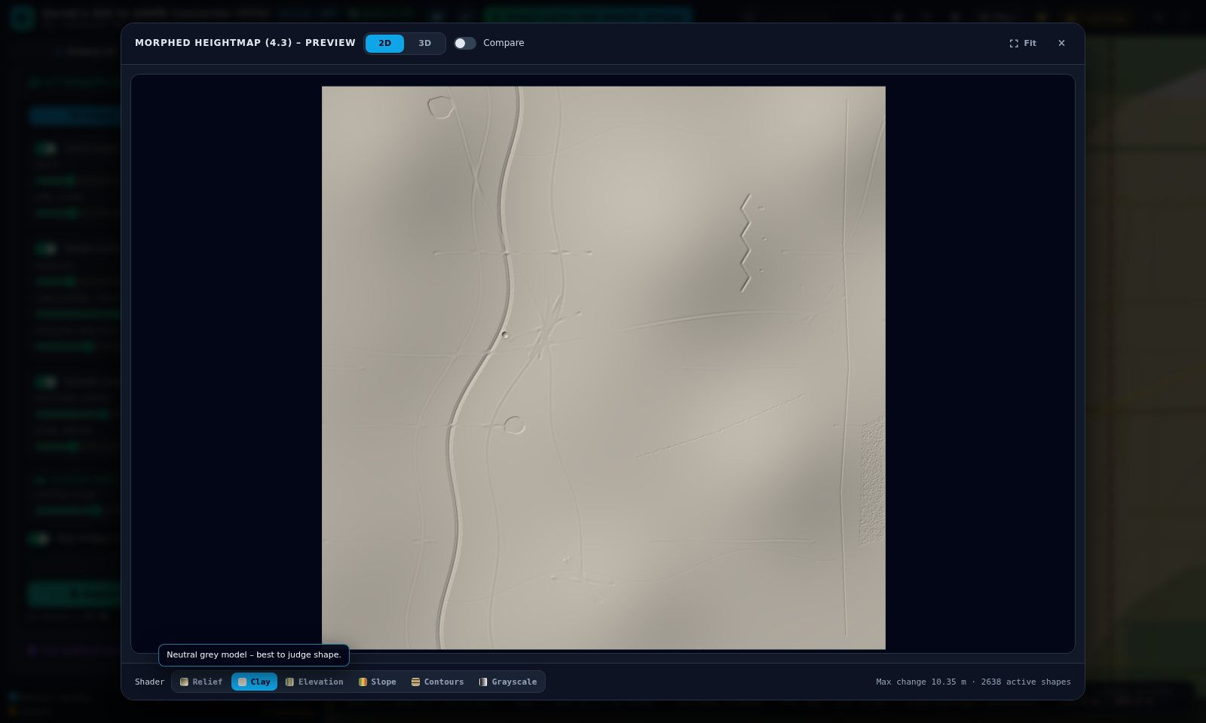
Figure 47 – Clay shader – neutral model of the morphed tutorial terrain

3.9 Section 4.4 – Surface masks
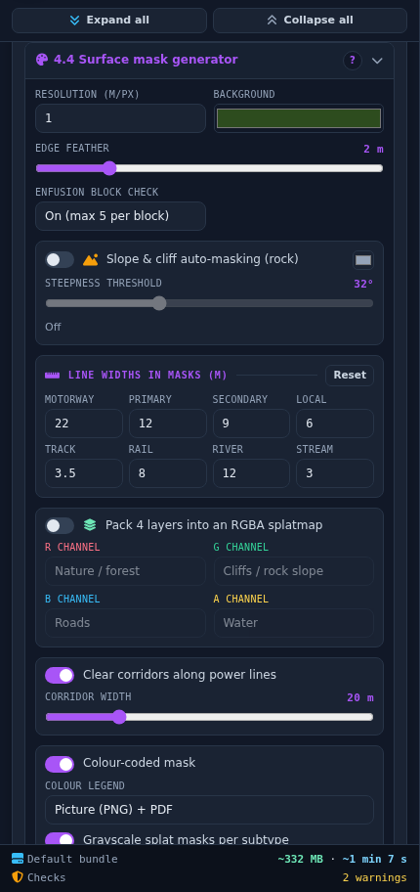
Figure 48 – Section 4.4
- Resolution & background – metres per mask pixel and colour of empty pixels.
- Edge feather – soft edges for grayscale splat masks.
- Splat masks – one grayscale PNG for every active subtype, numbered in stack order, listed in Surfaces_order.csv.
- Enfusion block check – marks 32 × 32-face blocks with more than 5 surfaces; exports BlockCheck.png / .csv.
- Slope & cliff auto-masking – rock on slopes above the threshold (30–35° typical).
- Line widths, RGBA splatmap, clearings – widths in masks and morphing; four layers in one PNG; corridors along power lines.
- Colour legend – Picture + PDF, Picture, PDF or None; lists only classes that appear in the mask, with hex colour and area share.
- Show surface mask on map – colour-coded mask over the map with transparent background, opacity and compare slider.
Note Class changes made with the selection bar are used in every mask – the tutorial’s wetland meadows get the wetland colour and their own splat mask.

3.10 Preview window
- Mouse wheel zooms, drag pans, double-click fits; the orange handle moves the compare split; “Compare” switches the before / after view.
- Shaders: Texture (3D), Relief, Clay, Elevation, Slope, Contours, Grayscale, Wireframe and Normals (3D).
- 3D tab: orbit with the mouse, extra height factor for viewing only.

3.11 Project management
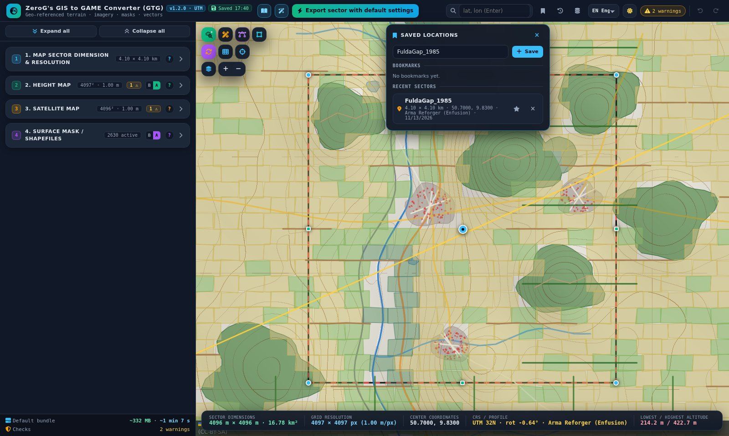
Figure 49 – Locations: bookmarks and recent sectors
- Locations – bookmark the current sector; recent sectors are recorded after each scan and export.
- History – last 20 versions: restore, compare with now, download as .json.
- Data cache – tiles and OpenStreetMap scans are kept between sessions; size limit and clearing.
- Auto-save – settings and shapes are saved while you work.

3.12 Language and theme
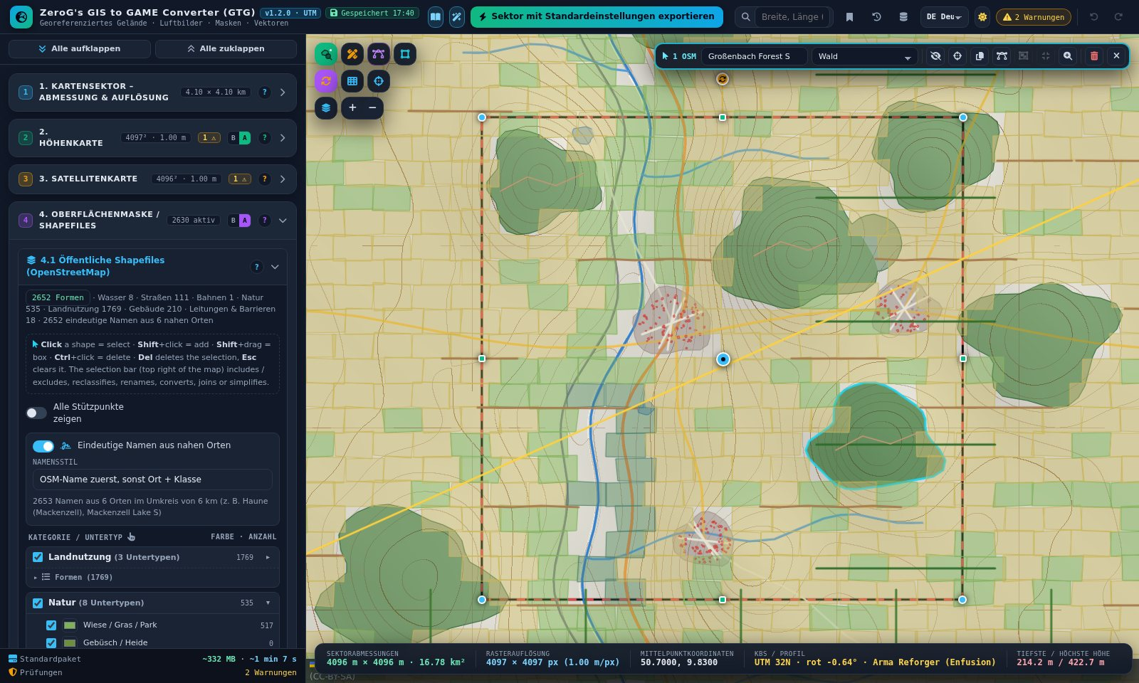
Figure 50 – German interface with the translated selection bar
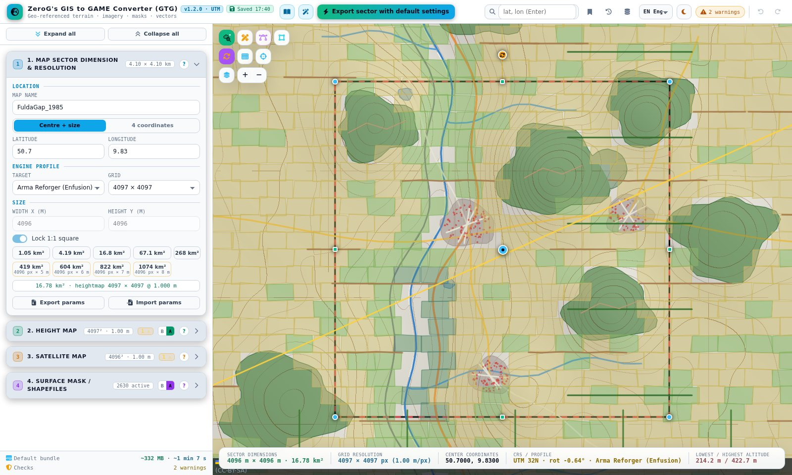
Figure 51 – Bright theme

Part 4 – Reference

4.1 Keyboard and mouse
Key / action | Function
Click shape | Select it (click again to deselect)
Shift+click shape | Add to / remove from the selection
Shift+drag on the map | Box select (adds to the selection)
Ctrl+click shape | Delete it (Ctrl+Z restores)
Del / Backspace (with selection) | Delete the selected shapes
Esc | Clear selection, close dialog, cancel template, end box select, finish editing
E | Edit vertices on / off (opens the selected shape)
Ctrl+click vertex | Delete the vertex (edit mode)
Del (vertex selected) | Remove the selected vertex
Enter (name field in the selection bar) | Apply the new name
Ctrl+Z / Ctrl+Y | Undo / redo
Ctrl + drag corner | Keep the sector square
Ctrl + drag rotation handle | Rotate in 5° steps
Shift+click scan icon | Force a fresh OpenStreetMap download
Shift+click map (template) | Place several copies
← / → | Wizard steps

4.2 Engine import notes
Engine | Key values
Arma Reforger | Terrain at 0,0,0; grid − 1 faces; .asc in true metres or 16-bit PNG with “Resample heights” (min / max in params). Height scale 0.03125 m = 2,048 m range – params tells you if you need more. One grayscale PNG per surface; max 5 surfaces per block.
Arma 3 | .asc heightmap, satellite and colour-coded mask with legend, UTM shapefiles.
Unreal Engine 5 | 16-bit PNG or RAW; X/Y scale = cell size × 100; Z scale from params.
Unity | RAW 16-bit, Windows byte order; terrain size and height from params.

4.3 Limits and formats
- Cell size 0.25–8 m; heightmap and images at most 8,192 px per side; sector at most 65,536 m.
- UTM is defined between 80° S and 84° N.
- OpenStreetMap scans above ~64 km² may time out; the automatic rescan is paused above 64 km².
- Vertex editing up to 4,000 vertices per shape. Box select picks only visible shapes with a vertex inside the box.
- Many WMS servers block browser access (CORS) – the tool shows a message.

4.4 Troubleshooting
Problem | Solution
A click on a shape no longer excludes it | Since 1.2.0 a click selects. Use the eye icon in the selection bar or the checkbox in the 4.1 / 4.2 list.
Ctrl+click deleted a shape | Ctrl+click deletes since 1.2.0 – press Ctrl+Z. To mark shapes for 4.3 use ⌖ in the selection bar.
My changes to OpenStreetMap shapes are gone | A rescan (also the automatic one after moving the sector) replaces them. Use Ctrl+Z or History, and convert shapes you edit into custom shapes.
Box select catches the wrong shapes | Only visible shapes are selected. Switch off the categories you do not want in 4.1, or Shift+click single shapes out of the selection.
Join or Simplify is greyed out | Both work on custom shapes only – convert OpenStreetMap shapes first. Join needs at least two custom shapes of the same type.
Class list in the bar is disabled | The selection mixes lines and polygons or contains special zones.
Shapes do not show on the map | Switch on the scan icon – scanned shapes are shown only while it is on. Your own shapes follow “Show custom shapefiles on map” in 4.2.
“Out of bounds” on shapefile import | Set 4.1 → Coordinates to “Terrain / world”.
The legend is missing in the mask export | Switch on “Colour-coded mask” in 4.4 and choose a format for “Colour legend”.
Special zone has no effect | “Apply special zones” on, zone ticked, section 4 in Advanced, preview the morphed heightmap (4.3).
WMS does not load | The server blocks browser requests (CORS) or lacks EPSG:3857.
Export is slow | Larger cell size or smaller sector; the estimate under every export button shows size and time.

4.5 Credits and licences
- OpenStreetMap – © OpenStreetMap contributors, ODbL 1.0. Derived published data must stay under ODbL.
- Mapzen Terrain Tiles on AWS – USGS 3DEP, GMTED2010, SRTM; NOAA ETOPO1; EU-DEM (Copernicus) and regional sources.
- Sentinel-2 cloudless – s2maps.eu by EOX IT Services GmbH; 2016 CC BY 4.0, 2018+ CC BY-NC-SA 4.0.
- OpenTopoMap – map data © OpenStreetMap contributors, SRTM; style © OpenTopoMap (CC-BY-SA).
- Software – Leaflet (BSD-2), Leaflet-Geoman Free, JSZip, geotiff.js, three.js (MIT); Font Awesome Free; Inter and JetBrains Mono (OFL).
- Every export ZIP contains ATTRIBUTION.txt with the required credit text.

